YESHIVAT HAR ETZION
ISRAEL KOSCHITZKY VIRTUAL BEIT MIDRASH (VBM)
*********************************************************

GEOGRAPHY IN THE PARASHA

EREV YOM KIPPUR

The Temple and Azazel
By Prof. Yoel Elitzur

Two Places in the Chapter of the Yom Kippur Service

Of all the places in the land of Israel, which one interests us the most on Yom Kippur?

There are two answers to this question. The first place is the most important and exalted place of them all: the Holy Temple, which housed the Holy of Holies. It was there that the high priest would enter the sanctuary within on Yom Kippur each year to atone for the sins of the people of Israel.

But there is a second place that is the parallel opposite of the Holy of Holies: Azazel – “Azazel in the wilderness” (Leviticus 16:10). This parallel opposition on the holiest day of the year is a mysterious dichotomy that commentators and thinkers – including notable Rishonim and Acharonim – have discussed at length. Ibn Ezra hinted at a daring interpretation and Ramban (commenting on Leviticus 16:8) deciphered his riddle; indeed, there are many deep insights that can be gleaned from the matter. But I want to discuss Azazel from a geographical perspective.

First of all, we must remember that Jerusalem was only chosen as the home of the Temple in the time of David and Solomon. Before that, the Mishkan was located in other places, but the mitzva of the Yom Kippur service always existed. In other words, if “Azazel in the wilderness” is an expression with geographical implications (rather than referring to the name of an angel or a demon, as more than a few early and modern authorities thought), it does not necessarily refer to a specific point on the globe. Rather, it is a general name for a desert-like place that contains a precipice from which a goat can be thrown, as it says, “To an inaccessible region (el eretz gezera)” (16:22). We see from here that the particular location of the precipice where the goat was brought from Jerusalem was not mandated by the Torah.

Where was this place? The Mishna states: “There were ten booths from Jerusalem up to the tzok (lit. “the precipice”), [a distance of] ninety ris, seven and a half of which make a mil” (Yoma 6:4), meaning that the distance was twelve mil. A parallel baraita to this mishna is cited in the Tosefta and in the Talmuds in which twelve mil is the position advanced by Rabbi Meir, while according to Rabbi Judah and Rabbi Jose the distance was only ten mil.

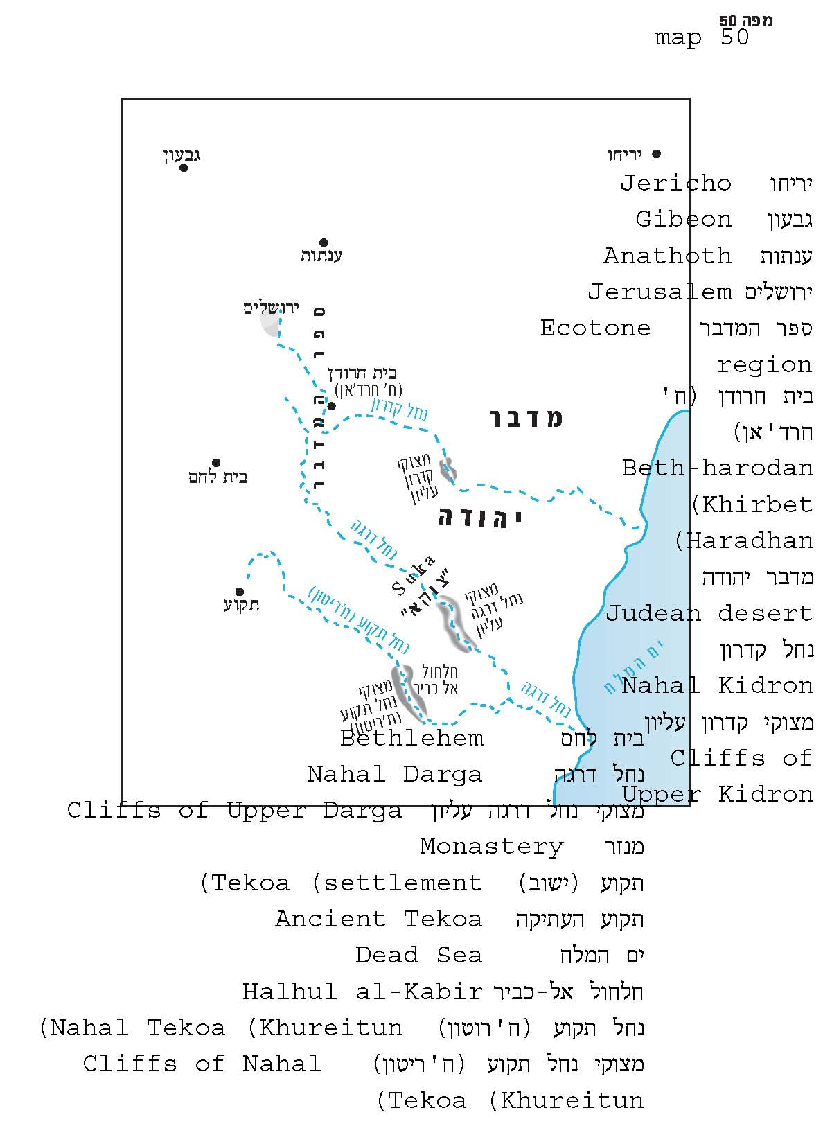

The Mil

I have a theory concerning the mil, a unit of length used by Chazal. It is a debatable position, and it requires much explanation. I heard the foundations of this theory many years ago from Rabbi Yoel Bin-Nun, and I developed the details through my own analysis. A few years ago, an article by J. J. Ajdler was published that proposed a similar view, but it seems to me that a few details in his study need some correction. We previously addressed this issue briefly in our discussion on Chanuka and the location of Modi’in. We will again dedicate a few words here to the main parts of the theory, while going into greater detail regarding the points that relate to the matter at hand.

In general, it is widely accepted in Jewish literature – in Talmudic exegesis, in the halakhic literature of the Rishonim and Acharonim and even in modern Talmudic scholarship – that the mil of the Tanna’im and Amora’im is equivalent to 2,000 cubits. In other words, the Jewish mil was different from the Roman mile, which was about 4,850 feet (sometimes a bit less). According to Bin-Nun and Ajdler, and in my own humble opinion, it seems that, with all due respect to the Rishonim, Acharonim, and scholars, we can infer from both reasoning and from the sources that Chazal’s mil was actually the same as the Roman mile.

How can this position be inferred through reasoning? The word mil is a Roman noun, meaning one thousand double paces (an average man can indeed travel a distance of 4,800-4,900 feet in one thousand double paces). It is inconceivable that Chazal took the Roman word, which was in common use at the time, and gave it a different numerical value. Furthermore, the Romans used milestones on all their paved roads, placing a milestone at every (Roman) mile. The names and titles of the current Caesar and governor were engraved or written in color on each milestone. The Jews were obligated to rely on these milestones that the Roman government would erect, as in that time there was no other way to measure distances. They did not have maps, clocks or speedometers then, nor would anyone have dared erect alternative Jewish markers on the roads if he valued his life.

How can this position be inferred through the sources? There is a positive testimony and a negative testimony supporting this approach. The positive testimony is the accounts of our Sages regarding the distances between various places in the land of Israel, such as from Hammathan to Tiberias, from Tiberias to Sepphoris, from Chezib to the Ladder of Tyre, from Gerab to Shiloh, etc. In general, in almost every case in which we can identify the places mentioned, the distance provided by Chazal is accurate using the Roman mile – and not the 2,000 cubits measurement. Some of the sources are questionable and require their own discussion. In any case, this is not the place to discuss of all these details. Ajdler discussed some of them at length in the article mentioned above, and I hope to make my own additions and corrections to his approach in the future. In the present framework, I focus on two such issues – possibly the most complicated of the lot: the distance between Modi’in and Jerusalem (in our discussion on Chanuka); and the distance between Jerusalem and the tzok (in the present discussion).

The negative testimony for our view is the fact that the term mil does not appear at all in places where the term would have been expected. The concept of techum Shabbat (the maximum distance that one is permitted to walk outside his settlement on Shabbat) is mentioned countless times in the masekhtot of Shabbat, Eruvin and Beitza. The distance there is always defined using the words “two thousand cubits,” rather than referring to the mil.

Thus, it is reasonable that the Roman mile is identical to the mil that Chazal use in their literature. So how did the incontrovertible assumption that Chazal used a different mil enter our minds in the first place? The primary cause of this phenomenon was the passage from Masekhet Yoma, as well as a few more solitary statements from rabbinic literature. In addition, there is the fact that the Rishonim and Acharonim – and even some Talmudic scholars – were not personally familiar with the land of Israel, or were not sufficiently immersed in its landscape or its historical geography. The remainder of this discussion will be dedicated to the passage in Yoma and its ramifications for the common understanding of the length of the mil.

What Is the Ris?

First we must clarify the meaning of the ris, and why the Mishna chose to use this unit of length while presenting it parallel to the mil, instead of simply using the mil. Ris, or more accurately, reis, is a word of Persian origin, meaning an arena for horse racing. The Persian reis is parallel to the Greek word stadion, which is generally found in the plural form stadia (referring either to a stadium or to the length of the race track). The length of a stadion varied in different places (between 600 and 660 feet) since not all stadiums were equal in size. In general, Chazal used the mil when measuring distances along municipal roads, which contained milestones. The reis is only mentioned in a few contexts in the Dead Sea Scrolls and in rabbinic literature. The word reis is used to refer to something other than a unit of measure on three occasions: once in the Midrash – “The beit midrash of Rabbi Eliezer was shaped like an arena (ke-min reis)” (Shir Ha-shirim Rabba 1:1); once in Targum Onkelos, translating the expression emek ha-melekh (Genesis 14:17) – “The king’s arena (beit reisa de-malka)”; and once in Targum Jonathan, translating the expression sha’ar ha-susim (Jeremiah 31:39) – “The Gate of the King’s Arena (tera’ beit reisa de-malka).” In all other instances the word reis refers to a unit of distance, always in cases of distances across open spaces, rather than along paved roads. One of these instances is our case, in which the person entrusted with bringing the goat to the wilderness would pass through wadis and mountains, most of the way in an uninhabited area, with no official roads or milestones. One of the characteristics of the use of the reis or the stadia is the use of either numbers smaller than ten or round numbers. We find this, for instance, in the writings of Josephus. Josephus always used stadia and not miles, since in his time the Roman road system was not yet developed in the land of Israel.

Where Was the Tzok from Which the Goat Was Thrown, and How Does This Affect the Length of a Mil?

The Mishna refers to Azazel – the place where the goat would be sent and thrown during the Temple period – as tzok or tzuk, generally with the definite article: “the tzok.” The word tzok is unique to the Hebrew of the Second Temple period and to rabbinic literature. It is mentioned twice in the Copper Scroll (one of the Dead Sea Scrolls found at Qumran): “the mouth of the tzok of the Qidron”; and “the mouth of the tzok of Beth-Tamar.” In rabbinic literature, aside from the context of the scapegoat, the word tzok is also found in the Mishna: “If it ascended to the top of tzukim and then fell down, it is an unavoidable accident; but if he took it up to the top of tzukim and it fell and died, it is no unavoidable accident” (Bava Metzi’a 7:10; see parallel passage in Tosefta Bava Metzi’a 8:15, cited in Bava Metzi’a 36b). The word tzok is used to refer to the place where the scapegoat was thrown to its death on Yom Kippur in dozens of the well-known piyyutim that focused on the Yom Kippur service. One of the versions of the Jerusalem Targum (MS Neofiti) translates the expression “to Azazel in the wilderness” as “to the wilderness of Tzok – to Azazel.”

The location of this tzok was apparently southeast of Jerusalem. The well-known researcher of the historical geography of the land of Israel Gustaf Dalman called attention to a Christian source – The Life of Chariton. Chariton lived in the fourth century CE and was the father of the ascetic movement in the Judean desert. The Life of Chariton was written in Greek by an anonymous ascetic between the years 560-614 CE. The third and final monastery that Chariton constructed, in which he lived for several years, is described in The Life of Chariton as follows:

…and he went to a different part of the desert, to a place approximately fourteen stadia from Tekoa (Thekō), which was the name of a certain possession (ktēma in Greek; the residents of Tekoa were apparently sharecroppers who worked the land for its wealthy owners)…. Thus Chariton founded in this place as well a holy laura (a primary type of monastery for hermits). This laura is called Souka (Σουκα) by some, who claim to use the Syriac language, while others call it in Greek “the New Laura.”

Fourteen stadia are approximately 8,500 feet. The ruins of the monastery, along with the small spring nearby and the “hanging cave” where Chariton himself lived, are well known today and have been studied from an archaeological perspective. They are located below the modern Jewish settlement of Tekoa and about 9,000 feet northeast of ancient Tekoa on the cliffs of Nahal Tekoa (Wadi Khureitun).

Dalman believed that Souka (Σουκα in the Greek source) is actually tzuka – the tzok, the place where the goat was thrown – whose name was preserved in local tradition since the time of the Temple. He speculates that this was a territorial name that related to the higher, craggy areas of Nahal Tekoa and Nahal Dragot, citing other Christian sources on the ascetic movement in the Judean desert that mention the names of two additional regions in the Judean desert. The vicinity of the monastery itself, located today by the section of the wadi between the settlements of Tekoa and Nokdim, is not particularly desert-like. Thus, it would seem that the goat would be thrown from cliffs farther to the east in the same region.

Based on this, the road from Jerusalem to the tzok must have run from the northwest to the southeast. This conclusion has importance that transcends all topographical questions. The Mishna relates that there were ten booths (sukkot) along this road, and that the nobility of Jerusalem would accompany the “designated man” up to the first booth, and then from booth to booth – each time traveling the maximum distance permitted under the laws of techum Shabbat. This would seem to be an explicit proof that a mil is 2,000 cubits. However, the distance from Jerusalem to the estimated location of the tzok is greater than 50,000 feet, which is a close approximation of 10-12 mils only when a mil is defined as one Roman mile, and not when it is defined as 2,000 cubits.

It seems that the solution is as follows. According to the halakha, the distance of techum Shabbat is not measured in a circle, but in a square that is oriented according to the cardinal directions. Thus, if one walks to the north or to the east, he is permitted to travel up to 2,000 cubits, but if one walks in a diagonal direction – e.g., northeast or southeast – he is permitted up to the distance of the diagonal of a 2000x2000 cubit square (Eruvin 55a; Rambam, Hilkhot Shabbat 28:7; Shulchan Arukh, Orach Chayyim 398:3). Thus, it turns out that the techum Shabbat of those accompanying the designated man was not 2,000 cubits but more than 2,800 cubits (2000 x √2), a distance that is very close to one Roman mile.

On the road to the tzok, at a distance of three mils from Jerusalem, there is another place that is mentioned in the Mishna (Yoma 6:8), though the traditions differ regarding its precise name. The printed versions read “Beth-hidodo”; the most reliable manuscripts of the Mishna read “Beth-haroro”; Rambam, the Mishna in the Yerushalmi and a manuscript from the Vatican library read “Beth-horon”; and other versions abound. It seems that the best reading is “Beth-harodan,” since we are familiar with a place that bears a similar name in an appropriate location – south of Abu Dis, about three Roman miles from Jerusalem. This site is called Khirbet Haradhan. I visited there and ascertained from local Arabs that the name of the site is actually pronounced in this way. At this place, the landscape begins to resemble that of a desert. The moment the goat reached this point, the High Priest would be able to continue his service. The designated man could continue accompanying the goat until reaching the place where he could fulfill the mitzva of throwing the goat from the precipice (an element of the mitzva that is not absolutely necessary; the main part of the obligation is that he reach the wilderness). A distance of ten mils (according to Rabbi Judah and Rabbi Jose) fits with the cliffs of Nahal Kidron in the vicinity of the Mar Saba monastery, while a distance of twelve mils (according to Rabbi Meir) fits with the cliffs of upper Nahal Dragot.

A tradition identifying the tzok with a location in the upper Nahal Dragot region apparently continued to exist until the time of Rabbi Ishtori Haparchi, about seven hundred years ago. He writes: “From Jerusalem to Azazel is [a journey of] about three hours, and Halhul and Tekoa are near there.” The “Halhul” that he mentions here is not the well-known city of Halhul located north of Hebron, but a desert-like region known on today’s maps as Halhul al-Kabir, about six miles southeast of Tekoa. The maps note the location of Wadi Halhul in this region as well, between Nahal Darga and Nahal Tekoa (Khureitun). From the language used by R. Ishtori Haparchi, it seems that he was relating an eyewitness account rather than some kind of inference made on his own.

Could the Temple Have Been in Tel Aviv?

I would like to conclude by presenting a novel understanding of the connection between the Temple and the wilderness. In our discussion on Parashat Re’eh, we spoke about the term ha-makom (“the place”). We determined that, in reality, according to the Torah, “the place (ha-makom) that the Lord will choose” is not necessarily Jerusalem. As the Sifrei Zuta states, “the land of Canaan is suitable as a home for the Divine Presence, while the Transjordan is not suitable as a home for the Divine Presence” (Sifrei Zuta, Naso, 228). In other words, every place in the western part of the land of Israel – in the Cisjordan – can be “the place that the Lord will choose.” It was the prophets who revealed that just as God was already planning to choose David and his descendants as kings of Israel, He was also already planning to choose Jerusalem: “This is my resting-place for all time” (Psalms 132:14). From the present discussion, we learn that every version of “the place that the Lord will choose” always had its own Azazel attached to it. When the Mishkan was in Shiloh, the scapegoat was certainly thrown from a different place, somewhere in the arid cliffs above the Jordan Rift Valley.

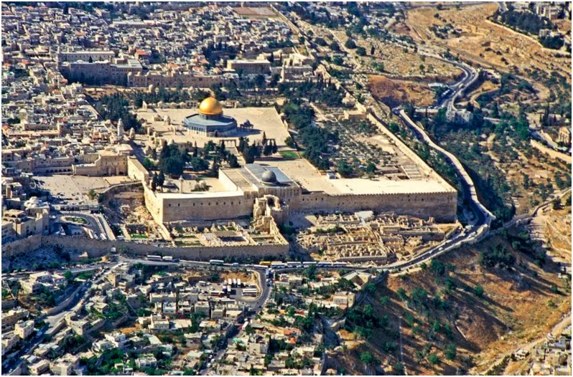
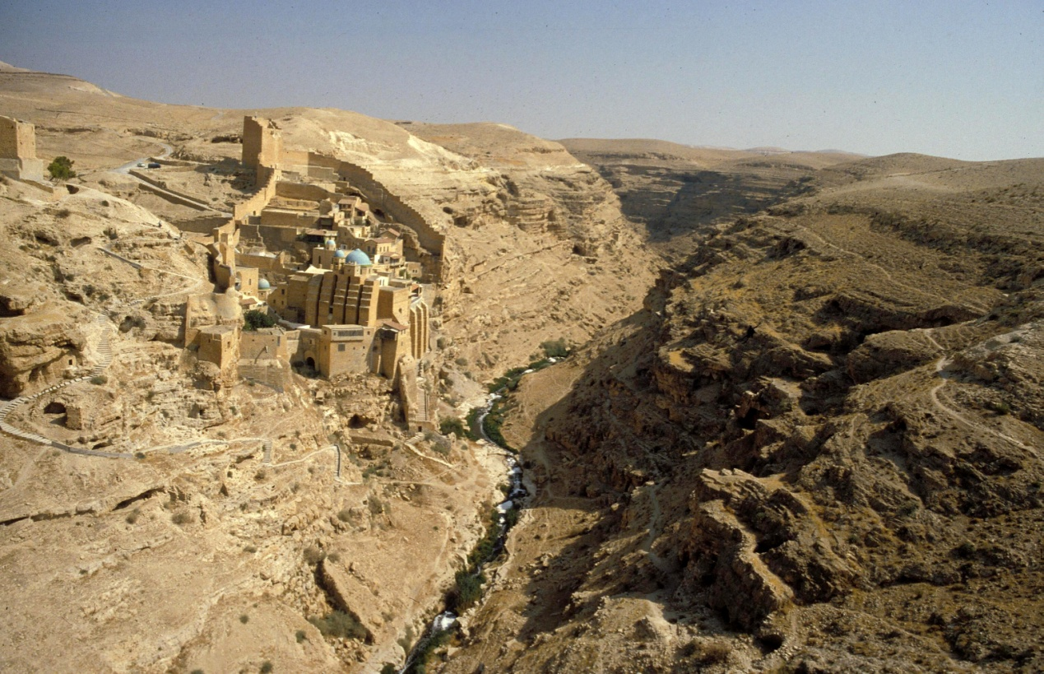
The two opposite parallels of Yom Kippur: The Temple Mount (above) and the cliffs of the wilderness (below). Pictured here are the cliffs of Nahal Kidron, near Mar Saba – probably the site of Azazel according to R. Judah and R. Jose (Z. Radovan).

At this juncture, an interesting point arises. It seems that in principle, the entire land of Israel was actually “suitable as a home for the Divine Presence” until Jerusalem was chosen as the place of the Mishkan or of the Temple, but not all of the land was suitable in practice. For example, I would claim that places like Tel Aviv, Haifa, Bnei Brak and Tiberias are not appropriate places. Why? Because the place of the Mishkan or the Temple must be located within a day’s walking distance of the desert. What this means is that places that are not close to a desert area cannot host the Shekhina. The Shekhina requires a wilderness in its close vicinity! It seems that this notion is connected to the choice of the land of Israel that we addressed in our discussion on Parashat Ekev and Parashat Nitzavim. The land of Israel, in its essence, is a land that experiences both extreme blooming and extreme desert conditions. In light of this, it is clear that the Temple – the heart of the land of Israel – must be located in a place that is not desert-like but is close to the desert, near the border between the fertile and the desolate.

In a historic moment described in Jeremiah 28, two people representing these two starkly contrasting landscapes on either side of Jerusalem stood together in the Temple. These two people were Hananiah son of Azzur, the prophet from Gibeon, and Jeremiah, the prophet from Anathoth. Gibeon is located just a few miles northwest of Jerusalem, in a region that receives abundant rainfall, on a hill encircled by springs and surrounded by a fertile valley. In contrast, Anathoth is located a few miles northeast of Jerusalem, in the semi-desert ecotone region that is reflected in all the prophecies of Jeremiah, who lived there. When Hananiah, the false prophet, came to the house of God, it was as if the false promises that he uttered reflected the serene landscape of his home city, whereas the prophecy of Jeremiah, the true prophet, reflected the harsh nature of his own. Perhaps it was specifically because of Jeremiah’s personal connection to the unforgiving desert that there are no prophecies of consolation more stirring and uplifting than those few prophecies of consolation in the book of Jeremiah.

In the Holy Temple – the most unique and sacred place in the world – and on Yom Kippur – the epicenter and the quintessence of the entire year (“‘In due time they were formed, to the very last one of them’ [Psalms 139:16] – this is Yom Kippur” [Pesikta Rabbati 23 and parallels]) – the day’s service centers on the concept of “One lot marked for the Lord and one lot marked for Azazel” (Leviticus 16:8).

This is how the fundamental principles of the Torah and of the faith of Israel are actualized – “See, this day I set before you blessing and curse” (Deuteronomy 11:26). May it be God’s will that we merit the blessing.

For further study:

J. J. Ajdler, “Talmudic Metrology I: The Mile as a Unit of Length,” BDD 19 (2008), pp. 55-83.

M. Avi-Yonah, Historical Geography of Palestine, Jerusalem 1984, 104 [Hebrew].

E. Ben-Yehuda, A Complete Dictionary of Ancient and Modern Hebrew, 6575-6576 [Hebrew].

G. Dalman, Sacred Sites and Ways, translated by P. P. Levertoff, London 1935, pp. 95-96.

L. Di Segni, “The Life of Chariton,” in V. L. Wimbush (ed.), Ascetic Behavior in Greco-Roman Antiquity: A Source Book, Minneapolis 1990, 410.

M. Fischer, B. Isaac and I. Roll, Roman Roads in Judaea II. The Jaffa-Jerusalem Roads (British Archaeological Reports, International Series, No. 628), Oxford 1996, 329-330.

Y. Hirschfeld, “Life of Chariton in Light of Archeological Research,” in V. L. Wimbush (ed.), Ascetic Behavior in Greco-Roman Antiquity: A Source Book, Minneapolis 1990, 439-446.

Rabbi Ishtori Haparchi, Kaftor Va-ferach, ed. Lunz, Jerusalem 1897, 299 [Hebrew].

R. Margaliot, He’arot al Ha-Shulchan Arukh ve-Nos’ei Kelav: Orach Chayyim, Tel Aviv 5714 (1954).

Y. Tsafrir, L. Di Segni and J. Green, Tabula Imperii Romani Iudaea Palaestina: Eretz Israel in the Hellenistic, Roman and Byzantine Periods, Jerusalem 1994, 236.

Translated by Daniel Landman

See Map 50
The extent to which the accepted equation of the mil with 2,000 cubits has influenced the great Torah sages can be seen in the commentary of Rabbi David Ha-Levi Segal, the author of Turei Zahav (Taz), one of the greatest poskim of all time. Commenting on the law that residents of a village situated adjacent to a city “walled from the days of Joshua son of Nun” must similarly read Megillat Esther on the fifteenth of Adar – as long as the distance between the two locales is not greater than one mil – Taz states: “The measure of a mil is two thousand cubits, and the entirety of Masekhet Shabbat is full of this” (Orach Chayyim 688:3; also see his discussion in light of this pronouncement). The truth, however, is that the equation of 2,000 cubits and one mil does not appear even once in Masekhet Shabbat. But when this equation become lodged in one’s consciousness, it is easy to unwittingly switch the terms, thinking that he read the word mil instead of “two thousand cubits.” (This impreciseness of Taz was discerned already by R. Reuven Margaliot in 1954; I am indebted to R. Yisrael Ariel of Yitzhar for this note).
The word is punctuated רֵיס with a tzere in the most reliable manuscripts of the Mishna and similarly רֵיסָא in the good testimonies of the Targumim.
The Talmud states: “Every cubit in the side of a square corresponds to one and two fifths of a cubit in its diagonal” (Eruvin 57a; see Tosafot there). When the dimensions in question are larger, we find that the Sages were more precise in their calculations: The Sages evaluated 50 x √2 as “seventy cubits and a fraction,” and that fraction was evaluated as close to 2/3 or 5/7 of a cubit (Eruvin 23a-b, 57a).
The name “Harodan” is also mentioned in an ancient ketuba that was discovered in the Judean desert.

