YESHIVAT HAR ETZION
ISRAEL KOSCHITZKY VIRTUAL BEIT MIDRASH (VBM)
*********************************************************

GEOGRAPHY IN THE PARASHA

PARASHAT KI TETZE

“Alternate Weights, Larger or Smaller”
By Prof. Yoel Elitzur

The Gold and Silver Standard

Until the advent of the coinage system, all commerce in ancient times was based on the gold and silver standard. In a normal transaction, the buyer would bring a gold or silver bar or jewelry and would then weigh them on balance scales. Every instance of buying and selling in the Tanakh involved this weighing procedure: “Abraham weighed out for Ephron the silver that he had named in the hearing of the Hittites” (Genesis 23:16); “He must weigh out silver in accordance with the bride-price for virgins” (Exodus 22:16); “Even if a thousand shekels were weighed out into my hands” (II Samuel 18:12); “Why do you spend money [lit. weigh out silver] for what is not bread” (Isaiah 55:2); and finally, in Jeremiah’s description of his purchase of Hanamel’s field, he says, “And I weighed out the silver on a balance” (Jeremiah 32:10).

In earlier periods, the more primitive barter method was used to carry out commercial transactions. In this system, a person would offer his cow in exchange for a donkey or one hundred sheep in exchange for a plot of land. From a linguistic perspective, it is worth noting that in the language of the Tanakh, the word mikneh is the general term for sheep and cattle, undoubtedly because these livestock were used in order to acquire (liknot) other items. The use of precious and semiprecious metals in place of livestock or grains was an early development that allowed people to purchase goods without having to carry heavy or cumbersome items long distances. The transition from cattle-based transactions to the first metal-based transactions can be seen in the archaeological findings. A decorated bronze vessel from the mid-second century CE found in Cyprus integrated two figures, one carrying a goat over his shoulder and a second figure a large copper bar. In the Aegean world, copper bars with the figure of an ox imprinted upon them have been found. However, in every place where people had access to gold and silver, they understandably preferred to carry a few ounces of these precious metals in their pockets rather than numerous pounds of copper. One ancient and obscure means of payment was the kesitah. The kesitah, whose etymological background is unknown, is mentioned in the story of Jacob’s purchase of the “parcel of land” in Shechem (Genesis 33:19, Joshua 24:32) and in the description of Job’s restoration in Job 42:11. The prevailing view among the ancient translations (i.e., the Septuagint, Onkelos, Jonathan, the Peshitta, the Vulgate, the Job Targum) is that the word kesita refers to a ewe, and there is room to speculate that this interpretation is based on an exegetical tradition rather than a mere guess. It is very likely that the word relates to the quantity of silver that is equal in value to a ewe.

Items of jewelry were made intentionally so that their weights would be round numbers so that they could be used as weights for commercial transactions. This is implied in the story of Rebekah and Abraham’s servant: “The man took a gold nose-ring weighing a half-shekel (beka mishkalo), and two gold bands for her hands, ten shekels in weight” (Genesis 24:22).

The use of the word beka (literally, “rift”) to refer to a half-shekel alludes to the fact that originally, a half-shekel consisted of a piece of silver weighing one shekel that was actually split into two halves. Similarly, it seems that the term betza kesef, which appears in the Song of Deborah (Judges 5:19), and its shortened version betza (literally, “piece” or “slice”), which appears twenty-two times in the Tanakh, originated in the practice of slicing pieces from gold and silver bars to be used as payment. Gold and silver bars that had been cut in two were found at various archaeological sites, as well as bars with a groove in the middle indicating where to cut in order to produce two equal halves.

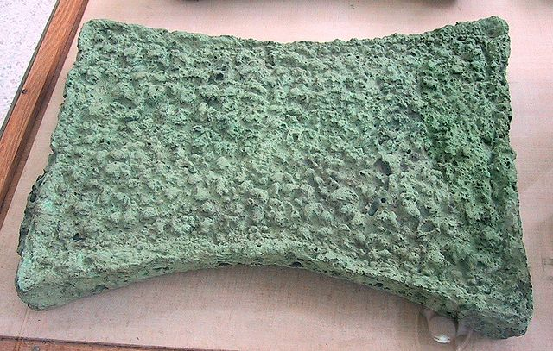
Bronze Age copper ingot found in Zakros, Crete (Wikimedia Commons – User “Chris 73”)

The Invention of Coinage

Today’s coins are a form of fiat currency, possessing only symbolic value rather than actual intrinsic value. This was a very late development, which began in Europe in the seventeenth century, while the Middle East only completely converted to the system in the twentieth century. I would hazard a guess that over the course of the twenty-first century, this system will fall by the wayside as well, as electronic payment or some other more sophisticated system will supplant coins and paper bills entirely.

For more than two thousand years, the world was full of gold or silver coins whose value was assessed based on their weight. It must be stated, though, that as early as the time of Chazal, the coin had symbolic value to a certain extent; a coin maintained a fixed value even if it wore out and the quantity of metal it contained decreased. Conversely, if a government declared a coin obsolete, it would lose all its value. The Talmud distinguished between a money transaction and a barter transaction, and between tiv’a – the use of coinage (matbe’a) as a method of acquisition – and peira – the use of objects or merchandise for acquisition (Bava Metzi’a 44a-47b).

The invention of coinage became possible the moment that people developed the technical ability to imprint silver tokens with intricate designs, which a simple person without sophisticated tools would find difficult to forge. The earliest coins in the world were minted in western Asia Minor during the end of the First Temple period. The technique first spread through Greece and the surrounding areas, then throughout the civilized world. The first coins mentioned in the Tanakh are darkemonim (Ezra 2:69; Nehemiah 7:66-71) and adarkhonim (Ezra 8:27; I Chronicles 29:7). Another version of adarkhonim found in other traditional texts is drakhonot: “When the Israelites came up out of the captivity they used to pay the Machatzit Ha-shekel in drakhonot” (Mishna Shekalim 2:4). Despite the similarity between the names of the two coins mentioned in Ezra, most scholars believe that these are two distinct coins. These scholars identify darkemonim with the drachma (literally, “handful”), a common Greek coin, and the (a)darkhonim with the Persian daric. It should be noted that a Sidonian/Greek bilingual inscription found in the vicinity of Athens (dated to the late third century BCE) mentions drknm and drkmnm as synonyms. The earliest coin discovered in the land of Israel was found accidentally by the great coin expert, my teacher, Prof. Ya’akov Meshorer, z”l. Meshorer was a sort of coin hunter: He had a special knack for finding coins, and would succeed in doing so almost every time he would visit an ancient site. In 1960, when he was a 25-year-old student, he was walking one morning in Jerusalem to the Givat Ram campus of the Hebrew University. When he passed through the site of the Binyanei HaUma convention center (then under construction), he suddenly noticed an ancient coin. Upon inspection, it became clear that this coin was an authentic tetradrachm from the sixth century BCE, apparently imported to the land of Israel around the time of the Edict of Cyrus! Coins that were native to the land of Israel from their conception began to be minted about one hundred years after the return to Zion, starting in Gaza (imitating the Athenian coins) and then in Ashkelon, Judah (in Jerusalem, apparently) and in Samaria. The Judite coins are imprinted with the word yhd (pronounced yehud) and sometimes (either in place of yehud or in addition to it) with a person’s name and title, such as “Johanan the Priest”; “Jaddua”; “Judah”; and “Hezekiah the Governor.” The Samaritan coins contain the word šmryn (pronounced shāmrayin) and occasionally names of people: Abdael (a name that appears in the Samaritan chronicles); San(ballat); Jeroboam (!) and others. One particularly interesting finding is a Samaritan coin apparently dated to shortly after the Macedonian conquest, whose obverse depicts a bearded deity sitting on a throne and holding a scepter in his hand. Next to this figure, the word ΖΕΥΣ (Zeus) is written. The same coin’s reverse depicts a rider on horseback raising a sword, beneath him the word yhw^{c}nh (Jeho’anah), certainly the name of a Samaritan official. This integration of a distinctly Israelite name, characteristic of those who believed in the God of Israel, with the Greek god Zeus, fits the description of the Samaritans in the Tanakh and in Josephus’ writings. In the Tanakh, even in the books set during the return to Zion, the verb “weigh out” (the root Š-Q-L) still appears frequently, in every context of monetary payment: “So they weighed out my wages, thirty shekels of silver” (Zechariah 11:12); “I will weigh out ten thousand talents of silver to the stewards for deposit in the royal treasury” (Esther 3:9). Meshorer maintains that the values of coins during that period were still not uniform or completely set. As a result, people would not rely on this coinage and continued to weigh out their silver.

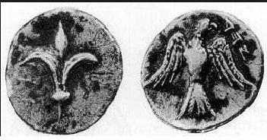
A YHD coin minted in Judea during the Persian period

Stone Weights during the Biblical Period

From the Tanakh we are familiar with the shekel, the beka (or half-shekel), the “one-third of a shekel” (Nehemiah 10:33) and the quarter-shekel (I Samuel 9:8). An example of a smaller unit is the gerah or agora (“twenty gerahs to the shekel” [Exodus 30:13]), while larger units include the talent (kikar, equal to 3,000 shekels according to Exodus 38:25-26) and the mina (maneh, appearing in the later parts of the Tanakh and in rabbinic literature, equal to one hundred dinar or twenty-five sela’im.

The archaeological findings in the land of Israel contain numerous weight stones from the First Temple period, each engraved with a notation indicating the weight of the stone. There were some rare weights, such as one featuring the image of a turtle labeled peleg reva (“a part or half of one quarter”), along with another turtle labeled chamesh (“five”). The most common symbol used to denote the shekel was ע, sometimes depicted alongside digits (of the sort used at the time) indicating the number of shekels. Smaller stones were also found, engraved with the words beka, pim, and nezeph. The shekel weighed, on average, about 0.4 ounce, the beka weighed about 0.2 ounce, the pim weighed about 0.28 ounce and the nezeph weighed about 0.35 ounce. It seems, then, that the pim was equal to about two-thirds of the value of the shekel, while the nezeph was about five-sixths of its value. When the first pim was discovered in the City of David in the early twentieth century, a connection to the following passage from I Samuel was immediately suggested:

No smith was to be found in all the land of Israel, for the Philistines were afraid that the Hebrews would make swords or spears. So all the Israelites had to go down to the Philistines to have their plowshares, their mattocks, axes and colters sharpened. And the sharpening was a pim for plowshares, mattocks, three-pronged forks and axes, and for setting the goads. (I Samuel 13:19-21)

The commentators and the grammarians struggled to interpret the word pim here. In light of the finding, it was suggested that the Philistines would charge the Israelites a pim for every sharpening. Some understood pim as a shortened version of the expression pi shnayim. This expression is commonly thought to mean “double,” based on a casual reading of the instances where it appears in the Tanakh. But the truth is that pi shnayim means two parts out of three or more. For example, in our parasha the firstborn son inherits pi shnayim of his father’s estate, meaning two parts out of all the parts into which the estate was divided. Similarly, Elisha asked of Elijah that he be considered a “firstborn son” with respect to his spiritual inheritance, in relation to the other disciples of the prophets: “Let two parts (pi shnayim) of your spirit pass on to me” (II Kings 2:9). Finally, see also Zechariah 13:8: “Two-thirds (pi shnayim) shall perish, shall die, and one-third of it shall survive.”

Nezeph is a word that is not found in the Hebrew vocabulary. However, it is a word in Arabic that means “half.” The finding demonstrates that in the Hebrew of the First Temple period, the word was used in the sense of five-sixths.

The sela that appears in rabbinic literature is the Tyrian tetradrachm, whose weight was about half an ounce. It is interesting to note that all the Jewish coins from the Hasmonean period, and even from the time of Herod, were cheap copper coins. On the other hand, numerous Tyrian tetradrachms have been found in Jerusalem and in Judea, many more, in fact, than the number of such coins found in Tyre itself. Meshorer speculated that because of the quality of the Tyrian sela’ and its importance for use in the Temple and for other halakhic purposes, the Jews in Jerusalem would mint these Tyrian coins. The first Hebrew silver coins since the ancient yhd coins were the beautiful and poignant coins that the Jewish rebels minted during the Great Revolt against Rome. These coins were equal in value to the Tyrian sela’; they bore the inscription Shekel Yisrael on one side and Yerushalayim Ha-kedosha (“the holy Jerusalem”) on the other. Ramban, in a letter from the land of Israel (printed verbatim at the end of his commentary on the Torah in the Chavel edition), describes this coin, using it as a basis for establishing the halakha regarding the precise weight of the Biblical shekel. It seems that the increase in the weight of the shekel from the 0.4 ounce indicated by the weights from the First Temple period to the half-ounce of the Tyrian shekel is about the same as the increase of a sixth that the Sages defined as the upper limit of how much the measure of a coin may be increased. It is likely that in ancient times each weight had various values, and it may be that Biblical phrases like “at the going merchants’ rate,” “by the sanctuary weight” and “by the royal weight” referred to measures that were larger than the standard shekel.

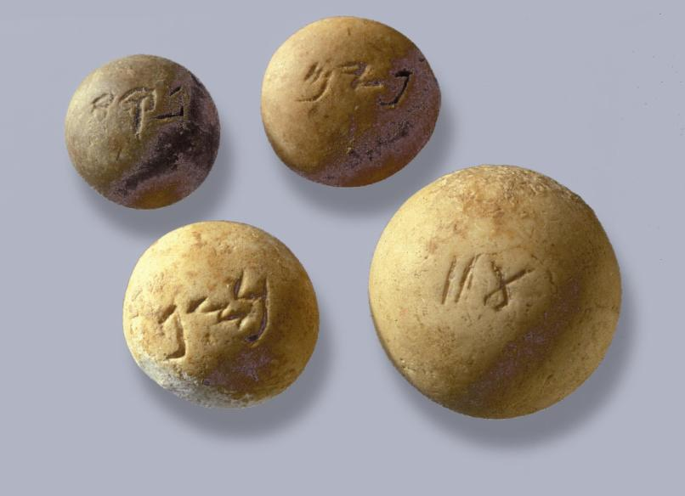
Weight stones from the First Temple period. Clockwise from top-left: beka, pim, two shekels and nezeph. (Z. Radovan)

“You Shall Not Have in Your Pouch Alternate Weights”

We can now return to this week’s parasha. It is well known that a small, imperceptible increase in an object’s length, width or depth can have a significant impact on its volume. As a result, the degree of precision in the dimensions of the weights in a person’s pouch could be an effective gauge of that person’s moral compass: “Honest scales and balances are the Lord’s; all the weights in the bag are His work” (Proverbs 16:11). The books in the Tanakh from the monarchy period include several references to “false balances” and “false weights” (see Hosea 12:8; Amos 8:5; Micah 6:11; and Proverbs 11:1, 20:23). The Torah states:

You shall not have in your pouch alternate weights, larger and smaller. You shall not have in your house alternate measures, a larger and a smaller. You must have completely honest weights and completely honest measures, if you are to endure long on the soil that the Lord your God is giving to you. For everyone who does those things, everyone who deals dishonestly, is abhorred to the Lord your God.

The measures here, like the weights, are identified by their set volume, and as a result they too are easy to manipulate without causing a noticeable change. A dishonest person might prepare a “smaller weight” that he would use when weighing out the amount of money he would need to pay when buying, as well a “larger weight” that he would use when determining the amount of money he would receive when selling. The Torah teach that even a small act of dishonesty, of which other people are not even aware, is an abhorrent injustice. The book of Proverbs presents an abridged version of the passage in our parasha, converting the verses into a succinct adage: “False scales are an abomination to the Lord; an honest weight pleases Him” (11:1); and “False weights and false measures, both are an abomination to the Lord.”

For further study:

Y. Aharoni, “The Use of Hieratic Numerals in Hebrew Ostraca and in the Shekel Weights,” BASOR 184 (1966), 13-19.

R. Kletter, Economic Keystones: The Weight System of the Kingdom of Judah, JSOT Supplement 276, Sheffield 1998.

Y. Meshorer, Ancient Means of Exchange, Weights and Coins (ed. R. Reich), Haifa 1998, 15-18.

Y. Meshorer, “The Coins of Samaria in the Persian Period,” Michmanim 6 (1992), 7-13.

Y. Meshorer, A Treasury of Jewish Coins, Jerusalem 2001, 1-17, 72-78.

Y. Meshorer, The Third Side of the Coin, Jerusalem 2006, 19-22 [Hebrew].

Y. Meshorer and S. Qedar, The Coinage of Samaria in the Fourth Century BCE, Jerusalem 1991, esp. 13-18.

M. A. Powell, “Weights and Measures,” Anchor Bible Dictionary 6, 905-908.

N. Slouschz, Thesaurus of Phoenician Inscriptions, Tel-Aviv 1942, 116-118 [Hebrew].

E. Stern, “Midot U-mishkalot,” Encyclopaedia Biblica 4, 846-878 [Hebrew].

Y. Yadin, “Ancient Judaean Weights and the Date of the Samaria Ostraca,” Scripta Hierosolymitana 8 (1961), 9-25.

Translated by Daniel Landman

The verb livtzo’a appears in the Tanakh ten times, in the sense of robbery and theft.
The vowelization of the word as derakhon, rather than darkon, follows credible manuscripts of the Mishna.
The daric was named for the Persian king Darius.
The Greek drachma is equivalent to the dinar used by the Romans (as well as by Chazal); the tetradrachm is equivalent to four dinars, a sela (representing the Biblical shekel) in the language of Chazal.
Compare to Ezra 5:8: yehud medinta – “the province of Judah.”
Compare to Ezra 4:10 and others.
See II Kings 17:33: “They worshiped the Lord, while serving their own gods.”
See Antiquities XII, where he relates that the Samaritans approached Antiochus Epiphanes and requested permission to call their temple on Mount Gerizzim “the Temple of Zeus Hellenius” (257-264).
This symbol may have been a schematic illustration of a tied bundle in which one might keep his money.
According to Yohanan Aharoni, this practice was influenced by the Egyptian writing system.
A similar expression existed in ancient Egyptian: The consonant r is represented by the mouth hieroglyph, and thus rwy means “two mouths,” or two-thirds. This is the linguistic equivalent of pi shnayim, as the Hebrew expression literally means “two mouths” as well.
Compare to Isaiah 44:16-19, where the word “half” refers to any fraction, and not necessarily fifty percent.
Ramban confirmed Rashi’s opinion on this matter, against the opinion of the Geonim: “And we weighed it at the money changer’s tables and its weight was ten units of silver which are half an ounce, which Rashi has mentioned (see Rashi to Exodus 21:32).” This greatly supports Rashi’s opinion.
See Bava Batra 90a and Tosafot there; Menachot 77a; Bekhorot 5b. In the Torah, Onkelos translates the verse “twenty gerahs to the shekel” as “twenty ma’ahs to the sela”; the sela of the Second Temple period was equal to 24 ma’ahs, perhaps due to the influence of Mesopotamian measures.
The phrase even kis (“weight in the bag”) exists in Akkadian as well: aban kīsi.

