YESHIVAT HAR ETZION
ISRAEL KOSCHITZKY VIRTUAL BEIT MIDRASH (VBM)
*********************************************************

GEOGRAPHY IN THE PARASHA

PARASHAT SHOFTIM

Nachal Eitan
By Prof. Yoel Elitzur

Nachal Eitan – Earlier vs. Later Commentary

In describing the egla arufa ritual, the Torah states: “And the elders of that town shall bring the heifer down to a nachal eitan, which is not tilled or sown. There, in the wadi, they shall break the heifer’s neck” (Deuteronomy 21:4). What is a nachal eitan? For Modern Hebrew speakers who are familiar with the basic types of streams, the answer should be simple. A nachal eitan is a perennial stream, one that contains flowing water all year long. The other major stream type is a nachal akhzav, an intermittent stream, which only contains flowing water when it rains or immediately thereafter.

Interestingly, if we take a look at the interpretation of our early sources, we see that they did not interpret nachal eitan in this manner. All the ancient translations, first among them the Greek-language Septuagint, followed by the Targum Onkelos, the Jerusalem Targum in its various versions, the Samaritan Pentateuch translation and the Latin Vulgate, and even Rabbi Saadia Gaon’s Arabic translation, interpret nachal eitan as a hard place, a rocky ravine or something of that nature. Josephus interpreted this way as well – “To a valley, and to a place therein where there is no land ploughed or trees planted” (Antiquities IV, 8:16) – as did the Mishna, according to the simple reading of Sota 9:5: “Eitan is to be understood in its literal sense: hard.”

When I examined this question, I found that modern commentators, almost without exception, interpret nachal eitan in line with its meaning in Modern Hebrew: a flowing stream, or one that flows forcefully. This interpretation is the most common among both modern commentators and contemporary English translations. These modern commentators explain that the idea behind the inclusion of the nachal eitan in the egla arufa ritual is atonement. The murderer was not found, so the elders declare their innocence and the priests beseech God: “Absolve, O Lord, Your people Israel whom You redeemed” (Deuteronomy 21:8). Similar, in a way, to the modern tashlikh ritual that is customarily performed on Rosh Ha-shana, here too the city elders stand before a body of flowing water and wash their hands in the water, which in turn washes away their sin, as it were: “And they will be absolved of bloodguilt.” If so, we are dealing with a mitzva that is characterized by reconciliation.

Thus, we find that there is a dispute between the earlier and later commentators. The early commentators maintained that nachal eitan refers to a rocky, craggy ravine, while the later commentators maintained that it refers to a flowing stream. The historical inflection point when the interpretation changed occurred at a surprising time: during the heart of the Middle Ages. The early medieval commentators Rashi and Ibn Ezra continued along the lines of their predecessors. Rashi states: “Nachal eitan: hard, never tilled.” Ibn Ezra explains: “Eitan: firm.” However, beginning with Rambam, who lived shortly after Rashi and Ibn Ezra, the “flowing water” meaning entered the scene. Rambam writes in Hilkhot Rotze’ach 9:2: “They bring the calf down to a stream that flows forcefully. This is the meaning of the term eitan found in the Torah.” This became the predominant interpretation from that point on, both among Jewish commentators (such as Chizkuni and Abrabanel) and among modern-era Christian commentators, as well as in all Hebrew dictionaries, both ancient and modern. Only a small minority of commentators from the modern period deviated from the “flowing water” interpretation, while some attempted to formulate a position that would reconcile between those of the earlier and later commentators (see Malbim). One prominent exception among the modern commentators is Shmuel David Luzzatto, who outlined the two conflicting approaches and sided explicitly with the earlier commentators. Among the dictionaries, the Even-Shoshan Dictionary can be singled out for siding with the earlier commentators on the nachal eitan question.

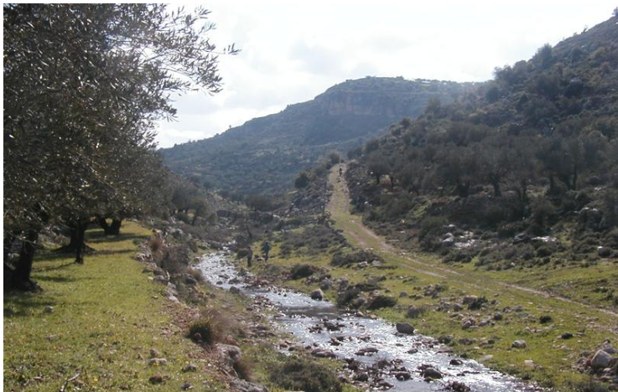
Wadi Dilb in southern Samaria: a perennial stream and an example of a nachal eitan according to the later commentators and dictionaries (Courtesy of Amit Mendelsohn)

Who is Right?

On the face of it, it seems as though the later commentators were right. Indeed, there are multiple arguments that can be made in support of their approach. First of all, the expression nachal eitan appears one other time in the Tanakh, in a context that makes its meaning undisputable: “But let justice well up like water, righteousness like an unfailing stream (ke-nachal eitan)” (Amos 5:24). The parallel structure in this verse makes clear the connection between nachal eitan and flowing water. Perhaps additional support can be drawn from the verse, “It was You who made mighty rivers (neharot eitan) run dry” (Psalms 74:15) and even, “And at daybreak the sea returned to its strength (le-eitano)” (Exodus 14:27). In all of these cases, the word eitan indicates abundant water. The proof from the verse in Amos was cited by Rabbi Zvi Hirsch Chajes in his glosses on Massekhet Sota, in the name of Rabbi Jacob Emden. He writes at the end of the gloss, “This requires much further study,” referring to anyone who interprets nachal eitan as anything other than a stream with flowing water.

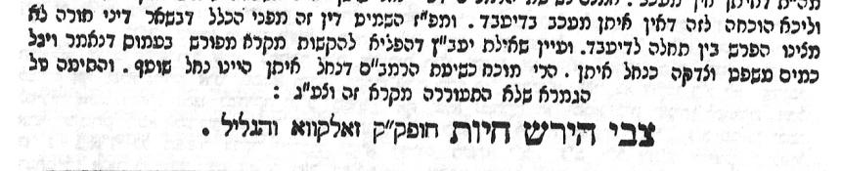
“See the [Responsa] She’eilat Ya’avetz who argued vigorously from an explicit verse in Amos: ‘But let justice well up like water, righteousness like an unfailing stream (ke-nachal eitan)’” (Rabbi Z. H. Chajes)

In addition, the egla arufa passage itself contains a strong support for the later commentators. The Torah states there: “Then all the elders of the town nearest to the corpse shall wash their hands over the heifer whose neck was broken in the wadi” (Deuteronomy 21:6). In order for the elders to “wash their hands” in the wadi, it must have contained flowing water!

Thus, it seems clear that the approach of the later commentators is indeed correct.

What is a Nachal?

However, before we discuss the question of nachal eitan, we must ask what the meaning of the word nachal is in general. If one were to open a Bible concordance and examine the ways in which the Tanakh refers to streams, he would find, first of all, that there is a distinct difference between a nahar and a nachal. Not one stream in the land of Israel is called a nahar – not even the mighty Jordan. Only the largest and widest bodies of water are called neharot in the Tanakh, and these include only the greatest rivers by international standards: the Tigris, the Euphrates and the Nile and its Ethiopian sources (naharei kush, Isaiah 18:1). In contrast, the land of Israel contains nechalim – smaller streams. Some of these streams contain water, such as the Kishon, the Yabbok and the Arnon. Others are dry, like the wadi between Socoh and Azekah, where David found smooth stones to use as shot for his sling, and like Nahal Besor, in whose vicinity David and his men found an Egyptian youth who had “drunk no water for three days and three nights.” An interesting verse that effectively illustrates the meaning of a dry stream can be found in Genesis 26:19: “Isaac’s servants, digging in the wadi, found there a well of spring water.”

Nevertheless, my father, z”l, instilled in me the awareness that two identical phrases in the Tanakh can mean two different things depending on whether the context is one of poetry or prose. When a verse is speaking metaphorically or using a figure of speech, nahar and nachal generally appear in tandem, as synonyms expressing abundance. Examples of this usage include “The rivers (naharei) of honey, the brooks (nachalei) of cream” (Job 20:17) and “Prosperity like a stream (ke-nahar), like a wadi (u-khenachal) in flood” (Isaiah 66:12). In contrast, when a verse is describing a physical, geographical area using concrete terms, there is a very clear distinction: All the neharot are mighty bodies of water located outside the land of Israel, whereas almost all the nechalim are wadis (with or without flowing water) that can be found within the land of Israel.

Why is the same word – nachal – used for both dry streams and flowing streams? The landscape of the land of Israel itself can help explain this curiosity. The land of Israel is a land of hills and valleys. When one assesses the landscape from a geological perspective, the only thing that is important is the valley between the hills. The question whether such a valley contains flowing water or not is immaterial to the essential definition of the geological feature; it is merely an additional detail. In other words, when the word nachal is used in Biblical prose, it serves to define the essence of the land formation rather than the water flowing within it. Pay close attention to the wording in Psalms 104:10: “You make springs gush forth in torrents (ba-nechalim)” – the nachal is the geological essence, and God causes water to flow within it.

Returning to Nachal Eitan

If nachal is the geological essence, then it must be that the word eitan acts as a modifier for the land rather than the water – in other words, following the interpretation of the earlier commentators!

It is worth considering here the landscape of the land of Israel. Our parasha discusses the case of a corpse that is found in a field, where the identity of the murderer is unknown. What would be done if such a corpse was found somewhere between Arad and Beersheba or between Lachish and Azekah – areas that were teeming with settlements during the Biblical period (see Joshua 15:20-47) but nowhere near any forcefully flowing stream? Where would the elders bring the heifer in such a case? Taking logic and the geographical reality of the land of Israel into consideration, it would be much more reasonable to think of the nachal eitan as a rocky ravine rather than a flowing channel. Thus, the descriptive phrase “which is not tilled or sown” is part of the definition of nachal eitan and not merely an additional piece of information.

That is to say, both the definition of the term nachal and a consideration of the landscape of the land of Israel seem to support the interpretation of the earlier commentators in the question of the meaning of nachal eitan.

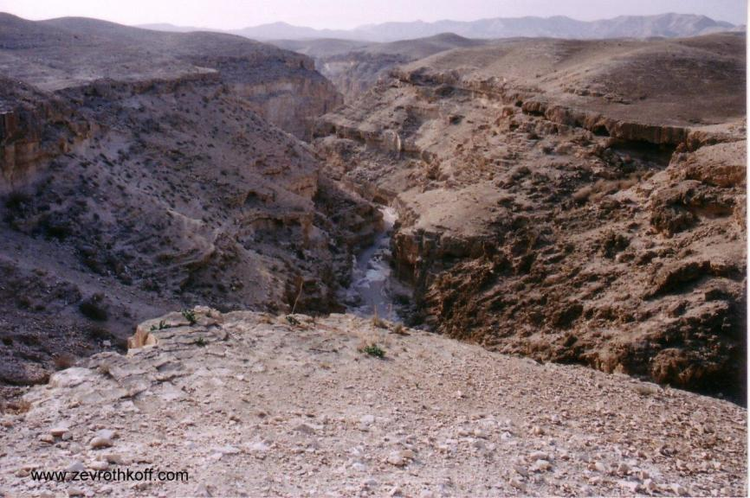
Nahal Darga in the Judean Desert: a rocky ravine and an example of a nachal eitan according to the earlier translations, sages and authors (Courtesy of Dr. Zev Rothkoff)

In light of this, how can we counter the strong proofs that we cited above in support of the later commentators? Regarding Rabbi Chajes’ pronouncement that “this requires much further study,” the solution is simple: Amos was using poetic, metaphorical language, while the egla arufa passage in Deuteronomy is pure prose. As we demonstrated above, nachal refers to a wadi in prose, while in poetry it is a symbol of abundance and plentiful water. The Prophets occasionally use a literary device in which they quote an expression from the Torah or from earlier books in the Tanakh in order to extract new meaning from the expression. Our case is a particularly effective example of this device from a literary perspective. The prophet takes an expression that was originally used in prose, and transplants it into a context of poetic imagery. By doing this, he transforms the meaning of the expression into the polar opposite of its original sense.

“They Shall Wash Their Hands”

As for the point we made above that the elders could not possibly have washed their hands in a stream that lacked flowing water, it is worth paying attention to the division of the verse indicated by the Masoretic cantillation marks and by the diacritical marks. Specifically, in the phrase “they shall wash their hands over the heifer,” the cantillation marks indicate a pause at the word ha-egla (“the heifer”), while the final section of the verse – ha-arufa va-nachal (“whose neck was broken in the wadi”) – stands as an independent segment. In light of this, the word va-nachal is not an object or an adverbial adjunct of the word yirchatzu (“they shall wash”), but of the word ha-arufa (“whose neck was broken”). The elders do not wash their hands in the water of the stream; rather, they bring a bottle of water with them and then use that water to wash their hands over the heifer whose neck was broken in the wadi. An internal analysis of the passage supports this interpretation as well; the words ha-arufa va-nachal allude to the earlier verse: ve-arefu sham et ha-egla va-nachal (“there, in the wadi, they shall break the heifer’s neck”).

According to this interpretation, the whole essence of the mitzva takes on a new meaning. This is not an act of reconciliation, but quite the opposite: It is an act that expresses the intent to see justice done. It is an act in the vein of “She set her blood upon the bare rock, so that it was not covered” (Ezekiel 24:8) and “the land can have no expiation for blood that is shed on it, except by the blood of him who shed it” (Numbers 35:33). It is a stern message to the populace that they must continue to search for the murderer and bring him to justice (see Luzzatto).

Another point to consider: In light of all that we have seen here, it seems that we can compare the atonement of the heifer to the atonement of the “scapegoat” of Yom Kippur. Regarding the goat, which is sent off “to Azazel,” the ritual’s designated location is the wilderness, and eretz gezeira – an inaccessible region. In other words, it is a harsh, rocky land.

Why the Commentators Suddenly Changed Their Tune

There is one more piece of the puzzle that remains to be explained. How could such an extreme reversal in the approach of the commentators have occurred? How could it be that all the translators and early commentators interpreted nachal eitan to mean “rocky ravine,” while almost all the later commentators – both Jewish and non-Jewish – understood the phrase to mean “flowing stream”?

Perhaps the key to answering this question lies in the fact that the early authors and sages were more familiar with the land of Israel and its landscapes. Many of them actually lived in the land itself, and others – especially Rashi, whom Luzzatto describes as having a “palate for tasting the taste of the Holy Tongue” – seemed to have had a unique sense for preserving the spirit of the land of Israel. These earlier authors interpreted nachal eitan in accordance with the landscape and atmosphere of the land of Israel. By contrast, the later writers generally lived in completely different landscapes. Many lived near the rivers of Europe, or on the banks of the Nile in Egypt, in the case of Rambam, and it may be that their interpretation was subconsciously influenced by the landscape in their own vicinity.

For further study:

S. R. Driver, A Critical and Exegetical Commentary on Deuteronomy (ICC), Edinburgh 1901, 241-242.

Yoel Elitzur, “Geographical Terminology in the Bible: nhr, nḥl, and nḥl ‘ytn,” Iggud: Selected Essays in Jewish Studies 1 (2008), 3-19 [Hebrew].

S. D. Luzzatto, Torah Commentary, trans. E. Munk, Jerusalem 2012, [pages].

Translated by Daniel Landman

One example of this phenomenon is Migdal Eder, a place name in Genesis and later a literary epithet for Jerusalem in Micah 5:1. Another example is Er and Onan (Genesis 38), two of Judah’s sons who were displeasing to God and whose lives were taken by God; in Malachi, er and oneh are literary descriptions for the Judites, who were unfaithful to God and were subsequently cut off by God.
This division of the verse also explains why the first letter of the word va-nachal (“in the wadi”) loses its dagesh, changing from the plosive bet to the fricative vet: It is connected to the preceding word ha-arufa, which ends with a vowel.
See Rashi’s commentary on Leviticus 16:8; compare to Torat Kohanim, Acharei Mot 2: “From where do we know that it must be on a cliff? We learn this from the verse ‘to an inaccessible region.’”

