YESHIVAT HAR ETZION
ISRAEL KOSCHITZKY VIRTUAL BEIT MIDRASH (VBM)
*********************************************************

GEOGRAPHY IN THE PARASHA

PARASHAT DEVARIM

*********************************************************
IN LOVING MEMORY OF

Jeffrey Paul Friedman
August 15, 1968 – July 29, 2012

לע"נ

יהודה פנחס בן הרב שרגא פייוועל
כ"ב אב תשכ"ח – י' אב תשע"ב

ת.נ.צ.ב.ה
*********************************************************

The Rephaim, Emim and Zamzummim
By Prof. Yoel Elitzur

A Word on the Unique Character of Parashat Devarim

Parashat Devarim is always read on the Shabbat immediately preceding Tisha Be-av. Tisha Be-av, the ninth day of the Hebrew month of Av, is our great national day of mourning, but in the future, according to the prophecy of Zechariah, it will become a holiday, a day of joy and celebration. At the heart of the matter, it can be said that there is no less joy embedded at the root of Tisha Be-Av than there is mourning. The fundamental reason for Tisha Be-Av’s identity as a day of mourning is the sin of the spies and the malcontents within the nation. The nation rejected the land of Israel – “a delightful land” (Psalms 106:24) – and it was decreed as a result that they would not merit seeing it. However, this is not the fundamental essence of this day. Rather, it is a complete perversion of what the essence of the day was meant to be. The ninth day of Av was designated to be a day of great celebration – the day when the spies would return from scouting out the land and sing its praises to the nation. The nation would then bow down to God and then, led by Moses and the Ark of the Covenant, would set out immediately to the top of the hill to storm the land. The reality of this expectation made the sin that followed all the more egregious, in the vein of the Talmud’s analogy of a shameless bride who is unfaithful to her husband under the very bridal canopy (Gittin 36b). Throughout the history of the nation of Israel, this sin has never been rectified completely. When this does occur, though, the day will revert to its original, fundamental identity as a day of joy and transcendence, re-establishing our intimate connection to the holiness of the land.

Parashat Devarim is made up of two parts that express very effectively the two opposing identities of Tisha Be-av. The first part relates once more, emphatically, the story of the sin of the spies and the punishment that resulted. The second part describes, with a joyful tone and with poetic language, the journey toward the land of Israel and the conquest of the land of Sihon and Og. There is some similarity between the second part of Parashat Devarim and the second part of Parashat Chukat (many people who read the Torah using the traditional cantillation consider both these sections favorites). Like the second part of Parashat Chukat, the second part of Parashat Devarim contains a combination of movement and song. The Torah uses lofty, poetic language in both places, including unique expressions, and recounts condensed versions of movement and battle, victories and dispossession.

Another similarity between the two parashot is seemingly quite surprising. Both parashot contain poetic sections that opt specifically to recount a kind of general history that is at first glance unconnected to the nation of Israel. In Parashat Chukat it is the Song of the bards, who sang words of encouragement to King Sihon of the Amorites during his war against Moab. In Parashat Devarim it is mostly information about early, mysterious nations, whose people were as tall as giants, and who were destroyed long before the people of Israel arrived in the land. In addition, there is a rather peculiar piece of information about King Og of Bashan’s iron bedstead. We will now attempt to review these details and understand what it all means.

A Side Note about Giants and Anakites

The parasha makes reference to the notably tall anakim three times, twice in its description of the Emim (Deuteronomy 2:11-12) and once in its description of the Zamzummim (2:21). There are conflicting versions of the vowelization of the word ka-anakim: Most printed Chumashim render the word with a patach at the beginning (כַּעֲנָקִים), but the exemplary manuscripts from the Masoretes and the newer editions based on these manuscripts, as well as the Yemenite tradition, render the word with a kamatz at the beginning (כָּעֲנָקִים). The difference between the two versions is manifested in the question if the word is a common noun or a proper noun. If it is a common noun (with a patach) then the meaning of ka-anakim is “as giants.” However, if the word is a proper noun (with a kamatz) then the meaning is “as the Anakites.” Most translations, both old and new, follow this latter position. In any case, in terms of content it is clear that the Anakites were chosen because they were archetypical giants, so from the perspective of the spirit of the text the difference between the two versions is negligible.

The Early Nations in our Parasha and Elsewhere in the Tanakh

Five early nations are mentioned in our parasha. Four of these resided in the Transjordan, ordered from south to north: the Horites, the Emim, the Zamzummim and the Rephaim. Another nation, the Avvim, resided in the Cisjordan. The Horites resided in Seir until the descendants of Esau wiped them out and settled in their place (2:13, 23). The Emim were the early residents of the land of Moab (2:11); the Zamzummim were the early residents of the land of the Ammonites, until the Ammonites wiped them out and settled in their place (2:21-22); and the last surviving member of the Rephaim, who had settled in Bashan, was King Og of Bashan (3:11, 13). The Avvim settled in “villages in the vicinity of Gaza” until the Caphtorim, who came from Crete, wiped them out and settled in their place (2:24).

The clear Biblical parallel to the text in our parasha is Genesis 14, which relates that when Chedarlaomer and the kings allied with him entered the land from the north, they “defeated the Rephaim at Ashteroth-karnaim, the Zuzim at Ham, the Emim at Shaveh-kiriathaim and the Horites in their hill country of Seir as far as El-paran, which is by the wilderness” (14:5). This list provides us, first of all, with an exceedingly early dating for the presence of these nations in the Transjordan – more than 450 years before Moses’ conquest of this land. It seems that the Zuzim of Genesis are identical to the Zamzummim of Deuteronomy. The order of these nations from north to south in Genesis fits precisely with the account in Deuteronomy. We know nothing about the language or culture of these nations, but it should be noted that several ancient inscriptions were found in the Transjordan, written in pictographs that have not yet been deciphered. It may be that the place name Ham, the meaning of which is unknown, is a word in the language of the Zuzim.

Ancient undeciphered pictographic inscriptions from the Transjordan (Courtesy of Dr. Ada Yardeni and the Hebrew University Magnes Press)

Between the three cities mentioned here, two have certain identifications. Ashtaroth has been identified with Tell Ashtara, about eleven miles southeast of Ramat Magshimim in the southern Golan Heights. Ham has been identified with Tell Ham, about four miles southwest of Irbid in the northern Gilead. Kiriathaim appears several times in the Tanakh and in the Mesha Stele among the Reubenite cities in northern Moab, and it has several suggested identifications. The meaning of the name Shaveh-kiriathaim is uncertain.

The Horites appear as well in Parashat Vayishlach (Genesis 36), where it says that Esau settled peacefully in Mount Seir, and that Timna daughter of Seir the Horite was the concubine of Esau’s son Eliphaz and the mother of Amalek through that union (36:12, 22). This does not contradict our parasha’s statement that “the descendants of Esau dispossessed them, wiping them out and settling in their place.” Throughout history, it is not uncommon that during a process of population overhaul there may be incidents of both integration and intermarriage on one side and battle and dispossession on the other (similar to Israel in the land of Canaan during the time of the Judges, as well to the Spanish in South America in the sixteenth century CE).

The Avvim appear in Joshua 13 among the “territory that remains,” of which the people of Israel did not take possession: “All the districts of the Philistines… and those of the Avvim on the south” (13:3-4); in other words, there were Avvim in southern Philistia. In our discussion on Parashat Toldot, we addressed the observation that the early Philistines described in the Torah were practically different from the later Philistines from the periods of the Judges and of Samuel (their residence was farther south, among other things). We also noted that several groups of nations that arrived from the west and settled in the southwestern part of the land over the course of several centuries became known as “Philistines.” Thus, it seems that the term “Avvim” is an epithet that was used to refer specifically to the Philistines who existed during the time of the patriarchs, while the new population that came from Crete, dispossessed the early Philistines and settled in their place are the “Philistines” from the time of the Exodus and the conquest of the land of Canaan. We must therefore conclude that the Avvim were not dispossessed completely, and that some of them remained in the southern part of the region during the time of Joshua.

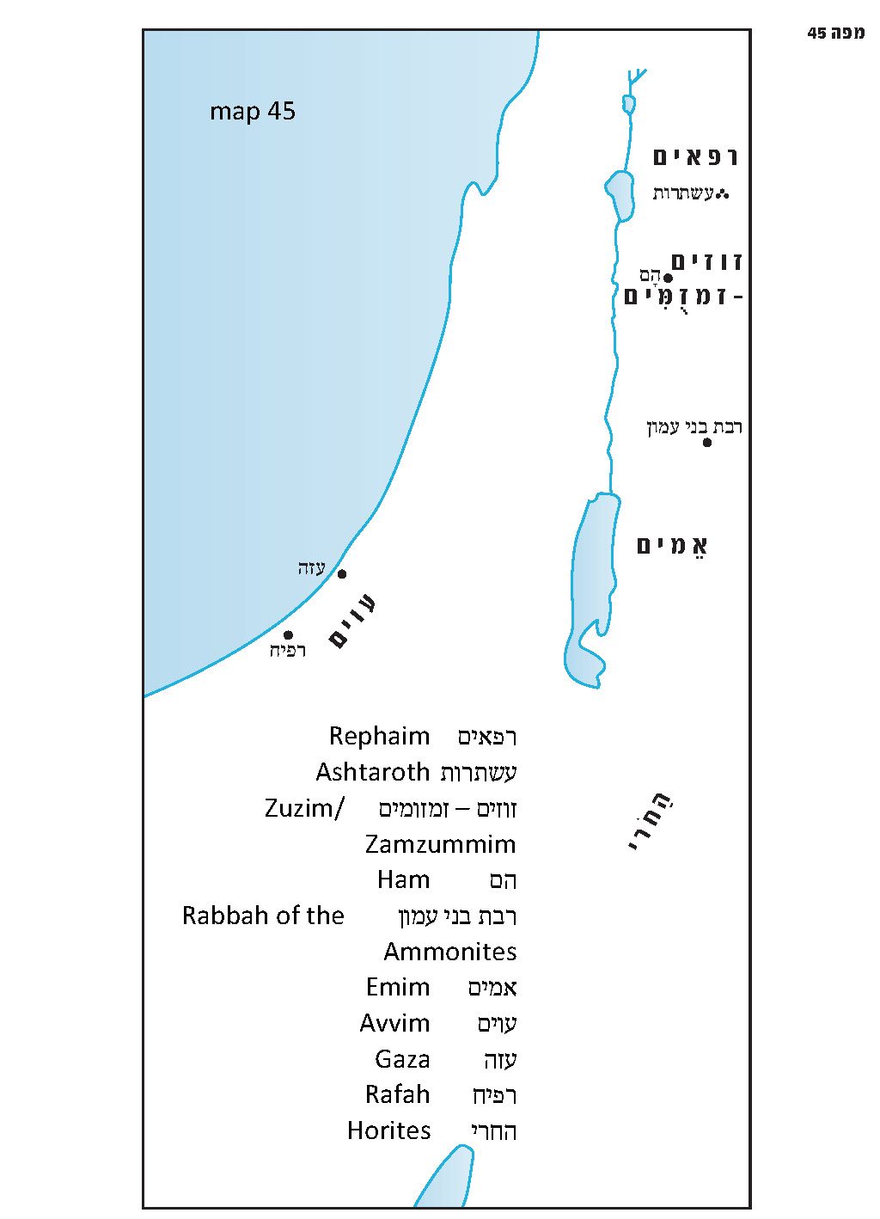

Yeichashevu and Teichashev

The words yeichashevu and teichashev are key words in the Torah’s description of the lands of the Emim and the Zamzummim:

And the Lord said to me: Do not harass the Moabites or provoke them to war. For I will not give you any of their land as a possession; I have assigned Ar as a possession to the descendants of Lot. It was formerly inhabited by the Emim, a people great and numerous, as tall as the Anakites. Like the Anakites, they, too, are counted (yeichashevu) as Rephaim; but the Moabites call them Emim…

You are now passing through the territory of Moab, through Ar. You will then be close to the Ammonites; do not harass them or start a fight with them. For I will not give you any part of the land of the Ammonites to you as a possession; I have assigned it as a possession to the descendants of Lot. It, too, is counted (teichashev) as Rephaim country. It was formerly inhabited by Rephaim, whom the Ammonites call Zamzummim, a people great and numerous and as tall as the Anakites. (Deuteronomy 2:10-22)

In the Hebrew text of the Torah we encounter here a case of a slightly irregular syntactic structure, where the object of the sentence (Rephaim or Rephaim country) precedes the subject (hem, i.e., the Emim or hi, i.e., the land of the Ammonites). The verses most likely use this syntax because “Rephaim” and “Rephaim country” are terms that are important to emphasize.
Thus, we see that the parasha is especially interested in the Rephaim and their territory, and that it emphasizes that the Emim and the Zamzummim are counted (yeichashevu) as Rephaim and that their lands are counted as Rephaim country.

Why does the Torah use this unique verb that appears here in the forms yeichashevu and teichashev? This verb has legal-halakhic significance, which can be seen in the following examples. First, Parashat Behar states that, in contrast to a dwelling house in a walled city, which “shall not be released in the jubilee,” “houses in villages that have no encircling walls shall be classed as open country (al sedeh ha-aretz yeichashev): They may be redeemed and they shall be released through the jubilee” (Leviticus 25:30-31). These are houses that are legally classed as open country. Parashat Korach, in discussing tithes, describes the tithe that the Levites are required to give to the priests:

When you receive from the Israelites their tithes, which I have assigned to you as your share, you shall set aside from them one-tenth of the tithe as an offering to the Lord. Your offering will be accounted (ve-nechshav) to you as the new grain from the threshing floor or juice from the winepress… (Numbers 18:26-27)

A few verses later, the chapter discusses what should be done with the quantity of the tithe that is left over after separating the one-tenth: “When you have removed the best part from it, you Levites may consider it (ve-nechshav la-leviyim) the same as the yield of threshing floor or winepress. You and your households may eat it anywhere” (18:30-31). In contrast to the permissible deer, gazelle and roebuck, which are distinctly different from the forbidden camel, hare and hyrax – or Shabbat and festivals, which are distinctly different from the days of the week – tithed produce appears exactly the same as it did before it was tithed. The Torah stresses that the “tithe of the tithe” that the Levite must separate from the tithe that he receives has great sanctity and is legally equivalent to the teruma that Israelites must separate from their produce and deliver to the priests. After this, the Torah stresses that the nine tenths that remain in the hands of the Levite are completely chullin (non-sacred) and they are legally equivalent to regular produce belonging to an Israelite. A similar usage of this verb is found in Leviticus 7:18: “If any of the flesh of his sacrifice of well-being is eaten on the third day, it shall not be acceptable; it shall not count for him (lo yeichashev lo) who offered it. It is an offensive thing (piggul).” In other words, this sacrifice is not legally considered an offering; rather, it is piggul.

What is the Significance of Rephaim Country?

In light of this, it is important for us to search for the meaning of “Rephaim country” as a concept in halakhic or legal terminology. It is not necessarily a concept that is easily recognizable on the ground, but the Torah found it important to point out the geographical regions that, from a legal perspective, are considered part of this land.

The verse here that refers to Rephaim country clearly bases itself on God’s promise of the land of Israel to Abraham:

On that day the Lord made a covenant with Abram, saying, “To your offspring I assign this land, from the river of Egypt to the great river, the river Euphrates: the Kenites, the Kenizzites and the Kadmonites, the Hittites, the Perizzites, the Rephaim, the Amorites, the Canaanites, the Girgashites and the Jebusites.” (Genesis 15:18-20)

Ten nations are listed here: six of the seven Canaanite nations (only the Hivvites are missing) and an additional four: the Kenites, the Kenizzites and the Kadmonites, and the Rephaim.

In Parashat Devarim, as well as in the story of the war between the four kings and the five kings in Genesis 14, there is one region that is considered Rephaim country par excellence: the northern region, consisting of Ashtaroth and Bashan, the land of King Og (who was himself one of the last surviving Rephaim, despite the fact that his subjects were Amorites). In describing this region, the Torah states that it “is called (yikarei) Rephaim country” (Deuteronomy 3:13). This teaches us another thing about the Torah’s legal terminology: If the word yeichashev means de jure – a technical legal consideration – then the word yikarei means de facto – a consideration in practice, though not by law. Gilead, the area south of Bashan, was already the land of the Zuzim (apparently the Zamzummim of our parasha) in Genesis 14, its eastern part later became Ammonite land and its central and western part became Amorite land under the rule of King Sihon of Heshbon. The next area to the south, east of the Dead Sea, is – according to Genesis 14 and the “prehistoric” account in our parasha – the land of the Emim. The Emim were dispossessed by the Moabites, but shortly before the arrival of the people of Israel Sihon gained control over the northern half of this land, the area north of the Arnon River. The Torah stresses here that despite the fact that these two lands had been known since ancient times as the land of the Zuzim/Zamzummim and the land of the Emim (including in Genesis 14!), this is only what they are called (yikarei) – de facto. In other words, these are merely the names that the Ammonites and Moabites use to refer to the lands. From a legal perspective, however, the lands are counted (yeichashevu) as part of Rephaim country, which God had promised to Abraham. It is important for the Torah to emphasize the giant stature of the members of these nations, since this was a characteristic trait of the Rephaim, and pointing this out lends support to the idea that all these nations share a common ethnic background. The Torah is saying that, formally, all the giants of the Transjordan are members of the same nation: the Rephaim. “Emim” and “Zamzummim” are simply names for Rephaite tribes. The story of King Og of Bashan’s giant bedstead serves to strengthen the de facto usage of “Rephaim country” to refer to Bashan. The nation that resided in Bashan at the time, after all, consisted mostly of Amorites. The fact that the king of this nation was not Amorite but Rephaite is reinforced by reminding the reader of the king’s enormous dimensions. The reader can get a sense of these dimensions even after Og himself was already dead and buried, thanks to Og’s iron bedstead, which was preserved.

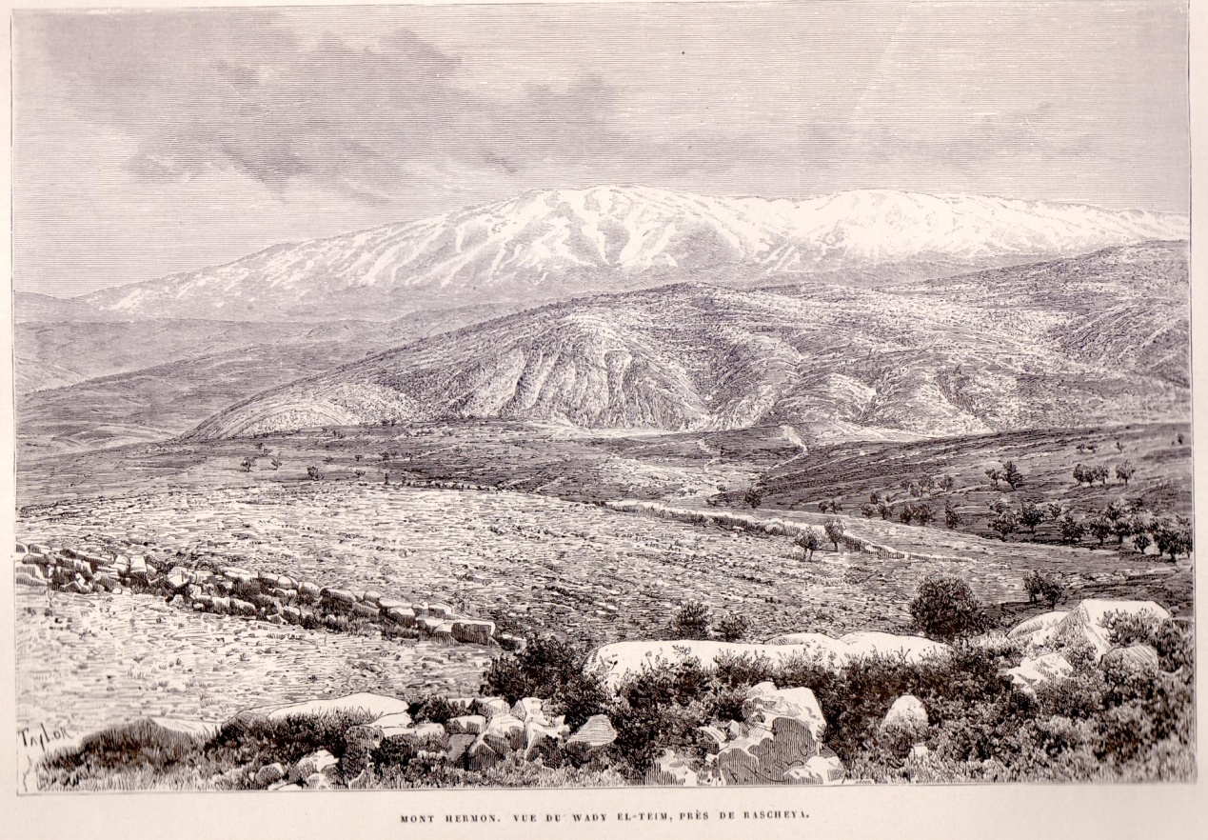
Rephaim country de facto: View of northern Bashan and Mount Hermon (L. C. Lortet, La Syrie, Paris 1884)

The Horites

After discussing Rephaim country, the Torah goes on to describe another area in the Transjordan that completes the picture: the land of the Horites southeast of the Dead Sea, which became the land of descendants of Esau. This region is also included in the land promised to Abraham, as it is situated between the Sea of Suph and the Euphrates River, west of the large Syrian Desert. It is likely that the Kenites, the Kenizzites and the Kadmonites – or part of these nations – resided within this region.

“Do Not Harass Them or Start a Fight with Them”

God warns Moses and the people of Israel not to harm the descendants of Esau, Moab and the Ammonites, “for… I have given the hill country of Seir as a possession to Esau” and “I have assigned it as a possession to the descendants of Lot.” These territories are part of the land that God promised to Abraham, but others aside from the people of Israel have a claim to this inheritance. Ishmael son of Hagar and the descendants of Keturah are also Abraham’s heirs, but they have no claim in the inheritance of the land. This is because Abraham gave them their portion in moveable property during his own lifetime, distancing them from the Promised Land, as the Torah states: “But to Abraham’s sons by concubines Abraham gave gifts while he was still living, and he sent them away from his son Isaac eastward, to the land of the East” (Genesis 25:6). This was certainly not Abraham’s way of shortchanging these heirs; Abraham was notably “very rich in cattle, silver and gold” (13:2), and undoubtedly left them a considerable inheritance. The only remaining heir aside from Jacob and his descendants is Esau. On the other hand, Abraham consciously included an additional person among his heirs, giving him a gift of land during his lifetime:

Abram said to Lot, “Let there be no strife between you and me, between my herdsmen and yours, for we are kinsmen. Is not the whole land before you? Let us separate: If you go north, I will go south; and if you go south, I will go north.” (13:8-9)

Since Esau and the descendants of Lot already controlled parts of the Promised Land, in the land of the Horites and in the greater Rephaim country, and it was forbidden for Israel to dispossess them, Israel would only be able to inherit these territories in one of three conditions:

- A foreign nation could capture the land or part of the land from them, and then the people of Israel could, in turn, capture the land from that conquering force. This occurred in the northern half of Moab, in the area north of the Arnon River and in the western part of the land of the Ammonites. These regions were conquered by Sihon, leading the Sages to state: “Ammon and Moab were purified through Sihon” (Gittin 38a, Chullin 60b). This also led Jephthah to say to the king of the Ammonites: “Now, then, the Lord, the God of Israel, dispossessed the Amorites before his people Israel; and should you possess their land?” (Judges 11:23).

- Ammon, Moab or Edom could attack Israel without provocation. This occurred in the cases of King Eglon of Moab who enslaved Israel (Judges 3:13-14) and King Hanun son of Nahash of the Ammonites who humiliated the messengers that David had sent to him as a gesture of friendship and good will (II Samuel 10:4).

- The nations themselves could no longer exist. Every nation in the world is subject to the same basic historical laws that apply to individuals: they are born, they mature, they grow old and, in the end, they pass from the world. With the power of the divine covenant and promise, the eternal nation of Israel outlasts them all, regrouping and returning to the land after having been exiled and scattered. Once the descendants of Lot and the descendants of Esau served their purposes in the world, their inheritance returned to the people of Israel. Chazal expressed this idea in a midrashic statement:

“For I will not give you of their land so much as a foot can tread on” (Deuteronomy 2:5). Rabbi Meir says: “Until his feet stand on that day.” Rabbi Samuel [Simeon?] says: “Until the one of whom it is written, ‘A star rises from Jacob’ (Numbers 24:17) comes – that is, the King Messiah. The Holy One, blessed be He, said to them: ‘In this world, you do not have permission to inherit this hill country, but in the World to Come you will be redeemed and you will inherit it.’ As it is said, ‘For liberators shall march up on Mount Zion to wreak judgment on Mount Esau; and dominion shall be the Lords’ (Obadiah 1:21).” (Tanhuma Deuteronomy [Buber], addition 6)

In a slightly different expression of this idea, a different midrash explains: “Hide yourselves from him until he passes from this world” (Devarim Rabba 1:19).

The Avvim

Joshua 13 stresses that the land of the Philistines that Joshua was supposed to conquer “are accounted Canaanite (la-kena’ani teichashev)” (13:3). Despite the fact that it was in Philistine hands, from a legal perspective it was part of the land of the Canaanites (who “dwell by the Sea and along the Jordan” [Numbers 13:29]) and it was designated for Israel even in the framework of the “limited” borders of the land. In our parasha, the Torah stresses that the Avvim – the early Philistines who lived in the land during the Patriarchal age – are no longer there; in their place dwell the Caphtorim, who came from Crete. The reason for this emphasis is seemingly the covenant that Abraham and Isaac forged with King Abimelech of the Philistines and Phicol, chief of his troops: “That you will not deal falsely with me or with my kith and kin” (Genesis 21:23). The verse informs us that the land of the Avvim was already conquered by the Caphtorim, and thus the people of Israel are permitted to go to war with the current Philistines – as they are actually the Caphtorim, who were unrelated to Abimelech.

For further study:

W. F. Albright, The Archaeology of Palestine and the Bible, New York-London-Edinburgh 1932, 142, 211.

M. A. Astour, “Ham,” Anchor Bible Dictionary, 3, 32.

Yoel Elitzur, Ancient Place Names in the Holy Land, Jerusalem-Winona Lake 2004, 109.

B. MacDonald, “Kiriathaim,” East of the Jordan: Territories and Sites of the Hebrew Scriptures, Boston 2000, 122-123.

J. Naveh, “Undeciphered Scripts in Syria-Palestine,” in Early History of the Alphabet, Jerusalem 1997, 21-22.

B. Oded, “Kiryatayim,” Encyclopaedia Biblica 7, 272-273 [Hebrew].

Translated by Daniel Landman

The word the Torah uses here, chatzerim, refers to unwalled, nomadic villages (see Genesis 25:16 and others). The Jerusalem Targum and the various versions of the Samaritan Targum translate in this way (be-kufranayya or the like), while other Targumim maintain that chatzerim is a place name (Onkelos identifies it with Rafah).
In my visit to the tell in July 1998, we found, in addition to a wealth of pottery and residents attempting to sell sherds and ancient (possibly forged) scarabs to visitors, the tomb of a sheikh known as Nebi Ham. Opposite this tomb was a Jewish burial cave from the Second Temple era containing six ossuaries and two sarcophagi, with their original covers in place. There was also an ancient pool south of the modern-day village of Ham.
It may be interpreted as a construct state, i.e., the town of Shaveh in the vicinity of Kiriathaim. Another possible suggestion invokes the meaning of the word shaveh (even or flat), which would mean that the name refers to the plain of Kiriathaim.
The inclusion of the word mi-teiman (“on the south”) in the previous verse follows the position of Rav in Chullin 60b, contrary to the masoretic division of the verses.
See Map 45 below.
Rashi comments here: “Even in the cemetery.”
See our discussion on Parashat Mishpatim.
Rashi cites this midrash in brief in his commentary on Deuteronomy 2:5.
See our discussion on Parashat Mishpatim.
This discussion is based primarily on Ramban’s interpretation and, at the end, on that of Rashi.

