YESHIVAT HAR ETZION
ISRAEL KOSCHITZKY VIRTUAL BEIT MIDRASH (VBM)
*********************************************************

GEOGRAPHY IN THE PARASHA

Archive copy
Click here for Word format

PARASHAT KORACH

Guarding the Sanctuary and the Gates of the Courtyard
By Prof. Yoel Elitzur

The Commandment to Guard the Temple

After the ground opened up and swallowed Korach and his company, and the two hundred fifty incense-offerers died fiery deaths, after the complaints, the plague and the flowering of Aaron’s staff came the additional complaint of “Lo, we perish! We are lost, all of us lost! Everyone who so much as ventures near the Lord’s Tabernacle must die. Alas, we are doomed to perish!” (Numbers 17:27-28). Immediately thereafter, Aaron and his sons, and with them the tribe of Levi, are commanded to guard the Tent of Meeting and the altar, to prevent the encroachment of “outsiders”:

The Lord said to Aaron: You and your sons and the ancestral house under your charge shall bear any guilt connected with the sanctuary; you and your sons alone shall bear any guilt connected with your priesthood. You shall also associate with yourself your kinsmen the tribe of Levi, your ancestral tribe, to be attached to you and to minister to you, while you and your sons under your charge are before the Tent of the Pact. They shall discharge their duties to you and to the Tent as a whole, but they must not have any contact with the furnishings of the Shrine or with the altar, lest both they and you die. They shall be attached to you and discharge the duties of the Tent of Meeting, all the service of the Tent; but no outsider shall intrude upon you as you discharge the duties connected with the Shrine and the altar, that wrath may not again strike the Israelites. I hereby take your fellow Levites from among the Israelites; they are assigned to you in dedication to the Lord, to do the work of the Tent of Meeting; while you and your sons shall be careful to perform your priestly duties in everything pertaining to the altar and to what is behind the curtain. I make your priesthood a service of dedication; any outsider who encroaches shall be put to death. (18:1-7)

The commandment to guard the sanctuary applies in future generations as well, as we read in Sifrei:

“To be attached to you and to minister to you,” in their service, and appoint from among them treasurers and supervisors… “while you and your sons under your charge are before the Tent of the Pact,” the priests on the inside and the Levites on the outside. (Parashat Korach 116)

We read further in the Mishna (Middot 1:5) and in the parallel baraita (Tamid 26b): “The priests guard above and the Levites below.” Regarding the number of watches and the places where they were stationed, the Mishna states:

In three places priests guard in the Temple – in the Chamber of Abtinas, in the Flash Chamber and in the Fire Chamber. The Levites guard in twenty-one places – five at the five gates of the Temple Mount, four at its four corners on the inside, five at the five gates of the Courtyard. Four at its four corners on the outside, one at the Offering Chamber, one at the Chamber of the Veil and one behind the place of the mercy seat. (Middot 1:1; and in brief in Tamid 1:1)

The source for the three guarding places for the priests is revealed in the Gemara’s interpretation of the verse, “Those who were to camp before the Tabernacle, in front… were Moses and Aaron and his sons, attending to the duties of the sanctuary, as a duty on behalf of the Israelites” (Numbers 3:38). The verse is used as a source for the three guards in two ways: a) Just as Moses was in one place by himself, so Aaron and his sons were each in one place by themselves; and b) Shomerim (attending to) – one, mishmeret (duties) – two and le-mishmeret (as a duty) – three (Tamid 26a). The twenty-one watches of the Levites were derived from I Chronicles 26:17-18 (27a).

Rambam recorded two surprising and innovative halakhot regarding this matter. In both cases he based himself on what he called Mekhilta, which was apparently his name for the Midrash Halakha that we call Sifrei Zuta. These two halakhic innovations were generally accepted by the authorities who came after Rambam, but both halakhot are somewhat questionable.

- Rambam enumerated “guarding the sanctuary” as a positive commandment (Sefer Ha-mitzvot, PC 22), but he added a negative commandment (NC 67) as well – the prohibition of neglecting to guard the sanctuary. For the source of this negative commandment, Rambam based himself on the Mekhilta (our Sifrei Zuta). However, in the text of Sifrei Zuta that we possess, the formulation is different from the version cited by Rambam. Our version reads: “‘But no outsider shall intrude upon you’ – this refers to a negative commandment. From where [do we learn that it includes] a positive commandment? Say, [from the verse,] ‘As you discharge the duties connected with the Shrine.’” According to this version, the negative commandment is a prohibition imposed upon outsiders from entering to serve in the sanctuary (Negative Commandment 74 in Rambam’s enumeration), and the Midrash adds the novel element of a positive commandment imposed on the priests to guard the sanctuary, blocking outsiders from entering. In this version, there would be no prohibition involved for neglecting to guard the sanctuary. The Midrash Halakha as presented by Rambam is quite problematic. Rambam cites:

“Discharge (ve-shameru) the duties of the Tent of Meeting” – this refers to a positive commandment. From where [do we learn that it includes] a negative commandment? We learn this [from the verse], “As you discharge (u-shmartem) the duties connected with the Shrine….”

The notion that u-shmartem designates a negative command is certainly based on the principle that “Every instance of hishamer (‘take care’), pen (‘so that you do not’) and al (‘do not’) refers to a negative commandment.” However, although our verse does contain language related to hishamer, it is in the context of a positive command. Thus, it should be considered a positive command. Indeed, the Talmud states on three occasions that even hishamer refers to a positive commandment if the word is used in a context that suggests this (Eruvin 96a and parallels; see Minchat Chinukh 391). In any case, one wonders why u-shmartem is at all different from ve-shameru, such that one refers to a negative commandment and the other refers to a positive commandment. (It may be that the teaching is based on the very repetition of this verb).

- Regarding the reason for the commandment, Rambam cites from the Mekhilta (our Sifrei Zuta): “A palace without guards cannot compare to a palace with guards,” and emphasizes several times:

There is a positive commandment to guard the sanctuary. [This commandment] applies even though there is no fear of enemies or thieves, for guarding [the sanctuary] is an expression of respect for it. A palace without guards cannot compare to a palace with guards. (Beit Ha-bechira 8:1 and similarly in Sefer Ha-mitzvot and the Commentary on the Mishna)

There is a fundamental problem here. The reason for the commandment, as presented by Rambam, explicitly contradicts what is written in the Torah. Quite surprisingly, no one commented on this point before the Vilna Gaon. The Vilna Gaon, in his commentary on Mishna Tamid, disagrees with Rambam’s opinion without mentioning his name, writing simply: “It is written explicitly in Seder [Parashat] Korach that this guarding is so that no outsider will enter it.” According to this approach, the statement of the Midrash Halakha that “a palace without guards cannot compare to a palace with guards” can simply be a saying that complements the law and not the primary reason for it.

It may be that the dispute over the reason for guarding the sanctuary hinges on a different dispute – whether the commandment to guard the sanctuary applies during both day and night. If the reason for guarding the sanctuary is to prevent outsiders from entering, then the optimal time for fulfilling the commandment is during the day, when the gates are open and people are entering the courtyard. However, if the whole reason for guarding the sanctuary is to show respect and highlight the site’s importance, then it may be that this is only required at night. As Rabbi Yisrael Lipschitz writes in Tiferet Yisrael at the beginning of Tamid, “During the day there is no need to guard as a sign of respect, as even without this, by virtue of the priests walking back and forth as they perform their service, all say ‘Glory!’ [see Psalms 29:9].”

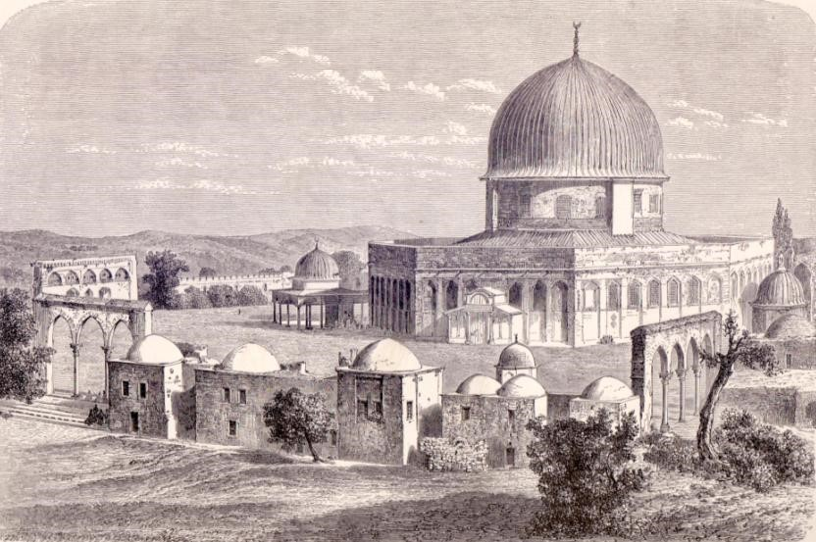

The higher platform of the golden dome in the middle of the Temple Mount, as seen from the northwest. The platform includes the whole space of the Courtyard of the Temple. The lower dome to the left of the Dome of the Rock is probably situated where the altar once stood (L. C. Lortet, 1884)

The Gates of the Courtyard

The Mishna teaches that the Levites guard in twenty-one places, five of which in the five gates of the Temple Mount and five of which in the five gates of the Courtyard. The five gates of the Temple Mount mentioned here fit with the five gates of the Temple Mount enumerated in the continuation of the chapter in Middot:

There were five gates to the Temple Mount: the two Gates of Huldah on the south, which were used both for entrance and exit; the Gate of Kiponus on the west, which was used both for entrance and exit; the Gate of Taddi on the north, which was not used [by the public] at all; and the eastern gate, over which was a representation of the palace of Susa, and through which the High Priest who burned the red heifer and all who assisted with it used to go forth to the Mount of Olives. (1:3)

In contrast, the number of gates of the Courtyard mentioned in our mishna does not fit with the number mentioned in the continuation of the chapter:

There were seven gates in the Courtyard: three in the north and three in the south and one in the east. In the south there was first the Gate of Kindling, then the Gate of Offering [alternately: the Gate of the Firstborn], then the Water Gate. In the east there was the Gate of Nicanor, which had two rooms attached, one on its right and one on its left – one the room of Phineas the dresser and one the room of the griddle cake makers.

On the north was the Gate of the Flash, which was shaped like a veranda. It had an upper chamber built on it, and the priests used to guard above and the Levites below, and it had a door opening into the cheil. Next to it was the Gate of Offering and next to that the Fire Chamber.

The Talmud notes this seeming contradiction and cites two solutions. According to Abaye, there were actually seven gates, but watches only took place at five of these. (Perhaps the two middle gates on the south and the north did not require guarding, since there were already guards posted to the right and to the left of them.) But Rava maintains that the contradiction between the mishnayot reflects a dispute over the historical reality:

Rava said: There is a difference of Tannaim on this point, as it has been taught: There must not be less than thirteen treasurers [attached to the Courtyard] and seven supervisors. Rabbi Nathan said: “There must be not less than thirteen treasurers corresponding to the thirteen gates.” Subtract five for the Temple Mount, and eight are left for the Courtyard. We see therefore that there is a Tanna who says there were eight, and one who says there were seven, and one who says there were five. (Tamid 27a)

Indeed, the number of gates of the Courtyard is disputed explicitly in the Mishna. Aside from the seven gates mentioned in the above mishna, there is another attestation of Abba Jose son of Hanan at the end of Middot 2, as well as that of an unnamed Tanna in Shekalim 6, enumerating thirteen gates in the Courtyard:

And thirteen prostrations were made there. Abba Jose son of Hanan says: They were made facing thirteen gates. On the south adjoining the west there were the Upper Gate, the Gate of Kindling, the Gate of the Firstborn and the Water Gate. Why was it called the Water Gate? Because they brought in through it the pitcher of water for libation on the festival. Rabbi Eliezer son of Jacob says: In it the water welled up, and in the time to come they will issue from under the threshold of the Temple. Corresponding to them in the north adjoining the west were the Gate of Jeconiah, the Gate of the Offering, the Women’s Gate, the Gate of Song. Why was it called the Gate of Jeconiah? Because Jeconiah went forth into captivity through it. On the east was the Gate of Nicanor; it had two wickets, one on its right and one on its left. There were further two gates in the west which had no special name.

Rava in our discussion does not cite this position, and according to the manuscripts, neither does he cite the position in chapter 1 that there were seven gates; it may be that he simply wanted to focus on novel ideas. However, Rambam, in his commentary on Middot 1:1, cites Rava somewhat differently:

And his statement here is that “five gates of the Courtyard” is according to the position of one particular Tanna, as among the Tannaim there is one who said that there were five gates to the Courtyard, and it is he who is speaking here. Among them there is also one who said [there were] seven [gates] – this is the view of the Sages – and among them there is one who said [there were] thirteen [gates], as we explained in the sixth [chapter] of Shekalim and as will be explained in the second [chapter] of this tractate.

It seems that Rambam’s version of the Gemara was different from ours – and simpler. According to him, there is no position maintaining that there were eight gates.

Another different testimony regarding this matter can be found in the writings of Josephus. Josephus’ description of the Courtyard and, east of the Courtyard, the Women’s Court, is similar to the description in Middot 2. However, according to him, there were nine gates to the Courtyard and another three gates to the Women’s Court, totaling twelve gates altogether:

…Which gates on the north and south sides were eight, on each of those sides four, and of necessity two on the east. For since there was a partition built for the women on that side, as the proper place wherein they were to worship, there was a necessity for a second gate for them: This gate was cut out of its wall, over against the first gate. There were also on the other sides one southern and one northern gate, through which was a passage into the court of the women…

Now nine of these gates were on every side covered over with gold and silver, as were the jambs of their doors and their lintels; but there was one gate that was without the [inward court], which was of Corinthian copper, and greatly excelled those that were only covered over with silver and gold. (War of the Jews V 5:2-3)

Contradictory Firsthand Accounts

Let us make some sense of the various accounts, which total between three and five different traditions:

- Unnamed Tanna (Mishna Middot 1:4-5): Seven total gates – three in the north (Gate of the Flash, Gate of Offering, Fire Chamber), three in the south (Gate of Kindling, Gate of the Offering [or Gate of the Firstborn], Water Gate) and one in the east (Gate of Nicanor)

- Abba Jose son of Hanan (Mishna Middot 2) and unnamed Tanna (Shekalim 6): Thirteen total gates – four in the north (Gate of Jeconiah, Gate of Offering, Women’s Gate, Gate of Song), four in the south (Upper Gate, Gate of Kindling, Gate of the Firstborn, Water Gate), three in the east (Gate of Nicanor and two wickets attached on its right and left) and two unnamed gates in the west

- Josephus (War of the Jews): Nine total gates – four in the north, four in the south and one in the east (Gate of Nicanor)

- First mishna in Tamid and first mishna in Middot (according to Rava and against Abaye): Five total gates

- Rabbi Nathan (according to the Talmud’s deduction within Rava’s opinion, and according to our edition but not that of Rambam): Eight total gates

The two latter positions are not agreed upon, and they are possibly even problematic. In order to insist that among the Tanna’im, there is a position maintaining that there were only five gates altogether, one must understand that the unattributed mishna in Middot 1 is presenting two contradictory positions in two near-consecutive mishnayot in the same chapter – without indicating the existence of any dispute and while leaving both positions unattributed.

The final position attributes an independent tradition specifically to Rabbi Nathan, one of the later Tanna’im. Not only does this position go against every position on the issue that preceded it, but Rabbi Nathan expresses the position not as a tradition in its own right, but incidentally, as an explanation of an entirely different matter. The very essence of this position is based on a sophisticated exegesis that Rabbi Nathan never actually stated explicitly. If we take Rabbi Nathan’s position at face value, as Rambam does, it turns out that Rabbi Nathan is simply presenting a tangential statement that is based on the second position in our above list – which is found twice in the Mishna.

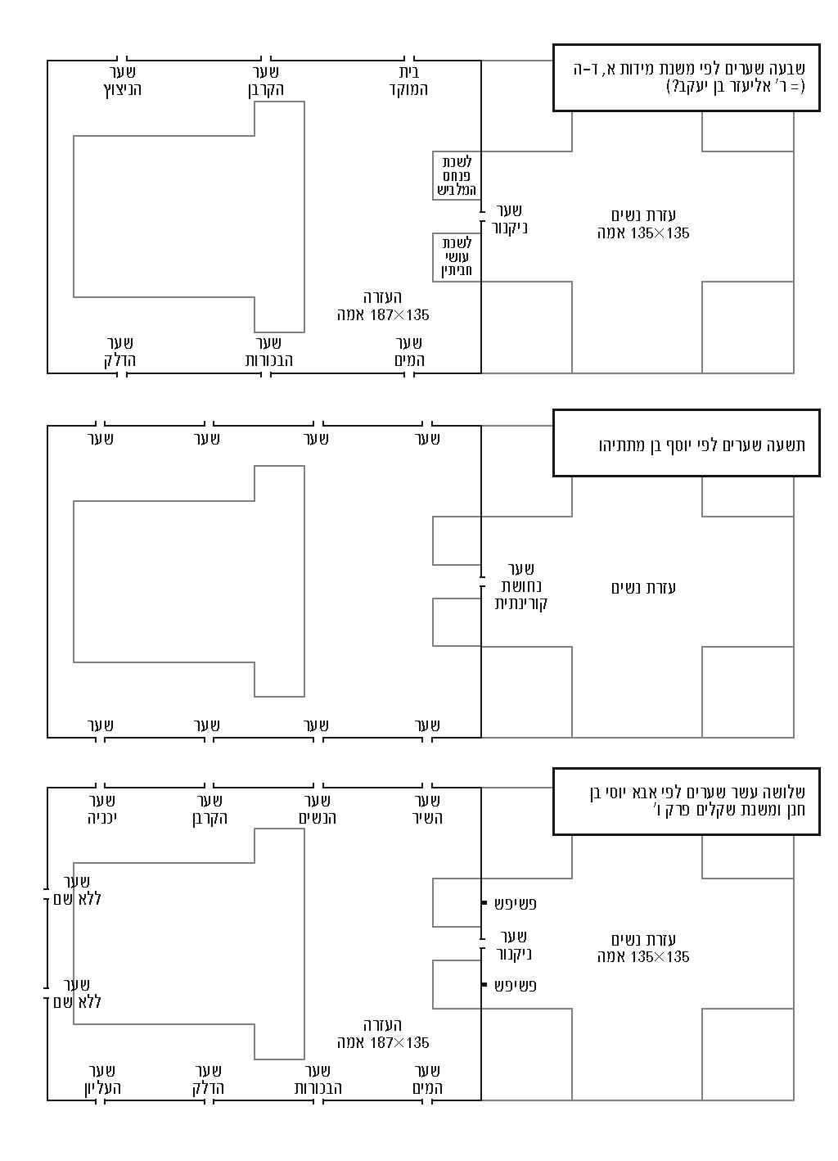

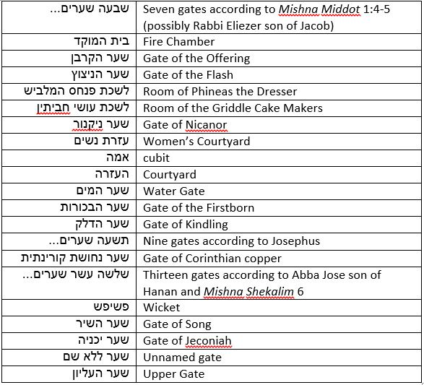

Thus, in the following discussion I will limit my focus to the first three positions listed above. What is the common thread among the three?

- All three positions are stated explicitly. None of these positions is a sophisticated deduction from a different statement.

- All three represent firsthand accounts from people who saw the intact Temple with their own eyes. The first position, an unattributed mishna in Middot, can be ascribed to Rabbi Eliezer son of Jacob (the first), who lived during the Second Temple period. The Gemara (Yoma 16a) deduces this from the recurring line, “Eliezer son of Jacob said: I forget what it was used for” (Middot 2:5; 5:4). In addition, Rabbi Eliezer son of Jacob said, “Once they found my mother’s brother asleep, and they burned his clothes” (1:2). Scholars of the language of the Mishna even claimed that the language in Tamid and Middot is not entirely identical to the standard language of the Mishna; there are signs that the language used in these two tractates is early in comparison.

The second position is attributed to Abba Jose son of Hanan, a sage whose name is mentioned several times in rabbinic literature. On one of these occasions, his name is given as the author of a folk song: “Woe is me because of the house of Boethus… Woe is me because of the house of Kathros… Woe is me because of the house of Ishmael son of Phabi” (Pesachim 57a) – a charming personal testimony from a time when the Temple still stood.

The third position is that of Josephus Flavius, a native Jerusalemite. According to his own testimony about himself, he was a Pharisee priest from the family of Jehoiarib (The Life of Flavius Josephus 1:12). Josephus describes numerous incidents that transpired in Jerusalem and in the Temple during the years prior to its destruction; his is undoubtedly an eyewitness account.

- All three positions include details that could only have been provided by someone who knew the place personally. The divisions of the gates, their dimensions and their names, as well as Josephus’ detailed description of the copper gate – all of these are the typical elements of a primary source.

In light of this, how can it be that three eyewitnesses who lived during the same time period – who saw the same Temple with their own eyes – gave such different detailed testimonies? Here we must emphasize that none of the three testimonies includes any kind of conceptual statement or attempt to connect these details to a particular Biblical verse; nor is any of the testimonies describing a miraculous occurrence. Each testimony is a technical account with no discernible agenda.

Before we attempt to answer this question, I would like to present a prefatory comment. As of today, there is no archaeological evidence in our possession supporting any side in this discussion. By contrast, the topic of the gates to the Temple Mount can be studied with an eye to the well-known gates at the walls of the Temple Mount compound, but there are no clear remnants of the walls of the Temple courtyards and their gates. Perhaps when the legal status of the Temple Mount changes for the better, allowing for excavations beyond those authorized by the Jerusalem Islamic Waqf, we will be able to determine the answer to this question as well, along with several other important questions surrounding the Temple and the Temple Mount. In the present state of things, we are limited to the sources to which we have access.

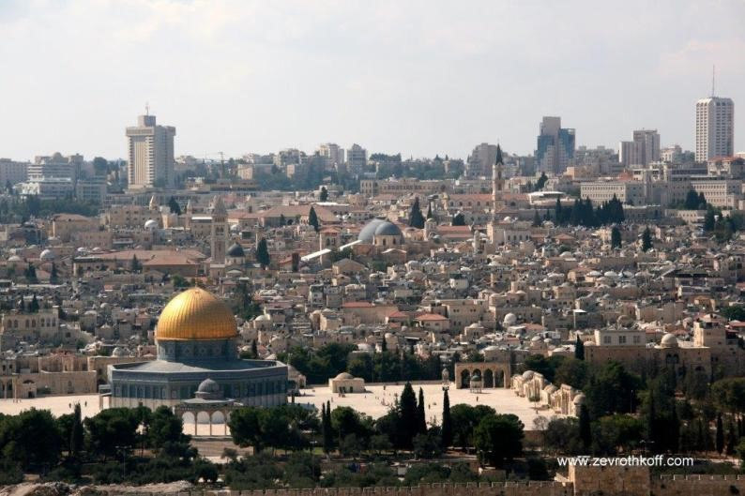

The Temple Mount from the east. In front of the golden Dome of the Rock, four arches can be seen above a staircase. This is the assumed location of the Gate of Nicanor and the fifteen stairs between the Courtyard and the Women’s Court. (Courtesy of Dr. Zev Rothkoff, 2011)

Is There a Solution?

I will now examine each of the three major traditions regarding the number of gates in the Courtyard, and attempt, to the best of my ability, to suggest a few partial solutions to the problem before us.

We will begin with the tradition of Abba Jose son of Hanan – thirteen gates. The number thirteen was first presented as one of a list of three series consisting of thirteen elements. Thus we read in Shekalim 6 of thirteen chests, thirteen tables and thirteen prostrations that were in the Temple. It is interesting to note that this mishna, which is clearly highlighting groups of thirteen, does not explicitly enumerate thirteen gates, but only explains that the thirteen prostrations were “made facing thirteen gates.” In Middot 2, the thirteen prostrations are mentioned twice, each time with a different explanation. First we read:

Within it was the soreg [a kind of lattice work], ten handbreadths high. There were thirteen breaches in it; these had been originally made by the kings of Greece, and when they repaired them they enacted that thirteen prostrations should be made facing them. (2:3)

Then, at the end of the chapter, in a section that appears to be a kind of appendix, we read: “The whole of the Courtyard was a hundred eighty-seven cubits in length by a hundred thirty-five in breadth, and thirteen prostrations were made there. Abba Jose son of Hanan says: They were made facing thirteen gates…” (2:6). The prostrations seem to have taken place on the Temple Mount, outside the soreg encompassing the cheil, which surrounded the Courtyard and the Women’s Court. This indicates that the source of the number thirteen in this context was the prostrations, while the two historical explanations served to explain the source. Thus, it may be that some of the thirteen gates were not exactly attested to firsthand. The main contingent of the group of thirteen gates certainly did exist: They were the Gate of Nicanor in the east, the four in the north and the four in the south. These nine gates were enumerated by name and in order, and it is clear that the Mishna’s description of these gates constitutes real testimony and not merely exegetical speculation. These nine also fit perfectly with the testimony of Josephus.

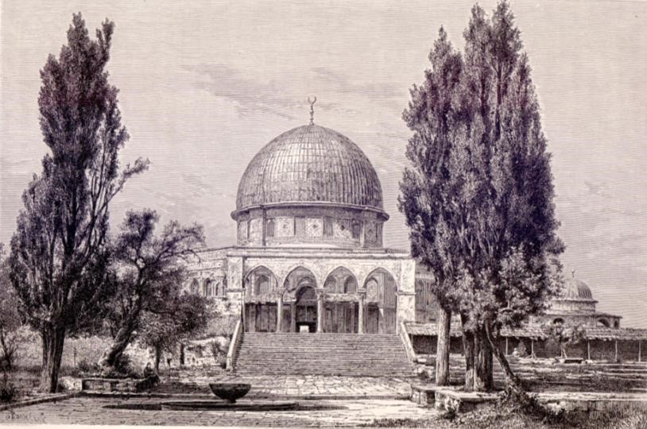

A closer view of the staircase and the four arches (L. C. Lortet, 1884)

What about the remaining four gates? These were the two wickets to the right and to the left of the Gate of Nicanor and two in the west that “had no special name.” Regarding the wickets attached to the Gate of Nicanor, it should be noted that the Tanna in Middot 1 who enumerated seven gates felt the need to add a seemingly unnecessary detail that is unconnected to the number of gates in the Courtyard: “In the east there was the Gate of Nicanor, which had two rooms attached, one on its right and one on its left – one the room of Phineas the dresser and one the room of the griddle cake makers.” What was the purpose of this comment? Perhaps this is an allusion – embedded by the redactor of the tractate – to the dispute with Abba Jose son of Hanan. This Tanna (seemingly Rabbi Eliezer son of Jacob) maintains that there were only two rooms here, recalling the precise name and function of each of them. It is difficult to imagine that Abba Jose son of Hanan would dispute this testimony, nor have we heard anything to that effect.

On the other hand, it is unsurprising that a dispute would arise in such a case regarding the existence of open doorways from these rooms to the rest of the Courtyard. Wickets are small openings that are not meant for the general public; it would have been difficult for the average person to know if such doorways – only used by a select few professionals – existed at all. It may even be that all agree that there were small wickets here, but the proponent of the “seven gates” position and Josephus felt that these were not significant enough to enumerate. The Mishna stresses: “All the doorways (and the gates) in the Temple were twenty cubits high and ten cubits broad” (Middot 2:3). Only Abba Jose son of Hanan, in his position explaining the connection between the thirteen prostrations and the thirteen gates, must either mention the existence of the two wickets here, or else enumerate the small wickets as gates. The two unnamed gates on the west must be explained in a similar manner.

What is left for us now is to address the question of the north and the south. In the south, there is only a small difference between the different positions. Both the “seven gates” Tanna and the “thirteen gates” Tanna agree, more or less, on three consecutive gates in the south (apparently listed from west to east) – the Gate of Kindling, the Gate of the Firstborn (or the Gate of the Offering; the firstborn is one of the most common offerings brought by individuals) and the Water Gate – but the full list adds another gate on the western end – the Upper Gate. The name “Upper Gate” alludes to where it is situated topographically (it is clear from Middot 2-3 that the terrain rises gradually from east to west). This, along with this gate’s lack of a defined function, may allude to the possibility that this gate was less important than the others (despite its appearance in Josephus’ account). In addition, the Upper Gate was located in the area of the Chamber of Hewn Stones (Middot 5:4, according to the Mishna’s version, which is primary), which had one opening on holy ground and one opening on non-holy ground (Yoma 25a). It may be, then, that the gate was situated inside the chamber, and thus the “seven gates” Tanna did not enumerate it.

The differences are starker in the north. Only one name appears on both lists: the Gate of Offering. The short list includes: the Gate of the Flash, the Gate of Offering and the Fire Chamber. The long list includes: the Gate of Jeconiah, the Gate of Offering, the Women’s Gate and the Gate of Song. The necessary conclusion is that many of the gates had multiple names. It is not easy to interpret these names; the commentators struggled to do so. The Mishna itself interprets the Gate of Jeconiah: “Because Jeconiah went forth into captivity through it.” In other words, it is a historical name for an early one-time incident from an ancient reality that has since been destroyed and rebuilt. It is only logical, then, that this gate would have a new name that is more appropriate for the reality of the Second Temple period.

The name “Gate of the Flash” is not easy to understand, and it is unclear what the Women’s Gate was, considering that women usually would not enter the Courtyard. Regarding the question of the coexistence of two authentic traditions, one of three gates and another of four gates, it may be that here too the answer lies in the existence of a wicket. Middot 1:7 reads:

The Fire Chamber had two gates, one opening on to the cheil and one on to the Courtyard. Rabbi Judah says: The one that opened on to the Courtyard had a small wicket through which they went in to search the Courtyard.

The commentators generally explained that this wicket was a small opening in the door of the large gate. However, if we explain that it refers to a small wicket near the large gate, it may be that the longer list chose to enumerate it while the shorter list chose to exclude it.

For further study:

Y. Babad, Minchat Chinukh (commentary on Sefer Ha-chinukh), Mitzva 388.
J. N. Epstein, Introduction to Tannaitic Literature, Jerusalem and Tel-Aviv 1957, 15-58 [Hebrew].

H. Geva, “Jerusalem: The Temple Mount and its Environs,” The New Encyclopedia of Archaeological Excavations in the Holy Land 2, 1993, 736-744.

A. Hyman, “R. Eliezer ben Ya’akov I” and “Abba Yossei ben Chanan,” Toldot Tanna’im Ve-Amora’im, 181, 726 [Hebrew].

Translated by Daniel Landman

According to Rambam and Rabbeinu Shemaya (a prominent disciple of Rashi), it applies only at night. According to the anonymous commentator on Tamid, the commentary attributed to Ra’avad and Rosh, it applies during both day and night. Later authors continued this dispute more forcefully. Rabbi Yissachar Ber of Eilenburg, in his work Be’er Sheva, and Rabbi Yehuda Rosanes, author of Mishneh La-melekh, maintained that the opinion that guarding the sanctuary applies during both day and night is impossible. On the other hand, Rabbi Yosef Babad, author of Minchat Chinukh, claimed just the opposite – that the other opinion “requires examination.”
“The Gate of Offering” appears in the most reliable manuscripts of the Mishna, while “the Gate of the Firstborn” appears in the printed editions. The former is quite difficult since the Gate of Offering appears in the northern wall as well. The latter is seemingly more reasonable as well because it fits with the four gates of Abba Jose son of Hanan (see below). However, as the credible manuscripts agree on “Offering,” it would seem that in this case lectio difficilior potior – the more difficult reading is the stronger. It may be that there were two gates devoted to offerings; after all, this was the main activity performed in the Temple.
According to Rabbi Betzalel Ashkenazi’s version in his Shita Mekubetzet here (his editions are generally based on manuscripts), as well as MS Firenze and MS Vatican 120-121, the words “and one who says there were seven” should be deleted.
The magnificent gate made from “Corinthian brass” was certainly the Gate of Nicanor in the eastern part of the Courtyard “because the copper of them gleamed [like gold]” (Middot 2:3).
See map and translation below.
There are two ancient gates at the southern wall of the Mount that are parallel to the Huldah Gates mentioned in the Mishna; in the west and the north there is no fitting parallel, and in the east there is a questionable parallel. There is a general problem in the fact that the entire compound – according to the Mishna and Josephus – should be square, whereas today it is rectangular. All these topics are beyond the scope of the current discussion.
Josephus’ measurements are larger than those of the Mishna.
Tosefot Yom Tov explained, in the name of Ra’avya, that women would stand there during the semicha and slaughtering of their offering.

