YESHIVAT HAR ETZION
ISRAEL KOSCHITZKY VIRTUAL BEIT MIDRASH (VBM)
*********************************************************

GEOGRAPHY IN THE PARASHA

PARASHAT SHELACH

Emek and Har: The Dwelling Place of the Amalekites and the Canaanites
By Prof. Yoel Elitzur

The Valley or the Hill Country?

After it had been decreed that our ancestors would not enter the land of Canaan, God adds an implicit warning: “Now the Amalekites and the Canaanites dwell in the valley (emek). Start out, then, tomorrow and march into the wilderness by way of the Sea of Suph” (Numbers 14:25; see Rashi there). The following day, the people of Israel prepare to violate God’s instructions: “We are prepared to go up to the place that the Lord has spoken of, for we were wrong” (14:40). Moses repeats God’s warning, this time making it explicit:

Do not go up, for the Lord is not in your midst… For the Amalekites and the Canaanites will be there to face you, and you will fall by the sword, inasmuch as you have turned from following the Lord and the Lord will not be with you. (14:42-43)

The nation does not heed the warning: “Yet defiantly they marched toward the crest of the hill country (har)… And the Amalekites and the Canaanites who dwelt in that hill country came down and dealt them a shattering blow at Hormah” (14:44-45).

The contradictory information in this passage is plain to see. Verses 40-45 stress that the Amalekites and the Canaanites dwell in the crest of the hill country. According to the verses, one must go up to reach this place and one must come down to return. But verse 25 states that they lived in the valley. How can this be?

An excellent “correction” to the verse is found in the Peshitta, the Syriac translation of the Bible used by many churches of Eastern Christianity (the prevailing view is that the Peshitta was the work of Jews). The Peshitta’s translation of verse 25 states that the Amalekites and the Canaanites dwell in the tura – meaning the hill country. However, the fact that no other known source features this word substitution found in the Peshitta indicates that this change was entirely arbitrary, an emendation to the word that the author felt should really have appeared in the verse.

Ibn Ezra writes: “‘Dwell in the valley’ – to ambush you. And some say: Even though the Amalekites and the Canaanites dwell in the valley, start out by way of the Sea of Suph and do not be afraid.” Here, Ibn Ezra presents two improbable solutions to the hill country/valley contradiction. a) While it is true that the Amalekites and the Canaanites dwell in the hill country of the land of Canaan above you, they are lying in ambush in the valley at the moment. b) Most of the Amalekites and the Canaanites indeed dwell in the hill country of the land of Canaan, but some of them dwell in the opposite direction as well, in the valley that awaits you when you make your way back. Do not fear them; since you are fulfilling God’s decree they will not harm you.

I found an unusual suggestion in Elliger and Rudolph’s Biblica Hebraica Stuttgartensia, a critical edition of the Bible (fourth edition, Stuttgart 1990). They suggest, without citing support for their proposal, attaching the first half of verse 25 to verse 24 and changing the text and vowelization accordingly, to read:

But My servant Caleb, because he was imbued with a different spirit and remained loyal to Me – him I will bring into the land that he entered, and his offspring shall hold it as a possession, and the Amalekites and the Canaanites will dwell in the valley.

It seems that they based themselves on a few Biblical passages that teach us that the Canaanites dwell in the valley and the people of Israel were not able to dispossess them because they had iron chariots. But it seems very strange that the Torah would use information about the Canaanites – learned after the fact in Joshua and Judges – to formulate an a priori statement in Numbers. Thus it seems that this “emendation” is merely another testimony to the difficulty of our question here: Why does the verse say “valley” and not “hill country”?

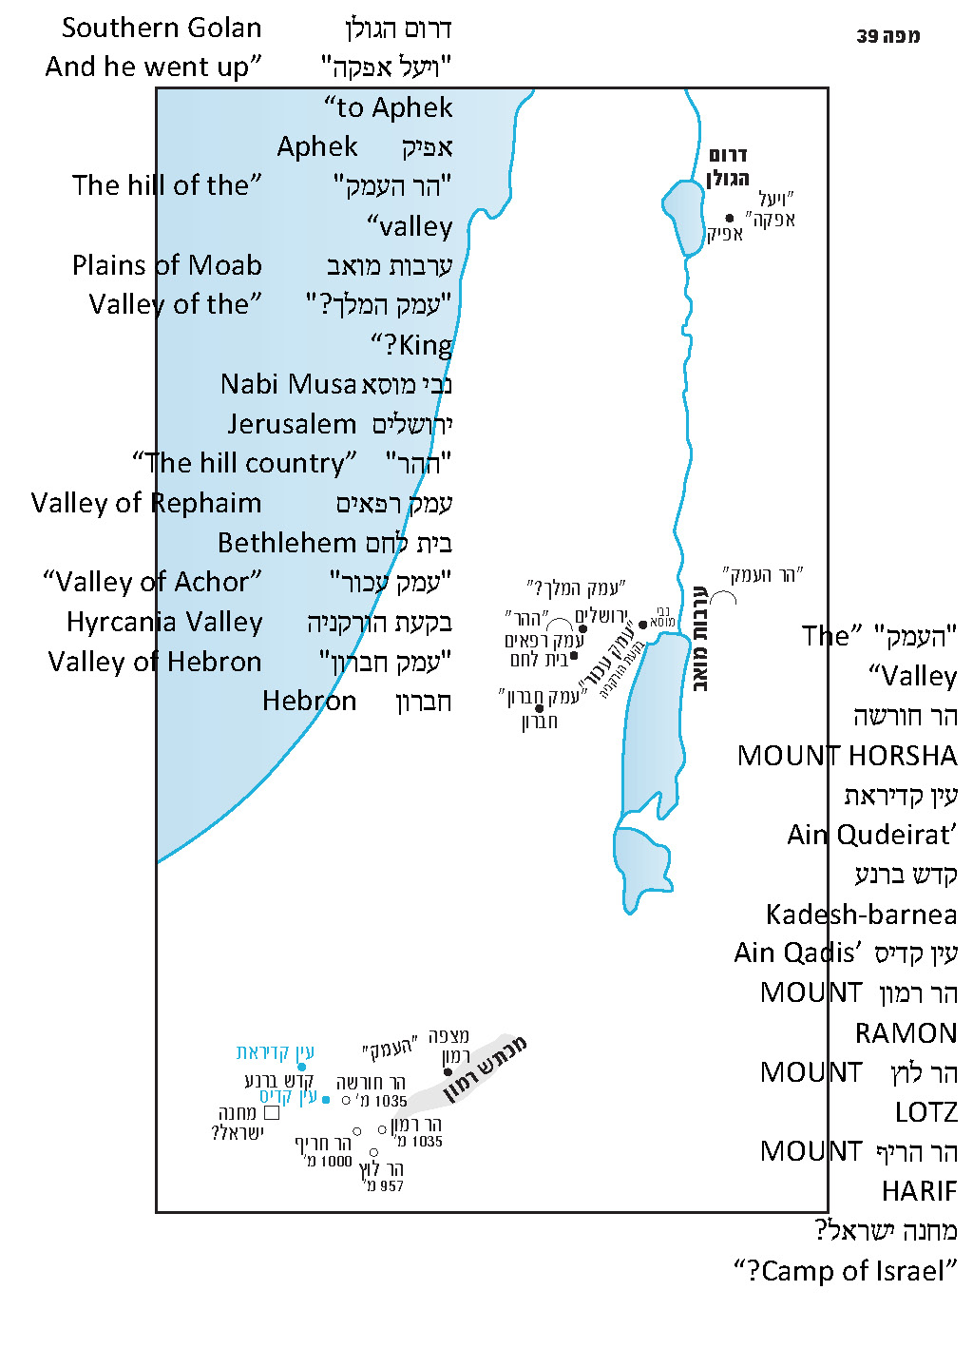

Other Examples of “Going Up” to a Valley

Upon examination, it appears that our case is not the only one in the Tanakh involving “going up” to a valley. The Valley of Achor is mentioned twice in the book of Joshua. The first time is in the incident of Achan: “And they brought them up to the Valley of Achor” (7:24). The second time is in the description of the northern border of the tribe of Judah:

On the northern side, the boundary began at the tongue of the [Dead] Sea at the mouth of the Jordan. The boundary ascended to Beth-hoglah… then the boundary ascended to the Stone of Bohan son of Reuben. The boundary ascended from the Valley of Achor to Debir and turned north…. (15:5-7)

It seems from the passage that the borderline ascends twice from the point where the Jordan meets the Dead Sea until the Valley of Achor, and it ascends an additional time after that point. It is accepted and reasonable to identify the Valley of Achor with the Nabi Musa region and the Hyrcania Valley – a plain that is much higher than the Jordan Valley but lower than the mountains to its west.

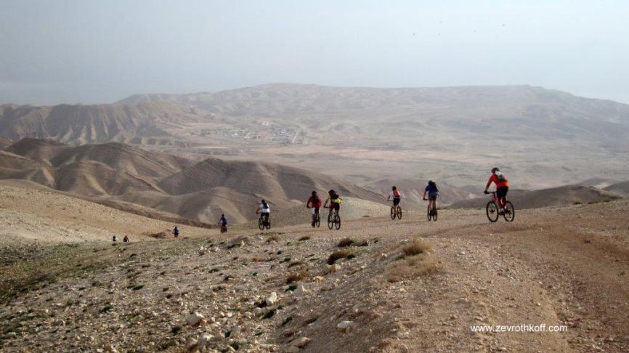
Hyrcania Plain between Jerusalem and the Dead Sea. It is most probably identical with emek achor, mentioned in Joshua 15 and 18. (Courtesy of Dr. Zev Rothkoff)

Another somewhat more complex example of this phenomenon is Aphek, mentioned twice in I Kings 20. After the Arameans lost to Israel in battle in the Samaria area, they interpreted their defeat in theological terms: “Their God is a God of the mountains; that is why they got the better of us. But if we fight them in the plain (mishor), we will surely get the better of them” (20:23). Thus, King Ben-hadad of Aram prepared for the next battle in Aphek: “And he went up to Aphek to fight” (20:26). A man of God approached the king of Israel and quoted the Arameans’ declaration, with a minor change that is nonetheless extremely significant for our purposes:

Then the man of God approached and spoke to the king of Israel, “Thus said the Lord: Because the Arameans have said, ‘The Lord is a God of mountains, but He is not a God of valleys (amakim),’ I will deliver that great host into your hands; and you shall know that I am the Lord.” (20:28)

The king of Aram goes up to Aphek, yet the region surrounding Aphek is called a “plain” and a “valley.”

As for the identification of Aphek, the site that features in I Kings 20 cannot be the same Aphek that is located at the headwaters of the Yarkon, and it seems that neither can it be the Aphek that the Asherites neglected to dispossess (Judges 1:31). It must be between Israel and Aram of Damascus, on a plain that one must ascend to reach. Thus, it is accepted to identify this Aphek with Afik/Fiq in the Golan Heights; the battle must have taken place in the southern part of the Golan Heights. Once again, we see that emek can refer to a high place.

Additional Examples of the Hilly Emek in the Tanakh

We know where the Valley of Rephaim is located from the description of the border between Judah and Benjamin. This border is described in detail twice in the book of Joshua, once in the description of the northern borderline of Judah in chapter 15 and another time in the description of the southern border of Benjamin in chapter 18. Both of these parallel passages use similar language to describe a certain point west of the Valley of Ben-hinnom: “The hill which flanks the Wadi of Hinnom on the west, at the northern end of the Valley of Rephaim” (15:8); “The hill which flanks the Wadi of Ben-hinnom at the northern end of the Valley of Rephaim” (18:16).

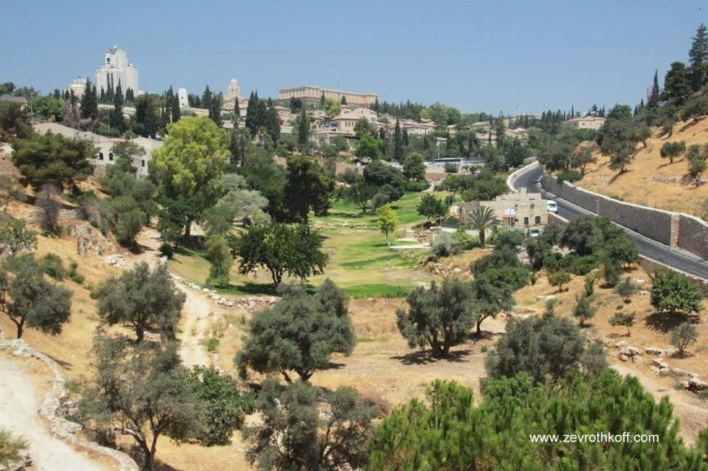
The Wadi of Ben-hinnom with “the hill which flanks the Wadi of Ben-hinnom” (Courtesy of Dr. Zev Rothkoff)

In light of the topography of Jerusalem, this undoubtedly refers to the hill that is today an important part of the New City of Jerusalem, which includes the King David Hotel area, Heichal Shlomo and the Yeshurun Central Synagogue. At the peak of this hill sits the Ratisbonne Monastery on Shmuel HaNagid Street. Based on the description in Joshua 15 and 18, scholars as early as the nineteenth century came to the convincing conclusion that the “Valley of Rephaim” is located in the area that today includes the Old Train Station, the Liberty Bell Park and Emek Refaim Street. However, while this identification is true, it is not the whole truth. The verses do not say, “the hill north of the Valley of Rephaim,” but “the hill… at the northern end of the Valley of Rephaim.” In other words, the hill itself is part of the Valley of Rephaim, situated in the northern part of the valley.

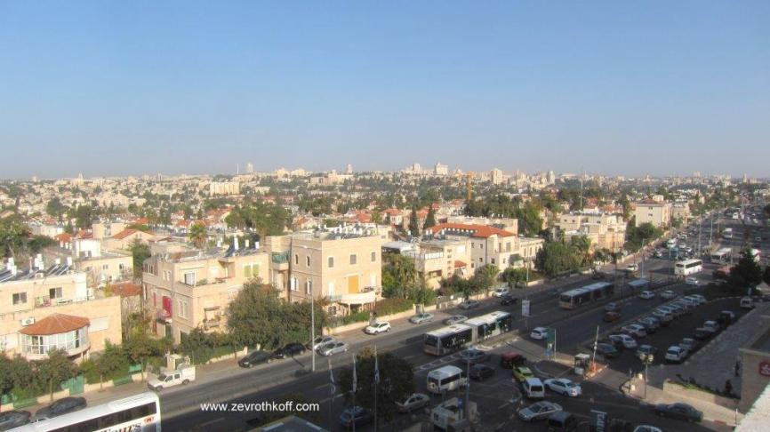
Hebron Road in modern-day Jerusalem, in the middle of the Biblical Valley of Rephaim (Courtesy of Dr. Zev Rothkoff)

Another Biblical story – the story of the three warriors who brought water to David (II Samuel 23:13-17; I Chronicles 11:15-19) – teaches us where the southern end of the Valley of Rephaim was located. There, we read that the Philistines were then encamped along the Valley of Rephaim, with their headquarters at Bethlehem. When David voiced his craving for the waters of Bethlehem, his birth city now captured by the enemy – “If only I could get a drink of water from the cistern which is by the gate of Bethlehem!” – three warriors took him seriously. They “got through” the Philistine camps, drew water from under the noses of the Philistine generals, crossed through the enemy camps once more in darkness and brought the water to David. From the story, it is clear (as Josephus indicates in Antiquities as well) that the Philistine camps were scattered throughout the Bethlehem area, while the commanders were situated within the city itself.

By integrating the information that we gleaned from Joshua and Samuel, we can infer that the entire area from Jaffa Street in Jerusalem to beyond Bethlehem is called “the Valley of Rephaim.” This area is quite flat, but it contains several hills that are not particularly prominent compared to the area surrounding them, including the hill of Ramat Rachel, that of Tantur (by the entrance to the Tunnels Road leading out of the city to the south) and, of course, “the hill which flanks the Wadi of Hinnom on the west” in the northern part of this area. This “valley” does not fit the classic appearance of a valley that we have in our minds. It is not a low area between tall mountains, like the Jezreel Valley, the Beit She’an Valley, the Elah Valley or the Ayalon Valley, which we recognize from other places in the Tanakh. The Valley of Rephaim is an elevated plateau, with an average height of about 2500 feet above sea level, close to the watershed of the country in most of its area.

As a marginal point to this discussion, it must be said loudly and clearly that the modern-day Nahal Refaim was conceived and born in error. First of all, there is no equivalence in Biblical Hebrew between “valley (emek)” and “stream (nachal).” Emek always refers to a wide area and not to a narrow ravine. Geographically as well, “Nahal Refaim” also skews far to the west of the Biblical Valley of Rephaim.

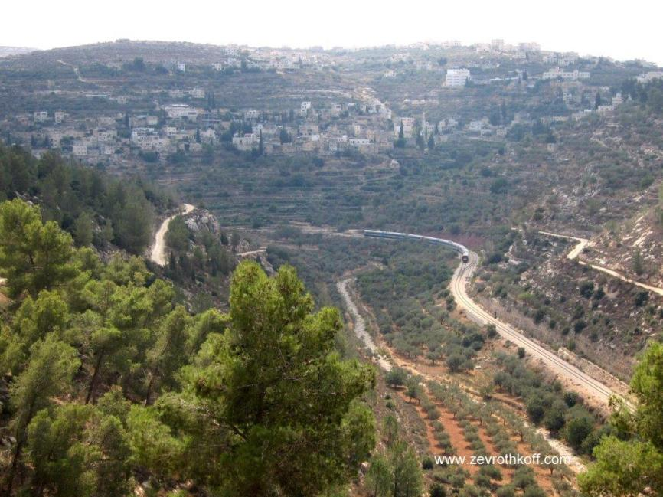
Modern-day Nahal Refaim, located far west of the original Valley of Rephaim, which designated a hilly plain and not a deep gorge. (Courtesy of Dr. Zev Rothkoff)

Jeremiah refers to Jerusalem as “inhabitant of the valley”: “I will deal with you, O inhabitant of the valley, O rock of the plain – declares the Lord – You who say, ‘Who can come down against us? Who can get into our lairs?’” (Jeremiah 21:13). Several far-fetched interpretations have been suggested in attempts to resolve this verse. In light of our conclusion that emek can refer to a relatively flat area within a hilly area, we can understand this verse as well. It seems that the valley in this verse does not refer to the Valley of Rephaim but to the plains north of the Old City of Jerusalem. Jerusalem borders on deep wadis on the east, south and west. To the north, a plain stretches out, where Highway 1 and the northern neighborhoods of the city now lie. This area north of the ancient city was, on the one hand, “the weak part of Jerusalem – it could easily be captured from there” (Tosefta Sanhedrin 3:4). But on the other hand, it represented the potential for the expansion of the city. In Jeremiah’s prophecy of comfort regarding the future expansion of the city, it says, “See, a time is coming – declares the Lord – when the city shall be rebuilt for the Lord from the Tower of Hananel to the Corner Gate… and the entire Valley of the Corpses and Ashes” (Jeremiah 31:38-39). It seems that these two passages from Jeremiah are referring to the same hilly plain.

Two places in the Tanakh speak of the Valley of the King near Jerusalem. The first is Genesis 14:

The king of Sodom came out to meet him in the Valley of Shaveh, which is the Valley of the King. And King Melchizedek of Salem brought out bread and wine; he was a priest of God Most High. (14:17-18)

The second is II Samuel 18:18: “Now Absalom, in his lifetime, had taken and reared up for himself a pillar which is in the Valley of the King… and it has been called Absalom’s Monument to this day.” In contrast to the folk tradition identifying Absalom’s Monument in the Kidron channel (based on the incorrect assumption that emek refers to a wadi), it seems that it was actually located in one of the elevated plains surrounding Jerusalem – possibly to the north of the city.

Nineteenth-century illustration of the so-called “Absalom’s Monument” in the Kidron Valley. The mistaken identification of Absalom’s Monument here is based, among other things, on the incorrect interpretation of the Hebrew word emek.

Now that we have established that emek can refer to an elevated plain, we can grapple with a famous problem. Everyone knows Rashi’s famous expression, citing the Midrash:

“So he sent him from the valley of Hebron”: But is not Hebron on a mountain? As it is said, “They went up into the Negeb and came to Hebron” (Numbers 13:22). Rather, [he sent him] from the deep counsel of the righteous man who is buried in Hebron (Abraham), to fulfill what was said to Abraham [at the Covenant] between the Pieces, “Your offspring shall be strangers” (Genesis 15:13). (Commentary on Genesis 37:14)

The problem here is rooted in peshat – we cannot understand the simple reading of the text – but the answer given here is super-derash. There must be a simple, peshat solution as well. In light of all we have seen, we can understand the plain meaning of the verse perfectly, and it is as follows: The Hebron area, which is generally quite flat – including Elonei Mamre, the dwelling place of the patriarchs from the time of Abraham – is called by the Torah “the Valley of Hebron.” This “Valley of Hebron,” somewhat paradoxically, is one of the highest regions in the land of Israel, 3100-3300 feet above sea level – but it is still called an emek.

Returning to Our Parasha

The region that was the setting for both the incident of the spies and that of the ma’apilim (those who marched defiantly to the land before being defeated at Hormah) was apparently located at the foot of the massif west of Makhtesh Ramon, namely, the area of Mount Horsha, Mount Harif and Mount Lotz. In this region, whose altitude is about 1300-1600 feet above sea level, the huge, dry wilderness of Paran meets the mountains, whose altitude is about 3300 feet above sea level. The area of these high mountains, albeit quite arid, has a climate that can support life, and therefore it is included in the borders of the land of Canaan. The camp of the people of Israel was located below the mountains, south of Kadesh-barnea, outside the borders of the land; on the other hand, its region bore the same name – the wilderness of Kadesh. Above these mountains, north and northwest of the cliff of the makhtesh, in the environs of “Mishor HaRuhot” near the Bahad 1 IDF Officers’ School and the road that runs from there to the peak of Mount Harif, there are areas that are quite flat – at an altitude of about 3000 feet above sea level. In the terminology of Biblical Hebrew, it can justifiably be called an emek, similar to “the Valley of Hebron” discussed above. In order to reach this emek, one must ascend a steep rise of about 1600 feet.

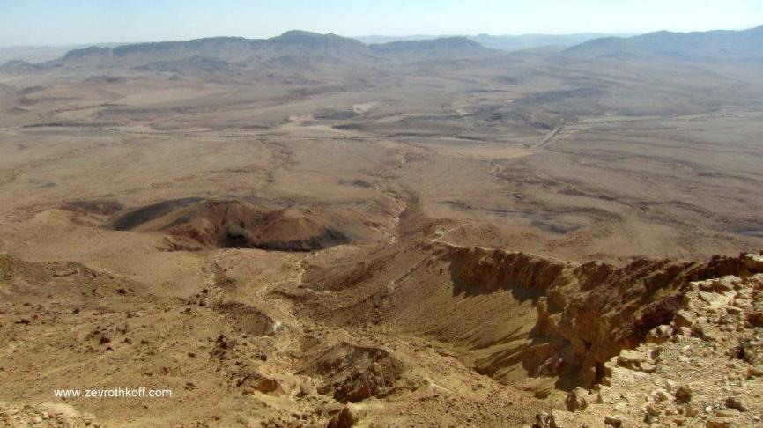
The hilly emek of the Amalekites and the Canaanites north and northwest of Mitzpe Ramon (Courtesy of Dr. Zev Rothkoff)

A Hill within the Valley

We have seen that there is a hill at the edge of “the Valley of Rephaim.” The high emek in the southern part of the land of Canaan contained a hill as well, one that dominates the landscape of the edge of the wilderness of Paran – where the people of Israel were encamped – from above: “Yet defiantly they marched toward the crest of the hill… And the Amalekites and the Canaanites who dwelt in that hill came down….” The best candidate for identification with this peak may be the tall Mount Harif overlooking the desert plains south of Kadesh. There are apparently two additional examples in the Tanakh of a hill within a valley:

- “The hill of the valley (har ha-emek)” (Joshua 13:19) in the territory of Reuben. This expression, which seems self-contradictory, is now easily understandable. It certainly refers to a certain prominent hill that is recognizable within a valley. The valley in the territory of Reuben appears to be the southern part of the eastern Jordan Rift Valley (in 13:27 an emek is mentioned in the territory of Gad, which refers to the remainder of the eastern Jordan Rift Valley – until the Sea of Galilee). In light of this, har ha-emek represents the parallel opposite of hor ha-har – a prominent hill within a hill country.

- “The hill of Perazim” in the book of Isaiah – “For the Lord will arise as on the hill of Perazim, He will rouse Himself as in the valley of Gibeon” (28:21). This verse in Isaiah alludes to David’s first two victories over the Philistines (II Samuel 5:16-25; I Chronicles 14:8-16). The war took place in Baal-perazim in the Valley of Rephaim. Isaiah calls that place “the hill of Perazim,” thus indicating that this is another example of a hill within the Valley of Rephaim.

The Takeaway Lesson

We must learn from this discussion to be cautious when dealing with etymology. From a linguistic perspective, it is clear that the word emek is derived from the Semitic root ^{c}-M-Q, meaning “deep” or “deepening.” Despite this, a deep wadi is never called an emek in the Tanakh, whereas an elevated plain is called an emek on multiple occasions. We may speculate that the term was originally used solely to describe low valleys, and only afterward its usage expanded to include elevated plains. In any case, the meaning of the word and its linguistic connections should not get in the way of the task that should always come first: scouring the Biblical contexts in which the word appears in order to learn how to interpret it properly. A similar example can be seen in the case of the word arava, whose literal meaning does not seem to fit well with the strip of land known in the Tanakh as the Arabah. Likewise, the Mizpah (literally, “lookout”) does not need to be located in the highest site with the greatest view of the land, and the Sea of Suph (literally, “reeds”) is, in all likelihood, not located in a place where reeds grow. There is no substitute for simply studying each verse and each term used in the Tanakh within its context.

The basic principle of this discussion and the analysis of some of the sources cited here were based on the unwritten teachings of my father, z”l.

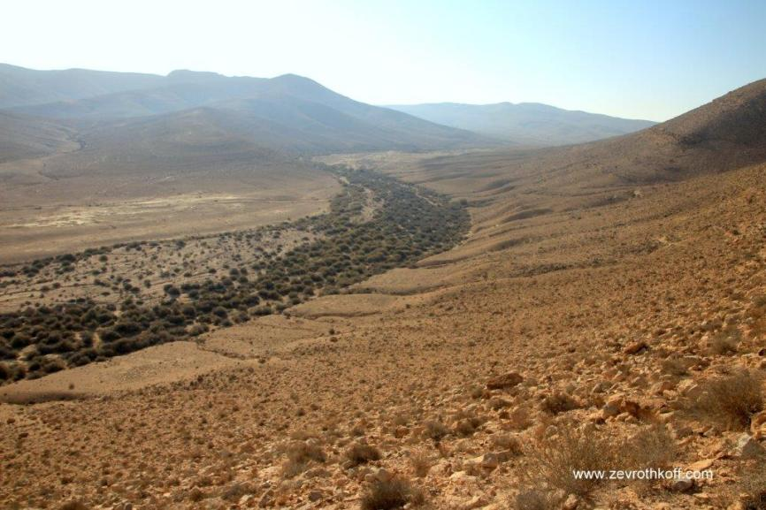
The hilly emek north and northwest of Mitzpe Ramon. Note the modest vegetation in the bed of the wadi, attesting to the region’s ability to sustain life and agriculture. (Courtesy of Dr. Zev Rothkoff)

For further study:

Yoel Elitzur, Ancient Place Names in the Holy Land, Jerusalem-Winona Lake 2004, 124-125.

Yoel Elitzur, “‘So He Sent Him Out to the Vale of Hebron.’ On the Hilly ‘Emeq in the Hebrew Bible,” Beit Mikra 54 (2009), 5-20 [Hebrew].

Translated by Daniel Landman

Chizkuni presented similar suggestions.
See Map 39 below.
For a more detailed explanation, see our discussion on Parashat Bechukotai.
See our discussion on Parashat Beha’alotekha.
This is alluded to in the passage in I Chronicles: “They ascended Baal-perazim” (14:11).
See our discussion on Sukkot (forthcoming).
See our discussion on the Seventh Day of Passover (forthcoming).

