YESHIVAT HAR ETZION
ISRAEL KOSCHITZKY VIRTUAL BEIT MIDRASH (VBM)
*********************************************************

GEOGRAPHY IN THE PARASHA

PARASHAT BEMIDBAR – 2 SIVAN

The Golan in the Torah
By Prof. Yoel Elitzur

Each year, Parashat Bemidbar is read during or shortly before the beginning of the month of Sivan. Aside from their role in heralding the upcoming festival of Shavuot, the first two days of the month of Sivan have taken on a special significance in the last several decades, as these days in 1967 were the fifth and sixth days of the Six-Day War, when we merited receiving an incredible and unique divine gift: the Golan Heights. In 1967, these two days fell out on Friday and Shabbat, June 9-10. As a final operation ending those six days of salvation, seven brigades of Israeli soldiers advanced to the Golan Heights and the slopes of Mount Hermon. For years leading up to the Six-Day War, the Syrians had been firing artillery shells at the towns in the Hula Valley and the Jordan Valley from their position in the Golan, and these attacks increased dramatically during the first few days of the War. In addition, the Syrians built a diversion canal in the Golan with the purpose of robbing Israel of its share of the Jordan’s waters.

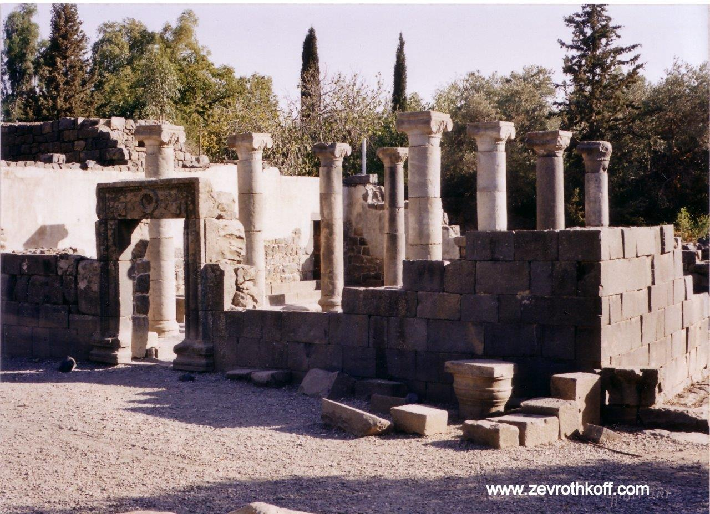
Ancient synagogue at Katzrin, a Jewish settlement from the Talmudic period that became a flourishing modern Israeli city. (Courtesy of Dr. Zev Rothkoff)

The advance on the Golan, the subject of which had been mired in internal debates among the military and state leadership, began on Friday, 1 Sivan with difficult battles that continued through Friday night, killing many soldiers and wounding many as well. A dramatic, perhaps even miraculous turning point occurred the next morning. The Syrian command received the erroneous impression that the battle for the Golan was lost, and was suddenly seized by tremendous fear. The Syrian chief of staff instructed all Syrian forces to destroy their posts and to retreat past Quneitra for the purpose of defending Damascus, the Syrian capital. Damascus Radio broadcast the erroneous report that Quneitra had fallen to the Zionists, causing a mass exodus of Syrian soldiers and civilians eastward, accompanied by clouds of smoke from the bombing of their own outposts and stations. Israel immediately took advantage of this opportunity and stormed ahead to Quneitra and the Ruqad River, which flows north-south along the eastern side of the Golan Heights in the direction of the Yarmouk River. When the Golan region, with its prominent open plains, abundant water and beautiful streams, fell into Israeli hands, it was entirely devoid of inhabitants. Afterward, ancient synagogues and batei midrash – including that of Rabbi Eliezer Ha-Kappar – were discovered, many settlements and one city were founded, agriculture and cattle-raising infrastructure was established and the nation of Israel arrived (and continues to arrive) en masse to tour in the beautiful Golan. On December 14, 1981, the Israeli Knesset passed the Golan Heights Law, which applied Israel’s laws and government to the Golan Heights.

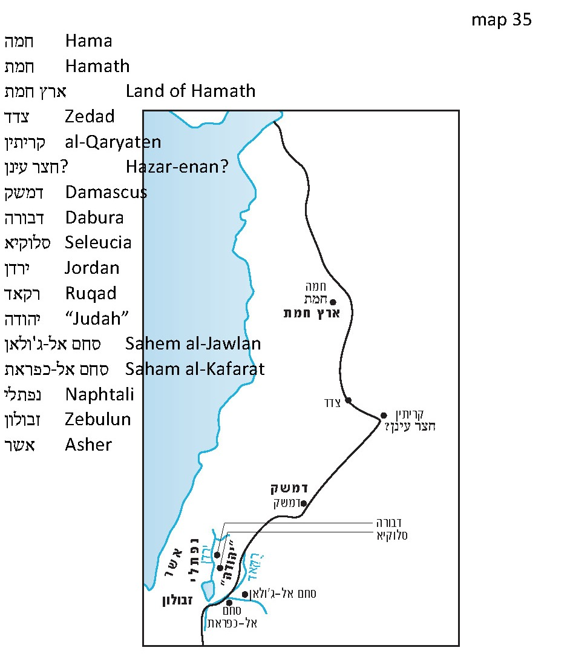

Golan: A City that Gave its Name to a Region

In the Tanakh, the name Golan refers to a city of refuge and Levite city located in the Bashan region. Josephus referred to the city as Gaulana, mentioning it in its Biblical context as a city of refuge (Antiquities 4:173) and in a later context, among the conquests of Alexander Jannaeus (Antiquities 13:393). However, the Golan region features more prominently and more frequently in Josephus’ writings, under the Greek name Gaulanitis or Gaulanitikē, and his writings even distinguish between the Upper Golan and the Lower Golan. Rabbinic literature mentions a place called Ha-Gavlan, or in Aramaic, Gavlana or Gavlona, a region that is equivalent to the Galilee: “In the footsteps of the Messiah… Galilee will be destroyed, Gablan (Ha-Gavlan) desolated” (Mishna Sota 9:15). There is no settlement in Rabbinic literature called Golan or Gavlan, but Eusebius, who lived during the time of the Amoraim, recognized in the Bashan region (which he calls “Batanaea”) “a large village called Gaulōn in a district of the same name” (Onomasticon 64:8). Eusebius did not provide further information, and it is unclear to which site he is referring. In any case, Eusebius is the latest source that mentions a specific settlement called Golan. Since then, until today, the name Golan has only been used in the regional sense.

The identification of the Biblical city of Golan is not truly known. The “large village” that Eusebius describes is not mentioned in other sources. In the Jerusalem Targum (Targum Neofiti) and Targum Pseudo-Jonathan, the city of Golan is translated as Dabra. It is thought that the Targum is referring to Dabura, where the inscription from the beit midrash of Rabbi Eliezer Ha-Kappar was found, along with additional Jewish inscriptions, but one of the Geniza Fragments of the Halakhic Midrashim identifies the city of Golan with Seleucia, which is mentioned in Josephus’ writings (Antiquities 13:393, Wars 4:3) and whose name was preserved until 1967. In the scholarly literature, a different identification is very common, but this is only an error stemming from a lack of understanding. What is this mistaken identification? East of the eastern border of Israel in the Golan, about nine miles east of the moshav of Nov in the southern part of the Golan Heights there is a village called Sahem al-Jawlan. Gottlieb Schumacher, a scholar of the region during the 1880s, believed that the name of this village represented a preservation of the Biblical name Golan, and many other scholars followed in his footsteps from then until today. The truth, however, is that these scholars did not completely understand the nature of place names of this variety. The second component of two-word place names (with the exception of names of the form ain-X, bayt-X, deir-X, etc.) is almost never part of the actual place name. Rather, it serves as an epithet meant to distinguish the place from a different place that bears the same name. For example, Dura al-Qar’ (“Dura of the gourds”) near Beit El bears this name to distinguish it from the town of Dura in the Mount Hebron region. Similarly, al-Lubban ash-Sharqiyya (“eastern”) bears this name to distinguish it from al-Lubban Rantis near Rantis and Beit Aryeh. The same is true of Sahem in this case. The ending “al-Jawlan” is meant to distinguish it from Saham al-Kafarat not far from there, in the northern Gilead region, south of the Yarmouk.

The Golan and the Borders of the Land of Canaan

In Numbers 34, the borders of “the land of Canaan with its various boundaries” are outlined (34:2). These are the more limited borders compared with the vast predestined borders of the land that we encountered in other places in the Torah, which reach until the Euphrates River.

The eastern border of “the land of Canaan with its various boundaries” begins in the northeast in a place called Hazar-enan. Its identification is unknown, but general borderline logic dictates that it must be located around the town of al-Qaryatēn, about 75 miles northeast of Damascus. From Hazar-enan, the border continues to Shepham and “Riblah on the east side of Ain,” which also lack clear identifications. The passage continues: “From there the boundary shall continue downward and abut on the katef of the Sea of Chinnereth to the east. The boundary shall then descend along the Jordan and terminate at the Dead Sea” (34:11-12). We all know the Jordan and the Dead Sea. We even recognize the Sea of Chinnereth (better known today as Lake Kinneret or the Sea of Galilee). But what is the meaning of the phrase “and abut on the katef of the Sea of Chinnereth to the east”?

Upon examination, I found that the word katef in the topographical sense appears in the Tanakh nine times, eight of which in Joshua 15 and 18, in the descriptions of the borders of Judah and Benjamin. The ninth time is here in Numbers 34, in the description of the eastern border of the land of Canaan.

When tracing the frequency of the word katef’s appearance in its topographical sense, it becomes clear that there is a certain defining element that accompanies the word every time it is used: direction. The word katef never appears alone; it is always juxtaposed with a direction. The instances of katef in Joshua come in the context of descriptions of east-west borderlines, and each time katef appears there, it is accompanied by the word negba (“south”) or tzafona (“north”). In our case, where the borderline runs north-south, katef is accompanied by the word kedma (“east”). It seems, then, that this reflects a systematic usage.

What is the mechanism of this usage? To begin, we must first explain that the use of the word katef, whose primary meaning is “shoulder,” in the topographical sense at all is part of a semantic system that borrows topographical terminology from the human body. Unlike modern Hebrew, which, under the influence of European languages, has also adopted topographical terms derived from animal terminology (e.g. “back of the mountain” and “saddle”), biblical Hebrew favors topographical terms derived specifically from parts of the human body. Examples include parts of the face, including “lip”; “tooth of the rock”; “tongue”; “eye”; and parts of the whole body such as “head of the mountain”; “rib of the mountain”; “navel of the land”; and finally, “shoulder.”

It would be reasonable to assume, then, that the biblical katef must be a topographical feature similar in appearance to a person’s shoulder. In other words, it should be a flat area of ground with a steep vertical slope on one side. (Interestingly, Modern Hebrew uses this term in the same way.)

Let us return to our findings. We saw that the topographical katef is always accompanied by a direction, and that the direction is always perpendicular to the borderline described in the verse. This seems to indicate that the direction marks the point at which the katef begins to break downward, allowing the katef to serve as a kind of waypoint. When the borderline runs east-west, the point at which the table-like mountain begins to break to the north or south is a significant piece of information for mapping out the line. When the line runs north-south, the break to the east is similarly significant.

It is possible to trace the katef-containing borderlines described in the apportionment chapters in the book of Joshua. Let us cite two examples here.

On the northern border of the territory of Judah, between Kiriath-jearim and Beth-shemesh, the borderline reaches “to the katef of Mount Jearim on its northern side – that is, Chesalon” (Joshua 15:10). The modern-day moshav of Ksalon is located several hundred feet south of ancient Chesalon, which was situated atop a tall hill. The ancient name was preserved until the War of Independence through the name of the village of Kasla, which was situated on the ruins of the ancient city atop that same hill. This hill is located in the northern part of a large mountainous ridge, and it contains an extremely steep slope down into the stream we now call Nahal Ksalon. This large mountainous ridge is the “Mount Jearim” described in Joshua, which was certainly given this name due to its wooded scenery (then as now). The site of ancient Chesalon is the point where the mountain begins its steep slope into Nahal Ksalon, or as the Tanakh describes it: “the katef of Mount Jearim on its northern side – that is, Chesalon.”

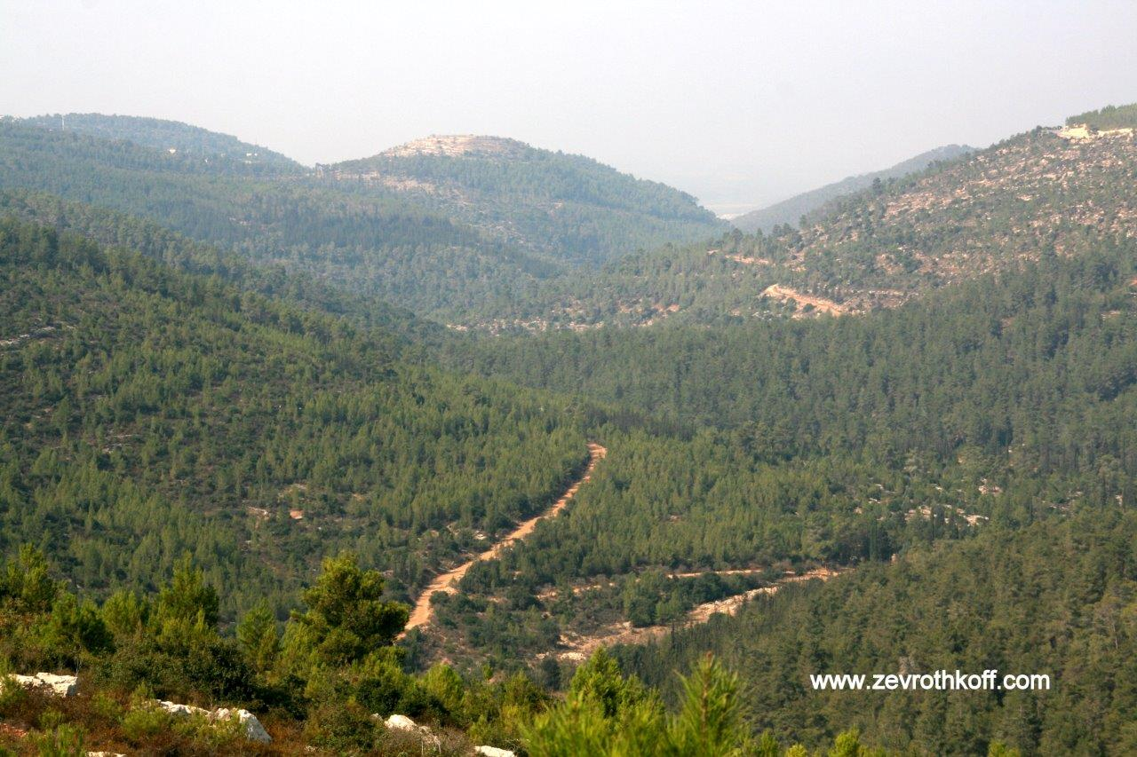
Nahal Ksalon with the tell of Kasla – ancient Chesalon (the bright area on the top of the central hill). The wooded slope below the tell is “the katef of Mount Jearim to the north.” (Courtesy of Dr. Zev Rothkoff)

A second example can be found in Joshua 18. On the eastern part of the southern border of the territory of Benjamin, we find the description, “to the katef adjacent to the Arabah northward” (18:18). The Arabah here is the Jordan Valley and the Dead Sea and “the katef adjacent to the Arabah” is what is known today as the “Fault Cliff,” an intense, craggy slope that descends in the direction of the Dead Sea. The northernmost point of this slope is Nahal Og in the northern Dead Sea region, near Kibbutz Almog; it serves as the southern border of the territory of Benjamin and the northern border of neighboring Judah.

Now we can return to the phrase “the katef of the Sea of Chinnereth to the east.” In light of the other instances of katef in the Tanakh, we must immediately reject any interpretation that maintains that this is simply a neutral expression describing the eastern shore of the Sea of Galilee or a certain protrusion in the waterline (if indeed such a protrusion exists). “The katef of the Sea of Chinnereth” must be an elevated plain or a wide, horizontal ridge adjacent to the Sea of Galilee, and defined by it. In theory, this katef could be situated on either side of the sea, but in practice the ridges west of the sea do not come into the equation, for two reasons. First, the borderline described in the Torah originates in the northeast. Second, if we move the eastern borderline of the land of Canaan to the western side of the Sea of Galilee, this would mean that the western shore of the sea would not be included within the borders of the land of Canaan. This notion would conflict with the account in Joshua 19:35, which states that Hammath, Rakkath and Chinnereth – cities on the western shore of the Sea of Galilee – are included in the territory of the tribe of Naphtali. Thus, it seems that “the katef of the Sea of Chinnereth” is the Golan Heights, the large elevated plain that runs along the length of the Sea of Galilee (similar to “the katef adjacent to the Arabah,” which runs along the Arabah Sea, i.e., the Dead Sea).

What, then, is “the katef of the Sea of Chinnereth to the east”? Various scholars interpreted this to mean “the katef that is east of the Sea of Chinnereth” – a general term for the Golan Heights – and moved the borderline to the western slope of the Golan Heights. But the parallel instances of katef in the Tanakh and the consistent role of the direction in each instance teach us that the opposite is true. In order to find the location described in the verse, we must search for the eastern slope of the Golan Heights. The eastern slope of the Golan Heights consists of the cliffs that descend from the Golan Heights into Nahal Rukad, which is “coincidentally” the contemporary northern part of the eastern border of the State of Israel.

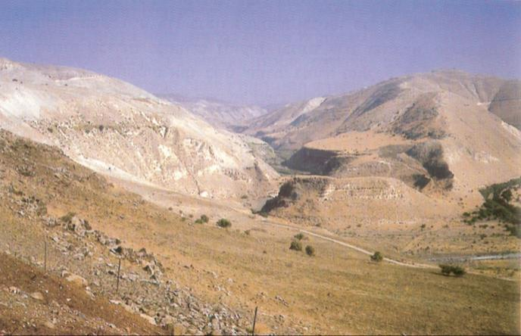
Nahal Rukad. The white slope on the left is “the katef of the Sea of Chinnereth to the east.” (Courtesy of Samuel Klein)

Did the Golan Belong to the Tribes of the Transjordan or the Tribes of the Cisjordan?

There is one more question that we must answer. Based on the ideas that we have developed here, it would seem that the Golan Heights were part of the Cisjordan – the western side of the Jordan River. This seems difficult to accept, as the Golan lies east of the Jordan and the Sea of Galilee. It is part of the Bashan, the land of Og, a region that was given to the half-tribe of Manasseh. This region contained Havvoth-jair, named for Jair son of Manasseh (Deuteronomy 3:13-14 and others), and “Golan, in Bashan, belonging to the Manassites” (4:43) – the northern city of refuge in the Transjordan! Can it truly be that this region was included in the “land of the nine and one-half tribes”?

The genealogical list of the tribe of Judah in I Chronicles 2 provides the answer to this question. According to this list (2:21-23), the famous Jair son of Manasseh was actually from the tribe of Judah, and his affiliation with the tribe of Manasseh stemmed from the fact that he was a grandson of the daughter of Machir son of Manasseh. In any case, the list in Chronicles teaches us that from a certain perspective, the Golan was a kind of territorial addition for the tribe of Judah.

There are two other verses in the Tanakh that only recognition of the association of the Golan Heights with the tribe of Judah can satisfactorily explain. The first is Joshua 19:34. The chapter describes in a general sense the territory of Naphtali in the eastern Galilee: “It touched Zebulun on the south, and it touched Asher on the west, and Judah at the Jordan on the east.” At first glance, this statement is completely incomprehensible: The geographical distance between the outlet of the Jordan from the Sea of Galilee (the southeasternmost point of Naphtali) and the Jordan estuary at the Dead Sea (the northeasternmost point of Judah) is almost seventy miles! How can the border of Naphtali touch the border of Judah? The classical commentators did not have a clear understanding of the geography involved, and thus were not overly troubled by this question. The Metzudot and the Vilna Gaon explained that the entire Jordan River belonged, for some reason, to Naphtali, thus enabling its territory to stretch until Judah. On the other end of the spectrum, some modern commentators excised the tribe of Judah from the verse entirely. They either suggested fanciful interpretations for the word yehuda or searched for a site called Yehuda near the Jordan. Others edited and emended the Biblical text. Despite this, the verse as it stands states that the Golan Heights are part of Judah.

The second verse is II Kings 14:28. This verse describes the extensive conquests of King Jeroboam son of Joash of Israel, who restored the border of the Kingdom of Israel to Lebo-hamath. The verse ends: “The other events of Jeroboam’s reign, and all his actions and exploits, how he fought and recovered Damascus and Hamath for Judah in Israel, are recorded in the Annals of the Kings of Israel.” Commentators both old and new suggested farfetched interpretations here. The simple understanding is that the northeast region of the Kingdom of Israel – the Golan and the Hermon – were known as “Judah in Israel.” Jeroboam added to this territory by annexing the regions of Damascus and Hamath to the north.

It should be added that in Rabbinic sources as well, the northern section of the Jordan River, which lies north of the Sea of Galilee, is viewed as “not really the Jordan” compared to the section that lies south of the Sea of Galilee. Chazal stated: “The real Jordan is only from Beth-jericho and below” (Tosefta Bekhorot 7:4; Bavli Bekhorot 55a). They also regarded Gamla as part of the Galilee, and there is evidence that Josephus did so as well.

In the end, “the land of Canaan with its various boundaries” – the land of the nine and one-half tribes – included within it the Golan Heights until Nahal Rukad. Based on this, it turns out that – coincidentally or not – the new eastern border that Israel reached by the end of the Six-Day War, upon which Israeli law was conferred in 1982, lies precisely on the eastern borderline of “the land of Canaan with its various boundaries” according to the Torah.

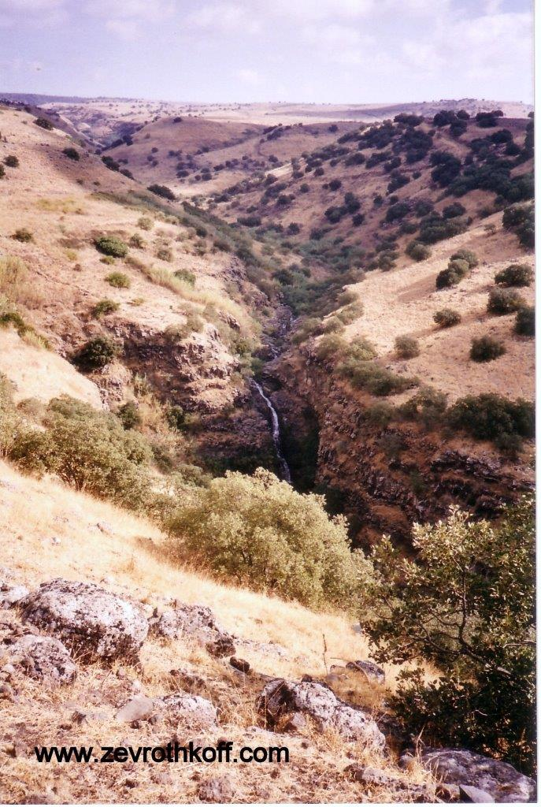
Nahal Yahudiyya in the Golan. The Arabic name Yahudiyya preserved the existence of Jews in this region in the past. (Courtesy of Dr. Zev Rothkoff)

For further study:

“Prof. Yehuda Elitzur U-beit Midrasho shel R. Eliezer Hakappar,” from “Yehudah Elitzur” website: http://www.daat.ac.il/elitzur/sipur.asp [Hebrew].

Yoel Elitzur, “Toponyms in the Land of Israel: Two-word Place Names,” Encyclopedia of Hebrew Language and Linguistics, Leiden and Boston 2013, 3:783.

Yoel Elitzur, “Ma hu Katef Ve-heikhan Ketef Yam Kineret Kedma,” Al Atar 4-5 (1999), 41-50 [Hebrew].

Yoel Elitzur, “‘Katef,’ A Topographical Term in the Benjaminite Dialect,” HUCA 70-71 (1999-2000), 27-38.

Z. Kallai, “Kateph – כתף,” Israel Exploration Journal 15 (1965), 177-179.

Z. Maoz, “Golan Heights,” Anchor Bible Dictionary, 2, 1058-1065.

D. Syon, “The Identification of Gamla – Through the Sources and by the Results of the Excavations,” Cathedra 78, 3-24 [Hebrew].

Translated by Daniel Landman

Incidentally, my father, z”l, was the first to decipher the inscription reading “This is the beit midrash of Rabbi Eliezer Ha-Kappar in the summer of 1968.
See below Map 35.
In a case of ketiv u-kerei, the Masoretic text of the book of Joshua twice renders the name Galon, with the traditional pronunciation Golan. The Septuagint generally refers to the city as Gaulōn.
See our discussion on Parashat Mishpatim.
The literal meaning of ye’arim is “forests.”
We will deal with the question of when Jair lived and, more importantly, what brought him to conquer the cities of the Bashan and settle that region along with Manassite families, in our discussion on Parashat Matot.
“Beth-jericho” is Bet Yerah at the outlet of the Jordan from the Sea of Galilee.
According to most modern scholars, the Gamla that appears in the Talmud is located in the Golan; see our discussion on Parashat Behar.

