YESHIVAT HAR ETZION
ISRAEL KOSCHITZKY VIRTUAL BEIT MIDRASH (VBM)
*********************************************************

GEOGRAPHY IN THE PARASHA

PARASHAT EMOR

Sunset and Teruma: The Haifa Connection
By Prof. Yoel Elitzur

Sunset and the Permission to Eat Teruma

The person who touches such shall be unclean until evening and shall not eat of the sacred donations (ha-kodashim) unless he has washed his body in water. As soon as the sun sets, he shall be clean; and afterward he may eat of the sacred donations, for they are his food. (Leviticus 22:6-7)

In this passage, the Torah relates to two different types of kodashim: one that may be eaten immediately after one washes his body in water; and one that may only be eaten after the sun sets. An even higher level than these two is described in Parashat Tazria:

On the completion of her period of purification, for either son or daughter, she shall bring to the priest, at the entrance of the Tent of Meeting, a lamb in its first year for a burnt offering, and a pigeon or a turtledove for a sin offering… The priest shall make expiation on her behalf, and she shall be clean. (12:6-8)

The Sages explained that there are three types of kodashim in total, each of which demands a process of purification to permit eating it that corresponds to its level of sanctity: “If he immersed himself and came up, he may eat of the [second] tithe; after sunset he may eat teruma; and after he has brought his atonement he may eat the kodashim” (Yevamot 74b, based on Nega’im 14:3). This explanation implies that the second kodashim that the Torah mentions in the first passage above refers to teruma, which is indeed the simple meaning of the text. The Torah’s addition of the phrase “for they are his food” is an explicit reference to teruma, as both the second tithe on one side and the kodashim of the Temple on the other side may be eaten by Israelites as well – and not only by priests.

The consumption of teruma was once an everyday occurrence; the halakhot of teruma were thus important and highly relevant. The priests were systematically supported by the gifts of teruma that they received from the rest of the nation, and they were required to eat the teruma in a state of tahara (ritual purity). In contrast to the second tithe and the kodashim, which could only be eaten in Jerusalem, teruma could be eaten anywhere in the land of Israel. The consumption of teruma is not connected to the existence of the Temple, but only to the reality of tahara. Hundreds of years after the destruction of the Second Temple, priests in the land of Israel had preserved ashes from the red heifer and were thus still able to purify themselves and eat teruma. In the time of the Amoraim, there was a group of people in the Galilee who took great care to keep their wine and oil in the highest state of tahara, so that if the Temple would be rebuilt in their lifetimes they would be able to produce pure wine and oil for meal offerings and libations (Chagiga 25a, Nida 6b). Finally, Sefer Ha-ma’asim Li-venei Eretz Yisrael, a halakhic work found in the Cairo Geniza, implies that some residents of the land of Israel still maintained a state of tahara until the end of the Geonic period.

The first mishna in the six orders of the Mishna opens: “From what time may one recite the Shema in the evening? From the time that the priests enter [their houses] in order to eat their teruma” (Berakhot 1:1). The formulation of the mishna teaches us that during the Tannaitic period, eating teruma was a basic and practical reality.

When Does the Evening Begin?

In this chapter, I will attempt to present in the simplest way possible a considerably complicated Talmudic subject. The main locus for the treatment of this subject in the Talmud Bavli is Shabbat 34b-35b and in the Talmud Yerushalmi at the beginning of Masekhet Berakhot.

According to the Sages, there is a received tradition that each day following sunset there is a period of time called bein ha-shemashot (literally, “between the suns”) when it is uncertain whether it is day or night. This period is followed by certain night. When exactly does bein ha-shemashot transpire? The answer to this question is subject to a Tannaitic dispute:

- Rabbi Judah: “From sunset as long as the face of the east has a reddish glow, and if the lower [horizon] is pale but not the upper, that is bein ha-shemashot. But when the upper horizon is pale and the same as the lower, it is night.” The Amoraim were divided over the interpretation of this statement. According to Rabba, bein ha-shemashot begins immediately following sunset and ends when the upper horizon becomes pale, whereas according to Rav Joseph and the anonymous opinion of the Yerushalmi, bein ha-shemashot begins only when the lower horizon becomes pale. A different version of the dispute between Rabba and Rav Joseph is cited in the Bavli as well: According to Rabba, bein ha-shemashot lasts for the time it takes a person to walk three quarters of a mil (13.5 minutes), and according to Rav Joseph it lasts for the time it takes a person to walk two thirds of a mil (12 minutes).

- Rabbi Nehemiah: For the time it takes a person to walk half a mil from sunset (9 minutes).

- Rabbi Jose: “Bein ha-shemashot is as the twinkling of an eye, one entering and the other departing, and it is impossible to determine it.” As Rabbi Tanhuma in the Yerushalmi formulates it: “It is like a drop of blood placed on the edge of a sword; in the time it takes for the drop to divide to this side and the other – that is bein ha-shemashot.” When does bein ha-shemashot transpire according to Rabbi Jose? The Yerushalmi cites two opinions: the first is that it occurs following the half-mil time interval advocated by Rabbi Nehemiah; and the second is that every “twinkling of an eye” within Rabbi Nehemiah’s half-mil time interval possesses the uncertain status of bein ha-shemashot. The Bavli (Nida 53a) cites two other opinions: that Rabbi Jose’s bein ha-shemashot occurs at a particular point within Rabbi Judah’s bein ha-shemashot; and that it occurs after Rabbi Judah’s bein ha-shemashot ends. This last opinion represents the conclusion of the Talmud’s discussion in Masekhet Shabbat (which, as we stated above, is the main locus for the Talmud’s treatment of this subject), so it may be considered the primary opinion. The Rishonim proved from the discussion that Rabbi Jose’s bein ha-shemashot does not occur immediately following the conclusion of Rabbi Judah’s bein ha-shemashot, but only after a certain unspecified period of time has passed.

Both Talmuds cite another definition for bein ha-shemashot and the beginning of the night: tzeit ha-kokhavim (literally, “the emergence of the stars”). The term tzeit ha-kokhavim is mentioned in Tanakh (Nehemiah 4:15) and the Talmud is precise in interpreting it: “When one star [is visible], it is day; when two [appear], it is bein ha-shemashot; three, it is night.” Interestingly, this definition is cited in both Talmuds by Amoraim, and both Talmuds ignore the question of the relation between the use of tzeit ha-kokhavim to determine nightfall and the opinions of the Tannaim Rabbis Judah, Nehemiah and Jose. In practice, the emergence of three medium-sized stars occurs about 20-30 minutes after sunset. The reasonable solution to this problem is that tzeit ha-kokhavim is equivalent to Rabbi Jose’s “twinkling of an eye,” which occurs, according to this, about ten minutes (or slightly less) after the conclusion of Rabbi Judah’s bein ha-shemashot. Another possibility is that tzeit ha-kokhavim is equivalent to Rabbi Judah’s bein ha-shemashot itself. Both measurements cited as calculations of Rabbi Judah’s bein ha-shemashot (three quarters of a mil and two thirds of a mil) were reached based on the simple understanding of the baraita – that one must observe the color of the sunset while facing east. However, according to Rava’s interpretation, Rabbi Judah’s bein ha-shemashot is calculated while facing west, where the paling of both the upper and lower horizons occurs much later. This can easily be corroborated by anyone who wishes to verify Rava’s observation in reality.

I want to dedicate another few words to the position known as “tzeit ha-kokhavim of Rabbeinu Tam.” Rabbeinu Tam’s position is that night begins after the time it takes a person to walk four mils after sunset (72 minutes). The source for his position is a passage in Masekhet Pesachim that states that travelers continue walking five mils after sunset until night falls (this is eventually revised to four mils in the conclusion). In order to resolve the contradiction between the positions of three quarters of a mil found in Shabbat and four mils found in Pesachim, Rabbeinu Tam explained that there are actually two “sunsets,” the second occurring three and one quarter hours after the first. Several great poskim adopted Rabbeinu Tam’s position, but it is difficult to square his approach with the empirical reality. The Vilna Gaon rejected Rabbeinu Tam’s position, explaining the contradiction between the Talmudic passages simply: The “four mils” position derived from Pesachim was not referring to halakhic times, but only to the habits of travelers who would try to take advantage of the twilight period in order to continue walking until the last light had truly faded.

A Geographical Tradition for Calculating Bein Ha-shemashot

Alongside the Tannaitic dispute over the exact definition and nature of bein ha-shemashot, both Talmuds cite a tradition for calculating the times of bein ha-shemashot that is connected to Mount Carmel, immersion in the sea and eating teruma. Both Talmuds attribute the tradition to Rabbi Hanina, but they differ regarding the details of the tradition.

The Talmud Bavli states: “Rabbi Hanina said: One who wishes to know Rabbi Nehemiah’s period should leave the sun on the top of the Carmel, descend, dip in the sea and ascend, and this is Rabbi Nehemiah’s period.” In contrast, the Talmud Yerushalmi states:

Rav Samuel son of Hiyya son of Judah said in the name of Rabbi Hanina: If the sun’s orb has begun to set, one standing atop Mount Carmel descends and dips in the Great Sea, ascends and eats his teruma – it is presumed that he dipped in the day. Under what circumstances is this true? When one travels on the shortcut. But one who travels on the promenade is not included in this.

Historical and Geographical Background

Before we explain this passage – in both its version – let us present some background information on the personalities involved in the discussion and on the region in question.

Rabbi Hanina (son of Hama) was a prominent disciple of Rabbi Judah the Prince. One of the first Amoraim, Rabbi Hanina was apparently born in Babylonia and immigrated at a young age to the land of Israel. Citations of his halakhot and customs can be found scattered throughout Rabbinic literature. When Rabbi Judah the Prince was on his deathbed, he commanded: “Hanina son of Hama shall preside [at the college]” (Ketubot 103b). Rabbi Hanina lived a long life, notably retaining his vigor even in old age:

It was said of Rabbi Hanina that at the age of eighty years he was able to stand on one foot and put on and take off his shoe. Rabbi Hanina said: The warm baths and the oil with which my mother anointed me in my youth have stood me in good stead in my old age. (Chullin 24b)

In contrast, Rabbi Samuel son of Hiyya son of Judah was an obscure sage, about whom nothing is known. He is mentioned in six contexts in the Talmud Yerushalmi and in three additional contexts in the midrashim of the land of Israel. In each of these nine instances he cites statements in the name of Rabbi Hanina!

Haifa was a Jewish city during the time of the Tannaim and Amoraim. Sources from the Biblical period do not indicate the existence at the time of settlements in the Haifa region. In sources from the Hellenistic-Roman-Byzantine period, four place names are mentioned in this area: Shikmona (Sycamina in Greek and Roman sources), Haifa (Hēpha), Castra or Gastra and Porphyreon.

Etymology

The name Shikmona apparently derives from the word shikma, meaning “sycamore” – “as plentiful as sycamores (ka-shikmim) in the Shephelah” (I Kings 10:5). In Greek, sykaminon/sykaminos means “mulberry.” Since this was not one of the central cities in the land, and it is mentioned in its Hebrew version in Rabbinic sources, it seems that the Hebrew version is the original one and the name was adapted to the Greek.

The name Haifa seems to be connected to the word chof, meaning “seacoast,” as R. Ishtori Haparchi speculated almost 700 years ago. This speculation was proposed again in the nineteenth century. Among the names of the coastal cities in the land of Israel, we find another two examples in which a cholam vowel (as in the “o” sound in chof) becomes a tzere (as in the “ai” sound in Haifa): The Hebrew Akko (Acre) and Yaffo (Jaffa) became ^{c}ky and ypy in Phoenician inscriptions, and Akē and Ioppē in Greek sources/.

Castra means “fortress” in Latin. The site was also known as Castra Samaritanorum, or “fortress of the Samaritans.”

Porphyreon was named for the porphyra (in Latin purpura, related to the English word “purple”), a genus of sea snails of the variety used to produce the blue and red-purple dyes used in the Mishkan. As the Talmud states: “These are those that catch snails from the promontory of Tyre as far as Haifa” (Shabbat 26a). An additional place bearing this name is known to exist between Beirut and Sidon.

Identification

Ancient Haifa is known to be situated near the western side of the port of Haifa, east of the Central Bus Station of modern-day Haifa, north of Kiryat Eliyahu and south of the Rambam Hospital. Ancient Haifa was destroyed in the mid-eighteenth century by Daher el-Omar, who then established a new city approximately where today’s downtown Haifa lies. Archaeological surveys (excavations have not yet been conducted) in the ancient Haifa region have yielded various antiquities, including a pool designed for salt production and a rock-hewn burial complex from the Roman period. On a PEF map from the 1890s, the region is labeled “Haifa el-‘Atikah.”

The Carmel Ridge, bare of any vegetation. Visible are ancient Haifa, the German Colony and the Carmelite Monastery. (Drawing from the nineteenth century)

Tel Shikmona is the Hebrew name given to Tel es-Samak (“tell of the fish”) near the sea, at the western foot of Mount Carmel, about two miles from ancient Haifa. The two sites are divided by the steep slope of “Carmel by the sea,” atop which lies the Stella Maris Monastery and beside it the “Cave of Elijah.” Ancient Haifa is found at the northeast foot of the mountain and Tel Shikmona is found at its western foot, on the seacoast. Israeli researchers conducted extensive archaeological excavations at Shikmona during the 1960s and 1970s, and again in 2010. The tell is small (only two acres in area), but it and the surrounding area have yielded many findings. The flat areas adjacent to the tell were inhabited during various periods throughout history. Numerous rock-hewn tombs were found on the slopes of Mount Carmel east of the tell, the earliest of which contained an Egyptian scarab seal of Yaqub-Har, a Hyksos ruler during the Middle Canaanite IIB period, i.e., the Patriarchal age. Tel Shikmona was inhabited from the Late Canaanite period (fifteenth century BCE) until after the Arab conquest (seventh century CE). From the Israelite period, several Hebrew inscriptions were found. One prominent discovery at the tell was a burnt layer that excavators date to the time of Shishaq’s conquests in the late tenth century BCE. In this burnt layer, a jug was found with the inscription “of Malkiel.”

Haifa and Shikmona are not mentioned together in Hebrew or foreign sources. Shikmona is found frequently in Greek and Roman sources, but is mentioned in a few instances in Rabbinic sources as well. Chazal laud the rim trees of Shikmona, which boasted fruit of higher quality than other rimmin, and are thus subject to the laws of demai (doubtfully tithed produce). Chazal also noted that the carobs of Shikmona were of lesser quality than other carobs, and are thus exempt from tithing. One of Rabbi Akiva’s disciples was named Simeon the Shikmonite. In the itinerary of Antoninus of Piacenza from the late Byzantine period, the author describes his journey along the coastline from Ptolemais (Acre) to “the city of the Jews, Sucamina.”

Haifa is mentioned quite a few times in Rabbinic sources. In both Talmuds, Rabbi Abdimi of Haifa is mentioned numerous times, as well as Rabbi Abba of Haifa and Rabbi Dimi of Haifa. Yerushalmi Eruvin 2:1 recounts a teaching given in Haifa by Rabbi Abdimi of Haifa. There is even a site near ancient Haifa where, according to tradition, Rabbi Abdimi is buried. We read in Sifre Deuteronomy:

“For they draw from the riches of the sea” (Deuteronomy 33:19) – this is the sea of Haifa, which is hidden for the righteous [to enjoy] in the future… for there is no boat that is lost in the Great Sea, or bundle of silver or gold or precious stones or gems or crystals or any treasure that the Great Sea does not deposit into the sea of Haifa. (354)

Pesikta De-Rav Kahana relates:

It happened that a certain pious man was traveling along the sea wall of the sea of Haifa and thought to himself, and said: “How can it be that the Holy One, Blessed Be He will make the eastern gate of the Temple and its two wickets out of one single gemstone?” … Immediately, a miracle occurred and the sea split before him, and he saw the ministering angels chiseling and carving and kneading [a stone]. He said to them: “What is this?” They said to him: “This is the eastern gate of the Temple – it and its two wickets – [made of] one single gemstone. (18:5)

Lastly, we learn that the residents of Haifa could not pronounce Hebrew words properly: “We do not allow to pass before the Ark men from Haifa or men from Beth-shean or men from Tib’on, because they pronounce he as het and ayin as alef” (Yerushalmi Berakhot 2 and similarly in Bavli Megilla 24b).

Only one non-Jewish source mentions the name Haifa: Eusebius’ Onomasticon (108:30). His identification is surprising: “And the maritime village Sykaminos on the way from Caesarea to Ptolemais [Acre] near the Carmel is called Hēpha.” The prevailing opinion among scholars is that Eusebius was not entirely precise here, and that this was actually two adjacent Jewish settlements on opposite sides of the slope of Mount Carmel that expanded and merged. The Jews generally referred to the entire complex as “Haifa,” while the non-Jews preferred the name Shikmona/Sycamina.

The precise location of Castra is not clear from the sources. Chazal stressed the contrast between the Jewish Haifa and Castra, its hostile non-Jewish neighbor: “‘The Lord has summoned against Jacob His enemies all about him’ (Lamentations 1:17). For example, Hallamish to Naveh, Castra to Haifa, Susitha to Tiberias, Jericho to Naaron, Lydda to Ono” (Lamentations Rabba 1:52 and parallels). The itinerary attributed to Antoninus of Piacenza from the sixth century states that Castra is one mil from Shikmona, and half a mil above it is “the monastery of Elisha the prophet” at the site where Elisha met the woman whose son he revived. The monastery described in the itinerary is estimated to have been situated at the site of the current Carmelite monastery known as “Stella Maris.” It is difficult to ascertain the exact intent of the pilgrim, but the distances recorded in the itinerary – in its various versions, and in particular in the example in question – are problematic. The name “Chorvat Castra” was given in modern times to the ruins at Kfar Samir, near the bank of Nahal Ezov beneath the Haifa neighborhood of Karmeliya and above the cemetery. In the course of excavations performed there in the 1990s, a fairly large (approx. 8.5 acres) Christian town was discovered from the Roman-Byzantine period. The site yielded many findings, including fourteen winepresses, eleven olive presses and remnants of two churches, each floored with a colorful mosaic. It seems that this is the Castra found in the sources. The shopping and cultural center built in the last decade about half a mile southwest of the ruins was named Castra as a result. On display at the Castra Center is a selection of findings from the adjacent ruins.

Porphyreon does not have a convincing identification. It is likely that this is simply another name for Haifa and/or Shikmona. On the Shikmona seacoast, piles of seashells were found, which were used to produce blue and red-purple dyes, the tekhelet and argaman of the Torah.

Rabbi Hanina in the Talmud Bavli and Yerushalmi

It is clear that there is a dispute between the two Talmuds over the true nature of Rabbi Hanina’s opinion. The Bavli stresses that Rabbi Hanina’s opinion follows the Tannaitic position of Rabbi Nehemiah. The Yerushalmi, in contrast, cites Rabbi Hanina before mentioning Rabbi Nehemiah at all. According to the Yerushalmi, the walk toward the sea only begins at sunset, which is certainly impossible according to Rabbi Nehemiah’s position. It seems that the two versions of the passage are not describing a hypothetical experiment, but rather are giving practical advice to a priest who wants to make the most out of his schedule within the constraints of halakha; he wants to immerse himself at the last possible time, and to eat an evening meal of teruma in a state of tahara at the first possible time. According to Torah law, immersion must take place during the day, while teruma may only be eaten at night. Neither of the two activities may take place during bein ha-shemashot.

Rabbi Hanina’s statement in the Bavli was seemingly directed at a priest living in “Haifa el-‘Atikah.” This priest lives in the shadow of the slope of Mount Carmel and of Stella Maris situated to his west. The sun disappears from his field of vision about ten minutes before it can be seen setting over the sea west of Mount Carmel (for one whose vision is not obstructed by the mountain). It seems that it should only take about five minutes to reach the sea from the priest’s house. Until he removes his clothes and examines his body for items or substances that might invalidate his immersion, two or three minutes have passed. The immersion itself takes all of one minute, and by the time he ascends and dries off it is already sunset. It takes another two or three minutes to dress and comb his beard, and five more to return home. By the time he enters his house, greets his family members and washes his hands, the nine minutes of a half-mil journey – the time interval of bein ha-shemashot according to Rabbi Nehemiah – have passed and he is permitted to eat his teruma.

In contrast to Rabbi Hanina in the Bavli, who speaks of the sun vanishing behind the peak of Mount Carmel, Rabbi Hanina in the Yerushalmi speaks of a man who is himself standing atop the mountain. He is certainly referring here to the Stella Maris area above the steep slope that descends to the sea. Rabbi Hanina is teaching this man that when he sees the orb of the sun beginning to set (a process that takes about three minutes – “half of one tenth of an hour” in Rambam’s terminology), he should descend to the sea, immerse himself, ascend and eat his teruma. However, this in on condition that he takes the “shortcut”; he must walk in a straight path and may not stroll along the promenade at a leisurely pace. I do not know why the priest addressed by the Yerushalmi would have been at the top of the mountain in the late afternoon before the advent of taxis, buses, cable cars or the Carmelit railway, but the language of the Yerushalmi implies categorically that the subject of the discussion is indeed standing atop the mountain. Perhaps he is equipped with a small backpack containing his dinner. The route that our priest must take is perhaps equivalent to that of the cable car that currently operates at the mountain. The route of the Haifa cable car is 1165 feet long, and the difference in altitude between its two stations is 427 feet. Its upper station is at the top of the mountain and its lower station is by the sea. In the lower part of the slope, above the lower station, lies the “Cave of Elijah.” While this site is not mentioned in Rabbinic sources, it seems to preserve an ancient tradition recorded in the dozens of Greek inscriptions and the menorah engraving on its walls.

The priest of the Yerushalmi must have been in good physical shape, since the descent from the mountain is exceedingly steep, and some of the descent even consists of smooth diagonal rock. But it must be noted that at least near the Cave of Elijah and above it there are clearly delineated steps that were hewn from the rock in ancient periods (see the image below).

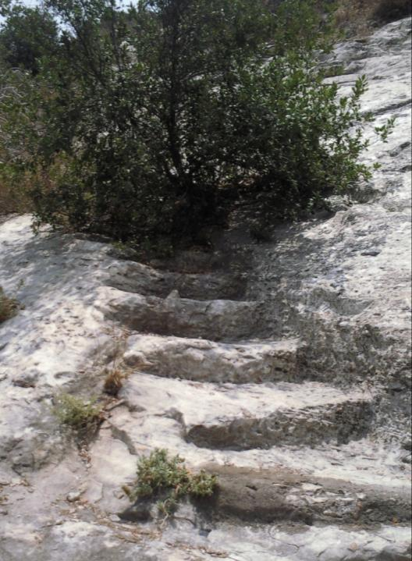
Steps hewn in the rock near Elijah’s Cave

Which halakhic position do Rabbi Hanina’s instructions in the Yerushalmi follow? I believe that his statement fits with the “three stars” position, which, as we noted above, is mentioned in both the Bavli and the Yerushalmi in the name of Amoraim. In the Yerushalmi, not long before we encounter Rabbi Hanina’s passage, we read: “Rabbi Phinehas said in the name of Rabbi Abba son of Papa: ‘One star is certainly day; two is uncertain; three is certainly night.” The steep descent toward the sea apparently takes just over twenty minutes, which, according to observations, is the amount of time that passes from the time the sun begins to set until one medium-sized star appears. At that point, the priest may still immerse in the sea, and by the time he manages to dry off and dress, three stars are already visible and he can eat his teruma immediately.

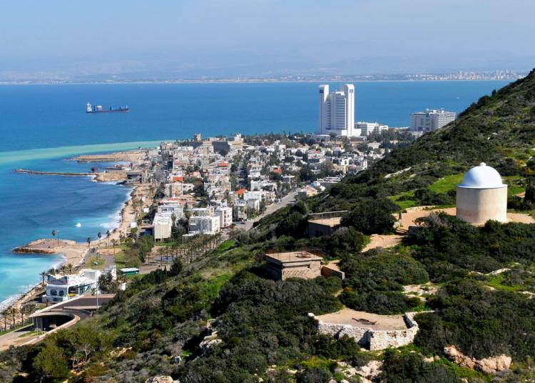
Mount Carmel in 2010 (Image courtesy of Zvi Roger, Haifa Municipality)

For further study:

J. Elgavish, “Shiqmona,” The New Encyclopedia of Archaeological Excavations in the Holy Land, Jerusalem 1993, 1373-1378.

J. Elgavish, The Excavations of Shikmona, Haifa 1973.

J. Elgavish, Shikmona on the Seacoast of Mount Carmel, Tel Aviv 1994 [Hebrew].

Yoel Elitzur, “ō-ē Interchanges in Toponyms in Moab and on the Coast,” M. Bar-Asher (ed.), Studies in Hebrew and Jewish Languages: Presented to Shlomo Morag, Jerusalem 1996, 63-71 [Hebrew].

E. Haddad, “Roman Byzantine Amphorae from a Terrestrial Site and its Underwater Environs: Horbat Castra and Kfar Samir (Southern Levant) as a Case Study,” Levant 41 (2009), 79-91 (http://www.maneyonline.com/doi/pdfplus/10.1179/175638009X427602).

H. Newman, The Ma’asim of the People of the Land of Israel, Jerusalem 2011, 52-57 [Hebrew].

G. Reeg, “Haifa,” “Qastra,” “Shiqmah,” Die Ortsnamen Israels nach der rabbinischen Literatur, Wiesbaden 1989, 251-253, 573-574, 612-613 [German].

Y. Tsafrir, L. Di Segni and J. Green, “Carmel Mons,” “Castra Samaritanorum,” “Hefa,” “Porphyreon,” “Sycamina,” Tabula Imperii Romani Iudaea-Palestina: Eretz Israel in the Hellenistic, Roman and Byzantine Periods, Jerusalem 1994, 100-102, 141-142, 204, 237.

Z. Vilnai, “Haifa,” Ariel: Entziklopedia Li-yediat Eretz Yisrael, Tel Aviv 1977, 2290-2365 [Hebrew].

S. Yankelewitz, “Ha-arkheologiya shel Merchav Cheifa,” S. & M. Aharoni (eds.), Ishim U-ma’asim Be-Cheifa Ve-haseviva, Kfar Saba 1993, 10-15 [Hebrew].

Z. Yeivin and G. Finkelstein, Castra, at the Foot of Mount Carmel: The City and its Secrets, Haifa 1999 [Hebrew].

A. Zigelman, “Castra or Porphyrion?” Michmanim 15 (2001), 32-36 [Hebrew].

Translated by Daniel Landman

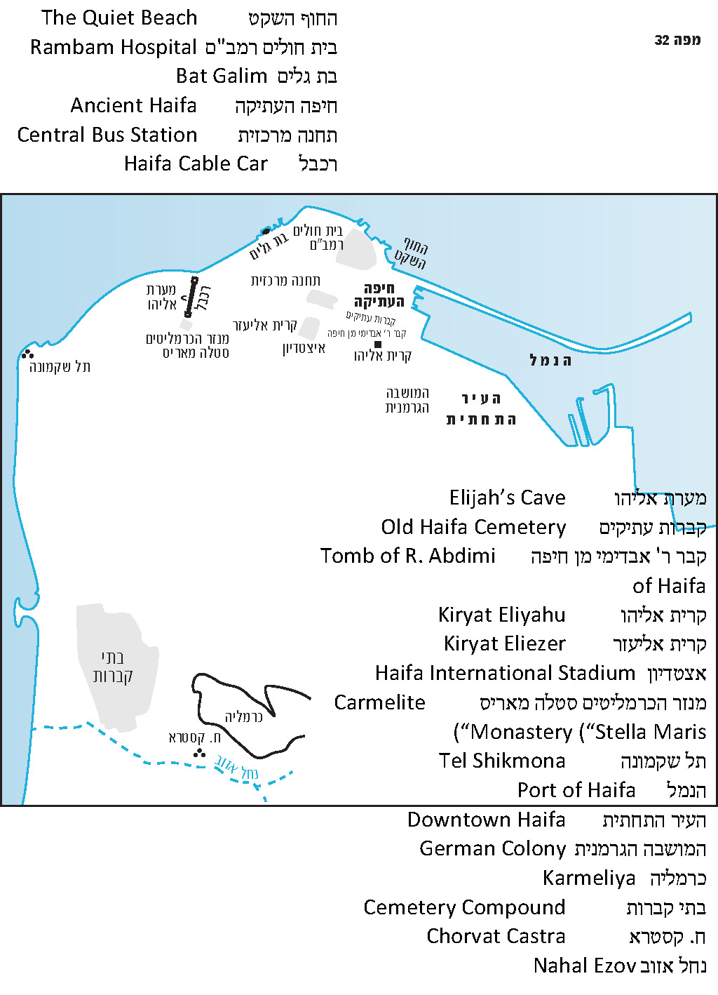

The Yerushalmi cites this position as an anonymous baraita.
This calculation is based on the most accepted opinion (it is beyond the scope of this discussion to go into detail here).
Later, the Bavli does quote a baraita that supports this definition.
In Terumot 7:2 (according to the manuscript version), Rambam estimates this interval as “about a third of an hour.” In Israel, most calendars listing Shabbat times follow the observations of R. Yechiel Michel Tukachinsky, who found that the emergence of three small stars (taking the stringent approach) occurs in practice 35 minutes after sunset.
I heard this idea from R. Yoel Bin-Nun.
A shift from cholam to tzere is found in some Hebrew pronunciation traditions. Manuscripts with Babylonian punctuation attest to this phenomenon, and it can be seen in modern times in the Hebrew pronunciation of many Yemenite and Lithuanian Jews.
This was not necessarily a reference to the Samaritan ethnoreligious group, but likely to a Roman military unit that transferred to the site from the Samaria region.
First, in a Greek cruise guidebook from the fourth century BCE, prior to the conquests of Alexander the Great.
The rim tree is apparently the Christ’s Thorn Jujube – thus named because some believe that Jesus’ Crown of Thorns was made from it – which bears a plum-like fruit.
It may be that all of these names refer to one person.
Jerome, in his edition of the Onomasticon, renders this name “Efa.”

