YESHIVAT HAR ETZION
ISRAEL KOSCHITZKY VIRTUAL BEIT MIDRASH (VBM)
*********************************************************

GEOGRAPHY IN THE PARASHA

PARASHAT SHEMINI

Kiriath-jearim and the Giv’a: Not (Exactly) What You Thought
By Prof. Yoel Elitzur

Kiriath-jearim and Ba’alei Yehuda

This week’s haftara recounts the story of the Ark of the Testimony’s journey from Kiriath-jearim to Jerusalem. Kiriath-jearim is alternately known as “Baalah” and “Kiriath-baal,” and Psalms refers to it poetically as “Ephrath” and “the region of Jaar” (132:6). Our haftara contains a unique expression that has proved confusing for translators and commentators alike: “Then David and all the troops that were with him set out from ba’alei Yehuda to bring up from there the Ark of God” (II Samuel 6:2). Ba’alei is a term that appears several times in the Early Prophets; it always refers to the residents of a city – usually to its aristocratic ruling class. Thus we find ba’alei Yericho, ba’alei Shekhem, ba’alei migdal Shekhem, ba’alei Ha-Giv’a, ba’alei Ke’ila and ba’alei Yavesh Gil’ad. Once the quality of life and governance in the land changed at the onset of the period of monarchy, the use of the expression died out. Thus, it would seem that the term ba’alei refers to people – the noblemen and dignitaries of the tribe of Judah who accompanied David as he escorted the Ark to its destination in Jerusalem. Accordingly, the verse should be translated, “Then David and all the troops that were with him of ba’alei Yehuda set out to bring up the Ark of God.” Indeed, the Septuagint, the Peshitta and the Vulgate all translate ba’alei in this manner. However, the continuation of the verse – “to bring up from there” – seems to indicate otherwise, implying that ba’alei Yehuda is the name of a place. But if ba’alei Yehuda is a place name, why is it in plural form (ba’alei rather than ba’al)? And why does the verse read “from ba’alei Yehuda” when “to ba’alei Yehuda” would make more sense, since David and his followers would have first traveled to the location to take the Ark “from there”?

To answer these questions, we turn to the earliest commentary on the book of Samuel: the book of Chronicles. As it does in many other places in its retelling of events depicted elsewhere in Tanakh, Chronicles replaces this difficult expression with a simpler one: “David and all Israel went up to Baalah, Kiriath-jearim of Judah, to bring up from there the Ark of God” (I Chronicles 13:6). One manuscript from Qumran even uses this version of the verse for the passage in Samuel. Influenced by this verse from Chronicles, all of the classical commentators (Rashi, Radak, Rid, Abrabanel and the Metzudot) wrote that ba’alei Yehuda refers to Baalah, which is in Judah. The commentators sensed the syntactical difficulty of the verse’s use of “from” instead of “to,” and provided unconvincing solutions to the problem. Targum Jonathan was troubled by the use of the plural form ba’alei, and translated the phrase “from the cities of the house of Judah.” This translation is difficult: Since when are cities called ba’alim? More significantly, in the end Targum Jonathan leaves unresolved the question of the verse’s use of “from.” Modern commentators and scholars – especially those who were particularly trigger-happy – rushed to suggest a plethora of textual emendations to reconcile this problematic verse, none of which merits mention here. Disregarding those suggestions, is there a satisfactory solution to the problem?

I believe that I can suggest one. It involves a general approach concerning which I intend to write a comprehensive article. Here, though, I will suffice with presenting the fundamental principles of this approach in brief. Several twentieth-century scholars have already discussed the notion that a Biblical verse does not need to be limited to one “correct” interpretation. Often in Tanakh, there is a dual meaning embedded in the original text. David Yellin was the first to deal with this subject in depth, in a comprehensive study published in 1934 in which he provides twenty-one detailed examples of this phenomenon. For instance: “Wolves of erev, they leave no bone until morning (boker)” (Zephaniah 3:3). At first glance, the word erev seems to mean “evening,” creating a phrase that runs parallel to the end of the verse. But are there really some wolves that are unique to the evening and others that are unique to the daytime? The answer is clear: The prophet is using the alternate meaning of the word erev and actually referring to “wolves of the steppe” – more commonly found in the form arava/aravot. Thus, the verse seems to be hinting at both meanings of erev simultaneously – “steppe” and “evening.”

I would like to add a new layer to this analysis. I believe that the Tanakh contains examples not only of words with dual meanings, but also of words that imply two versions of the original text. An excellent example of this phenomenon is a verse from Isaiah’s prophecy against Egypt, “one shall be called ‘city of heres’” (Isaiah 19:18). Isaiah is very clearly speaking of the “city of the sun (cheres),” a reference to On, an ancient city located in modern-day northern Cairo. Later renamed Heliopolis by the Greeks, this city was home to the center of sun worship in Egypt. By replacing cheres with heres, meaning “destruction,” Isaiah was predicting the imminent destruction of the city’s pagan temples, as is reflected in the translation of Targum Jonathan: “The city of the house of the sun, which will one day be destroyed.” In this case, cheres and heres do not constitute two alternate readings of the verse, but rather two versions of the original text that are meant to be read and understood simultaneously. Ideally, the reader recites the word heres, but knows in his heart that cheres is implied – or vice versa; otherwise the verse is meaningless. Cheres is an uncommon word, chosen here to convey this dual content.

Returning now to ba’alei Yehuda, it seems that here too the intention of the verse was to include both meanings – that the tribal dignitaries were with David when he took the Ark, and that the Ark was taken from Baalah/Kiriath-jearim – simultaneously. The conflation of these two statements resulted in the unique expression ba’alei Yehuda, which differs from other similar expressions in that its second clause is not the name of a city but the name of a tribe or geographical region. This caused a certain degree of quirkiness in the syntax of the verse as well. I must mention here that the question of ba’alei Yehuda was treated similarly, albeit with somewhat different points of emphasis, in an article by Prof. Yisrael Rosenson in 1996.

Kiriath-jearim in Tanakh

Kiriath-jearim is mentioned in Tanakh in seven contexts:

- In the story of the pact that the disguised Gibeonites made with Joshua: “Their cities were Gibeon, Chephirah, Beeroth and Kiriath-jearim” (Joshua 9:17).

- In the description of the tribal territories, Kiriath-jearim is a border city between Judah and Benjamin (Joshua 15:9, 60; 18:14-15, 28).

- It was home to several prominent families from the tribe of Judah (I Chronicles 2:50-53).

- The Danites encamped in its environs before they set out to conquer Laish (Judges 18:12).

- The Ark of the Testimony was brought there after it was captured by the Philistines and returned to Beth-shemesh. Years later, David removed the Ark from Kiriath-jearim and brought it to Jerusalem (I Samuel 6:21-7:2; I Chronicles 13:5-6; II Chronicles 1:4).

- It was the home city of the prophet Uriah, who was murdered by King Jehoiakim (Jeremiah 26:20-23).

- Kiriath-jearim was one of the destinations of the people who returned from exile – “each to his own city” – in the time of Zerubbabel (Ezra 2:25; Nehemiah 7:29).

A remarkable tradition concerning Kiriath-jearim was preserved in a baraita (Tosefta Makkot 2:2; Yerushalmi Makkot 2:7 [31d]), which states that Kiriath-jearim served as a city of refuge until Shekhem was conquered. Samuel Klein, a scholar of Talmudic geography, believed that this tradition originated in the early Hasmonean period. Based on various proofs, Klein claimed that the Hasmoneans reinstated the laws of the city of refuge as a kind of Jewish counterbalance to the autonomous Hellenistic asylum cities that were established during that period.

Kiriath-jearim and the Giv’a

We read in our haftara: “They loaded the Ark of God onto a new cart and conveyed it from the house of Abinadab, which was on the giv’a…” (II Samuel 6:3). A similar statement is found earlier in the book of Samuel as well: “The men of Kiriath-jearim came and took up the Ark of the Lord and brought it into the house of Abinadab on the giv’a; and they consecrated his son Eleazar to have charge of the Ark of the Lord” (I Samuel 7:1). The meaning of the word giv’a is “hill,” and thus this verse seems to be stating that there is a hill in Kiriath-jearim where the Ark of God was located, remaining there for all those years until David arrived to bring it to Jerusalem. Indeed, this is the interpretation found in the Septuagint’s translation, cited favorably by Edward Robinson in his reports of his 1838 exploration of the land of Israel – that giv’a here is no more than a common noun meaning “hill.” Despite this, other translators and commentators generally maintained that giv’a here is a proper noun, referring to a place name: Gibeah. The Gibeah in Kiriath-jearim was mentioned earlier, in the book of Joshua, and it is interesting to examine the relationship between Kiriath-jearim and the Gibeah of the book of Joshua. The borderline between Judah and Benjamin is described in Joshua twice: first in chapter 15 (from the side of Judah) and a second time in chapter 18 (from the side of Benjamin). The Tanakh’s emphasis in the latter description is unusual:

The boundary now turned and curved onto the western rim; and the boundary ran southward from the hill on the south side of Beth-horon till it ended at Kiriath-baal – that is, Kiriath-jearim – a city of the Judites. That was the western rim. The southern rim: From the outskirts of Kiriath-jearim… (Joshua 18:14-15)

This passage describes the territorial border of Benjamin, and Kiriath-jearim is a key point in the description, as it constitutes the southwestern corner of the border. However, the verse emphasizes that the city of Kiriath-jearim itself belongs to the Judites, while the territory of Benjamin only reached “the outskirts of Kiriath-jearim.”

“Kiriath-baal – that is, Kiriath-jearim” is enumerated in Joshua 15:60 as one of the hill cities belonging to the tribe of Judah, while the tribe of Benjamin’s list mentions “Gibeath Kiriath” (18:28; see below). Thus, it seems that Gibeah is a satellite town of Kiriath-jearim. When the Tanakh states that the Ark was “in Kiriath-jearim,” it is making a territorial statement: The Ark was in the city of Gibeah in the region of Kiriath-jearim. The boundary between the two tribes ran through both cities: Kiriath-jearim, the more prominent Judite city; and the nearby Benjaminite city of Gibeah.

Identification of Kiriath-jearim – Information from the Sources

The accepted identification for Kiriath-jearim is in the Abu-Ghosh/“Telz-Stone” area just west of Jerusalem. This identification is based on several considerations:

- First, the information found in the various Biblical passages seems to point to this region. Kiriath-jearim is located between Beth-shemesh and Jerusalem not only in the story of the Ark in Samuel, where it is not entirely clear if the narrative is referring to a straight line drawn between those two cities. It is also mentioned as part of the northern borderline of the territory of Judah, which is undoubtedly a more-or-less contiguous line. What is more, Kiriath-jearim is the point of intersection of two presumably straight Biblical lines: the northern border of Judah (Joshua 15:5-11), whose eastern half coincides with the southern border of Benjamin (18:15-19) and which runs east-west; and the western border of Benjamin (18:14), which runs north-south. The northern border of Judah runs from Jerusalem and the Waters of Nephtoah toward Kiriath-jearim, and continues west, passing through Mount Seir and “north of the slope of Mount Jearim – that is, Chesalon” toward Beth-shemesh. Chesalon is identified strongly with the ruins found at the top of a tell in the ruined Arab village of Kasla (destroyed during the War of Independence in 1948), north of modern-day Moshav Ksalon. The site is situated atop a steep slope south of Nahal Ksalon. Beth-shemesh is identified with a great degree of certainty with Tel Beth-shemesh (formerly Tell ‘Ain Shams), west of modern-day Beit Shemesh above a perennial stream. The western border of Benjamin begins at “the hill south of Lower Beth-horon” (18:13). Lower Beth-horon is identified with the village of Beit ‘Ur al-Tahta. There is no prominent hill, either in appearance or in height, south of this village; the verse simply wished to emphasize that the territory does not include Beth-horon itself, leaving it instead to the tribe of Ephraim. In any case, the line that runs south from the Lower Beth-horon border is the line that passes along the slopes between the high mountains and the lowlands. This line intersects the Jerusalem-Ksalon-Beth-shemesh line somewhere in the area of Abu-Ghosh and Telz-Stone.

- One of the most important sources in the study of the Biblical geography and history of the land of Israel – perhaps the most important among them – is the fourth-century CE Greek-language work of the Church Father Eusebius entitled On the Place-Names in the Holy Scripture, commonly known as the Onomasticon (literally, “book of names”). In this book, Eusebius collect close to a thousand place names from the books of the Torah and the Prophets, as well as from the four gospels of the New Testament. Eusebius identifies about a third of these places using the contemporary information of his time. His testimonies from the field are generally reliable, his Biblical exegesis less so. On the entry “Baal,” Eusebius writes: “This is… city of Iarim… There is a village Cariathiarim (today) on the road descending from Aelia [Jerusalem] to Diospolis [Lod] at the tenth milestone.” On the entry “Cariathiarim (also known as Cariathbaal),” he asserts that the place is located on the way between Jerusalem and Diospolis, at the ninth mile. The road from Jerusalem to Lod was approximately equivalent to the modern Jerusalem-Tel Aviv highway. It passed through Jerusalem along modern-day Jaffa Street and the Givat Shaul neighborhood, and continued to the Castel and Sha’ar HaGai. Keeping in mind that one Roman mile is slightly less than one standard modern mile, one who travels 9.5 Roman miles from the Jaffa Gate will reach the Abu-Ghosh region.

- Kiriath-jearim is mentioned as well in two early Christian accounts of pilgrimages to the Holy Land. The first, a twelfth-century source that was apparently copied from the fourth-century original, writes: “Nine miles from Jerusalem, at the place called Cariathiarim, where there was the Ark of God, a church was built.” The second, an early sixth-century source, writes: “From Jerusalem to Silona (Shiloh), where there was the Ark of the Testimony of God, nine miles. From there to Emmau, today called Nicopolis, nine miles.” It is clear that the author was referring to the road to Lod, and simply confused the Ark with the Mishkan.

- The preservation of the name. The modern village of Abu-Ghosh was named for a prominent family originating in Egypt, which took control of the village in the sixteenth century upon the Ottoman conquest of the land. Suleiman I (known as “the Magnificent”), who was sultan at the time, permitted the family to collect tolls from all travelers on the road between Jerusalem and Jaffa. The Abu-Ghosh family retained both their control over the town and their right to collect taxes for approximately three hundred years. These rights were finally abrogated in the time of Ibrahim Pasha, following the suppressed Peasants’ Revolt of 1834 CE. “Abu-Ghosh” is a shortened version of “Qaryat Abu Ghosh,” but the true original name of the village was “Qaryat al-Inab,” and it is this name that is found ubiquitously in historical documentation, from the mid-eleventh-century travel records of a Persian traveler to British maps from the Mandatory period.

Qaryat al-Inab (Wood engraving, from C. W. Wilson, Picturesque Palestine, Sinai and Egypt, 1, London 1881)

At first glance, one might think that the preservation of this name is not particularly valuable, since seemingly the only element from the name that was preserved is the first word – kiryat/qaryat; the second word, ye’arim, seems to have been lost. In truth, however, this is a good preservation. In most of the early place names in the land of Israel, including the Arabic names, that are comprised of two words, the first word is generally the primary one, while the second is merely an additional word that serves to distinguish that place from other places with the same primary name. Examples of Arabic place names that follow this principle include: al-Mazra’a ash-Sharqiya (“the eastern”) and al-Mazra’a al-Qibliya (“the southern”); and al-Lubban ash-Sharqiya and al-Lubban Rantis. Examples from Tanakh include: Timnath-heres and Timnah in Judea; and Abel-meholah, Abel-beth-maachah and Abel-cheramim. In each of these examples, the second word can easily be interchanged, since it is only an external descriptor for the name. Thus, we find that al-Mazra’a al-Qibliya is also called Mazra’at Bani Murra, named for the Arabic tribe that resided there. Similarly, Abel-beth-maachah is also called Abel-maim and, in later periods, Abil al-Qamh (“Abil of wheat”).

In an article that I published twenty-five years ago on two-word place names, I demonstrated that even names of the form Kiriath-X follow this principle. In contrast to the current norm, in early periods very few names beginning with Kiriath- existed, and the name of such a place was effectively “Kiriah” or “Kiriath.” Thus, we find that the city of Debir was also known as both Kiriath-sepher and Kiriath-sannah (Joshua 15:15, 49). Returning now to Kiriath-jearim, we find that it is called both Kiriath-baal and simply “Kiriath.”

Identifying Kiriath-jearim and Gibeah: The Archaeological Findings

Since the time of geographer R. Joseph Schwarz in the mid-nineteenth century until today, it has generally been accepted to identify the Judite city of Kiriath-jearim with the village of Qaryat al-Inab/Abu-Ghosh, and the Benjaminite city of Gibeath Kiriath-jearim with the tell overlooking that village from north. Archaeological excavations have not taken place in this tell or its environs, but surveys in the area have yielded pottery from the Neolithic period and the Canaanite and Israelite periods, as well as tesserae from the Byzantine period. Based on this, the border between Judah and Benjamin must have been the old Jerusalem-Tel Aviv highway, which passes between Abu-Ghosh and the tell and church.

Difficulties

This accepted identification is somewhat problematic:

- First, as we established above, Chesalon is identified strongly with the ruins of Kasla, located north of the moshav of Ksalon, at the northern edge of a mountainous region that continues east. It is at the top of a steep slope that descends to Nahal Ksalon, which flows south of the Abu-Ghosh/Telz-Stone area. Joshua 15:10 mentions that Chesalon is located on the northern border of Judah, two border points after Kiriath-jearim, and it is given a topographical descriptor: “The boundary passed north of the slope (katef) of Mount Jearim – that is, Chesalon.” In light of our interpretation of “Kiriath-jearim” as “Kiriath” with the appended identifying element “jearim,” this would mean that the “jearim” element was coincidentally given to both the city of Kiriath north of Nahal Ksalon and the mountainous region south of the wadi. Even though the scenery on both sides of this deep wadi was likely very similar, and was probably wooded (as ye’arim means “forests”), it is still somewhat strange that the proper name “jearim” was seemingly duplicated on either side of the stream.

- The overall border of northern Judea is very logical from a topographical perspective. It apparently follows Wadi Og on its eastern end and Nahal Sorek on its western end. Its proximity to Nahal Sorek is particularly prominent in the Shephelah between Beth-shemesh and the Mediterranean, passing through Ekron, Timnah and Jabneel/Yavne along the way. During Nahal Sorek’s mountainous portion, the borderline deviates from the stream twice. The first deviation is in the Jerusalem area – the borderline continues south, following Nahal Kidron until En-rogel. From there it turns west, following the Valley of Ben-hinnom and “the hill which flanks the Valley of Hinnom on the west” (Joshua 15:8) – the primary mountain of modern Jerusalem. Then it descends to the spring of the Waters of Nephtoah, identified according to most scholars as Lifta, and finally returns to Nahal Sorek. The purpose of this deviation is apparently to include Jerusalem in the territory of Benjamin.

The second deviation is in the area of the Castel. The existence of Chesalon on the borderline proves that in this section the border follows Nahal Ksalon, a more northern tributary of Nahal Sorek. This deviation is essentially a correction of a natural deviation. When Nahal Sorek reaches this area, it curves sharply to the south, circumventing the entire Castel ridge, Tzova, Giv’at Ye’arim and Ksalon from the south. Nahal Ksalon, which originates at the Castel bridge and flows west in a more-or-less straight line, helps the border remain a logical east-west line until the wadi merges back into Nahal Sorek near Beit Shemesh.

Based on this, topographical logic dictates that the border must have run from the spring of the Waters of Nephtoah/Lifta, following Nahal Sorek until Motza, then similarly ascended along with what is today the Jerusalem-Tel Aviv highway until the Castel bridge. Once there, it could continue along the southern slopes of Nahal Ksalon in the direction of Beit Shemesh. The inclusion of Abu-Ghosh in the borderline utterly reverses the topographical logic of the line, adding an ascent to Abu-Ghosh, a steep descent to Nahal Ksalon, and then another steep ascent to the ridge south of the wadi.

- The approach to defining land boundaries in the Biblical period was territorial. Biblical cities were, in practice, the regional centers of larger tracts of agricultural land that covered several acres. Every city was surrounded by such a swath of land, making it unreasonable for Kiriath-jearim and Gibeath Kiriath-jearim to be located in such close proximity to each other.

- From an archaeological perspective, no remnants of an ancient city have been found in either Abu-Ghosh or Telz-Stone. The scattered shards of pottery found in the area of the spring in Abu-Ghosh and in the rest of the area most likely come from the city situated on the tell overlooking the area. The approach that connects this Arab village from the modern era with an ancient Biblical site is typical of many nineteenth-century scholars, who often misguidedly assumed that the existence of an Arab village automatically meant the existence of a Biblical city. This assumption bears out in many cases, but the fact is that many Arab villages are not situated on an ancient site, and conversely, many ancient sites are located in tells or ruins in open areas.

Where Should We Search for Kiriath-jearim?

It seems to me that the Judite city of Kiriath-jearim must be located south of Nahal Ksalon. The name al-Qarya/Qaryat al-Inab/Qaryat Abu-Ghosh, which is a continuation of the Byzantine Cariathiarim, preserved the ancient name within the territorial area of Gibeath Kiriath-jearim, located in modern-day Tel Kiryat Ye’arim (Deir al-Azhar). The name Kiriath-jearim was not preserved in the area of the chief Judite city south of the stream. The tall ridge that runs west from the summit of the Castel, passing through Tzova and Giv’at Ye’arim in the direction of Ksalon, was known as Mount Jearim in the Biblical period. In the eastern or central part of this ridge, there was a central city – Kiriath-jearim. West of this city, within the Mount Jearim ridge, was Mount Seir,” and further west lay Chesalon/Kasla, at the top of the slope overlooking the wadi.

Mahaneh-dan and Kiriath-jearim

Before the Danites set out to conquer Laish in the northern part of the land, they encamped in Mahaneh-dan, which literally means “the camp of Dan.” The Tanakh states:

They departed from there, from the clan seat of the Danites, from Zorah and Eshtaol, six hundred strong, girt with weapons of war. They went up and encamped at Kiriath-jearim in Judah. That is why that place is called “Mahaneh-dan” to this day; it lies west of Kiriath-jearim. (Judges 18:11-12)

Kiriath-jearim is mentioned in this passage twice, the first in reference to its territorial area and the second time to the city itself. The Danites encamped in the land of Kiriath-jearim, in a space west of the city of Kiriath-jearim. Even though this was a piece of land within an open area, the passage makes a point of emphasizing that this is Kiriath-jearim in Judah, which – in light of what we have seen above – is certainly meant to stress that this location belonged to the Judite city of Kiriath-jearim rather than the Benjaminite city of Gibeath Kiriath-jearim. This passage supports our assumption that the distinction between the Judite Kiriath-jearim and the Benjaminite Gibeath Kiriath-jearim was most significant for its territorial implications, and was not merely a distinction between two points on the same plot of land.

In addition, it stands to reason that the Danites, who set out from Zorah and Eshtaol, would encamp in a location close to Zorah and Eshtaol. This logic is also supported by a second mention of Mahaneh-dan in a different generation and a different context: “The spirit of the Lord first moved him in Mahaneh-dan, between Zorah and Eshtaol” (Judges 13:25). Zorah and Eshtaol are a constant pair; they are always mentioned together. Zorah has a strong identification with the ruins of the village of Sar’a (captured in 1948) at the top of a hill between Tarum and the Naham-Hartuv industrial zone northeast of the contemporary Kibbutz Tzora. Eshtaol does not have a clear identification, but it must be somewhere near Zorah. Tell Zorah is located 7.5 miles southwest of Abu-Ghosh and about four miles west of Kasla/Chesalon. It may be that “between Zorah and Eshtaol” can be interpreted as the area located off to the east of both Zorah and Eshtaol themselves. Either way, since the area is named for Zorah and Eshtaol, it cannot be too far away from the two towns. In terms of the territorial division of the land in this region, the Zorah ridge can be considered a continuation of the mountainous area south of Nahal Ksalon. Thus, Mahaneh-dan and its surroundings are so distant and disconnected from Abu-Ghosh and Tel Kiryat Ye’arim (i.e., the Benjaminite Gibeah) that linking the two would be incongruous.

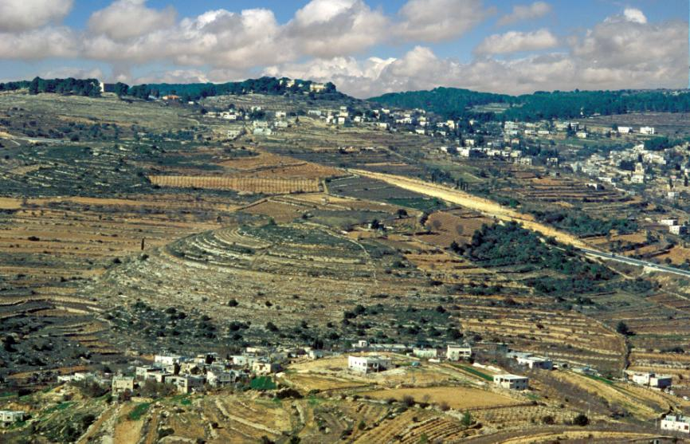
Abu-Ghosh and Tel Kiryat Ye’arim (Z. Radovan)

One Final Thought

On the northern border of Judah, between the Waters of Nephtoah and Kiriath-jearim, we find “the cities of Mount Ephron” (Joshua 15:9). Based on the implied logic of the borderline, it is reasonable that “Mount Ephron” refers to the Castel ridge. But we must ask: What is the meaning of the plural “cities of Mount Ephron”? After all, a borderline must follow a specific path – one that cannot be defined by such a general term referring to multiple cities. As a result of this difficulty, most versions of the Septuagint omitted the word “cities (arei),” and the Peshitta replaced it with the word “tip (keren).” Some modern commentators dealt with the problematic word by explaining that it was the result of a scribal error, but the wide variety of interpretations only reinforces the authenticity – and the problematic nature – of the Masoretic text.

In a similar case – “he was buried in the cities of Gilead” – the aggadists questioned the vague description of Jephthah’s burial site, and explained that “Jephthah died through the loss of his limbs. Wherever he went, a limb would fall off, and they would bury it there” (Bereishit Rabba 60 and parallels). Radak and other peshatists interpreted “in one of the cities of Gilead” to mean that at the time the book of Judges was written, Jephthah’s precise burial site was unknown (Da’at Mikra, Judges 12:7). This kind of solution is impossible in our case. But it is worth noting a different example of the same variety: one of David’s warriors, who was known as “Hiddai of Nachalei Ga’ash” (II Samuel 23:30). The meaning of Hiddai’s hometown is unclear. If nachalei ga’ash is translated as “the brooks of Gaash,” then, as above, this is too broad a location. The best solution here (suggested by Karl Elliger) is that nachalei ga’ash refers to one town whose name consists of two words: the name of the town – Nehalim or Nehalin – and the name of the mountainous region where the town was located – Mount Gaash, named for the city of Gaash. Perhaps we can suggest a similar approach in our case as well. It may be that the name of the town was “Arim,” and it was located in the Mount Ephron region. “Arim” may be a shortened form of “Jearim” (as in Hezekiah/Jehezekiah and Balaam/Ibleam), and the name appears in Tanakh both explicitly (Ezra 2:25) and implicitly (Joshua 18:28). According to this speculation, (Je)arim was the name of a city in Mount Ephron, a name that very aptly described the regional landscape as well. This city and its surroundings were thus the basis for the name of the whole nearby ridge – Mount Jearim – and the city of Kiriath within that ridge was thus called Kiriath-(je)arim.

Open Questions

Let us summarize what we have established until this point. The identification of Chesalon with Kasla at the top of the southern slope of Nahal Ksalon is certain. The border passes through here, apparently running all along the ridge south of Nahal Ksalon. The Tanakh calls this ridge Mount Jearim. Thus, the Judite city of Kiriath-jearim must be located on this ridge, at a point further to the east, and it is likely that even further to the east there was a site called (Je)arim. According to the Tanakh, an uninhabited wooded mountain called Mount Seir, which was actually a part of the ridge of Jearim, was situated between Kiriath-jearim and Chesalon.

We assume that the borderline ran all along the ridge and did not rise or fall sharply at any point. However, it is difficult to ascertain with certainty precisely where, within this region, it ran. The borderline might have passed through Tzova, Eitanim and Ramat Raziel. In order to suggest a precise identification for Kiriath-jearim itself, we must see what information we can glean from the regional sites themselves. The most prominent site in the region is the conical hill of Ṣūba – which the crusaders called Belmont (“the nice hill”) – atop Kibbutz Tzova, but the fact that this site has its own ancient Hebrew name is an argument against its identification with a different name.

From the perspective of preservation of ancient names, we assumed that the name “Qaryat al-Inab” (Abu-Ghosh) constituted a preservation of the ancient name “Kiriath,” but this is problematic, as it is located adjacent to the Benjaminite city of Gibeath Kiriath. Let us add a piece of information that will confuse matters further: The moshav of Giv’at Ye’arim, located south of Nahal Ksalon, is situated atop a ruin known as Khirbet Jab'a, and according to our analysis, it is located in the territorial area of the Judite city of Kiriath-jearim. It turns out that a strange transposition occurred here. In the Biblical Kiriath (Jearim) area, the name Gibeah (Jaba’) was preserved, while in the Gibeah (Gibeath Kiriath-jearim) area, the name Kiriath (Qaryat al-Inab) was preserved. At this point in our discussion, though, we must leave these questions for another time.

For further study:

M. Abegg, P. Flint and E. Ulrich, The Dead Sea Scroll Bible, New York 1999, 241.

J. H. Bernard, Theodosius (Palestine Pilgrims’ Text Society), London 1893, 9.

Yoel Elitzur, “Toponyms in the Land of Israel: Two-word Place Names,” Encyclopedia of Hebrew Language and Linguistics, Leiden and Boston 2013, 3, 783.

Yoel Elitzur, “The Concept of Territory in the Arab Village and in Biblical Geography,” Israel – Land and Nature 7 (1982), 146-150.

G. S. P. Freeman-Grenville, R. L. Chapman and J. E. Tailor, The Onomasticon of Eusebius of Caesarea, Jerusalem 2003, 34, 65.

A. Freimann (ed.), Sefer Ma’agal Tov, Ve-hu Sipur Mas’ot Ha-rav R. Chayim Yosef David Azulai, Jerusalem (1921) 1967, 47 [Hebrew].

S. Klein, “The Cities of the Priests and the Levites, and the Cities of Refuge,” Journal of the Jewish Palestine Exploration Society (1934-35), 81-107 [Hebrew].

E. Robinson and E. Smith, Biblical Researches in Palestine and in the Adjacent Regions: A Journal of Travels in the Year 1838, 2, Boston 1856, 12.

Y. Rosenson, “Kiriath-jearim – Baalah,” Al Atar 1 (1995), 83-88 [Hebrew].

J. Schwarz, A Descriptive Geography and Brief Historical Sketch of Palestine, Michigan 1899 (Jerusalem 1850), accessible at [http://www.tevuot.org/aretz/eng/cities_of_benjamin.html].

J. Wilkinson, Egeria’s Travels to the Holy Land, Revised Edition, Jerusalem 1981, 186-188.

D. Yellin, “Mishneh Ha-hora’a Ba-Tanakh,” Tarbiz 5 (1933), 1-17 [Hebrew].

Translated by Daniel Landman

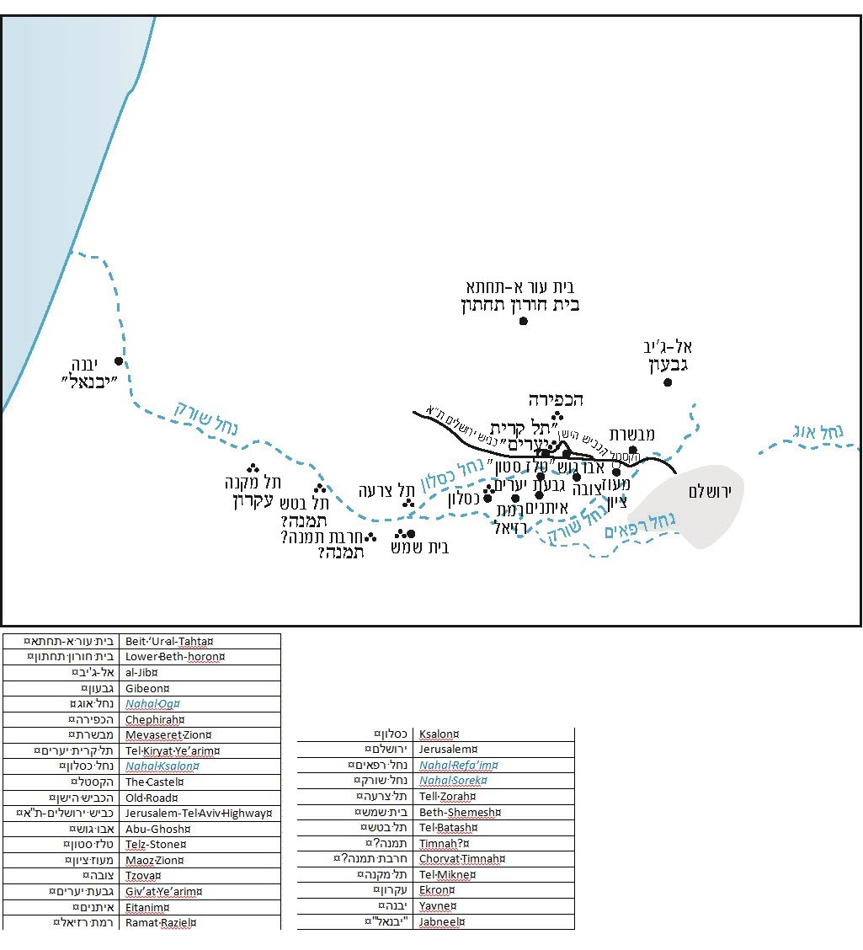

Compare to I Chronicles 2:50.
I will point out, however, that the word be’alot, which appears in Joshua 15:24, is translated in the Septuagint (B) as “villages.”
See Job 9:7: “Who commands the sun (la-cheres) not to shine.”
See our discussion on Parashat Masei.
We must distinguish between Gibeah and “Gibeah of Benjamin/Saul,” an entirely different Benjaminite city that is also often called simply “Gibeah.” There is also a third Gibeah, mentioned in Joshua 15:57 – “Kain, Gibeah and Timnah” – in the southern Mount Hebron region, in addition to Geba and Gibeon, which are different cities as well.
See our discussion on Parashat Vezot Haberakha.
An interesting proof for the identification of the Roman-Byzantine road from Jerusalem to Lod with the general route of the modern-day Jerusalem-Tel Aviv highway can be found in Midrash Eikha Rabba, which was written approximately during Eusebius’ lifetime. The Midrash mentions that among all the walls and towers of Jerusalem, the only thing that Titus left intact was the city’s western gate, which provided access to the road to Lod (1:31). This is a reference to the Jaffa Gate and to the enormous Herodian towers adjacent to it. We can infer from this that the road to the Shephelah that originated at the Jaffa Gate was known in the time of the Amoraim as “the road that goes to Lod (pylē ma’arvita de-nafqa le-Lod).”
An ancient fortress that once guarded this road is preserved in the courtyard of Herzog Hospital, a geriatric-psychiatric hospital in Givat Shaul.
They often accomplished this by means of violent attacks. The Chida, in his travel diary entitled Ma’agal Tov (“The Good Journey”), describes a frightening conflict with the Abu-Ghosh family that took place in 5524 (1764 CE). He relates that Abu-Ghosh, “the great snake, chief of the violent men,” was accompanied by “the offspring of the wicked, a pack of evil ones – two hundred fifty.” Together, they assaulted the guards escorting the Chida and his men, “and we settled the dispute [by paying] one hundred zilotas – blessed [is God] who redeems and saves.”
Compare to I Kings 15:20 and II Chronicles 16:4.
See Joshua 18:28; the word arim following the name Kiriath is meant to hint at the name Kiriath-jearim, but the simple meaning of the word in this context is “cities.”
In 1924, a monastery was built on this tell, atop the ruins of an ancient church, crowned by a statue that could be seen from afar. The site was labeled Deir al-‘Azar in old British maps, Deir al-Azhar in some scholarly literature, and Tel Kiryat Ye’arim in today’s maps.
See our discussion on Parashat Bemidbar regarding the topographical term ketef.
Explaining the reasoning behind this determination is beyond the scope of this discussion.
It is today a wooded area once again, after becoming a bare rocky land and remaining so for centuries due to uncontrolled chopping and pasturing by the Arab villagers.
The mountain was actually named for its ample vegetation, which resembled hair (se’arot). The word se’ira, which appears in Judges 3:26, probably also refers to a vegetated area. (Rashi points to a similar phrase in the Mishna in his commentary on the verse.)
This incident occurred later in history than the previous one, despite the story's earlier placement in Tanakh.
See our discussion on Parashat Naso.
Compare to the usage of the word bein (“between”) here to its usage in the verse, “you shall not… shave the front of your heads (bein eineikhem)” (Deuteronomy 14:1).
This name may have been mentioned in the addition of the Septuagint in its translation of Joshua 15:59, and perhaps in a document from the time of Bar Kokhba.

