YESHIVAT HAR ETZION
ISRAEL KOSCHITZKY VIRTUAL BEIT MIDRASH (VBM)
*********************************************************

GEOGRAPHY IN THE PARASHA

PARASHAT VAYIKRA

Tzafon
By Prof. Yoel Elitzur

“The Most Holy Sacrifices are Slaughtered in the North”

The insistence that the sacrifices possessing the highest level of sanctity be slaughtered specifically on the northern side of the altar (Mishna Zevachim 5:1) is a basic principle in the laws of sacrifices. At the opening to the book of Leviticus, this law is mentioned in connection with the burnt offering: “It shall be slaughtered before the Lord on the north side of the altar” (1:11). Later, the Torah reemphasizes this requirement in connection with the sacrifices that are eaten in the court of the tent of meeting:

It shall be slaughtered at the spot where the burnt offering is slaughtered before the Lord; it is a sin offering. (4:24)

And the sin offering shall be slaughtered at the place of the burnt offering. (4:29)

And it shall be slaughtered as a sin offering at the spot where the burnt offering is slaughtered. (4:33)

The sin offering shall be slaughtered before the Lord, at the spot where the burnt offering is slaughtered. (6:18)

The guilt offering shall be slaughtered at the spot where the burnt offering is slaughtered. (7:2)

Ibn Ezra and R. Samson Raphael Hirsch explained that slaughtering the holy sacrifices on the northern side of the altar is parallel to the placement of the table in the northern part of the Sanctuary. R. David Zvi Hoffman added to this suggestion, explaining that the showbread and the sacrifices represent material divine worship, whereas the Menorah represents spiritual divine worship. The “spiritual” Menorah was situated at the sunlit southern end of the Sanctuary, while the “material” meat and bread were situated on the shaded end – in the shade of the divine wisdom.

The Cardinal Directions in Biblical Hebrew

Rabbinic Hebrew and Modern Hebrew both resemble English with respect to the cardinal directions; only one word exists that corresponds to each of the directions – tzafon (north), darom (south), mizrach (east) and ma’arav (west). In contrast, Biblical Hebrew features a wealth of synonyms for the cardinal directions. For “east,” not only do we find mizrach and mizrach shemesh (“toward the sunrise”), but also motza (“origin”; Psalms 75:7) and the more common kedem (“front”). The word penei (“the face of”) seems to refer to east in some instances as well. The word ma’arav appears only rarely in Tanakh; usually yam (“sea”) is used, and occasionally mevo ha-shemesh (“sunset”). The word darom appears frequently in Ezekiel and in Ecclesiastes but almost not at all throughout the rest of Tanakh. Instead, negev is generally used, though occasionally we find teiman or yamin (“right”; Psalms 89:13 and others). In one instance, the word yam refers to the south (Psalms 107:3). The north is almost always called tzafon in Tanakh, as it is in today’s Hebrew, but we do find a few instances where the word semol (“left”) is used, such as “And he pursued them as far as Hobah, which is north (mi-semol) of Damascus” (Genesis 14:15).

The difference between Biblical Hebrew and Rabbinical Hebrew in this regard is not anomalous; the existence of multiple synonyms for a given word is a typical characteristic of Biblical Hebrew, while in Rabbinic Hebrew this phenomenon is rare.

By examining the various examples from Tanakh listed above from a semantic perspective, we can divide them into three basic categories. The first category consists of words that describe the state of the sun: The sun rises in the morning in the east, or, in other words, it leaves its place of origin – its motza (“as the sun rising [ke-tzeit ha-shemesh] in might”; “as the sun rose [yatz'a] upon the earth”; “not from the east [mi-motza] or the west”; and in ancient and royal Aramaic, moka shemesh or mo’a shemesh respectively). In the evening, the sun sets – mevo ha-shemesh – as if it were going to sleep for the night (“When the sun set [ba’a] and it was very dark”; “thus his hands remained steady until the sun set [ad bo ha-shemesh]”). In Ugaritic, the word ^{c}arab means “enter,” and thus ^{c}rb.špšm means “sunset”; y^{c}rb.bḫdrh.ybky means “he entered his room crying.” Similarly, the Akkadian word erēbu means “to enter.” We see from this that the Hebrew word ma’arav was originally a synonym for “sunset.”

The second category is based on one’s orientation when facing east. Why would one face east? Some connect this notion to ideas found in ancient pagan sun worship. Others maintain that this is rooted in primitive man’s dependence on the sun; each day one would eagerly await the sunrise, which would allow him to set out on a journey or begin his work in the fields. It seems, however, that it would be best to avoid such unprovable anthropological speculation and focus instead on the facts at hand. The facts are that in Hebrew and in related languages we find that the words for the cardinal directions are based on an east-facing orientation. East is therefore called kedem, west is called achor (“back”), north is called semol and south is called yamin. All four of these terms appear together in the book of Job, when Job searches for God in every direction but cannot find Him:

But if I go east (kedem) – He is not there; west (achor) – I still do not perceive Him; north (semol) – since He is concealed, I do not behold Him; south (yamin) – He is hidden, and I cannot see Him. (23:8-9)

The third category is the most interesting of them all. The cardinal directions are named for regions in the land of Israel, teaching us that the Hebrew language is, by its very nature, intrinsically connected to the land. This category includes yam, referring to the Mediterranean Sea in the west, and negev, referring to the arid region in the south. Once the use of these words to refer to cardinal directions was initially established, they began to be used to mean west and south even without any connection to the eponymous regions. Thus, for example, the “west wind (ruach yam)” (Exodus 10:19) that carried the locusts from Egypt was actually a land breeze originating in Libya, which is west of Egypt. In addition, the region “south of Chineroth (negev kinerot)” (Joshua 11:2) is located in one of the most fertile regions of the country, nowhere near the actual Negev region. As we mentioned above, there is one instance where yam surprisingly refers to the south: “Mi-mizrach u-mima’arav, mi-tzafon u-miyam” (Psalms 107:3). It seems, though, that the word yam here refers to the Sea of Suph in the southern part of the land of Israel.

Not all the names used in Tanakh for the cardinal directions are easy to understand and categorize. Several explanations have been suggested for darom, but Eliezer Ben-Yehuda said it best when he wrote in his dictionary, in the entry for darom: “Its origin is unclear.” The explanation generally given for teiman, in dictionaries and in the research literature, is that it is a synonymous form of yamin. However, there is no evidence that teiman was ever used consistently to mean “right” in the normal directional sense of the word. It seems to me that a combination of factors is at work here. The word teiman possesses a nominal derivation pattern that is commonly found in names of people and places (e.g., Tifsach [Thapsacus], Tirzah, Timnah and Timna’). Teman is a well-known town and region in Edom, and based on ancient inscriptions found in Kuntillet Ajrud in the western end of the southern Negev Mountains, it is assumed that another Teman existed in that region as well. Thus, it is reasonable to assume that the word teiman in the sense of “south” fits into the third category – cardinal directions named for places in the land of Israel – but that the place name Teman was originally derived from the fact that it was located on the “right” - yamin.

Returning to Tzafon

The word tzafon is written as tzefon in its construct state, its inflected form and sometimes in its absolute state as well (as in Joshua 11:2). The classical grammarians maintained that the word tzafon fit into the first of the three categories detailed above – relation to the sun. According to Radak, “The path of the sun is not on [the northern] side but rather on the southern side, and it is as if that direction is hidden (tzafun) from the sun” (Sefer Ha-shorashim). This interpretation seems overly homiletical, though.

The explanation suggested by German theologian Otto Eissfeldt seems more likely. According to Eissfeldt’s suggestion, tzafon would fit into the third category – directions named for places in the land of Israel. In documents found in Ugarit – an important city, kingdom and cultural center on the northeastern Mediterranean coast between the Patriarchal age and the period of the Judges – the name ṣpn appears many times. Ṣpn, or ṣrrt ṣpn, is a tall mountain or ridge where the gods lived, according to Ugaritic tradition (similar to Mt. Olympus for the Greeks). The chief gods were associated with ṣpn, and are often mentioned in names that combine the two terms, such as il ṣpn, b^{c}l ṣpn and ^{c}nt ṣpn. Thanks to the Ugaritic texts, we understand that Baal-zephon, located on the Egyptian border (Exodus 14:2; Numbers 33:7), was apparently home to a temple in honor of the Baal who revealed himself on Mt. Zaphon. This understanding also helps contextualize Isaiah’s statement regarding the king of Babylonia:

Once you thought in your heart, “I will climb to the sky; higher than the stars of God I will set my throne. I will sit in the mount of assembly, be-yarketei tzafon: I will mount the back of a cloud – I will match the Most High.” (Isaiah 14:13-14)

The expression yarketei tzafon in this verse is parallel in nature to, “the highest mountains… yarketei levanon” (II Kings 19:23; Isaiah 37:24).

Where is this tall mountain located? It is assumed that the peak in question is Mount Aqra’, which is located north of the ruins of Ugarit. This mountain/ridge is very prominent within its surroundings, its slopes reach the Mediterranean Sea and its highest point is 5670 feet above sea level. Almost seven centuries ago, R. Ishtori Haparchi visited this mountain and was impressed by it, as he writes in his book, Kaftor Va-ferach:

A very, very tall mountain, whose name in Arabic is Jabal al-Aqra’, which means Bald Mountain. This mountain stands alone, its nose enters the sea and on it are tall cedar trees that reach to the heart of the heavens, as well as pistachio trees. There are water springs and towns there, which add to its blessing, and its circumference is about [a] one or two days’ [journey].

It seems, then, that the name of the direction tzafon was coined in reference to this prominent mountain. From a linguistic perspective, tzafon is a very appropriate name for a tall mountain. The ending –on is a common ending for geographical names in general (e.g., Hebron, Eglon, Ashkelon and Sidon), and in particular for names of tall northern mountains (e.g. Lebanon and Hermon – “Sidonians called Hermon Sirion” [Deuteronomy 3:9]; “as far as Mount Sion, that is, Hermon” [4:48]). The root of the word tzafon, according to this approach, is Ṣ-P-Y, meaning “to look out” – fitting for a tall mountain from which people can look out to great distances.

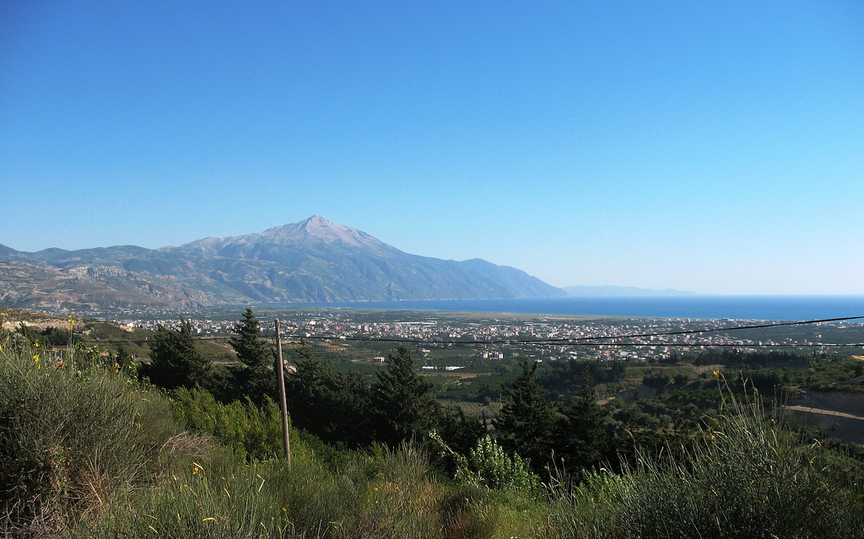
Mount Aqra’ (Anthiok at en.wikipedia)

Yarketei Tzafon in the Mishkan and in Jerusalem?

We will conclude with a subtle point. In the book of Psalms we find a title for Jerusalem that reflects its honor and holiness: “Mount Zion, yarketei tzafon, city of the great king” (48:3). But what is this yarketei tzafon in Jerusalem? In light of what we established above, it will be difficult to accept simple topographical explanations in this case, such as that the Temple Mount is located on the northern edge of Jerusalem. It seems, rather, that this expression – like many other concepts and expressions found in Tanakh – was first used by Israel’s neighbors in a pagan context. The expression was then given new meaning in the spirit of the monotheistic faith of Israel. While the King James Version – the classic English translation of Tanakh – translates yarketei tzafon as “the sides of the north,” many newer translations render the phrase more accurately as “the heights of Zaphon.” The psalm addresses the kings who gathered together and passed through Jerusalem, informing them that Mount Zion is the true “heights of Zaphon,” where the Divine presence resides.

Perhaps, then, we can suggest that even the mitzva to slaughter the most holy sacrifices on the northern end of the altar in the Mishkan represented an effort to clothe a concept from that period’s world of worship in new Israelite garb, consecrating it with the holiness of the God of Israel. Amos Hakham noted the linguistic similarity between the phrase yerekh ha-mizbe’ach tzafona (“the north side of the altar”) and the phrase yarketei tzafon. The Torah often adopts concepts from the cultural and legal world of the time, injecting within them an entirely different meaning. I will provide two examples here. The first is the law of the city of refuge. The idea that a holy place can act as a safe haven for any fugitive, whether his crime was intentional or unintentional, whether he is an escaped felon or a political dissident, was prevalent at the time of the revelation at Sinai (and to some extent today as well). The Torah vehemently rejects this kind of safe haven: “When a man schemes… you shall take him from My very altar to be put to death” (Exodus 21:14). Instead of this arrangement, the Torah suggests a haven for the unintentional murderer alone, situated not in the Temple, but in a city of Levites – those who taught Torah to the populace. In addition, a person’s flight to a city of refuge was fully coordinated by the elders of the nation. The Torah’s institution of this law effectively preserved the foreign concept of the city of refuge in name only, while changing its essence entirely by adapting the law to the Torah’s ethical principles.

The second example I will cite emphasizes the linguistic perspective: the law of the Hebrew slave (eved ivri). Throughout Tanakh, the word ivri is not used in the context of the nation of Israel. Instead, terms like “the people of Israel (benei yisrael),” “your kinsman (achikha),” “your fellow (amitekha)” and “the men of Israel (ish yisrael)” are generally preferred. In contrast, the term ivri was originally a name for the larger group of peoples that included Israel (“ancestor of all the descendants of Eber [ever]”; “Abram the Hebrew [ha-ivri]”). It was only later that ivri became a name for the people of Israel, and even then, this usage was generally limited to the conversations of non-Israelites among themselves or of Israelites with non-Israelites – including Egyptians, Philistines and the sailors in Jonah’s ship. When the Torah uncharacteristically uses the term eved ivri, it is clear that it is borrowing the precise language of the legal systems of the time (which apparently dealt with the Ḫabiru/‘Apiru slave trade). However, the Torah emphasizes the brotherly relationship between slave and master in the people of Israel. The Torah even states explicitly, “If a fellow Hebrew is sold to you…” (Deuteronomy 15:12).

To return to our discussion, the Torah is not influenced by the world views of foreign nations. While the world of sacrifices found in the Torah was clearly anchored in the world of the worship of the time, the Torah refined this institution, uprooting from within it the principles of ecstasy, licentiousness and self-mutilation – the latter with swords and spears to the point of blood loss (cf. I Kings 18:28). Perhaps the same principle can be applied here: The Torah adopts terminology like tzafon – a common term in the context of the pagan worship of the time – but couches it within its own sacrificial system.

For further study:

A. Bendavid, Biblical Hebrew and Mishnaic Hebrew I, Tel-Aviv 1967, 13-59 [Hebrew].

U. Cassuto, A Commentary on the Book of Exodus, trans. I. Abrahams, Jerusalem 1974, 265-266.

M. Dahood, Psalms I 1-50, Anchor Bible, New York 1966, 288-290.

A. Hakham, Sefer Tehillim 1, Da’at Mikra, Jerusalem 1990, 273 [Hebrew].

R. Ishtori Haparchi, Sefer Kaftor Va-ferach, Lunz ed., ch. 11, p. 250 [Hebrew].

D. Z. Hoffman, Leviticus with a Commentary, trans. Z. Har-Shefer and A. Liebermann, Jerusalem 1976, 98 [Hebrew].

E. Qimron, “The Names of the Cardinal Points in Ancient Hebrew Sources,” Beth Mikra 25 (1979), 41-47 [Hebrew].

D. Talshir, “The Relativity of Geographic Terms,” Journal of Semitic Studies 48 (2), Oxford 2003, 259-285.

Translated by Daniel Landman

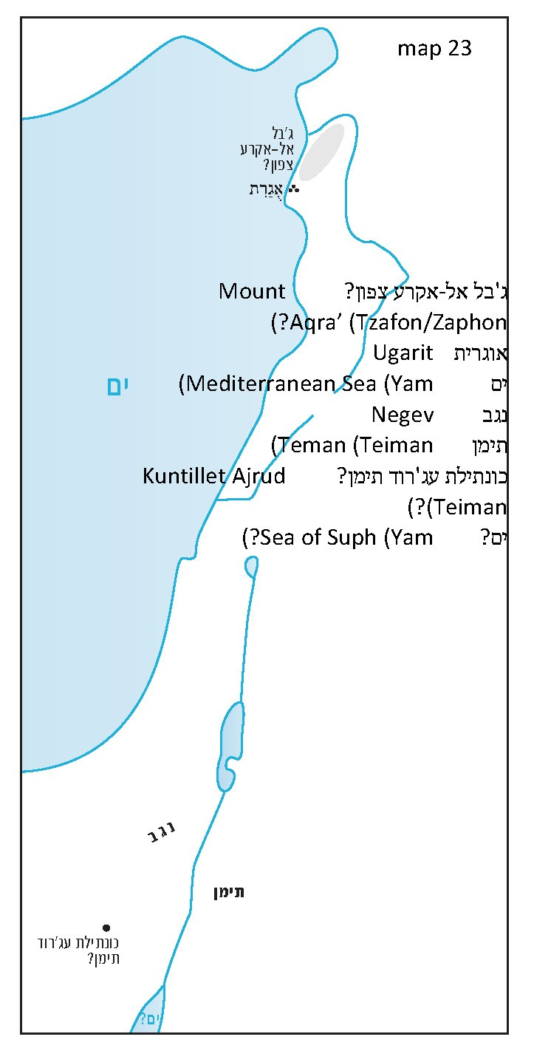

In Arabic, however, the root uses the velar consonant ghayn, as in gharb and maghreb. Apparently this is a case in which similar phonemes are switched, like the pairs Ṣ-Ḥ-Q/Ś-Ḥ-Q, Z-^{c}-Q/Ṣ-^{c}-Q and Š-M-Š/Š-P-Š.
And occasionally panim, as in “and he encamped east of [al penei] the city”; and “from Havilah, by Shur, which is east of [al penei] Egypt.” Of course, the word penei is used in Tanakh in other senses as well.
The Mediterranean Sea is called ha-yam ha-acharon, which the Targumim translate as yama ma’arva’a/ma’arvaya.
The word negev literally means “dry” in Hebrew.
Some claim instead that yam here is a shortened form of yamin.
Several Biblical verses can potentially corroborate this speculation.
There is, of course, no connection between the nation of Yemen in the southern Arabian Peninsula, called Teiman in Modern Hebrew, and either of the ancient locations known as Teman. Jews began to use the word Teiman to refer to Yemen in the Medieval period, when they would frequently (and imaginatively) use names culled from Tanakh to refer to their places of residence in the Diaspora. These included Ashkenaz, Sepharad, Togarmah, the land of Hagar and even the land of Canaan, each of which bore some similarity in linguistic form or in content to the lands in which they lived.
The southern border of modern-day Turkey runs this mountain’s southern slopes.
Haparchi identified this mountain with the northern Mount Hor, the northwestern point in the description of the boundaries of the land of Canaan in Numbers 34. However, Chazal identified Mount Hor with Turei Amanon/Tauros Amanos, the next ridge to the north, which is even higher and more impressive than Mount Aqra’ (see our discussion on Parashat Mishpatim).
Compare to Tzefat (Safed), a name derived from the same root, but with a feminine ending.
Thus reads the New International Version; others translate similarly.
R. David Zvi Hoffman challenged those who believe that the law of slaughtering sacrifices in the north is based on the notion of a deity that resides in the northern part of the world, asking why, if so, the Holy of Holies was not situated in the northern part of the Sanctuary.

