YESHIVAT HAR ETZION
ISRAEL KOSCHITZKY VIRTUAL BEIT MIDRASH (VBM)
*********************************************************

GEOGRAPHY IN THE PARASHA

********************************************************
This week’s shiurim are dedicated in memory of
Lillian Grossman z”l – Devorah Leah bas Shlomo Halevi
by Larry and Maureen Eisenberg
*********************************************************************
*********************************************************************
Dedicated le-zekher nishmot Amelia Ray and Morris Ray
on the occasion of their eighth yahrtzeits
by their children Patti Ray and Allen Ray
**********************************************************************

PARASHAT VAYAKHEL-PEKUDEI

Where is the Ark of the Covenant?
By Prof. Yoel Elitzur

The crowning glory of the Mishkan and its vessels, the focal point that exemplifies more than anything else the presence of the Shekhina within Israel, is the Ark of the Covenant, also known as the Ark of the Testimony. Located in the Holy of Holies, the Ark was plated with gold inside and out and contained both the tablets upon which the Ten Commandments were inscribed and a Torah scroll (Deuteronomy 31:26). The word of God emanated from atop the Ark, where the golden cover and cherubim were situated, as the Torah states: “There I will meet with you, and I will impart to you – from above the cover, from between the two cherubim” (Exodus 25:22). The High Priest would burn the incense between the two poles once a year (Yoma 5a). Chazal regarded the Ark and the cherubim as the pinnacle of the intimate connection between God and Israel. The Talmud describes the poles of the Ark:

They pressed forth and protruded as the two breasts of a woman, as it is said: “My beloved to me is a bag of myrrh lodged between my breasts” (Song of Songs 1:13). Rav Kattina said: “Whenever Israel came up to the Festival, the curtain would be removed for them and the cherubim were shown to them, whose bodies were intertwisted with one another, and they would be thus addressed: ‘Look! You are beloved before God as the love between a man and a woman.’” (Yoma 54a)

What happened to the Ark of the Covenant? Does it still exist?

The Ark of the Covenant Today?

The Christian residents of Ethiopia are certain that the Ark does exist there today, inside a church in the holy city of Axum in northern Ethiopia. A guardian monk is charged with the care of the Ark, and even he only enters the chamber that houses the Ark on rare occasions. According to an Abyssinian legend, the Ark was brought to Axum by Menelik, the son of King Solomon and the queen of Sheba. Solomon prepared an exact replica of the Ark for Menelik, but at the last second the original was switched with the replica. Menelik took the original Ark with him and Solomon was left with the replica… Replicas of the Ark are a central motif in Abyssinian Christianity; they are known as tabot and are found in churches throughout Ethiopia. Every year, on January 19, members of the Ethiopian Orthodox Church conduct large processions surrounding tabot arks. The arks are concealed from view, so that those who are “unfit” do not gaze upon it. These processions open the ceremonies of the festival of Timqat, which lasts three days. The ark in Axum is brought out as well, in a closely guarded procession; it is wrapped in cloths on all sides.

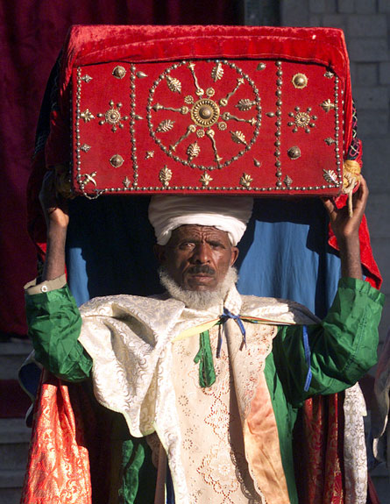
An Ethiopian priest with a tabot – a replica of the Ark of the Covenant (AP)

From a critical perspective, it may be speculated that this tradition of the “true” Ark of the Covenant originated with the custom of creating symbolic replicas of the Ark and distributing them during the public religious celebrations. It is only natural that in the most ancient and central church in the land, greater effort was invested into creating and preserving an accurate replica of the Ark. Over time, people likely became so convinced of this replica’s authenticity that they began to attribute it to Bezalel son of Uri and King Solomon. Note that even in the Menelik legend itself, there is uncertainty as to which ark is the original and which is the replica.

One of the most famous films of the twentieth century was dedicated to the riddle of the current location of the Ark of the Covenant. The film was Steven Spielberg’s Raiders of the Lost Ark, which became an international sensation in 1981. In this suspense-filled action film, the brave and adventurous Indiana Jones saves the beautiful daughter of his mentor from the clutches of the Nazis, who were pursuing her because she possessed the means of unlocking the Ark of the Covenant. By the end of a plot that takes its characters around the globe, traversing exotic locales and exciting landscapes, all the while battling the Nazis and their agents, the forces of good finally triumph over the forces of evil. The Nazis are prevented from obtaining the Ark and using it for their nefarious aims. The film ends with a brilliant comic twist: The American victors transport the Ark, covered in a military tarpaulin, to an enormous army warehouse, where a busy worker attaches a tag to the Ark and places it in an infinite pile of similar-looking crates. There, the Ark is seemingly lost once again – forever.

Second Temple Period

Legends attempting to solve the mystery of the fate of the Ark of the Covenant existed during ancient times as well. II Maccabees 2 cites an even earlier book, which relates that shortly before the destruction of the Temple, Jeremiah was commanded to take the Tent of Meeting, the Ark of the Covenant and the Incense Altar, and hide them in a cave in Mount Nebo. Jeremiah rebuked the people who wanted to mark the path to this cave, informing them that the location must remain hidden until the day comes when the glory of God will reveal itself in a cloud, as it did for Moses and Solomon. This story also found its way into Josippon, a Hebrew rendering of selections from Josephus’ writings, with various additions from the early Medieval period. In the version of the legend found in Josippon, the ending is slightly different:

The priests in those days chased after Jeremiah in order to find the location [of the Ark]. Jeremiah looked to his rear and saw the priests, and he became enraged and he swore, saying: “This place will not become known until I and Elijah, the servant of God, return. Then, we will restore the Ark to its place in the Holy of Holies, under the wings of the cherubim.”

In II Baruch 6, another pseudopigraphical work, a different story appears. Here, the story is attributed to Baruch son of Neriah, who speaks in the first person:

And it came to pass on the morrow that the army of the Chaldeans surrounded the city… Suddenly a strong wind raised me, and bore me aloft over the wall of Jerusalem. And I beheld four angels standing at the four corners of the city, each of them holding a torch of fire in his hands. And another angel began to descend from heaven and said to them: “Hold your lamps, and do not light them until I tell you. For I am first sent to speak a word to the earth, and to place in it what the Lord the Most High has commanded me.” And I saw him descend into the Holy of Holies, and take from there the curtain, and holy ephod, and the cover, and the two tables, and the holy raiment of the priests, and the altar of incense and the forty-eight precious stones, which adorned the High Priest and all the holy vessels of the Mishkan.

And he spoke to the earth with a loud voice: “Earth, earth, earth, hear the word of the mighty God, and receive what I deposit to you, and guard them until the end times, so that, when you are ordered, you may restore them, so that strangers may not get possession of them….” And the earth opened its mouth and swallowed them up.

A Tannaitic Dispute

Three different positions regarding the fate of the Ark can be found in rabbinic sources, one of which is based on an aggada as well. Thus we read in Shekalim 6:

There were in the temple… thirteen prostrations. [Members] of the household of Rabban Gamaliel and of Rabbi Hananiah the chief of the priests used to prostrate themselves fourteen [times]. And where was the additional [prostration]? In front of the store of wood, for they had a tradition from their forefathers that the Ark was hidden there.

It once happened that a certain priest who was busy [there] noticed that the pavement was different [there] from the others. He went and told his fellow, but before he had time to finish his words his soul departed. Then it became known with certainty that the Ark was hidden there.

Despite this aggada, the other sages – including the first opinion in the same mishna, which enumerates only thirteen prostrations – either did not believe the veracity of the story, or did not take it into account in their ruling. Perhaps they believed that the priest in the story simply died of a sudden heart attack, unconnected to the problem of the Ark’s location. If so, according to them, what was the eventual fate of the Ark?

The Talmud states: “Rabbi Eliezer said, ‘The Ark went into exile to Babylonia….’ Rabbi Judah son of Lakish said, ‘The Ark was hidden in its own place’” (Yoma 53b; Tosefta Shekalim 2; Baraita De-melekhet Ha-Mishkan 7). Rabbi Judah son of Lakish only appears rarely in the Talmud, and as a result, in some parallel versions his name was erroneously rendered as Rabbi Judah son of Ilai or Rabbi Simeon son of Lakish. According to one baraita in the Talmud Bavli, Rabbi Simeon son of Yohai maintained that the Ark was “hidden in its own place” as well, but according to a different baraita in the Bavli and according to the Tosefta, Rabbi Simeon actually supported Rabbi Eliezer’s position. It is interesting to note that the Tosefta opted to omit entirely the opinion that the Ark was hidden in the store of wood, despite the fact that the whole discussion of the fate of the Ark came about as a result of the dispute over the thirteen prostrations. The Bavli cites the Tannaitic dispute in connection to the passage in the mishna, “After the Ark had been taken away…,” pointing out that “the mishna does not teach ‘after the Ark had been hidden away,’ but ‘after the Ark had been taken away’ – this is in accord with him who holds that the Ark went into exile to Babylonia.”

All agree that during the Second Temple period there was no Ark: “In five things the First Temple differed from the Second: in the Ark, the cover, the cherubim, the fire, the Shekhina, the Holy Spirit and the Urim Ve-Tummim (Yoma 21b and parallels). In contrast to the other vessels in the Temple, the Ark could not be constructed anew, since the most important part of the Ark is the tablets that it is meant to contain. “And even though Solomon made a pattern for all the vessels, he did not make a pattern for the Ark” (Baraita De-melekhet Ha-Mishkan 7). The question is when and how the Ark disappeared. Those who maintain that the Ark was exiled to Babylonia are supported by the words of Isaiah: “nothing will remain behind” (II Kings 20:17; Isaiah 39:6) and by the description of the exile of Jehoiachin: “At the turn of the year, King Nebuchadnezzar sent to have him brought to Babylon with the precious vessels of the House of the Lord” (II Chronicles 36:10). Those who maintain that the Ark was hidden in its own place rely on the description of the Ark in Solomon’s Temple in the book of Kings: “The priests brought the Ark of the Lord’s Covenant to its place… the cherubim shielded the Ark… the poles were long… and there they remain to this day” (I Kings 8:6-8). According to this approach, the phrase “to this day” should be interpreted to mean until the time at which the book of Kings was written and redacted following the destruction of the Temple. Those who follow Rabbi Eliezer’s position must respond that “to this day” was written as a description of Solomon’s Temple during an earlier period, and the line was simply copied verbatim into the book of Kings. According to a different baraita (Tosefta Sota 13:1; Bavli Yoma 52b; Yerushalmi Shekalim 6:2; and parallels), Josiah hid the Ark. (The baraita does not explicate whether he hid the Ark in the store of wood or in some other place.) The baraita cites a unique verse in support of this theory – part of the description of Josiah’s preparations for Passover in Jerusalem: “He said to the Levites, consecrated to the Lord, who taught all Israel, ‘Put the Holy Ark in the House that Solomon son of David, king of Israel, built; as you no longer carry it on your shoulders’” (II Chronicles 35:3). The baraita explains: “What was his reason for hiding it? He saw the passage, ‘The Lord will drive you, and the king you have set over you’ (Deuteronomy 28:36) – therefore he hid it.” The verse in Chronicles is difficult to understand. According to the commentary attributed to Rashi, Manasseh and Amon, in their wickedness, removed the Ark and put their idols in its place. As a result, Josiah ordered that the Ark be returned to its place. However, Radak (who cited this explanation) took issue with it: Why did Josiah wait? Why did he not return the Ark to its place immediately, just as he removed the idol from the House of the Lord? The words “you no longer carry it on your shoulders” have generally not been interpreted satisfactorily by both the classical and modern commentators. The baraita explains that Josiah is commanding the Levites to hide the Ark in the place that had been designated for this purpose from the time of Solomon, interpreting the words “you no longer carry it on your shoulders” to mean, “He said to them, ‘If it is exiled with you to Babylonia, you will no longer return it to its place.’”

Both Rishonim and Acharonim marshaled textual support for Chazal’s interpretation. Rosh, in his Tosafot, noted the unique emphasis in the words, “the House that Solomon son of David, king of Israel, built,” explaining that this hints at a special construction commissioned by Solomon for the purpose of hiding the Ark. Tosefot Rosh goes on to explain that the words “the Levites, consecrated to the Lord, who taught all Israel” indicate that certain exceptionally pious priests and Levites were charged with preserving the knowledge of the Ark’s secret location, transmitting this secret from generation to generation. Maharsha inferred from Josiah’s choice of the words “put the Holy Ark,” rather than “return the Holy Ark,” that the command was to move the Ark to a new location, a place where it had not been previously. Chida speculated that even those who maintain that the Ark was exiled to Babylonia agree that the verse in Chronicles indicates that the Ark was hidden during the time of Josiah, only to later be discovered by Israel’s enemies (as a result of the people’s sins) and fall into their hands.

Modern Scholarship

Like the early exegetes, today’s scholars are similarly divided over the question of the Ark of the Covenant’s fate. Some maintain that the Ark was looted and exiled to Babylonia. In addition to the verses that Chazal cited in support of this position, modern scholars cited the verse, “He did not remember His Footstool on His day of wrath” (Lamentations 2:1). This, however, is not a particularly strong proof that the Ark was exiled, as “His Footstool” could be a reference to the Temple as a whole, or even to the city of Jerusalem. Menahem Haran claimed, in support of the second approach, that such a valuable and symbolic object would certainly have been mentioned explicitly in the list of the spoils of Nebuzaradan (II Kings 25; Jeremiah 52) if it had been taken to Babylonia. Yehuda Kiel was another scholar who maintained that the Ark was hidden. He suggested an original explanation for the verses in Chronicles, in particular regarding “the Levites, consecrated to the Lord, who taught all Israel.” According to Kiel, during the time of Manasseh the Ark was situated in the Holy of Holies alongside a statue of Asherah that Manasseh had erected (II Kings 21:7). A group of bold god-fearing Levites entered the Holy of Holies surreptitiously in the middle of the night, smuggled away the Ark and hid it in a secret location known only to them and their close friends. The verse in Chronicles relates that Josiah instructed these Levites to move the Ark from where they had concealed it to a different secret location that had been set aside for this purpose from the time of Solomon.

My father, z”l, lectured on this topic at the 12th World Congress of Jewish Studies in 1997 (a few months before he passed away), and the lecture was later published in the Congress’s proceedings and in a collection of his articles. He focused on a prophecy that appears toward the beginning of the book of Jeremiah that is difficult to understand:

And when you increase and are fertile in the land, in those days – declares the Lord – men shall no longer speak of the Ark of the Covenant of the Lord, nor shall it come to mind. They shall not mention it, or miss it, or make another. (Jeremiah 3:16)

This is a prophecy of consolation, describing the ideal state of things that will be in the future. But why should the people forget the Ark of the Covenant of the Lord? Why does Jeremiah stress this so emphatically – “Men shall no longer speak… nor shall it come to mind. They shall not mention it, or miss it, or make another”?

Some commentators focused on the connection between this prophecy and Jeremiah’s rebuke in chapter 7:

Don’t put your trust in illusions and say, “The Temple of the Lord, the Temple of the Lord, the Temple of the Lord are these [buildings]”… therefore I will do to the House which bears My name… just what I did to Shiloh. (7:4, 14)

In other words, Jeremiah is denouncing the approach that held that the Temple was indestructible due to its holiness – that God would not allow it to be destroyed.

According to my father, z”l, Jeremiah’s prophecy in chapter 3 contains much more than this. If we read between the lines of the prophecy, we can discern the deep, real-life conflict that existed in the nation at the time regarding the Ark. Some believed that the Temple was no longer a secure place. Since the Temple would likely fall into enemy hands, as they claimed, the prudent course of action would be to preemptively conceal the nation’s prized possession – the Ark of the Covenant – in a secret and secure location. In contrast, others believed that the Temple, and in particular the Ark, were so supremely holy that they could never be harmed. Jeremiah stresses that the Sanctuary itself is not protected simply because God’s name is invoked in connection with it. Rather, its continued existence within the nation depends on the actions of the people, and considering the actions of the people at the time, this did not bode well for the Temple.

Josephus records a surprising tradition: When Hasmonean leader John Hyrcanus found himself in financial distress, he took out three thousand silver talents from the treasures of King David’s sepulcher (Antiquities 13:249). It is clear that the treasures preserved in King David’s sepulcher would not have survived Nebuzaradan’s plundering at the time of the Temple’s destruction had they not been concealed in a hiding place whose location was known to only a select few. My father points out that King Manasseh of Judah changed the official burial site of the royal house, and as a result, he, his son and apparently his grandson Josiah as well were all buried in this new site: the garden of Uzza. Paradoxically, and in contrast to other kings who were more righteous than he was, Manasseh was the only king who followed the diplomatic policies advocated by the prophets. The prophets consistently preached fealty to the dominant superpower, encouraging kings to avoid misguided pacts and adventurous foreign policy. By following the advice of the prophets in this regard, Manasseh merited fifty-five years of continuous reign. My father estimates that Manasseh began a systematic operation to hide the royal treasures, among them the Ark. These actions, my father claims, garnered blessing from Jeremiah, and Josiah continued in his grandfather’s path in this regard as well. My father cites two important archaeological findings that, according to his interpretation, reflect a policy of hiding holy sites and artifacts during the time of Josiah: the tumuli west of Jerusalem and the Israelite temple and altars in Arad. According to this approach, the verse in Chronicles refers to a temporary removal of the Ark from its hiding place by the faithful priests and Levites who were charged with preserving the secret location of the royal treasures, and its placement in the Holy of Holies for the great Passover observance in Jerusalem. All the while, however, the intent was to return the Ark to its hiding place at the conclusion of the festival.

Rambam’s Position

I will conclude this discussion with a surprising ruling found in Rambam’s Mishneh Torah:

When Solomon built the Temple, he was aware that it would ultimately be destroyed. [Therefore,] he constructed a chamber, in which the Ark could be entombed below [the Holy of Holies] in deep, maze-like vaults. King Josiah commanded that [the Ark] be entombed in the chamber built by Solomon, as it is said: “He said to the Levites, consecrated to the Lord, who taught all Israel, ‘Put the Holy Ark in the House that Solomon son of David, king of Israel, built…’” (II Chronicles 35:3). (Hilkhot Beit Ha-bechira 4:1)

This is unusual, as Rambam generally does not rule on historical questions in Mishneh Torah, including the interpretation of texts and even halakhic questions that were only relevant in the past (such as the permissibility of the bamot), unless there is some practical halakhic implication for the present or the future, or if the question touches on a fundamental foundation of faith. In light of this, why did Rambam choose to rule with such certainty in our case, weighing in on what amounts to a Tannaitic historical dispute?

It is likely that the reason behind this ruling can be found in the Talmud Yerushalmi:

Rabbi Yassa said in the name of Rabbi Yohanan: “This is the rule – whenever the Ark is within [the Sanctuary], the bamot are forbidden; when it has left [the Sanctuary], the bamot are permitted.” Rabbi Ze’ira asked Rabbi Yassa: “Even [when the Ark has left the Sanctuary] temporarily, as in the case of Eli?” (Yerushalmi Megilla 1:12)

In the style of the Yerushalmi, Rabbi Ze’ira’s question that was seemingly left unanswered serves as its own conclusion: Indeed, even when the Ark leaves the Sanctuary temporarily, the bamot become permitted. Rabbi Meir Simcha of Dvinsk, in his Meshekh Chokhma commentary on Parashat Re’eh, expanded on this notion, using it to explain the apparent violation of the prohibition on bamot during the Shiloh period. According to him, during the time of the Mishkan in Shiloh, the Ark would be removed regularly from its place to be present at national gatherings elsewhere, and sometimes it would even remain in those other locations for extended periods of time. During those periods when the Ark was absent from the Mishkan in Shiloh, claims the Meshekh Chokhma, the bamot were permitted.

Now we can return to Rambam’s unusual ruling. In a different, well-known statement that is accepted as the normative halakha, Rambam rules that the “first consecration” performed by Solomon in Jerusalem applied “for that time and for eternity” (Hilkhot Beit Ha-bechira 6:14). This ruling has several halakhic implications, both positive – we can offer sacrifices on the Temple site even without the Temple itself; we can eat the “most holy” sacrifices even without the “hangings” of the Courtyard; we can eat sacrifices of lesser sanctity and ma’aser sheni even without the wall surrounding Jerusalem (Mishna Eduyot 8:6; Hilkhot Beit Ha-bechira 6:15) – and negative – the impure may not enter the area of the Courtyard; and bamot are prohibited outside of Jerusalem. In order to reconcile this ruling with the statement of the Yerushalmi, Rambam was forced to rule in accordance with Rabbi Judah son of Lakish – the Ark was hidden in its own place! If so, according to Rambam the Ark is still in its original location, waiting for us in the depths of the Holy of Holies, beneath the Foundation Stone in Jerusalem.

The Ark of the Covenant – illustration from circa 1900

For further study:

Chida, Sha’ar Yosef on Horayot 104b [Hebrew]. (http://www.hebrewbooks.org/pdfpager.aspx?req=19259&st=&pgnum=223&hilite=)

Yehudah Elitzur, “Pulmus Aron Ha-berit Bi-yemei Yoshiyahu,” Israel and the Bible, Ramat-Gan 2000, 230-234 [Hebrew].

D. Flusser, The Josippon, 1, Jerusalem 1981, 45 [Hebrew].

M. Haran, “The Removal of the Ark of Covenant,” Bulletin of the Israel Exploration Society 25, Jerusalem 1961, 211-223 [Hebrew].

Y. Kiel, Sefer Divrei Ha-yamim II, Da’at Mikra, 917-918 [Hebrew].

Wikipedia entries: “Ark of the Covenant,” “Axum,” “Indiana Jones,” “Raiders of the Lost Ark”.

Translated by Daniel Landman
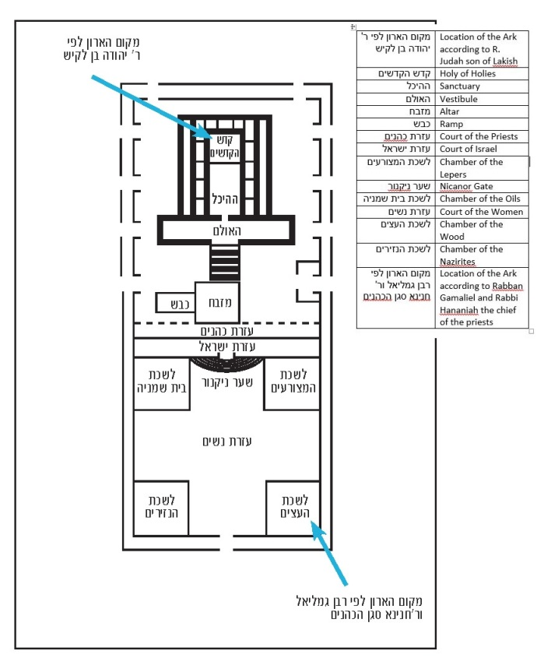

Compare to the Hebrew teva; the Aramaic tēvōta found in Targum Onkelos, the Palestinian Targumim and the Samaritan Targum; and the Arabic tābūt.
This book was most likely written originally in Hebrew; it was preserved in Greek.
This number apparently included the clappers within the bells on the robe of the ephod.
This was located in the northeast section of the court of the women (Midot 2:5).
A different version reads “He struck it with a hammer, and a fire came out and burned him” (Yerushalmi Shekalim 6; cf. Yoma 54a).
Rashi explains that the Ark, the cover and the cherubim were all considered one “thing.”
The Talmud (Yoma 54a) rejects Ulla’s position that “‘until this day’ means everywhere ‘forever,’” but cannot reject the words of the baraita that cited this verse.
This interpretation does not fit Chazal’s attitude mentioned above that this verse refers to hiding the ark.
It should be noted, however, that the golden vessels taken to Babylonia were mentioned in the account of the exile of Jehoiachin without naming each vessel individually, whereas Nebuzaradan’s list from the exile of Zedekiah primarily included copper vessels.
It should not come as a surprise that Manasseh, who famously worshiped many gods, would show respect to the Ark and the God of Israel, as polytheists generally do not object to worshiping an additional god.
Incidentally, Rabbi Yohanan who authored the above statement in the Yerushalmi ruled explicitly in the Bavli that the prohibition on bamot applies even today, because the first consecration applies for eternity (Zevachim 107b).

