YESHIVAT HAR ETZION
ISRAEL KOSCHITZKY VIRTUAL BEIT MIDRASH (VBM)
*********************************************************

GEOGRAPHY IN THE PARASHA

PARASHAT KI TISA

The Nations of Canaan and the Girgashites
By Prof. Yoel Elitzur

While this series is entitled “Geography in the Parasha,” this week’s discussion will focus on a group of people that is glaringly absent from Parashat Ki Tisa. On two occasions in the parasha, God promises the people of Israel that He will expel the Canaanite inhabitants of the land from before them:

I will send an angel before you, and I will drive out the Canaanites, the Amorites, the Hittites, the Perizzites, the Hivites and the Jebusites. (Exodus 33:2)

I will drive out before you the Amorites, the Canaanites, the Hittites, the Perizzites, the Hivites and the Jebusites. (34:11)

Perceptive readers will note immediately that each of these two lists includes only six nations. One of the nations of Canaan is missing: the Girgashites! While it may be that the Torah hints at the Girgashites in the text – “I will drive out (ve-gerashti)”; “I will drive out (hineni goresh)” – nevertheless it is curious that only six nations are listed outright.

The Girgashites and the Lists of the Nations of Canaan

The nations of Canaan are enumerated in Tanakh twenty-three times, mostly in the Torah and in Joshua. Only three of these lists actually include all seven nations – twice in Joshua (3:10 and 24:11) and only once in the Torah:

When the Lord your God brings you to the land that you are about to enter and possess, and He dislodges many nations before you – the Hittites, Girgashites, Amorites, Canaanites, Perizzites, Hivites and Jebusites, seven nations much larger than you… (Deuteronomy 7:1)

It is no accident that the Torah punctuates this list of nations with the words, “seven nations much larger than you,” as this is the only time in the Chumash that all seven nations are listed. The list of nations appears seven times in Exodus, all of which omit the Girgashites (in one list, the Perizzites are omitted as well, and in another only three nations are listed). The list appears another six times in Joshua and the beginning of Judges, and again, the Girgashites are missing from four of these lists!

In Genesis, it is a different story. There, the nations of Canaan are enumerated twice. The first time is in chapter 10, in the “Table of Nations,” which lists the names of the seventy nations of the world descended from Shem, Ham and Japheth. The second time is in chapter 15, in the Covenant of the Pieces, when God promises the land of Canaan to Abram. In both instances, more than seven nations are listed. In the Table of Nations, twelve names are enumerated among the “clans of the Canaanites.” Six of these are northern names that do not recur in the later lists of the nations of Canaan, and the remaining six are familiar to us from the other lists of Canaanite nations – Canaan, Heth, Jebusites, Amorites, Girgashites, Hivites. Here the missing nation is the Perizzites. In the Covenant of the Pieces, ten nations are enumerated: four that are unique to that parasha (the Kenites, Kenizzites, Kadmonites and Rephaim) and six that are familiar to us from the other lists – the Hittites, Perizzites, Amorites, Canaanites, Girgashites and Jebusites. This time it is the Hivites who are left out.

Thus we can summarize by saying that in the earliest periods, the Girgashites existed and even wielded greater power than the Hivites and Perizzites. However, from the time of Moses and on we barely hear of the Girgashites; they only appear three times, in celebratory lists that intentionally include all seven nations.

What do we know from Tanakh about the Girgashites? The answer is: virtually nothing. The Girgashites are not mentioned in any place in connection to a city or any particular place in the land. In the two verses that detail the regions throughout the land where each Canaanite nation resided (Numbers 13:29 and Joshua 11:3), the Girgashites are not mentioned. Josephus mentions the Girgashites once in his writings (Antiquities 1.139, on Genesis 10:15-18), noting regarding them and several other Canaanite nations that all we know about them from Scripture is their names.

What Happened to the Girgashites?

Chazal cite a surprising tradition that provides a historical-geographical solution to the omission of the Girgashites from most of the lists:

This is in line with what R. Samuel bar Nahman said, “Joshua sent three proclamations to [the Canaanites in] the land of Israel prior to the [Israelites’] entry into the land: ‘Whoever wishes to emigrate should emigrate; [whoever wishes] to make peace should make peace; [and whoever wishes] to wage war should do so.’ The Girgashites emigrated, for they believed the Holy One, Blessed Be He, and they went to Afrike. [This is in line with II Kings 18:32:] ‘To a land like your own’ – this refers to Afrike. The Gibeonites made peace. [This is in line with Joshua 10:1:] ‘The people of Gibeon had come to terms with Israel.’ Thirty-one kings waged war and fell [in battle].” (Yerushalmi Shevi’it 6:1)

At the time, “Afrike” referred to what is known today as North Africa, in particular the Tunis region. Chazal claimed that Afrike was a land like our own. To be sure, it does not possess the same spiritual character as our land, but perhaps the two lands share some physical characteristics, like climate and economic opportunities. From this minimalistic approach, at least, it is a land like our own.

Over the course of many generations, North Africa was home to nations of Canaanite origin who left numerous inscriptions written in the Phoenician language and alphabet. There were Canaanite towns scattered all along the coast of the Mediterranean Sea throughout the entire first millennium BCE and apparently even earlier. From the Israelites’ perspective, apparently when King Solomon forged a treaty with King Hiram of Tyre, this treaty included in practice economic control over these Canaanite coastal towns. The capital of these towns was Carthage (today a suburb of Tunis), known to the Phoenicians as Qart-ḥadašt, to the Greeks as Karkhēdōn and to the Romans as Carthago. The Carthaginians were culturally connected to Tyre, which was known as Qart, meaning “city.” According to a Greek myth of Carthaginian origin, Karkhēdōn was founded by Queen Dido of Tyre. Incidentally, it seems that the Zarephath mentioned in Obadiah – “And that exiled force of Israelites [shall possess] what belongs to the Phoenicians as far as Zarephath” (1:20) – is not the more well-known “Zarephath of Sidon” (I Kings 17:9), which, being part of the territory of the tribe of Asher, would not truly qualify as an “exile.” Rather, it is a city on a distant Mediterranean coast that was named for the city in the land of Israel. In the fifth century BCE (early Second Temple period), Carthage became the most important naval superpower in the Mediterranean Sea, and in the third-second centuries BCE it fought three great wars against Rome (the “Punic Wars”). In the Second Punic War, Rome was almost defeated by the Carthaginian military commander Hannibal (a Canaanite name par excellence!) and in 146 BCE Carthage was destroyed. About two hundred years later, Carthage was rebuilt as a Roman city.

The historical connection between North Africa and the land of Canaan is also expressed in another tradition cited by Chazal. According to this tradition, in the time of Alexander the Great, the people of Afrike brought a claim against Israel, arguing that the land of Canaan belonged to them. Gebiha son of Pesisa then argued against them and defeated the people of Afrike in the debate. We may conclude that according to R. Samuel bar Nahman in the Yerushalmi, whose claim may be supported by additional midrashic sources as well, the Canaanite people of Afrike are descended from the Girgashites.

A remarkable incarnation of this rabbinic tradition can be found in the Greek work History of the Wars, by Procopius of Caesarea, a Byzantine writer who was a member of the court of Justinian I in the sixth century CE. In this work, Procopius mentions the Moors, early Semitic residents of North Africa, and relates that they are descended from the Girgashites, the Jebusites and “some others with other names by which they are called in the history of the Hebrews” (book IV, chapter 10). These nations fled from Joshua, were not able to settle in overcrowded Egypt, and so continued onward to Libya.

And they established numerous cities and took possession of the whole of Libya as far as the Pillars of Heracles [the Strait of Gibraltar], and there they have lived even up to my time, using the Phoenician tongue. They also built a fortress in Numidia [the Atlas Mountains region], where now is the city call Tigisis. In that place are two columns made of white stone near by a great spring, having Phoenician letters cut in them which say in the Phoenician tongue: “We are they who fled from before the face of Joshua, the robber, the son of Nun!”

The veracity of this account assumes that Procopius, who did not know Phoenician and could not read the Phoenician alphabet, was still able to relate the fantastical content of a unique inscription written in this language. But now let us return to our own sages.

Rashi accepted the core of R. Samuel bar Nahman’s claim, citing it twice in brief: “They were six nations [listed here], and [this is because] the Girgashites rose and emigrated because of them [the Israelites] of their own accord” (commentary on Exodus 33:2). In contrast, Ibn Ezra and Ramban (in their commentaries on 3:8) apparently maintained that this is simply a homiletical interpretation that does not properly reflect the real history and the simple understanding of the text. Therefore, they suggested alternate solutions. Ibn Ezra states: “And [the Torah] did not mention the Girgashites because it was the smallest of the seven [nations]… and the text included them in the word ‘Canaanites.’” Ramban speculates: “Perhaps the [Girgashites’] land was not flowing with milk and honey [like the lands of the other nations].”

A nation with a name similar to Girgashi is found in an extrabiblical source from the Biblical period. This Egyptian source recounts the war between Ramesses II (thirteenth century BCE) and the Hittites, who had joined forces with a tribe or nation whose name was written in Egyptian as ḳrḳš3. Other sources feature first names that are similar to Girgashi. Interestingly, aside from examples in Ugaritic texts (Girgas and ben Girgash), it is noteworthy that the greatest concentration of names of this type is found in Phoenician-Carthaginian inscriptions from Qart-ḥadašt in Tunis – or in the language of Chazal, Afrike. The votive inscriptions for pagan temples in the city feature the names of donators to the temple, including Baalyaton ben Girgash, Girgash ben – – – and Matan ben Girgasham. In light of these findings, Prof. Nahum Slouschz permitted himself to speculate: “In the Talmud it is told that the Girgashites went to Africa… and perhaps the donator is of Girgashite descent.”

Nahum Slouschz (1872-1966) (Wikipedia)

Conclusion

The archaeological findings from Carthage serve to support the rabbinic tradition that commentators and scholars had written off as an imaginative homiletical interpretation. However, an examination of the information provided by Tanakh seems to indicate a slightly different version of this tradition; the Girgashites had already disappeared by the events of Exodus, and they were apparently no longer one of the nations residing in Canaan by the time the Israelites left Egypt. The departure of the Girgashites from Canaan at the behest of Joshua, then, is an aggadic formulation of the actual history. On the other hand, the three mentions of the Girgashites in Deuteronomy and Joshua seem to demonstrate that not all the Girgashites left the land. This is Ibn Ezra’s solution: The Girgashites were a smaller nation than the rest of the Canaanite nations, and thus were not listed independently aside from the celebratory lists that presented all seven nations. Instead, they were included within the general term “Canaanites.” It is worth noting that Ibn Ezra’s solution on its own does not fit the information that can be inferred from Genesis, where we see that the Girgashites were seemingly more important than the Hivites and the Perizzites. Nonetheless, in combination with the information that we have gleaned from analyzing the texts and connecting this with the archaeological findings, it seems that we should accept Ibn Ezra’s solution, but limit it to the period following the departure of most of the Girgashites from the land.

Thus, our conclusion integrates the tradition cited by R. Samuel bar Nahman with the interpretation of Ibn Ezra.

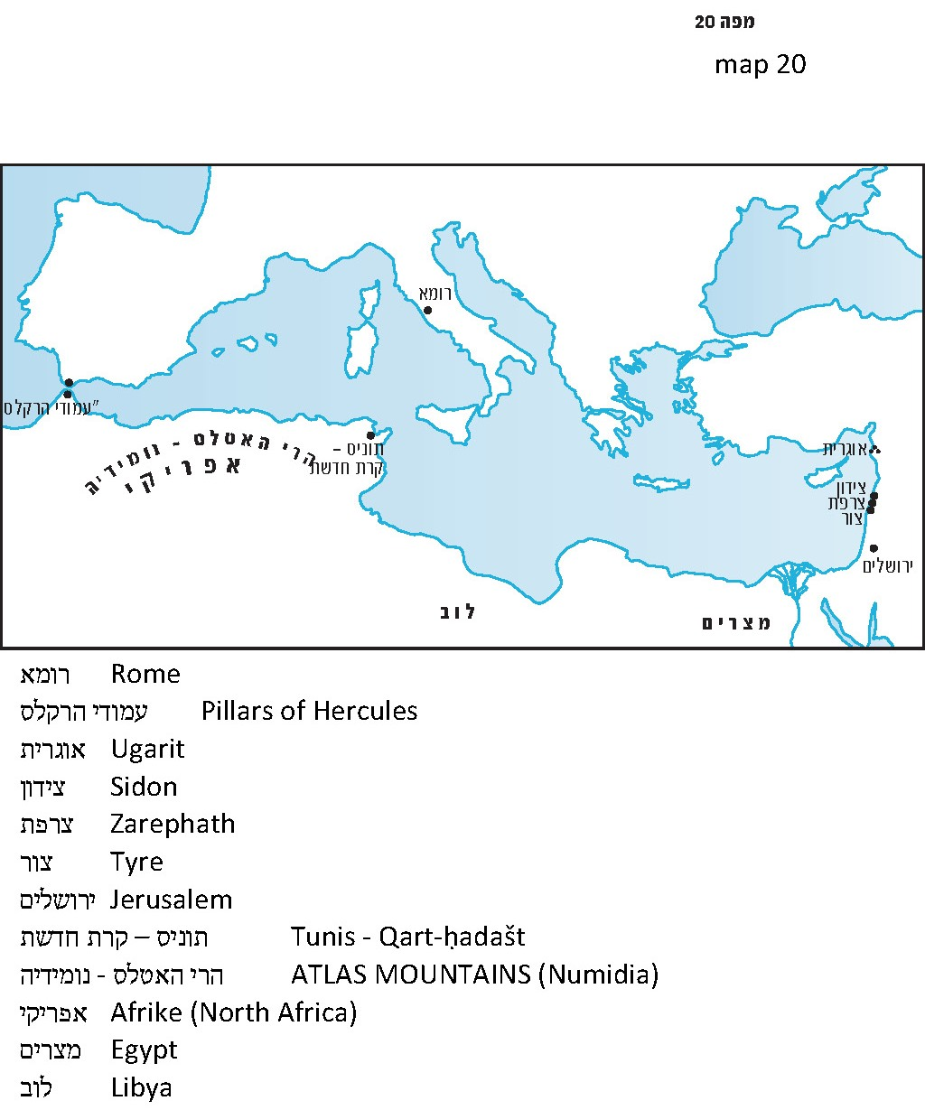

For further study:

Y. Aharoni, “Girgashi,” Encyclopaedia Biblica 2, 551 [Hebrew].

C. H. Gordon, Ugaritic Textbook, Rome 1998, 381.

J. Levy, Studies in Jewish Hellenism, Jerusalem 1969, 60 [Hebrew].

Procopius, trans. H. B. Dewing, II, London and Cambridge, Massachusetts, 1953, 286-289.

N. Slouschz, Thesaurus of Phoenician Inscriptions, Tel-Aviv 1942, 266, 273, 301 [Hebrew].

Translated by Daniel Landman

Some inaccurate versions of the Bible emended the text to “correct” perceived errors. Thus, the Samaritan Pentateuch added the Girgashites to each of the seven lists in Exodus, so that all of them include seven nations. In the Septuagint a similar emendation was implemented six times. In fragments of the Book of Exodus found in Qumran, four lists were found, two of which are identical with the Masoretic text, one contains all seven nations like the Samaritan Pentateuch and the Septuagint, and in one case the Girgashites replace the Amorites of our text.
Here again, the Samaritan version (but not the Septuagint) insists on adding the Hivites in order to ensure that the list contains seven nations.
Compare to “on the heights of the town (al gapei meromei karet)” (Proverbs 9:3), and to the Aramaic karta.
Hezi Katz, a resident of Yagur, pointed this out to me, and his suggestion appears to be accurate. See Radak and Ralbag on the verse in I Kings.
Megillat Ta’anit, 25th of Sivan, according to Scholion P; Sanhedrin 91a; Bereishit Rabba 61:7; compare to Tosefta Shabbat, end of chapter 7.
This same story about Canaanites who fled from Joshua appears, with minor changes, in excerpts from the work of Christian historian John of Antioch, as well as in the Suda, a Byzantine encyclopedia written circa 1000 CE.
Compare to Yohanan Aharoni’s claim that the source of this aggadic story is the linguistic similarity between ve-gerashti and goresh mi-panekha and Girgashi.
Ugarit was an ancient city and kingdom on the banks of the Mediterranean Sea in northern Syria. It was destroyed in the middle of the period of the Judges.
Compare to the migration of the Danites from Zorah and Eshtaol to Laish in the northern part of the land of Israel. Six hundred armed men, with their children and wives, moved to the north, but generations later we find that the Danites Manoah and Samson seem to have remained in Zorah and Eshtaol.

