YESHIVAT HAR ETZION
ISRAEL KOSCHITZKY VIRTUAL BEIT MIDRASH (VBM)
*********************************************************

LAWS OF SHABBAT: COOKING
By Rav Yosef Zvi Rimon

*********************************************************
Dedicated in memory of
Joseph Y. Nadler z”l, Yosef ben Yechezkel Tzvi
*********************************************************

Shiur #17 – Leaving Food on the Fire, Returning Food to the Fire
& Chapter XVIII: Replacement and Initial Placement

TYPES OF FOOD TO BE RETAINED ON THE FIRE

As we have seen in previous shiurim, on an uncovered fire, one may leave only a food that has reached ma’akhal ben Derusai or that has not been cooked at all, but one may not leave food that has started to cook but not reached the level of ma’akhal ben Derusai, as we are concerned about stoking the coals. Once the stove has been swept or sprinkled (garuf ve-katum), there is no concern of stoking, and retention is not a problem. Apparently, according to this, one may leave any food on a swept or sprinkled stove, even if this food has not reached ma’akhal ben Derusai. The same applies to a covered flame or a plata, which has the status of a stove that is ketuma.

However, even though shehiya may not apply, there is another potential problem. The Gemara (Shabbat 18b) mentions that one may not leave a pot of dye on a stove, because someone may stir the pot. Apparently, in light of the words of the Talmud, one should forbid shehiya of any uncooked food, lest a person stir it and violate the prohibition of cooking. For this issue, there is no benefit in the stove’s being swept or sprinkled, because we are talking not about the issue of turning up the fire, but rather about the issue of stirring the dish.

Most Rishonim

However, Tosafot (ad loc., s.v. Dilma) write that the issue of stirring relates to the melakha of dyeing. According to this, it may be that only concerning dyeing is there a decree lest one stir, since the dyers constantly stir the wool, but for a tavshil, the Sages do not decree lest one stir. Thus, in fact, most Rishonim — including the Ramban (36b, s.v. Gemara), Rashba (loc. cit., s.v. Ve-hai tavshil) and Ritva (37a, s.v. Ta shma) — rule that it is permissible to leave any dish on a swept stove, since there is no question of stoking the coals, and we do not worry that a person will stir the dish. This is how the Ran (17b, Rif, s.v. Ve-nimtzeu) rules:

Whenever a stove has been swept or sprinkled, we can leave upon it any food in the world, for there is no concern of stoking: even though it cooks of its own accord on Shabbat, it is permissible.

This is also indicated by the Shulchan Arukh (253:1): on a swept or sprinkled stove, one may put even a dish that has started cooking but has not yet reached the level of ma’akhal ben Derusai.

Rabbi Akiva Eger

On the other hand, Rabbi Akiva Eger (ad loc.) claims that a number of Rishonim (Remakh on Rambam, 9:3, cited by Kesef Mishneh ad loc.; Ramban and Rashba, 18b, in opposition to their words on 36b) apparently dispute this, and in their view, only if something has reached the level of ma’akhal ben Derusai is there no issue of stirring, because stirring is forbidden due to the acceleration of cooking (see what we wrote in the previous two shiurim). In their view, there is no prohibition of cooking something that has been cooked to the level of ma’akhal ben Derusai, but regarding food that has not reached this level, there is a concern of stirring. According to this, one should not leave food that has not reached the level of ma’akhal ben Derusai, even on a swept stove, because even if there is no issue of stoking, there is still an issue of stirring. In light of this, one may leave on a blech or plata only food that has reached the level of ma’akhal ben Derusai.

Halakha

Are Rabbi Akiva Eger’s suspicions accepted halakhically? Is one allowed to put on a blech or plata before Shabbat food that has not yet reached the level of ma’akhal ben Derusai?

Apparently, customs varied. In one somewhat peculiar incident, a couple almost divorced over this issue. A young couple came to Rav Joseph B. Soloveitchik in Boston and wanted to divorce because the woman had left cold water on a covered flame before the onset of Shabbat, following her mother’s custom, while the husband claimed that his own mother would always make sure the water had reached the boiling point before Shabbat. Rav Soloveitchik responded that there were varying customs (in Lithuania, they were lenient, following the Shulchan Arukh; in Galicia, they were stringent, following Rabbi Akiva Eger) but “This isn’t worth getting divorced over” (Mi-peninei Ha-Rav, p. 79).

The Mishna Berura does not mention Rabbi Eger’s view, but he is cited in Bei’ur Halakha (253:1, s.v. Ela); he writes that according to this view, “this law is unclear.” The Chazon Ish (37:22) mentions Rav Eger’s words. On the other hand, Shevitat Ha-Shabbat (Shehiya Ve-hatmana, Be’er Rechovot, 14) rules in accordance with the view of most Rishonim: if the stove has been swept, one may leave anything on it. Rav S.Z. Auerbach (Minchat Shelomo, Vol. II, ch. 12) writes:

In Shulchan Arukh, it is clear that if it is swept or sprinkled, we are not concerned about stirring, and this is the custom.

This is Rav Ovadya Yosef’s ruling in Yabbia Omer (Vol. VI, OC 32:1).

Blech or Plata, Practical Ruling

As a matter of practical halakha, we are talking about a case of rabbinical doubt, and even Rabbi Akiva Eger does not explicitly forbid this; he merely indicates that it is a matter of dispute. Since Rav Auerbach notes that the custom is to be lenient, we may follow this, unless the local custom prohibits it.

Consensus

We should note that all views allow leaving totally uncooked food on a swept or sprinkled stove, as the Gemara allows leaving such food even on an open flame, as we have seen. It appears that there is no concern of stirring such a dish, just as there is no concern of stoking coals, because one puts this out of his mind, as the food will not be ready for supper regardless.

Similarly, a dish that has reached the level of ma’akhal ben Derusai may be left on a swept or sprinkled stove, for halakhically we allow leaving such food even on an open flame. It appears that just as there is no concern of stoking, since in any case the dish is minimally edible and one is not eager to accelerate its cooking, we are similarly unconcerned that one will stir it. Moreover, according to many Rishonim, bishul does not apply to that which is minimally cooked, so stirring is not a problem (as we discussed in previous shiurim).

As we have already mentioned in the previous shiurim, there is no issue of shehiya for cooled liquids, and they may be left on an open flame, and all the more so on a swept or sprinkled stove; even though halakhically bishul still applies, people relate to these liquids as cooked, and one is not eager to accelerate their heating, so stirring and stoking are not issues with which to be concerned.

However, as we noted above, even though one may leave on the blech or plata foods that are not fully cooked, it is best to leave only cooked foods, since it is quite common for one of the household members to remove the lid, peek inside, and replace the lid, which involves accelerating the cooking and a question of biblical bishul.

Summary

To conclude, on a blech or plata one may, by the letter of the law, retain any and all foods. However, it is best to leave only cooked foods on the blech or plata, for two reasons:

- According to Rabbi Akiva Eger, when a food has not reached the level of ma’akhal ben Derusai, some are concerned about stirring.
- In many households, people may remove and replace the lid, violating bishul if the food has not yet been cooked.

However, since the letter of the law permits this, if one warns the members of the household not to remove and replace the lid (or sets some reminder), one may be lenient and leave on the blech or plata before Shabbat even a food that has started cooking but not reached ma’akhal ben Derusai (unless the familial or local custom is stringent). It is also permissible to leave on the blech or plata before Shabbat cold soup or another cooled liquid (that has been previously cooked), even if it will not become hot by the onset of Shabbat.

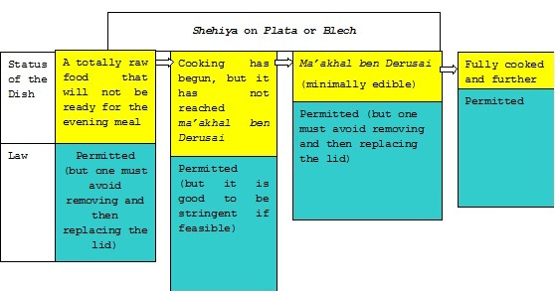

XVIII) Replacement and Initial Placement

How may one heat food on Shabbat itself?

Is one allowed to place food directly on the blech or plata or on an urn?

When may one return a dish taken off the blech or plata?

As we have already mentioned, the mishna (36b) forbids putting a dish on a coal-fueled stove:

If a stove is heated with stubble or twigs, a dish may be put thereon; with peat or wood, one may not put it thereon, unless one sweeps or sprinkles ashes upon it.

Placing or Replacing

The Gemara (loc. cit.) discusses whether this is talking about putting a dish back on Shabbat itself, or perhaps the intent is to refer even to leaving it on the stove before Shabbat, and all the more so to putting it back on Shabbat itself. The distinction between the commentaries is significant for the laws of shehiya, but there is no argument between them about the prohibition to return a dish to the stove on Shabbat itself, if it has not been swept or sprinkled.

Reasoning

The Rashba (40b, s.v. Mevi adam) writes that the reason for the prohibition is that it is mechzi ke-mevashel (“it appears like cooking”), and this is also what the Ritva (36b, s.v. Gemara ibbaya lehu) and the Ran (15b, Rif, s.v. Gemara) write. On the other hand, Rabbeinu Tam (Sefer Ha-yashar, ch. 235, 237) writes, and we find in Chiddushim Ha-myuchasim La-Ran (36b, s.v. Ibbaya), that the prohibition emanates from the concern that a person may stoke coals in order to increase the heat of the dish, which has time to cool after it is taken off the fire.

The Peri Megadim (Eshel Avraham, 318:24) decides that the prohibition of hachazara is based on mechzi ke-mevashel, and this is what the Mishna Berura writes (253:37). However, in Shaar Ha-tziyun (37), he notes that according to Rabbeinu Tam the reason for the prohibition is that one may stoke the coals.

Sealing the Knobs

We have seen in the laws of shehiya (in the previous shiur) that if one seals the knobs on a gas range, the stove is considered swept, at least according to Ashkenazim. Would a sealing such as this be enough to allow one to put the dish back on the stove on Shabbat? According to Rabbeinu Tam, it makes sense that the matter is permissible; in a case such as this, there is no possibility of stoking. However, according to the Rashba and the Ritva, it makes sense that one is forbidden to put it back even when the gas knobs are sealed, for there is still a concern of the appearance of bishul. According to this, since in fact the Peri Megadim and the Mishna Berura essentially accept the reason of mechzi ke-mevashel, one must be stringent about this: the sealing of the knobs will not help for putting the dish on the stove on Shabbat. Instead, one must cover the flames or use a plata.

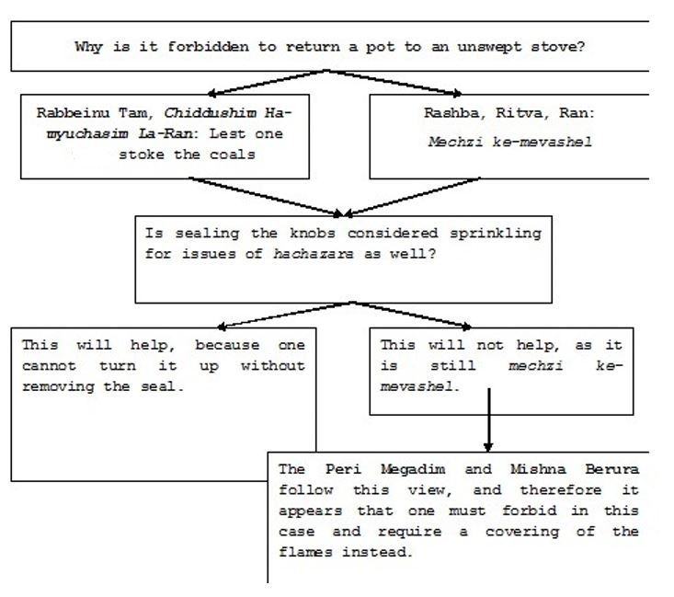

Translated by Rav Yoseif Bloch

In a somewhat different fashion, the Ramban and Rashba (ad loc.) write that the prohibition of stirring a dish exists only for the first act of stirring during the cooking process, because “there is no stirring after stirring.” Thus, assuming that one has already stirred once at the commencement of the cooking, there is no issue of further cooking.
Rashi on the Mishna (s.v. Lo machazirin) writes that the reason for the prohibition is that it is mechzi ke-mevashel. However, Rashi says these words while explaining the view of Beit Shammai, who believe that the prohibition of hachazara exists even for a stove that is gerufa or ketuma, and it may be that only for a stove such as this, regarding which the concern of stoking is not applicable, Rashi believes that the prohibition is based on mechzi ke-mevashel. However, according to Beit Hillel, the prohibition is for an unswept stove, so Rashi would concede that the concern is that one may come to stoke the coals. However, in Shaar Ha-tziyun (253:37), Rashi is counted among those who believe that every prohibition of hachazara is based on the appearance of bishul.

