YESHIVAT HAR ETZION
ISRAEL KOSCHITZKY VIRTUAL BEIT MIDRASH (VBM)
*********************************************************

GEOGRAPHY IN THE PARASHA

For easy printing, see
http://vbm-torah.org/archive/geography/15bo.htm

PARASHAT BO

The Land of Goshen
By Prof. Yoel Elitzur

Where is the Land of Goshen?

“But on that day I will set apart the land of Goshen, where My people dwell… that you may know that I the Lord am in the midst of the land” (Exodus 8:18). The people of Israel resided in the land of Goshen from the time they descended to Egypt until the time they left it. Immediately after Joseph revealed himself to his brothers, he invited his father and the entire family to the land of Goshen: “You will dwell in the land of Goshen, where you will be near me – you and your children and your grandchildren, your flocks and herds, and all that is yours” (Genesis 45:10). Indeed, while the family was still en route to Egypt, Judah was sent ahead to prepare accommodations for the family in Goshen: “He had sent Judah ahead of him to Joseph, to point the way before him to Goshen. They came to the land of Goshen” (46:28). But where is this land of Goshen, where the people of Israel resided?

One hint as to Goshen’s location can be found in the message that Joseph sent to his father: “You will dwell in the land of Goshen, where you will be near me.” We see from this that Goshen must have been close to the centers of the Egyptian government. We read in Exodus that the location among the reeds by the bank of the Nile where Jochebed placed the basket containing the infant Moses was near Pharaoh’s palace, where Pharaoh’s daughter went to bathe. In the context of the plagues as well, we read of the direct connection between Moses and Pharaoh, which reaches a climax during the plague of the firstborn: “He summoned Moses and Aaron in the night and said, ‘Up, depart from among my people’” (Exodus 12:31). The way this scenario is described demonstrates once more that the people of Israel lived in close proximity to Pharaoh.

The land of Goshen bore another name as well – Ramesses. Even as early as Genesis, the Torah recounts that Joseph settled his father and brothers “in the choicest part of the land [of Egypt], in the land of Ramesses” (47:11). When the period of enslavement began, the people of Israel built “garrison cities for Pharaoh: Pithom and Ramesses” (Exodus 1:11), and the Exodus, described in our parasha, begins in Ramesses: “The Israelites journeyed from Ramesses to Succoth” (12:37).

Ancient Egypt was shaped like a kind of long sausage, following the Nile from the heights of the south to the Mediterranean Sea in the north. Near Heliopolis, in the vicinity of modern Cairo, the Nile splits into tributaries, forming a triangular shape. The Greeks called the land within this triangle the “Delta,” due to the region’s similarity to the shape of the Greek letter delta. The Nile Delta is known as “Lower Egypt,” and its Egyptian hieroglyph was a wasp or a bee. Pithom and Ramesses have not been identified with certainty, but it is reasonable to assume that they were located within the Delta, apparently on its eastern end.,

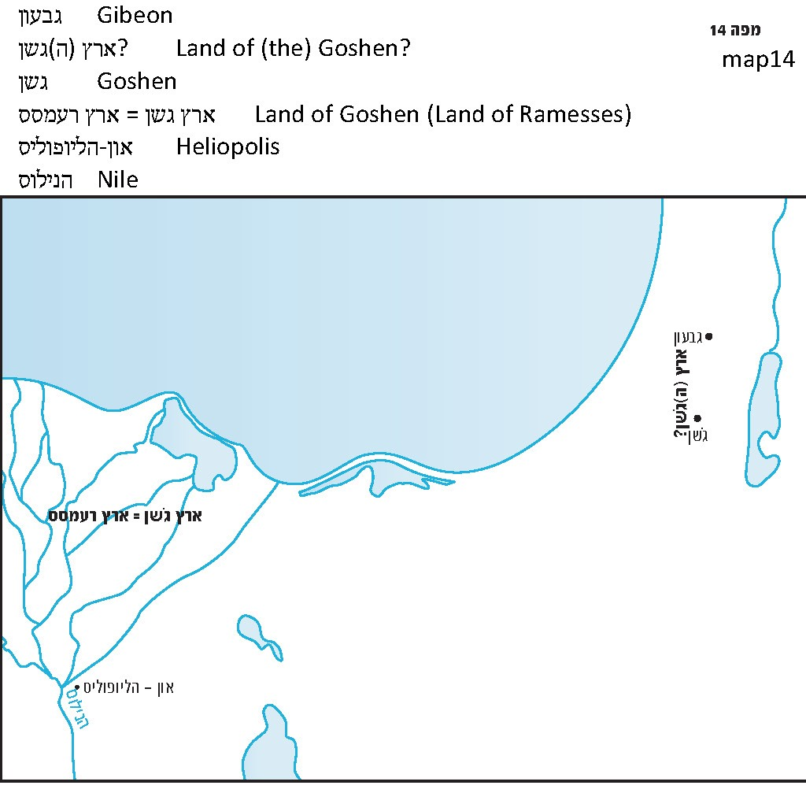

Goshen in the Land of Israel

What is known, from a linguistic perspective, about the name “Goshen”? Attempts to ascribe Egyptian or Semitic etymological roots to the name have not been fruitful. However, it is worth noting that the name Goshen appears in a non-Egyptian context three times in the book of Joshua – as locations in the land of Israel. Apparently, there were two different Goshens in the land of Israel at the time, both located in Judea. One was a city and the other was a “land,” more accurately a region, similar to the “land” of Goshen in Egypt. The city of Goshen is enumerated in the southwestern group of cities in the region of southern Mount Hebron, along with Jattir, Debir, Anab, Eshtemoh and Anim (Joshua 15:48-51). In contrast, the land of Goshen – also referred to as the land of the Goshen – is the name of a region in the land of Israel. In the summary of Joshua’s conquests in the southern part of the Land, we read: “Thus Joshua conquered the whole country: the hill country, the Negeb, the Shephelah, and the slopes… Joshua conquered them from Kadesh-barnea to Gaza, all the land of Goshen, and up to Gibeon” (10:40-41). Later, in the general summary, we read: “Joshua conquered the whole of this region: the hill country [of Judah], the Negeb, the whole land of the Goshen, the Shephelah, the Arabah, and the hill country and coastal plain of Israel” (11:16).

R. Yisrael Ariel, in his atlas of the borders of the land of Israel (following the commentary of Da’at Zekenim Mi-ba’alei Ha-Tosafot on Genesis 46:29, and a derash cited critically by Radak in his commentary on Joshua 11:16) includes the Egyptian Goshen within the borders of the land of Israel, stretching the territory of the tribe of Judah to the point where it reaches the Nile Delta! This detail is possibly the most extreme of his generally maximalist positions regarding the borders of the Land. I believe that this kind of view is patently impossible. The idea that Joshua could have conquered land in the eastern Nile Delta from the Canaanites is perplexing. As we will explain in our discussion on Parashat Mishpatim, the borders of the tribal territories fall within the smaller version of the Land’s borders. These borders reach in the southwest to the “wadi of Egypt,” whose identification with modern-day Wadi el-Arish is reasonable and accepted.

Most modern commentators and scholars of Biblical geography maintain that the land of Goshen mentioned in Joshua 10-11 refers to the territorial area of the city of Goshen mentioned in chapter 15. However, this view does not make sense for a number of reasons:

- The city of Goshen was a small city, mentioned only once in Tanakh, and its territorial area certainly did not exceed a few square miles. In its vicinity lay the well-known cities of Debir, Anab and Eshtemoh. The area of southern Mount Hebron was certainly named for these cities rather than for Goshen.

- The land of Goshen in the summaries of Joshua’s conquests is a vast region, mentioned alongside the hill country, the Shephelah, the Arabah, the Negeb and the slopes. The “hill country” refers to the mountainous region of Israel, the Shephelah is what is known today as the “inner Shephelah,” the Arabah is the Jordan Rift Valley and the Dead Sea, the Negeb refers to the northern Negeb region, and “the slopes” are the steep, rocky slopes of the east. The only region remaining in the land where the land of Goshen can possibly be placed is the western hillside region between the mountains and the Shephelah, which, as the verse specifies, extends to Gibeon at its northern end.

- An important linguistic consideration, discerned by John Gray in 1967, is the use of the definite article in Joshua 11:16 – “the whole land of the Goshen (Eretz Ha-Goshen).” As a rule in Biblical Hebrew, and to a great extent in modern Hebrew as well, the regions of the land are referred to using the definite article: the Negeb (Ha-Negev); the Sharon plain (Ha-Sharon); the Galilee (Ha-Galil); the valley of the Lebanon (Ha-Levanon); the Carmel region (Ha-Karmel); the Bashan (Ha-Bashan); the Gilead (Ha-Gil’ad). What we see from this is that Goshen belongs to this same family of names, and like the other items on this list, it too is apparently an ancient Semitic name for a large geographical area. It has a three-letter root, and it is formed from a common nominal pattern. Although we do not have the slightest idea how to understand the meaning of this root (suggestions proposed by scholars connecting Goshen to the root G-W-Š or to the name Geshuri are unlikely), it can be estimated that it expresses something connected to the topographic scenery or to the agriculture of the region, or perhaps to the manner in which animals were raised. Apparently, the same geographical characterization existed in the eastern Nile Delta as well.

Hebrew Names in Egypt?

It should come as no surprise that a Hebrew-Canaanite name existed in the eastern part of Lower Egypt. In the main part of Egypt, the place names are always Egyptian (examples mentioned in Tanakh include No-Amon, Tahpanhes, On, Moph and Syene). However, in northeast Egypt we find a number of Hebrew or Canaanite names, including Succoth, Migdol, Baal-zephon and apparently Etham, and in the desert that serves as Egypt’s eastern border we find the Semitic names Marah and Elim. In the same vein, the oldest known record of the Hebrew alphabet (from the Middle Bronze age) was found in the site Serabit el-Khadim in the western Sinai Peninsula. Apparently, the Hebrews and the Canaanites left their mark – even from ancient times – on the local place names in this region. Roads originating in this region lead directly to the land of Canaan, which the book of Genesis (referring to at least part of the land) calls “the land of the Hebrews” (40:15).

The strip of land where the people of Israel resided in Egypt had two names, one Egyptian – Ramesses, and one Hebrew – Goshen. This was certainly a result of the region’s location: between the center of Lower Egypt and the eastern border between Lower Egypt and the Semitic lands.

There is a symbolic message in the language of the verse, “The Israelites journeyed from Ramesses to Succoth” (12:37). Ramesses is a very Egyptian name, meaning “child of the god Ra,” the sun god. Succoth, on the other hand, is a very Hebrew name. The first step of the journey from Egypt undertaken by the people of Israel symbolized the transition from the Egyptian experience to the Israelite experience: “For the Egyptians whom you see today you will never see again” (Exodus 14:13). From now on – from a linguistic perspective as well – you are in a Hebrew world, the first step on the path to “when you have freed the people from Egypt, you shall worship God at this mountain” (3:12).

For further study:

Y. Ariel, Atlas Eretz Yisrael Li-gvuloteha al pi Ha-mekorot, Jerusalem 1993, 85-85 [Hebrew].

A. J. Brawer, “Eretz Goshen She-mimizrach La-Delta,” Beit Mikra 28 (1966), 91-92 [Hebrew].

G. A. Cooke, The Book of Joshua, Cambridge 1918, 98.

J. Gray, Joshua, Judges and Ruth (The Century Bible), London 1967, 116.

Y. Kil, Joshua, Da’at Mikra, Jerusalem 1970, 81 [Hebrew].

S. Leonstam, “Goshen 1”; B. Mazar, “Goshen 2,” Encyclopaedia Biblica, 2, 569-570 [Hebrew].

Y. Levin, “The Land of Goshen, Gibeon and the Southern Frontier of Saul’s Kingdom,” Judea and Samaria Research Studies 11 (2002), 51-68 [Hebrew].

Translated by Daniel Landman

See our discussion on Parashat Shemot.
See map.

