YESHIVAT HAR ETZION
ISRAEL KOSCHITZKY VIRTUAL BEIT MIDRASH (VBM)
*********************************************************

GEOGRAPHY IN THE PARASHA

This shiur is available in the archives at:
http://vbm-torah.org/archive/geography/10miketz.htm

****************************************************************
Dedicated in memory of my grandmother Mrs Irene Schenker z”l
by Zachary Schenker
***************************************************

PARASHAT MIKETZ (CHANUKA)

Modi’in
By Prof. Yoel Elitzur

“In those days arose Mattathias the son of John, the son of Simeon, a priest of the sons of Joarib, from Jerusalem, and dwelt in Modi’in” (I Maccabees 2:1). When Judah and his brothers died, they were buried in Modi’in, in an ancestral tomb. But where is Modi’in?

Today, it seems strange to even ask such a question. There is a large city in Israel known as Modi’in, in whose vicinity lie towns with names like Matityahu, Hashmonaim and Maccabim, as well as a historical site known as the Tombs of the Maccabees. It seems clear, then, that this region is where ancient Modi’in was located. But is this actually true? What is the source of this identification?

In reality, the connection between ancient Modi’in and its modern-day counterpart is not so simple. The identification is based on several sources.

Sources that Seem to Place Modi’in in the Eastern Part of Shephelat Lod

Let us begin with the book of Maccabees. Following the death of the High Priest Jonathan, who had been betrayed and captured by the Seleucid ruler Diodotus Tryphon, we read:

Then sent Simon, and took the bones of Jonathan his brother, and buried them in Modi’in, the city of his fathers… Simon also built a monument upon the tomb of his father and his brothers, and raised it aloft for all to see, of hewn stone behind and before. Moreover he set up seven pyramids, one against another, for his father, and his mother, and his four brothers. And in these he made cunning devices, about which he set great pillars, and upon the pillars he made all their armor for a perpetual memory, and by the armor ships carved, that they might be seen by all that sail on the sea. This is the tomb which he made at Modi’in, and it stands yet until this day. (I Maccabees 13:25-30)

According to Maccabees, Simon built a magnificent burial complex, with seven pyramids atop the tombs and carved pillars depicting weapons, armor and ships. But the interesting part of this passage for our purposes is the ending: “that they might be seen by all that sail on the sea” and “until this day.”

The words “until this day” refer to the time when I Maccabees was written, namely, several decades following the events recounted in the book. But later authors also seem to be familiar with the location. In Josephus’s Antiquities of the Jews, he writes: “Moreover, he built seven pyramids also for his parents and his brothers, one for each of them, which were made remarkably, both for their size and beauty, and which have been preserved to this day” (13:211). Apparently even in Josephus’s time – in other words, after the destruction of the Second Temple – Simon’s burial complex at Modi’in was still well known. See map below.
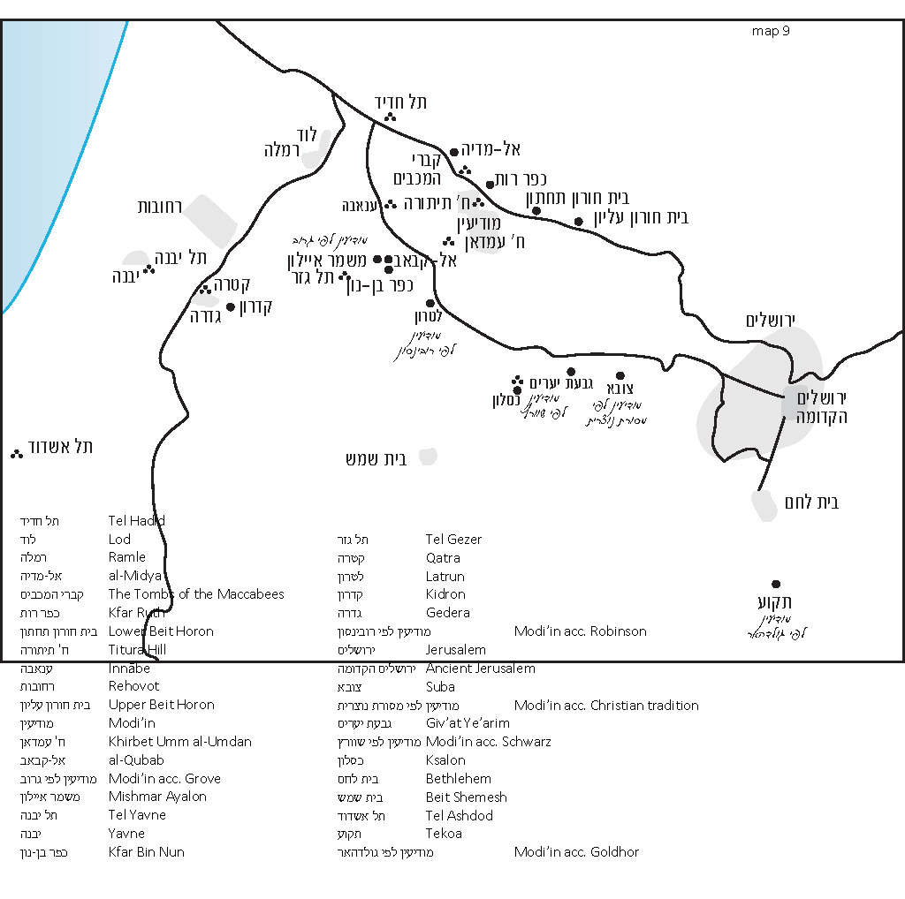
Today, we have not found any remnants of these seven adjacent pyramids anywhere in Israel. A nineteenth-century scholar named George Grove suggested that a vestige of these Maccabean tombs could be found in the name of the Arab village of al-Qubab (just east of Mishmar Ayalon and Kfar Bin Nun; abandoned in 1948). The word qubāb is a plural form of qubba “dome,” which can be used to refer to a burial structure for an important person. Victor Guérin rightfully rejected this highly dubious theory.

The expression “that they might be seen by all that sail at sea” perhaps hints at a location that is not far from the sea. This would also fit with an elevated location within the inner Shephelah. To be fair, though, there is no solid proof for this speculation; some explain that the reference to “all that sail at sea” simply means that the intricately carved pillars, which depicted ships, tended to attract sailors.

An additional, more explicit source supporting the inner Shephela theory can be found at the end of I Maccabees. In chapters 15-16, we read that Antiochus VII (Sidetes) demanded that Simon return to Seleucid hands Jaffa, Gezer and the Acra, a Jerusalem fortress built by Antiochus IV (Epiphanes). Simon refused, relaying the famous message to Antiochus’s envoy:

We have neither taken other men’s land, nor held that which belongs to others, but the inheritance of our fathers, which our enemies had conquered wrongfully at a certain time. And we, having opportunity, hold the inheritance of our fathers. (I Maccabees 15:33-34)

In response, Antiochus appointed the military leader Cendebeus commander of the coastal region and sent him to attack Judea.

In the course of the war narrative, the names Jamnia (Yavne in Hebrew, today an Israeli city) and Cedron appear in connection with the Seleucids, and Gezer and Modi’in in connection with the Jews. John Hyrcanus and Judah, the sons of Simon, led the fight against Cendebeus:

They rested that night at Modi’in. And when they rose in the morning, and went into the plain, behold, a mighty host both of footmen and horsemen came against them, and a brook was between them… and Cendebeus and his host were put to flight, so that many of them were slain, and the remnant fled to the stronghold… but John still followed after them, until he came to Cedron… So they fled to the towers in the fields of Azotus [Ashdod] where he burned it with fire. (16:4-10)

The location of Cedron is not known with certainty. Many believe that Qatra, an Arab village that lay at the northern edge of Gedera before it was destroyed in 1948, preserved a remnant of Cedron in its name. A similar name – Gedrus (variants: Kedus, Cedrus) – appears in Eusebius’s Onomasticon (circa 320 CE): “There is now a large village [called] Gedrus ten miles from Diospolis on the road to Eleutheropolis [Beit Guvrin]” (Onomasticon 68:22-23). Based on this identification, a moshav established in 1949 just east of that site was named Kidron.

Whether or not there is actually a connection between Kidron and Qatra, it is clear from the geographical context that Cedron, the site mentioned in I Maccabees, was located in this general region. In light of this, we can reasonably assume that Modi’in was not far from there as well. The details of the narrative point to a location that borders on the plains but is itself located on the Judean hillsides.

In the Onomasticon’s entry for Modi’in, Eusebius writes: “Village near Diospolis. Home of the Maccabees where their tomb is pointed out even now” (Onomasticon 132:16-17). We see from here that even centuries after the destruction of the Second Temple, the tombs of the Maccabees were still plainly visible in a village near Lod.

The most important piece of information in support of this identification of Modi’in is the Madaba Map. In this ancient mosaic map, dated to the sixth or seventh century CE, the village of Modi’in is accompanied by the following label in Greek: “Mōdeeim which is now Mōditha, whence were the Maccabees.” West of the village lies the city of “Lōd”; to the east lies the village of “Bethōrōn”; to the south lies “Bētoannaba”; to the northeast lies “[Kaph]eruta”; and to the northwest lies “Aditha.” All of these locations are familiar to us. Lod and Beth-horon (today Beit Ur al-Tahta) are well-known places. Bētoannaba refers to Innābe, an Arab village that was destroyed in the War of Independence. Its name is preserved today in the form of Nachal Anava and the Anava Interchange. Kapheruta apparently refers to Khirbet Kafr Lut, located east of Kfar Ruth. Finally, Aditha refers to al-Haditha, an Arab village, now known as the archaeological site Tel Hadid, inhabited until 1948. All of this information essentially corroborates the notion that ancient Modi’in and modern Modi’in are located in the same region.

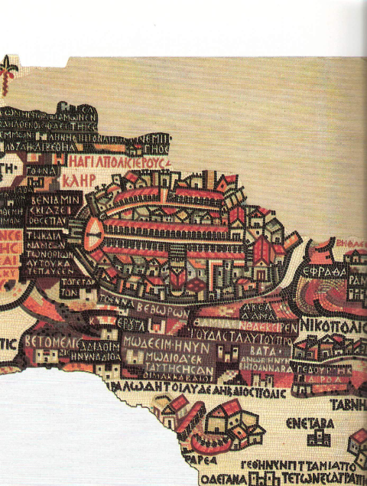
A portion of the Madaba Map. The map faces east. In the upper part of the image, the walled city of Jerusalem is visible. Below Jerusalem – the village of BEΘWPWN (Beth-horon). Below it – the village of K[ ]ERעTA (K[ap]eruta/Kfar Ruth). Below it – the village of MOΔΕΕΙΜ · Η ΝΥΝ ΜWΔΙΘΑ ˙ ΕΚ ΤΑΥΤΗC HCAN OI MAKKABAAIOI (Μοdi'im, which is today Moditha; home of the Maccabees). Below it – A large unwalled city with the label ΛWΔ Η ΤΟΙ ΛΥΔΕΑ Η Κ ΔΙΟCΠΟΛΙC (Lod, which is Lydea, also known as Diospolis). Left (north) of Modi'im – the village of AΔΙΑΘΙΜ Η ΝΥΝ ΑΔΙΘΑ (Adiathim, which is today Aditha). Right (south) of Modi'im – the village of ANWB H NYN BETOANNABA = (Anob, which is today Betoannaba).

Thirteenth-century theologian and bishop Jacques de Vitry and fifteenth-century pilgrim Bernhard von Breidenbach both identified Modi’in with Latrun. Edward Robinson wrote in 1841 that this was a reasonable identification. Despite this, it is difficult to accept such a theory, as Latrun is neither “east of Lod” nor in the vicinity of either Hadid or Kfar Ruth. The information in the sources points very clearly further north, toward modern Modi’in.

Scholars have found a preservation of the name Modi’in in the name of the Arab village of al-Midya, located near the town of Hashmonaim. Several locations have been suggested as the precise location of ancient Modi’in. Adjacent to the residential area in al-Midya, there is a tell that many have identified with Modi’in, but this is unlikely; the remnants of city life found at the tell date back to the biblical period, while there are relatively few remnants from the Second Temple period. Some suggested Titura Hill, formerly known as Qal’at Tantura, or Khirbet al-Burj, a large ruin on a hilltop where findings from throughout history have been unearthed, located north of modern Modi’in.

Recently, two new theories have been suggested. In 2004, it was suggested that ancient Modi’in might be identified with Khirbet Umm al-Umdan – “the ruin of the pillars” – on the southern edge of modern Modi’in. This site was excavated in 2001, when remnants were found of a town that existed mostly during the Hellenistic period and the Hasmonean period, and lasted until the Bar Kokhba revolt. A public building at the heart of the site was identified by the excavators as an ancient synagogue from the Hasmonean period, perhaps the oldest known synagogue today. According to the excavators, while the name “Umdan” has a very feasible interpretation – indeed, pillars were found at the site – it may still be that the name represents some kind of evolution from the name Modi’in. In 2008, the location of ancient Modi’in was debated further in the research of Boaz Zissu and Lior Perry. Zissu and Perry rejected the earlier identifications based on both archaeological reasons and methodological reasons. In the end, the pair opted to identify Modi’in with Khirbet Hammam, formerly known as Khirbet al-Midya, in the vicinity of the “Tombs of the Maccabees.” Numerous burial caves, built in the typical Jewish style, were found at the foot of the ruin. On one of the ossuaries found with the caves (in a series of salvage digs conducted in 1995 by Shimon Riklin), the names “Simon” and “Eleazar” were inscribed.

Let us summarize what we have established until this point:
Two separate passages in I Maccabees seem to indicate that Modi’in was located in the inner Shephelah, on the border of the hillsides and the plains, not far from the latitude of Yavne and Ashdod. The tombs of the Maccabees were a prominent site, visible even from afar. In the Byzantine period, Modi’in and the tombs of the Maccabees were known to be located east of Lod, in the vicinity of modern Modi’in. It is reasonable to assume that the information we have gleaned from the Byzantine-era sources is reliable, and that it is based on an authentic tradition. The precise location of ancient Modi’in within the greater Modi’in area has not been determined conclusively.

Complications Arise

Modi’in is mentioned in the Mishna on two separate occasions as a name for the outermost reaches of Jerusalem’s borders. The Mishna states: “What is ‘a far-off journey’? From Modi’im and beyond, and the same distance on all sides [of Jerusalem]; this is R. Akiba’s opinion” (Pesachim 9:2). Elsewhere we find: “From Modi’im inwards [the potters] are trusted in regard to earthenware vessels” (Chagiga 3:5). In other words, from Modi’in inwards one may purchase earthenware from any merchant, even if he is an am ha-aretz (one who is ignorant of the laws of ritual purity). The purpose of this leniency was to allow the entire nation to celebrate the festivals together in Jerusalem.

It seems from these examples that Modi’in refers to the border of Jerusalem. But where is this border located? The Gemara following the mishna cited above (Pesachim 93b) explains, in a position ascribed to the Palestinian amora Ulla, that “from Modi’im to Jerusalem is 15 miles (mil).” The problem with this is that fifteen miles is a much shorter distance than the distance between Jerusalem and the Modi’in we have been discussing until this point, on the border of Shephelat Lod. How can we deal with this discrepancy? As a result of these Talmudic sources, some authors ignored the evidence in Maccabees and the Greek sources and suggested identifying ancient Modi’in with a point located much closer to Jerusalem, in the mountainous region surrounding the city. Thus R. Joseph Schwarz in 1845 chose the Giv’at Ye’arim-Ksalon ridge, while Yitzhak Goldhor in 1913 chose the desert of Tekoa. Additionally, some Christian and Muslim traditions identified Modi’in with Suba (as reported by Victor Guérin). However, once again, Modi’in’s proximity to the Shephelah is practically proven by the account in I Maccabees, and moreover, it is difficult to question the authenticity of the early Christian traditions that seem to fundamentally match both the Modi’in of I Maccabees and the Modi’in of modern Israel.

Talmudic geography scholar Samuel Klein, who saw the name “Modi’in” as a territorial term, parallel to the phrase “Har Ha-moda’i” that appears in one of the later sources, proposed a compromise. Klein suggests that there were two parts of ancient Modi’in. First, there is the “city” at the eastern end of the larger metropolis, which, being closer to Jerusalem, fits Ulla’s statement in Pesachim. Second, there is the “village” in the western end which fits Eusebius’s description and the Madaba Map. With all due respect to Prof. Klein, this theory seems unlikely.

The Solution

I believe that the following solution provides the answer to all the questions raised above. Upon analyzing the Gemara in Pesachim, a careful reader will note that Ulla’s position is emphatically rejected, using the strong language, “teyuvta de-Ulla teyuvta.” Ulla’s position was his attempt at quantifying the distance of a “far-off journey” mentioned in the mishna. In his opinion, this term refers to the distance a person generally covers in a half-day’s walk, and Ulla calculated that this distance is 15 miles. However, it becomes clear by the end of the Gemara’s discussion, in light of the commentaries of the main Rishonim, that the accepted interpretation of a half-day’s walk is 20 miles – not 15 miles as Ulla claimed.

The Rambam adds a fascinating variable to the discussion. He writes:

One who was, on the 14th [of Nisan] at sunrise, at a distance of 15 miles or more from Jerusalem, this is considered a far-off journey. One who was at a shorter distance than that is not on a far-off journey, because he can reach Jerusalem after midday if he walks at a leisurely pace. (Hilkhot Korban Pesach 5:9)

The commentators on the Rambam did not seem to notice anything out of the ordinary in the language of this ruling. But something is indeed out of the ordinary here. In general, measurements of this nature that are based on a person’s physical ability are defined using an average person as a point of reference. Accordingly, we would have expected that the pace used to determine the distance of a half-day’s walk would be a normal walking pace, not a “leisurely pace,” as the Rambam states.

It seems to me that the Rambam intentionally used this language in order to resolve the discrepancy between the accepted position in the Gemara – that a half-day’s walk is 20 miles – and Ulla’s position – that it is only 15 miles. Perhaps the Rambam was reluctant to reject Ulla’s position outright because Ulla actually lived in the Land of Israel, making his position a kind of eyewitness account. Because of this, the Rambam proposed a novel explanation: In the case of the “far-off journey,” we measure distance based on a leisurely pace rather than a normal walking pace. In the Rambam’s reckoning, then, a 15-mile walk at a leisurely pace takes the same amount of time as a 20-mile walk at a normal pace – half a day.

Now that it has become clear to us that “Modi’im” is located more than 15 miles away from Jerusalem, perhaps we can beg the Rambam’s forgiveness and admit that Ulla’s position was most likely based on interpretive speculation rather than his personal experience. In light of this, we can accept that the Gemara’s conclusion – teyuvta de-Ulla teyuvta –actually means that “a far-off journey” is 20 miles and not 15 miles.

Before we actually measure the distance between Jerusalem and Modi’in, I would like to note that, in contrast to the commonly-held view of the Rishonim, Acharonim and even many contemporary Talmud scholars, I believe that when Chazal use the term mil, they were referring to the Roman mile, not their own independent measure of distance. This is a complicated issue that requires its own comprehensive discussion, far beyond the scope of this chapter. In this forum, I will suffice in saying that the word mil is, in essence, a Roman noun (the Latin phrase mille passuum means “a thousand double paces”), and the Romans who then ruled the land erected milestones all along the major roads. It is reasonable to assume, then, that the Roman mile was the same mile that Chazal used.

If we accept that the mil found in the Talmud is the Roman mile, which is approximately 4,800 feet, 20 Roman miles comes out to about 18 English miles. This is the precise distance between Jerusalem and modern-day Modi’in. I believe this is the best solution to the contradiction between the two groups of sources that we outlined above.

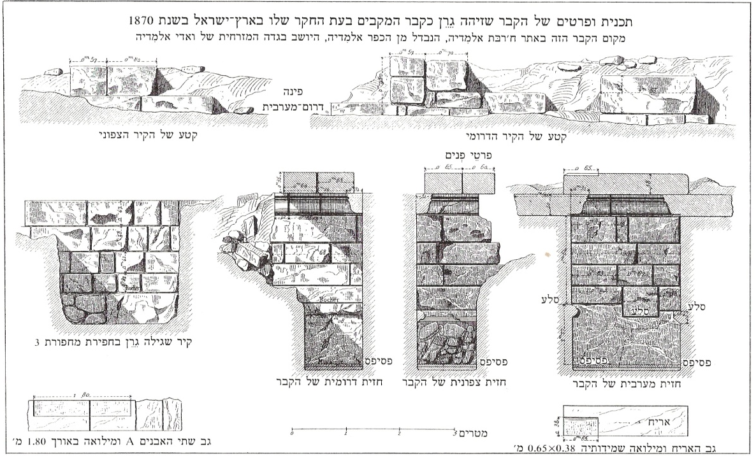
Detailed schematics of the tomb identified by Guérin as the tomb of the Maccabees in his expedition to the Holy Land in 1870. This tomb is located in Khirbet al-Midya, which is distinct from the village of al-Midya on the eastern bank of Wadi al-Midya. (Yad Ben Zvi)

As for the site known today as “the Tombs of the Maccabees,” although this place bore the Arabic name Qubur el-Yahud (Tombs of the Jews), the burial style indicates that these tombs postdate the Hasmonean period and are apparently non-Jewish. The actual tombs of the Maccabees described in the sources can likely be found in close proximity to these tombs, but their precise location is difficult to pinpoint with certainty. Several sites in the area were suggested as the tombs of the Maccabees during the last 150 years, and perhaps the truth of the matter will become clearer in the future. In any case, the important conclusion here is that the city of Modi’in and its surrounding towns – many of which bear the names of the heroes of ancient Modi’in, e.g., Matityahu, Hashmonaim and Maccabim – seem to have been established in the right place after all.

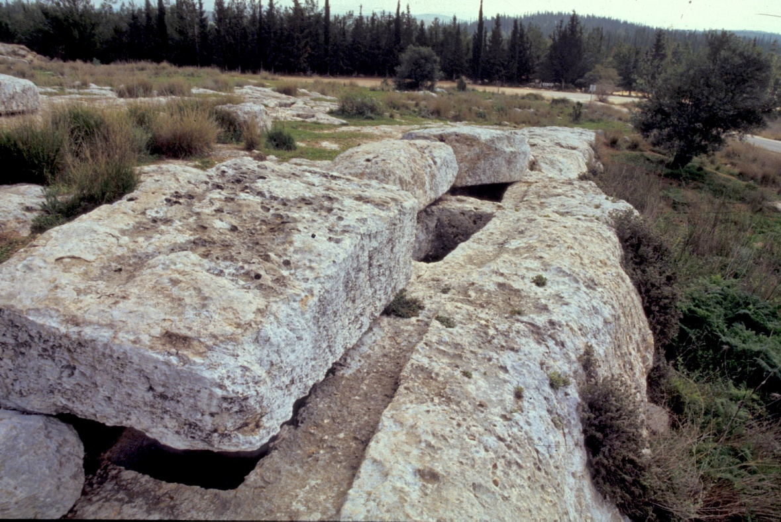
“The Tomb of the Maccabees,” formerly Qubur el-Yahud (Z. Radovan)

For further study:

J. J. Ajdler, “Talmudic Metrology: The Mile as a Unit of Length,” BDD 19 (2008), 57-60.

Z. H. Ehrlich, Gevurat Beit Chashmona’i, Jerusalem 1986, 7-10 [Hebrew].

Y. Goldhor, Admat Kodesh, Jerusalem 1913, 99a [Hebrew].

V. Guérin, Description géographique, historique et archéologique de la Palestine: Judée, 1, Paris 1868, 56-59; Samarie, 2, Paris 1875, 55-64; Galilée, 1, Paris 1880, 46-57 [French].

S. Klein, Eretz Yehuda, Tel Aviv 1939, 60 [Hebrew].

M. Piccirillo and E. Alliata, The Madaba Map Centenary, Jerusalem 1997, 71-73.

E. Robinson, E. Smith, Biblical Researches in Palestine, Mount Sinai and Arabia Petraea, London 1841, 2, 328-329; 3, 30.

J. Schwarz, Tevu’ot Ha-aretz, Jerusalem (1845) 1968, 115 [Hebrew].

J. E. Taylor, The Onomasticon by Eusebius of Caesarea, Jerusalem 2003, 42, 73.

S. Weksler-Bdolah, “Modi’in: Hometown of the Maccabees,” Biblical Archeology Review 40 (2014), 52-58, 70.

S. Weksler-Bdolah, A. Onn, Y. Rapuano, “Identifying the Hasmonean Village of Modi’in,” Cathedra 109 (2003), 69-86 [Hebrew].

B. Zissu, L. Perry, “Identification of Ancient Modi’in and Byzantine Moditha,” Cathedra 125 (2007), 5-25 [Hebrew].

Translated by Daniel Landman

This map can be found here.
This identification was first suggested by the Franciscan monk Emmanuel Forner in 1866.
The word qal’a means “fortress,” referring to a prominent fortress at the top of the hill that existing during the Middle Ages. A tantur, in colloquial Arabic, is a pointed hat; it can also refer to a conical hill.
Burj is another word for “fortress.”
Thanks to the work of advocates for the preservation of nature and antiquities, in particular Prof. Yair Parag, z”l, this hill was saved from the clutches of building developers and converted into a nature park.
Lending credence to this theory is the existence of other locations in the Land of Israel where the ancient name evolved and took on a new meaning in Arabic. Examples were detailed by the excavators in their article; see bibliography below.
The question concerns the distance beyond which a person is exempt from bringing the korban Pesach on its usual date, and must instead do so one month later on Pesach Sheni.
Literally, “the refutation of Ulla stands as a refutation”
According to Rashi, the half-day here refers to the hours during which the korban Pesach is slaughtered, i.e., from midday to sunset. In contrast, the Rambam writes that the half-day refers to the hours leading up to the time when the korban Pesach is slaughtered, i.e., from sunrise to midday.
The Rambam’s support of the 20-miles view can be deduced from his commentary to the Mishna Berakhot 1:1.
In the Rambam’s halakhic methodology, he tended to defend rulings based on the eyewitness accounts of Chazal, even when they went against the accepted halakha. See Hilkhot Kelei Mikdash 9:1 for comparison.
In order to accept this approach, it is necessary to find a logical or text-based explanation for why here, unlike other areas of halakha, a leisurely pace is used.
Modi’im was located in the region known as Har Ha-melekh (King’s Mount), which was inhabited solely by non-Jews during the Amoraic period. Visiting the area at the time often proved deadly for Jews; see Yerushalmi Shabbat 1:4 (10b). No synagogue remnants have been found in this region from the Byzantine period, while many churches from that era have in fact been found.
We will elaborate on this topic later, in the chapter on Yom Kippur.
J. J. Ajdler suggested a similar solution in his article, though his proposal contains several flaws and unnecessary complications.

