YESHIVAT HAR ETZION
ISRAEL KOSCHITZKY VIRTUAL BEIT MIDRASH (VBM)
*********************************************************

GEOGRAPHY IN THE PARASHA

For easy printing, see
http://vbm-torah.org/archive/geography/05chayesara.htm

PARASHAT CHAYEI SARA

*********************************************************
Dedicated in memory of Tzipporah Bat R’Mosheh z”l
*********************************************************

The Field of Machpelah

By Prof. Yoel Elitzur

Instead of adding one more chapter to the already vast literature on the cave of Machpelah, discussing and debating the finer points of its location, history and significance to the Jewish people, I would like to focus on a place that has garnered far less attention: the field of Machpelah.

What does “Machpelah” mean?

Our parasha mentions not only the storied cave of Machpelah, but also the surrounding field of Machpelah. Rashi comments on the verse, “Let him give me the cave of Machpelah that he owns” (Genesis 23:9): “A structure with an upper story over it. Another interpretation: [It was called this] because it was doubled with couples.” Rashi presents here an abridged version of a passage that appears in the Talmud:

The cave of Machpelah – Rav and Shmuel differ as to its meaning. One holds that the cave consisted of two chambers, one behind the other; and the other holds that it consisted of a lower and upper chamber. According to him who holds that the chambers were one above the other, the term “Machpelah” is justified. But according to him who holds that it consisted of two chambers, one behind the other, what could be the meaning of “Machpelah”? [The answer is] that it had multiples of couples. (Eiruvin 53a)

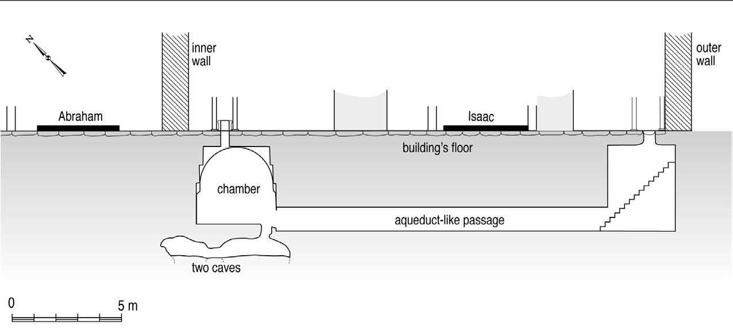
The subterranean passage, chambers and caves in the Machpelah structure: “Two chambers, one behind the other,” and “a lower and upper chamber” (Image courtesy of Prof. B. Z. Kedar)

The Ramban, in his commentary on this verse, was troubled by this interpretation, and allowed himself to voice a sharp critique on the approach of Rashi (and in truth, on the Talmud as well):

But this is not true, as the verse states, “Ephron’s land in Machpelah” (23:17), indicating that this was the name of the place where the field was located, and it is not necessary to seek explanations for names of places.

In other words, “Machpelah” is not the name of the cave, nor is it the name of the field surrounding the cave. It is, in fact, the name for the entire area, an area that happens to contain a field and a cave within it. If one is still curious as to the meaning of the name, the Ramban determines that one simply cannot know. Just as we ostensibly do not know the meaning of “Lachish” and “Ziklag,” or even “Jerusalem” or “Hebron,” so too do not bother trying to understand the meaning of “Machpelah.” It is a Canaanite place name, no more and no less, without any special significance to the history of our people.

Interestingly, those who, in recent years, have taken the opportunity to visit and inspect the underground cavities at the cave of Machpelah will be able to confirm both interpretations cited by Rashi. First, beneath the floor of the monumental Second Temple-era structure lie two ancient burial caves, one located behind the other. Second, above these caves is an underground chamber – a structure that fits with the approaches of both Rav and Shmuel. Thus, both interpretations of Chazal are supported by examining the actual layout of the site, which was probably accessible to our ancestors.

It is worth noting that the area surrounding the cave is littered with similar burial caves, all built in a style typical of the Middle Bronze Age, the Patriarchal age. Despite this, the name “Machpelah” as it is used in chapter 23 still clearly refers to the overall area, which includes within it both the field and the caves in question.

The field and the caves

It is important to emphasize that the Torah gives equal significance to the field of Machpelah and the cave of Machpelah. Later in the same chapter we find explicit evidence of this perspective:

So Ephron’s land in Machpelah, near Mamre – the field with its cave and all the trees anywhere within the confines of that field — passed to Abraham as his possession, in the presence of the Hittites, of all who entered the gate of his town. (17-18)

We see from this that, for the Torah, the purchase of the cave itself is not the main point of the narrative here. Rather, it is the purchase of “the field… and all the trees anywhere within the confines of that field” that is the crux of the matter. What this means, on a fundamental level, is that Parashat Chayei Sara is less concerned with Sarah’s burial and the events surrounding it and more concerned with the story of the first formal acquisition of land in Eretz Yisrael by the first Hebrew.

My father, Prof. Yehudah Elitzur, demonstrated how to read Parashat Chayei Sara properly, and the following interpretation is based on one of his articles, with minor changes. If one reads this parasha on a superficial level, it may seem that the conversation between Abraham and Ephron is a polite, amicable dialogue between two friends. Ephron uses the phrase “My lord, hear me” repeatedly, while Abraham bows humbly twice before the Hittites. Abraham demeans himself, saying, “I am a resident alien among you” (23:3), while the Hittites glorify him, saying, “You are the elect of God among us” (23:6). It seems almost as if this is a kind of lovers’ quarrel: Abraham wants to pay for the burial plot, while Ephron and the Hittites refuse (at first) to accept his money, insisting that Abraham take the site as a gift. Each party is exceedingly courteous to the other, almost cloyingly so.

But if we analyze further the language of these interactions, we find that the truth is quite different from what it seems. In fact, what we perceive as polite conversation is actually a trademark of the eastern marketplace, where vendors and buyers use friendly language to mask cutthroat bargaining tactics.

In light of this, what is actually going on behind the scenes in the story of Abraham and Ephron? In all ancient societies, the sale of land to foreigners was a serious taboo. This can be seen several times in Tanakh, such as in the narrative of the daughters of Zelophehad: “No inheritance shall pass over from one tribe to another” (Numbers 36:9); and later in Naboth the Jezreelite’s narrative: “The Lord forbid that I should give up to you what I have inherited from my fathers” (I Kings 21:3). This reluctance to sell land to outsiders features prominently throughout Ancient Near Eastern history, and, as we know all too well, in the geopolitics of today’s Middle East as well.

In 1925-1931, a series of excavations of the ancient city of Nuzi in northern Iraq unearthed thousands of clay tablets dating from the 15th-14th centuries BCE. These tablets contained a wide variety of documents, including documents detailing a complex adoption system. Apparently, adoption was a very common phenomenon in that society. What surprised scholars, however, is that some of these adoption records depicted a scenario in which a relatively young man would adopt an older, well-off man – an arrangement that seems odd to our sensibilities and in light of our modern notion of adoption. According to the Nuzi tablets, the adoptee would give his adopter a sizeable gift, at which point the adopter would designate a portion of his property as an inheritance for the adoptee. Sometimes, multiple people would adopt the same person simultaneously.

What is the meaning of this strange form of “adoption”? Scholars explain that this procedure is essentially a business arrangement that effectively allowed for the sale of land to foreigners without breaking the social taboo against such a transaction. The parties involved exploit a legal loophole that states that an adopted son may inherit his father’s property. While a landowner cannot sell his property to a foreigner outright, if that potential buyer becomes his “son” there could be no legal objection to his eventual acquisition of the land by way of inheritance.

Let us now return to Abraham in the land of Israel. Abraham has already been residing in the land for many years, but has not yet been able to acquire land for himself, his family and his descendants. God had promised him that “to your offspring I will assign this land” (Genesis 15:18), and “I assign the land you sojourn in to you and your offspring to come” (17:8). But despite this promise, the great wealth that Abraham had amassed and his sterling reputation and stature among the Canaanites, he was still essentially a stranger in a strange land. Abraham first lived between Bethel and Ai. When he then moved to Elonei Mamre in Hebron, he became a tenant farmer on land belonging to his “ally” Mamre the Amorite, kinsman of Eshkol and Aner. This meant that Mamre gave Abraham permission to live on his estate land, raise his flocks and support his growing household, which included hundreds of apprentices and servants. Abraham was given free rein to build his fortune of cattle, gold and silver, but not a speck of the land belonged to him.

The Canaanites greatly respected Abraham and probably even the new monotheistic religion that he discovered and represented. We read in Parashat Lekh Lekha that some of the native people even shared his views. King Melchizedek of Salem “brought out bread and wine” (Genesis 14:18) in Abraham’s honor, blessing him in the name of one God: “Blessed be Abram of God Most High, Creator of heaven and earth” (14:19). The people clearly held Abraham in great esteem, even, in the case of the Hittites, going so far as to call him “the elect of God among us” (23:6). But despite this respectful relationship, the people of Canaan would not, under any circumstances, sell Abraham land.

When Sarah dies, Abraham decides to take advantage of the opportunity to realize God’s promise of “I assign the land you sojourn in to you and your offspring to come, all the land of Canaan, as an everlasting holding” (Genesis 17:8), by making his first real attempt at acquiring land from the Canaanites. He begins his appeal while the people of the land are gathered around Sarah’s bier, mourning the death of a woman they had come to love, and honoring her respected husband. Abraham faces the crowd, saying, “I am a resident alien among you.” This introduction is not simply a display of modesty. Rather, Abraham is pointing out the frustration inherent in his current situation: I have been living in your midst now for decades, but I am still considered a resident alien. Abraham continues: “Give me a burial site among you, that I may remove my dead for burial.” In other words, Abraham is announcing that he will not bury Sarah until he is sold a burial site as an inheritance.

It may be that Abraham’s request takes the Hittites aback – here is an old man whom they know as an honorable idealist who is now exploiting the personal tragedy of his wife’s death in order to acquire property. But Abraham alone knows the truth: This is not just a plot of land, but a manifestation of his entire life’s purpose – “Go forth… to the land that I will show you”; “To your offspring I will assign this land.” It is for this reason alone that Abraham makes his brazen request of the Hittites.

The negotiation process that follows Abraham’s plea constitutes a shrewd battle of wits. The Hittites present their first offer – they are prepared to give Abraham permission to bury Sarah in their cave: “You are the elect of God among us. Bury your dead in the choicest of our burial places; none of us will withhold his burial place from you for burying your dead” (23:6). But Abraham is not interested in this kind of arrangement. Knowing that he is about to make a highly irregular request, Abraham bows to the Hittites and focuses his language, letting them know exactly what he wants:

You must agree to intercede for me with Ephron son of Zohar. Let him give me the cave of Machpelah that he owns, which is at the edge of his land. Let him give it to me, at the full price, for a burial site in your midst. (23:8-9)

The extreme public nature of this exchange certainly added to the drama of the situation. The crowd that had gathered simply to attend Sarah’s funeral and burial was now rapt with attention, hundreds of eyes alternately fixating on Abraham and Ephron, waiting for each figure to make his next strategic move. Abraham may have been counting on the psychological pressure of the moment to influence the outcome of the negotiation. Note that at this stage, all Abraham is requesting is the right to purchase the cave – a mere burial site. In response, Ephron acts as if he does not understand the request, repeating, with the same magnanimous language, the first offer that the Hittites made – permission to bury Sarah in the cave, which would continue to be owned by Ephron.

There is a subtle linguistic nuance at play here. Ephron recognizes that Abraham consistently uses the verb stem n-t-n, meaning “give”: “Give me a burial site”; “Let him give me the cave of Machpelah”; “Let him give it to me, at the full price.” Because of this, Ephron mirrors that language, using the words “I give” three times in succession: “I give you the field and I give you the cave that is in it; I give it to you in the presence of my people” (23:11). In Ephron’s usage, however, “giving” refers not to a sale of property, but to giving permission, thus bending Abraham’s phrasing to his own goals. This explains Ephron’s sudden addition of “the field” to the transaction: He is not offering the field for sale, but only giving Abraham permission to use his cave, which happens to be located within his field.

In response to Ephron’s continuing refusal to sell him land, Abraham bows once more and again makes a point to address Ephron in public, “before the people of the land” (23:12). He digs in further, ratcheting up his terminology to a new level: “Let me give the price of the land; accept it from me!” (23:13). In response, Ephron changes the scope of the land in question; instead of selling just the cave, as Abraham requested, Ephron is now speaking about the field surrounding it as well. Ephron then sets a price for the transaction that is astronomically high, masking this unreasonable sum with faux-courteous pleasantries: “My lord, do hear me! A piece of land worth four hundred shekels of silver – what is that between you and me?” (23:15). At that point, Ephron may have expected Abraham to back down from the deal, a sensible move from a pure business perspective. Instead, Abraham accepted Ephron’s terms: “Abraham paid out to Ephron the money that he had named in the hearing of the Hittites – four hundred shekels of silver at the going merchants’ rate” (23:16).

The deal was done, but on a much larger scale than Abraham had ever anticipated, and with the public acknowledgment of the people:

So Ephron’s land in Machpelah, near Mamre – the field with its cave and all the trees anywhere within the confines of that field – passed to Abraham as his possession, in the presence of the Hittites, of all who entered the gate of his town. (23:17-18)

Abraham finally achieved his goal: He became a legitimate landowner in the Promised Land. Then and only then was Abraham able to take the final step in cementing his ownership of the land: “And then Abraham buried his wife Sarah in the cave of the field of Machpelah” (23:19).

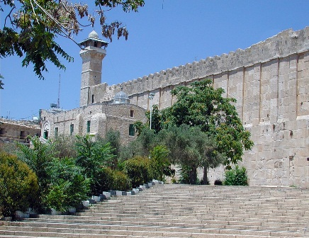
“The field of Ephron in Machpelah… and all the trees anywhere within the confines of that field – passed to Abraham as his possession” (Genesis 23:17-18; photo courtesy of David Wilder, Hebron)

3800 years later

In the wake of the Six Day War of 1967, we merited to return to Hebron, and with it, to the cave of Machpelah. Jewish families returned to Hebron as well, in a slow and politically complicated process. Every step forward in the growth of the Jewish communities in Kiryat Arba and Hebron was a result of the great dedication of the individual settlers, and in particular the women among them.

One incident that truly brings to mind Abraham’s purchase of the cave of Machpelah is the story of the burial of Avraham Yedidya Nachshon, the infant son of Baruch and Sarah Nachshon. Avraham Yedidya was born on March 11, 1975 in a clinic in Kiryat Arba. He was the first Jewish boy to be circumcised in the cave of Machpelah and was named for Abraham – beloved (yedid) of God. One night, when Avraham Yedidya was four months old, he died suddenly in his crib, without any clear medical cause. His parents decided to bury their son in the old Jewish cemetery in Hebron. When their car was blocked from entering by idf officers, Sarah took her son’s corpse, wrapped in burial shrouds, in her arms and strode toward the cemetery. Sarah’s determination paid off, and her son became the first Jew to be buried in Hebron since the Hebron Massacre of 1929.

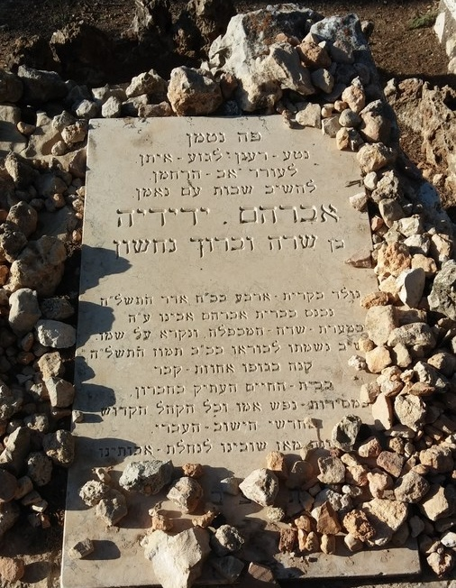
Tombstone of Avraham Yedidya Nachshon, the first to be buried in the old Jewish cemetery of Hebron after the Six-Day War (Photo courtesy of Noam Arnon, Hebron)

This incident paved the way for a resurgence of Jewish life in Hebron. Today, despite political agreements that have placed control over most of the city in Arab hands, the heart of the city – Tel Hebron of antiquity and the Jewish Quarter of the past few centuries – is currently populated by Jews, the descendants of Abraham, Isaac and Jacob. Furthermore, Jews from Israel and from around the world regularly visit the cave of Machpelah, something that was not always possible, even in recent memory.

The cave of Machpelah is not the only site in Hebron that is bustling with Jewish life at all hours of the day; the field of Machpelah fits this description as well. Today, the field of Machpelah consists of a large, landscaped area to the west, south and east of the magnificent Second Temple-era structure built directly atop the cave. At the southeast corner of that structure, Jews would pray and light candles opposite a small opening that led to an underground system of passages. These passages, in turn, led to the area adjacent to the actual tombs of the patriarchs. Jewish weddings and other celebrations are occasionally held in the field of Machpelah, and an enormous sukka is erected there every year for the festival of Sukkot. On all the festivals, and on Shabbat Chayei Sara as well, thousands of the descendants of Abraham, Isaac and Jacob converge on the cave of Machpelah to celebrate together at the very site where their ancestors rest. On those occasions, the field of Machpelah brims with prayer and joyous dancing.

The freedom to visit the cave of Machpelah that we enjoy today should not be taken for granted. Years ago, the area surrounding the cave was a crowded Arab neighborhood known as Ḥārat al-Akrad (the Kurdish Quarter), and contained a “qal^{c}a” (a large structure, partially in ruins, understood to be a kind of citadel; it was used for military purposes during the Ottoman Period), a small pool used for water storage (really an ancient cave that had been plastered over and converted to a pool) and residences for members of the Muslim waqf. Attached to the southern corner of the area was the stairway that later became known for its “seventh step,” the closest that Jews were allowed to approach the cave.

In Jerusalem, where a similar situation arose following the Six-Day War with regard to the area surrounding the Western Wall, the Israeli government had the fortitude to convert the crowded Moroccan Quarter into what we know today as the Western Wall Plaza. It is doubtful that Israel would have been capable of implementing a similar solution in Hebron – but such an operation was never necessary. King Hussein of Jordan, in an attempt to promote the cave of Machpelah as a tourist site, cleared out the area on his own in the early 1960s, evicting its residents and bulldozing their homes. Little did he know that his actions made it much simpler for Israel to access the field of Machpelah following its return to the city in 1967. Some say that Hussein razed the area in the context of infighting with radical Muslim groups, calling to mind the Talmud’s assertion that “Ammon and Moab became purified through Sihon” (Gittin 38a) – the occupation of Ammon and Moab by the Amorite king Sihon was what enabled the Israelites to capture their land, as the Torah (Deuteronomy 2:9, 19) forbids direct conflict with Ammon and Moab. Similarly here, one could say that the field of Machpelah was “purified through Hussein.”

But the person who deserves the most credit for reinforcing the ability of Jewish people to access the field and cave of Machpelah is Rechavam “Gandhi” Ze’evi, the legendary general and politician who was assassinated by an Arab terrorist in 2001. Ze’evi recounted that once, when he was a small child in the early 1930s, his father took him to visit Hebron. The senior Ze’evi climbed the steps, going as far as the permissible seventh step. Young Rechavam decided to try to continue to the eighth step. Just as his foot reached the forbidden eighth step, an Arab guard jumped out at him and kicked him all the way down to the bottom of the stairway. Rechavam swore never to forget this incident, resolving to someday destroy that stairway and rid the site of its Arab guards. Years later, Ze’evi made good on his vow. Following the Six Day War, Ze’evi was appointed head of the IDF’s Central Command, and one of his first directives was the removal of that degrading stairway.

The daily presence of crowds of Jews at the field and cave of Machpelah is what truly connects us to our roots. On a personal level, I feel a unique happiness when I visit the site and see trees growing in the area surrounding the cave. I like to think that, in a way, these are the very same trees that Abraham might have gazed upon when he purchased his land from Ephron the Hittite: “And all the trees anywhere within the confines of that field – passed to Abraham as his possession” (23:17-18).

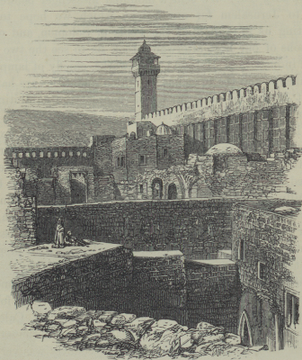
The Cave of Machpelah and its surroundings (H. B. Tristam, The Land of Israel, 1865)

For further study:

N. Arnon, “The Cave of Machpelah,” Niqrot Zurim 18 (1992), 27-36 [Hebrew].

O. Avissar (ed.), Sefer Chevron, Jerusalem 1970, 466-495 [Hebrew].

D. Chen, “Measuring the Cave of Abraham in Hebron,” Liber Annuus 37 (1987), 291-294.

Yehudah Elitzur, Israel and the Bible, Ramat Gan 2000, 37-39 [Hebrew].

B. Z. Kedar and H. Barbé, “Dating of the Subterranean Passage at the Patriarchs' Cave, Hebron,” Israel's Land (eds. J. Geiger, H. M. Cotton and G. Stiebel), Raanana 2009, 179*-184*.

A. Klein, “Me^{c}arat Sde ha-Makhpelah,” Meḥqerey Ḥevron 1 (2012), 95-123 [Hebrew].

J. B. Pritchard, Ancient Near Eastern Texts Relating to the Old Testament, Princeton 1950, 219-220.

Z. Yeivin, “The Machpelah Cave Subterranean Complex,” Israel – People and Land (ed. R. Ze'evy), 2-3 (1985-1986), 53-62 [Hebrew].

Translated by Daniel Landman

The abundance of burial sites in the vicinity of the cave of Machpelah calls to mind the Hittites’ statement to Abraham, “Bury your dead in the choicest of our burial places” (23:6).
According to Judges 17:10, a year’s salary was ten shekels. Leviticus 27:16 notes that the value of a field is fifty shekels per chomer of barley seed required to plant it, which is approximately fifty shekels per 4.5 acres of land.
This was the location of the notorious “seventh step,” the closest that Jews were allowed to approach the cave of Machpelah for hundreds of years.
The electrical generator that Hussein installed in the area is still in operation to this day.
I would like to thank Hebron residents Noam Arnon, Aryeh Klein, Shalom Elkobi and Gershon Bar-Kochba, who shared much of their vast knowledge with me.

