YESHIVAT HAR ETZION
ISRAEL KOSCHITZKY VIRTUAL BEIT MIDRASH (VBM)
*********************************************************

GEOGRAPHY IN THE PARASHA

For easy printing, see
http://vbm-torah.org/archive/geography/04vayera.htm

PARASHAT VAYERA

Sodom and Gomorrah

By Prof. Yoel Elitzur

Translated by Daniel Landman

Parashat Vayera contains the Torah’s account of the cataclysmic destruction of Sodom, Gomorrah, Admah and Zeboiim, four of the five major “cities of the Plain.” Following their demise, these cities became synonymous with extreme sinfulness and corruption, both throughout Tanakh and in today’s parlance. Similarly, the destruction of the cities became synonymous with utter desolation and ruin.

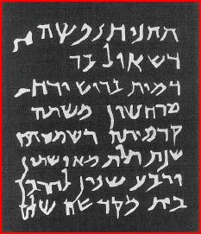
Jewish tombstone from Zoar, Talmudic period: “Rest in peace the soul of Saul son of… who died on Rosh Chodesh Marcheshvan of the first year of shemita, three hundred sixty-four years from the destruction of the Temple. Shalom” (E. Cowley, PEFQst, 1925)

Where are Sodom and Gomorrah?

The cities of the Plain are traditionally identified in the southern Dead Sea region. This identification is generally accepted today, as evidenced by the appearance of the names Sodom and Zoar on today’s maps. Modern Sodom is rich in phosphate and potash, and it is not far from a large hotel and resort complex. Mount Sodom looms over the area, a remarkable peak made up almost entirely of salt. Zoar, the only city of the Plain that survived destruction, is commonly identified as the modern-day Jordanian town of Safi in the southeast Dead Sea region. Remains have been found in Safi that shed light on Jewish life in the Talmudic period, including tombstones inscribed with dates from the destruction of the Second Temple and with the year of the shemita cycle.

In order to determine where the destruction of Sodom and Gomorrah took place, we must ask how it took place. The Torah’s description – “the Lord rained upon Sodom and Gomorrah sulfurous fire” (19:24) and “the smoke of the land rose like the smoke of a kiln” (19:28) – gives the impression of a kind of volcanic eruption. The eastern Dead Sea region does, in fact, contain deposits of volcanic ash, but experts have said that these are prehistoric in origin and thus irrelevant to our current discussion.

A more feasible claim is that the destruction of Sodom was the result of a powerful earthquake that featured “sulfurous fire” as a secondary effect. Accounts describing the flooding of the cities of the Plain can be found in both non-Jewish Second Temple era sources and in several passing remarks by Chazal, and some modern scholars considered the possibility that these ancient sites were flooded by the southern basin of the Dead Sea. To date, however, no remains of any cities have been found either beneath the waters of the Dead Sea or in its southern basin, which is now dry due to the sea’s receding water level (excluding areas that have been inundated artificially). To be sure, there is a rapid rate of sediment accumulation in the Dead Sea, and it is certainly possible that the lost cities were covered in multiple layers of sediment and simply have yet to be dug out.

Some scholars connected the story of Sodom’s destruction with several fortified towns in the southeast Dead Sea region that existed in the Early Bronze Age and were destroyed in approximately 2300 BCE. These scholars point to a large cemetery found in Bāb edh-Dhrā^{c} on the eastern coast of the Dead Sea, on the Lisan Peninsula, which seems isolated from any significant settlements of the same time period. The problem with this theory is that all of the findings at Bāb edh-Dhrā^{c} predate Abraham’s arrival in the region according to the Biblical account. In order to deal with this obstacle, some claimed that the Torah’s chronology is inaccurate, while others suggested that the chronology presented by archaeologists is at fault.

The Northern Theory

As a result of the difficulty that researchers experienced in locating the cities of the Plain in the southern Dead Sea region, some suggested that the cities could actually be found in the northern Dead Sea region, near the Jordan River estuary into the sea, not far from Jericho. Scholars who support this theory have based themselves on several considerations:

- The term “cities of the Plain” refers to the plain of the Jordan. The Torah states: “So Lot chose for himself the whole plain of the Jordan,” later summarizing, “Abram remained in the land of Canaan, while Lot settled in the cities of the Plain” (13:11-12). If so, Sodom and Gomorrah should be located near the Jordan River, rather than in the southern Dead Sea region.

- Abraham and Lot stood between Bethel and Ai, overlooking the plain of the Jordan: “Lot looked about him and saw how well watered was the whole plain of the Jordan, all of it – this was before the Lord had destroyed Sodom and Gomorrah… so Lot chose for himself the whole plain of the Jordan… and he moved his tents near Sodom” (13:10-12). According to this account, Sodom and the Plain are apparently visible from the Bethel region, a claim that is only possible if they are located in the northern Dead Sea region – the southern Dead Sea region is simply too far away.

- The narrative of Lot’s daughters and the subsequent births of Ammon and Moab took place on the heels of Lot and his family’s dramatic escape from the destruction of Sodom. Some have argued, based on this, that Sodom must be located near the ancient lands of both Ammon and Moab, which were inhabited by the descendants of Lot. While Moab was situated along the entire eastern coast of the Dead Sea, Ammon only bordered on the sea at its northeast corner. Therefore, Sodom could only have been somewhere in the northern Dead Sea region, in relative proximity to both Ammon and Moab.

- The city of Zoar is mentioned as one of the places that Moses viewed from his perch atop Mount Nebo: “Moses went up from the steppes of Moab to Mount Nebo… and the Lord showed him the whole land: Gilead as far as Dan; all Naphtali; the land of Ephraim and Manasseh; the whole land of Judah as far as the Western Sea the Negeb; and the Plain – the Valley of Jericho, the city of palm trees – as far as Zoar” (Deuteronomy 34:1-3). The verses essentially sketch out for us a large circle on the map, beginning with Mount Nebo and continuing counterclockwise, arcing north, west, south and finally returning to Mount Nebo – to Jericho and Zoar. The verse seems to imply that Jericho and Zoar are close to each other on the map, meaning that Zoar and the other cities of the Plain are in the northern Dead Sea region rather than the southern Dead Sea region.

In light of these considerations, proponents of the northern theory have identified various sites throughout the northern Dead Sea region as candidates for the ruins of Sodom, Gomorrah and the other cities of the Plain.

The Southern Theory

Despite the above considerations, there remain many indications that the cities of the Plain are located in the southern Dead Sea region, in accordance with the traditional identification.

- First and foremost, there is a well-documented ancient tradition placing the five cities in the south. Jerome, the famous early Church Father, wrote in approximately 400 CE that Zoar is the southern border of the land of Moab. The Madaba Map, commonly dated to the sixth century CE, features a fortified town called “Zoora” in the southeast Dead Sea region. In addition, in the late 1980s a monastery was discovered built atop a natural cave that early Christians apparently identified with Lot’s place of refuge after leaving Zoar. This monastery was also noted on the Madaba Map east of Zoora.

- Tanakh contains several detailed lists of the cities in the northeast Dead Sea region. These include the cities conquered from Sihon (Numbers 32:3), the cities settled by the tribes of Gad and Reuben (Numbers 32:34-38), the cities in the region occupied by the people of Israel when they encamped in the plains of Moab (Numbers 33:48-49), the cities that were given to the tribe of Reuben (Joshua 13:15-23) and the cities that the tribe of Reuben ceded to the Levites (I Chronicles 6:63-64). Tellingly, Zoar is not mentioned in any of these lists. Even in the Mesha Stele of King Mesha of Moab, which contains an extraordinary number of place names in northern Moab, Zoar is nowhere to be found. Zoar is mentioned, however, in Isaiah’s “burden of Moab” prophecy (Isaiah 15:5) and in Jeremiah’s Moab prophecy as well (Jeremiah 48:33), both of which include southern Moabite cities.

- The Torah says that Lot “moved his tents near Sodom” (13:12), and the same language is used for Abram – “And Abram moved his tent, and came to dwell at the terebinths of Mamre, which are in Hebron” (13:18). The word for “moving” one’s tent – “va-ye’ehal” – refers to the slow pace characteristic of nomadic shepherds, whose progress is limited by that of their flocks, and who pitch tents anew for themselves and for their cattle after each incremental move. When Abraham “moved his tent,” we learn the extent of such a move – from Bethel to Hebron, a distance of over 30 miles. If we assume that Lot “moved his tents” in a similar way, then he would still have had to travel a significant distance upon reaching the plain of Jordan before arriving in Sodom. Thus, Abraham's view from where he stood “between Bethel and Ai” did not include Sodom.

- There is one place in Tanakh that seems to explicitly corroborate the southern theory. Much of the first half of the book of Ezekiel contains harsh admonition directed at Judah and Jerusalem. In chapter 16, Ezekiel accuses Jerusalem of being worse than both Samaria and Sodom: “Your elder sister was Samaria, who lived with her daughters to the north of you; your younger sister was Sodom, who lived with her daughters to the south of you. Did you not walk in their ways and practice their abominations? Why, you were almost more corrupt than they in all your ways” (16:46-47). The prophet places Samaria north of Jerusalem and Sodom south of Jerusalem, proving that even as early as Ezekiel’s time it was accepted that Sodom lay to the south.

I will conclude with the words of Ezekiel from later in chapter 16. He relays an extraordinary prophecy, one that is unique in all of Tanakh:

I will restore their fortunes – the fortunes of Sodom and her daughters and the fortunes of Samaria and her daughters – and your fortunes along with theirs… Then your sister Sodom and her daughters shall return to their former state, and Samaria and her daughters shall return to their former state, and you and your daughters shall return to your former state. (53-55)

Amazingly, the prophecy speaks of redemption and return not just for Jerusalem and Samaria, but also for “Sodom and her daughters.” I believe that this trifold promise has been fulfilled in our generation: We have witnessed the return of Jerusalem to Jewish hands, along with its resurgence and expansion. Samaria too, while it is certainly far from its former glory, is beginning to grow and regain some of its lost stature. Finally, modern Sodom is a flourishing hub of tourism and industry, bearing little resemblance to the ruin of its ancient namesake. May we merit to see the return of all the cities of Israel to a state of lasting peace and economic and cultural prosperity.

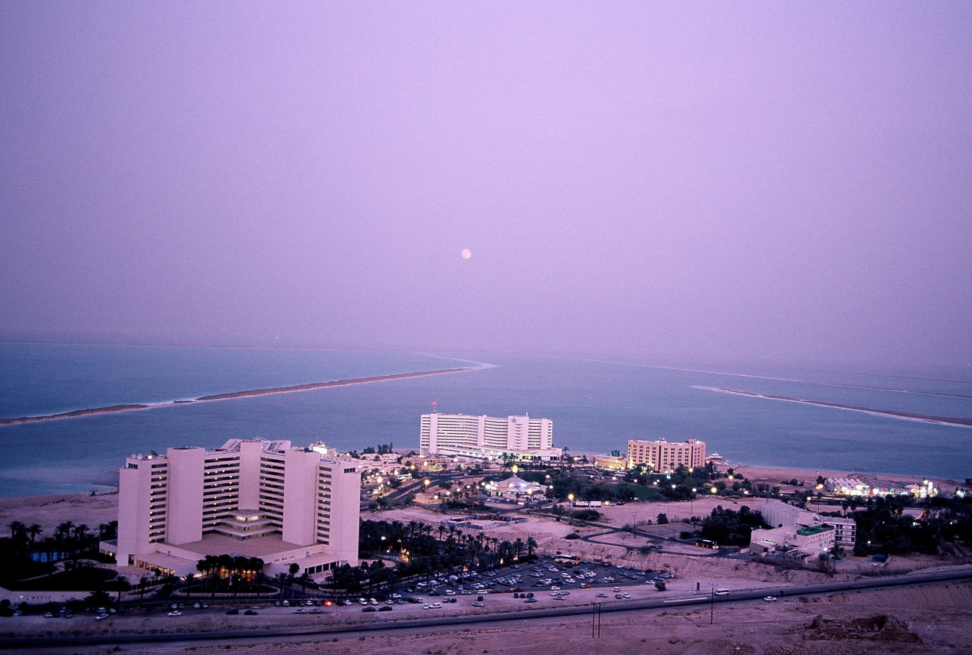
Hotel complex in the modern city of Sodom, which transformed from a desert to a flowering garden (Provided by the generosity of the Tamar Regional Council)

For further study:

Y. Bin-Nun, “Arei Ha-kikar Mi-tzafon Le-yam Ha-melach?!” in Z. Ehrlich (ed.), Shomron U-Binyamin, 2, Jerusalem 1991, 34-45 [Hebrew].

D. Ginzburg, “Hafichat Sedom Ve-Amora – Re’idat Adama o Tofa’a Ga’ashit,” Midrash U-ma’as 1 (1982), 31-35 [Hebrew].

B. MacDonald, East of the Jordan, Boston 2000, 45-61.

M. J. Mulder, “Sodom and Gomorra,” Anchor Bible Dictionary, 6:99-103.

W. E. Rast, “Bab edh-Dhra and the Origin of the Sodom Sage,” L. E. Toombs and G. L. Johnson (eds.), Archaeology and Biblical Interpretation, Atlanta 1987, 185-201.

G. Le Strange, Palestine under the Moslems, Beirut 1965, 286-292.

“Lisan” is Arabic for both “tongue” and “cape,” due to their similar shape. Compare to the Hebrew “lashon,” which functions in the same way.
The fact that Abraham was able to view the ruins of Sodom and Gomorrah from the area east of Hebron is not a proof in either direction, as Hebron lies at about the midpoint of the Dead Sea.
This argument is not foolproof, as it may be that the verse lumped together the entire Dead Sea region, both the north and the south.
It is noteworthy that remnants from the Middle Bronze Age (which coincided with the Patriarchal age) were also found in this cave.
I am indebted to Dr. Arye Bornstein for this consideration.

