YESHIVAT HAR ETZION
ISRAEL KOSCHITZKY VIRTUAL BEIT MIDRASH (VBM)
*********************************************************

GEOGRAPHY IN THE PARASHA

SUKKOT

Ka-Arava
By Prof. Yoel Elitzur

Zechariah’s Prophecy and the Essence of Sukkot

The Jewish festivals possess a dual identity: They are partly global, relevant to all of mankind, and partly exclusive, relevant to the people of Israel alone. The global side of the festivals is rooted in nature, while the other side is intrinsically connected to the history of the nation of Israel. Pesach is the Festival of Spring, of the blossoming and rejuvenation of the natural world. At the same time, it celebrates the rejuvenation of the nation of Israel, the pivotal transition from the darkness of enslavement to complete freedom. Shavuot marks the wheat harvest on the calendar and the beginning of the fruit season, while in terms of our national history it is a celebration of the Giving of the Torah and the promise of “But you shall be to Me a kingdom of priests and a holy nation” (Exodus 19:6). What about the festival of Sukkot? We are familiar with the natural side of the festival, the joyous celebration as we gather the summer harvest and bring it into our homes: “And the Feast of the Ingathering at the end of the year, when you gather in the results of your work from the field” (23:16). What is the side of the festival that pertains to the nation of Israel and its history? Of course, the verse, “I made the Israelite people live in booths” (Leviticus 23:43) is not relevant to this matter at all, as the verse does not refer to any particular date in the month of Tishrei, but rather to the overall experience of the nation of Israel. The answer to the question is provided by the prophet Zechariah, in a prophecy that we read as the haftara on the first day of Sukkot. Zechariah reveals to us that according to the divine plan, there will be a great war at the end of days. In this war, God will fight against the nations, and the wicked will be defeated at the gates of Jerusalem. Following this, the prophet states: “All who survive of all those nations that came up against Jerusalem shall make a pilgrimage year by year to bow low to the King Lord of Hosts and to celebrate the Feast of Booths” – Sukkot (Zechariah 14:16). It seems that the prophet is alluding here to the notion that this war will be “the war of the festival of Sukkot.” We find here the missing piece of the puzzle, the national historical event that stands parallel to the natural aspect of the festival. In addition to the agricultural ingathering of the harvest on Sukkot, we have a nation ingathering as well, redemption for a nation that has finally ended the saga of suffering and wandering. Henceforth, the nation of Israel will dwell safely and securely in its national homeland.

“Then the Whole Country Will Become Ka-Arava”

I would like to relate to a minor point in Zechariah’s prophecy, a linguistic point that has important geographical significance. The prophet speaks of changes that will affect the natural world as a result of the great war: the Mount of Olives will split, creating a huge gorge, fresh water shall flow from Jerusalem, etc. Then comes a unique verse: “Then the whole country will become ka-arava… but [Jerusalem] shall perch high up where it is, and shall be inhabited…” (Zechariah 14:10). What is the meaning of this verse? It seems that the verse is conveying that Jerusalem will be lifted up above all its surroundings.

The linguistic issue that I would like to clarify here does not concern a name, a word, a letter or even a whole vowel point. The issue concerns half of a vowel point, or more precisely, whether the point beneath the first letter in the word ka-arava is a kamatz (כָּעֲרָבָה) or a patach (כַּעֲרָבָה). Most accurate versions of the Tanakh print the word with a kamatz. Some older printings and a few manuscripts render the word with a patach.

Ka-arava in various printings; the top two versions read כָּעֲרָבָה, with a kamatz, while the bottom two versions read כַּעֲרָבָה, with a patach. Clockwise from top-left: Koren Bible (courtesy of Koren Publishing House); Keter Aram Zova – the Aleppo Codex (courtesy of Machon Ben Zvi and Ardon Bar-Hama; MS T-S A16.4 from the Cairo Geniza (Cambridge Library); D. Ginzburg Bible, London 1906.

What is the Difference between Arava and Ha-Arava?

What significance can there possibly be in such a seemingly miniscule distinction? As it turns out, even this tiny change in one diacritical mark can affect the deeper meaning of the entire message of the verse. First, a few word of background on prepositional prefixes in Hebrew. When the prefix letters bet, kaf and lamed are followed by the definite article, the letter heh is dropped and the prefix letter receives the vowel point of the heh (generally a patach followed by a dagesh). When the prefix is not followed by the definite article, it generally receives a shva. When the word arava – which begins with the guttural letter ayin punctuated with a chataf patach (עֲרָבָה) – is preceded by the definite article, it undergoes compensatory lengthening, becoming ha-arava with a kamatz (הָעֲרָבָה). When a preposition is added – ba-arava, ka-arava or la-arava – the prefix letter bet, kaf or lamed receives the kamatz of the definite article heh (בָּעֲרָבָה, כָּעֲרָבָה, לָעֲרָבָה). However, in the word’s indefinite form, the prefix letter does not receive a shva as in most other cases (due to the presence of the chataf patach following it). Instead, it receives a patach, yielding va-arava, ba-arava, ka-arava and la-arava (לַעֲרָבָה, כַּעֲרָבָה, בַּעֲרָבָה, וַעֲרָבָה).

Why does all this matter? If one were to open a Bible concordance to view the various instances of the word arava in the Tanakh, one would encounter an interesting phenomenon. It turns out that throughout the Tanakh, the word’s usage in poetic sections is distinctly different from its usage in prose sections. This is not the first time that we have highlighted this kind of distinction; we similarly noted in our discussion on Parashat Shoftim two different usages of the term nachal in Biblical poetry and prose. Indeed, the same dichotomy exists in the case of arava. It is easy to see that in every poetic, literary usage of the word arava, the meaning is “wilderness” or “desolation.” In addition, the word generally appears without the definite article, as in the following verses: “Arid desert shall be glad, wilderness (arava) shall rejoice and shall blossom like a rose” (Isaiah 35:1); “Who led us through the wilderness, a land of deserts (arava) and pits, a land of drought and darkness, a land no man had traversed, where no human being had dwelt?” (Jeremiah 2:6); “Her towns are a desolation, a dry land and a wilderness (va-arava)” (51:43). In contrast, in prose sections throughout the Tanakh the situation is quite different. There, the word consistently refers to the name of a region in the land of Israel, and thus it always appears with the definite article: Ha-Arava.

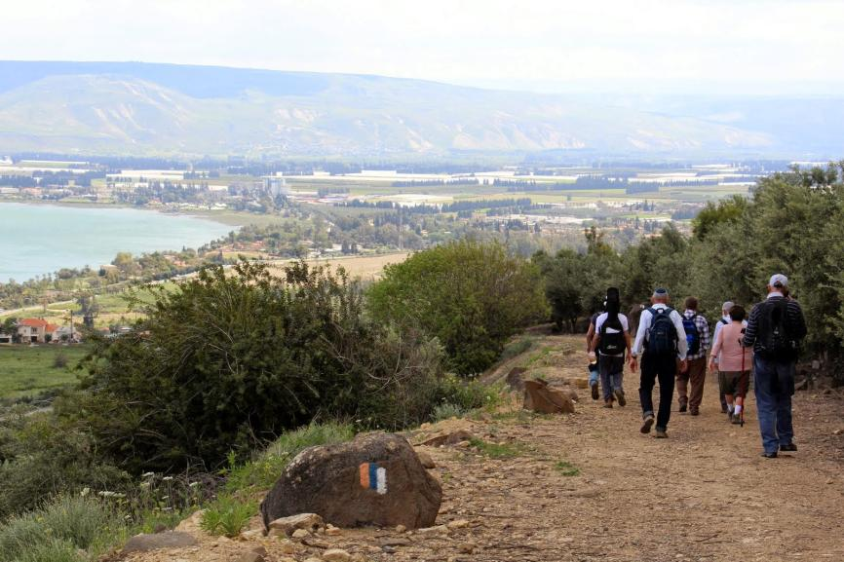
The fertile “Negev Kinnerot” south of the Sea of Galilee – part of the Biblical Arabah (Courtesy of Shabtay Shiran)

What is this region? Based on the lists of regions in the land of Israel that appear multiple times throughout the Tanakh – such as, “In the Arabah, the hill country, the Shephelah, the Negeb, the seacoast” (Deuteronomy 1:7); and, “Joshua conquered the whole of this region: the hill country, the Negeb, the whole land of Goshen, the Shephelah, the Arabah” (Joshua 11:16) – it seems that the Arabah is the Jordan Rift Valley and the Dead Sea. This is sometimes written explicitly, as in the verse, “And from Chinnereth down to the sea of the Arabah, the Dead Sea” (Deuteronomy 3:17). In another place, the word Ha-Arava is mentioned in relation to Elath and the Sea of Suph: “We then moved on, away from our kinsmen, the descendants of Esau, who live in Seir, away from the road of the Arabah, away from Elath and Ezion-geber” (2:8). However, we encounter the Arabah in the northern part of the land of Israel as well. King Jabin of Hazor calls to arms “the other kings in the north – in the hill country, in the Arabah, south of Chinnereth, in the lowlands and in the district of Dor on the west” (Joshua 11:2), meaning that there is a region called “the Arabah” in the north – a green, fertile region – as well. What can all these regions that the Tanakh calls “the Arabah” possibly have in common?

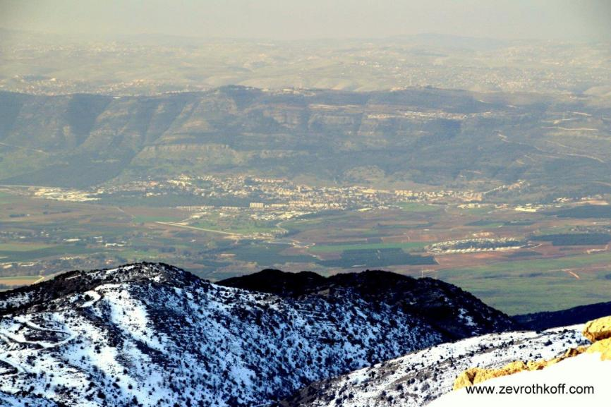
The region of the sources of the Jordan River (view from Mt. Hermon) – the northern part of the Biblical Arabah (Courtesy of Dr. Zev Rothkoff)

Apparently, all of these regions are found within what is known today as the Great Rift Valley, and the Arabah is the name of the long valley between the Transjordan and the Cisjordan, running from the sources of the Jordan all the way to Eilat. Several Biblical expressions containing the term arava or aravot also refer to locations within that same rift, including Arvot Mo’av; Arvot Yericho; Arvot Ha-Yarden and, of course, Yam Ha-Arava (the sea of the Arabah, i.e., the Dead Sea); and the old/new settlement Beit Ha-Arava to its north. The instances of these place names in the Tanakh are all found in section of Biblical prose, and they all are definite as well.

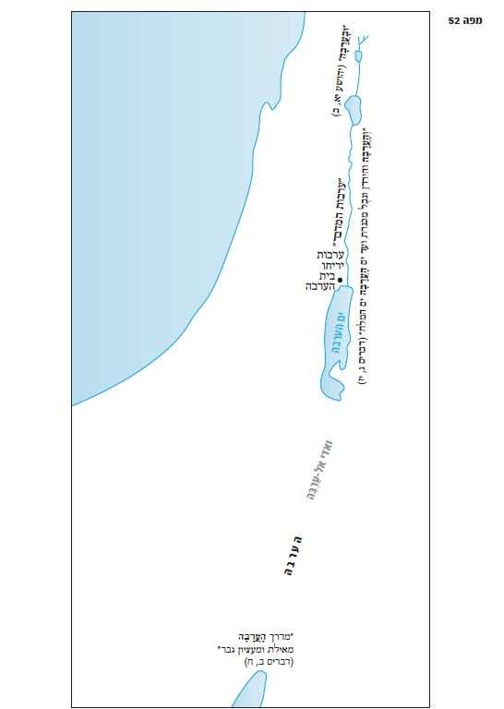

The region known today as the Arava (preserved also in Arabic as Wadi ‘Araba) is in fact one part of the Biblical region called the Arabah.

How did two different meanings for the same concept develop in Biblical Hebrew? It is doubtful if we will ever have the ability to answer this question, which relates to a very ancient period in the history of the Hebrew language. It may be that at first, the name referred to any region resembling the southern Dead Sea region – a region that was both very arid and very flat – and then each of these two features became the defining characteristic of arava in different linguistic contexts.

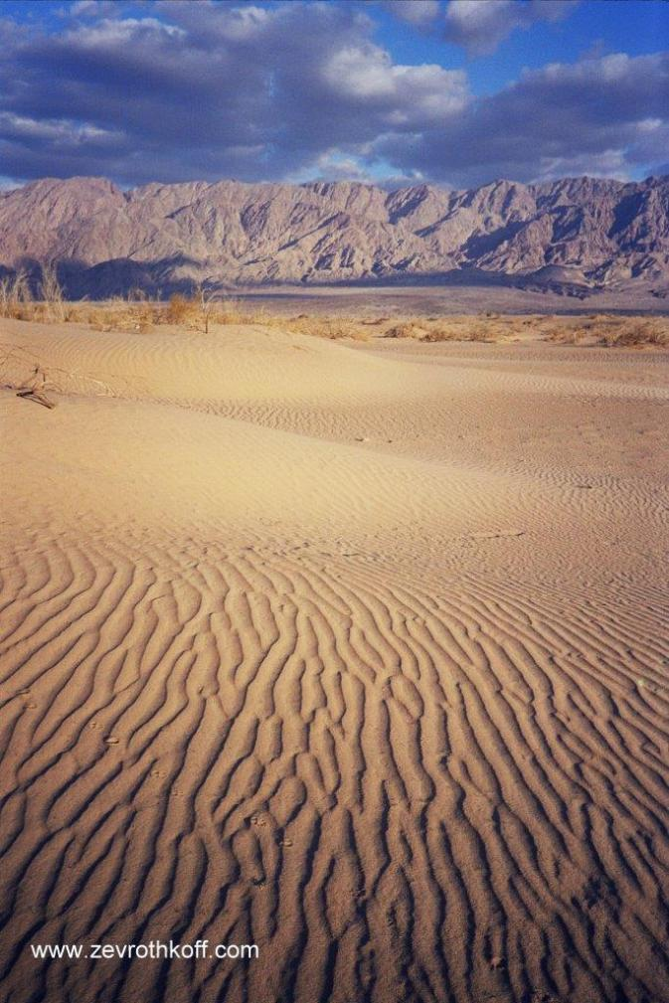
The southern Arabah, near Eilat (Courtesy of Dr. Zev Rothkoff)

Returning to the Verse in Zechariah

If the word ka-arava were vowelized with a patach (כַּערבה), the meaning of the verse would be that the entire land would become like an arava – like a desolate wilderness. If that were the case, the verse would completely negate the message of the rest of the chapter, a prophecy of consolation promising that “fresh water shall flow from Jerusalem, part of it to the Eastern Sea and part to the Western Sea, throughout the summer and winter” (Zechariah 10:8).

But the proper vowelization is with a kamatz (כָּעֲרָבָה) – meaning “like the Arabah.” In other words, the entire region surrounding Jerusalem will become completely flat, like the Arabah, and Jerusalem will perch high above it all. Thus, what we have here is a prophecy similar in its message to that of the book of Isaiah: “Let the rugged ground become level and the ridges become a plain. The Presence of the Lord shall appear” (Isaiah 40:4). I am not sure if the prophet was describing an actual geological phenomenon in this verse. Azaria Alon z”l, one of the founders of the Society for the Protection of Nature in Israel, once quipped in a radio interview that he hopes that the prophets who predicted that the deserts will transform into habitable land only meant this theoretically and symbolically – because if not, the Society would no longer be able to conduct their desert tours. In the same vein, we are permitted to hope that our prophets did not intend for Israel to transform in to the Netherlands, famous for its low and flat geography. In any case, what is clear from the verse in Zechariah is that Jerusalem will be lifted up as a model for all to see, a symbol of redemption for the people of Israel and for the world as a whole.

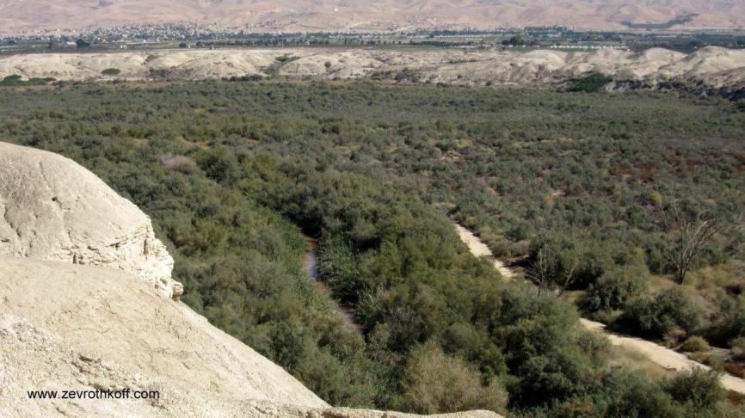
A typical view of the Jordan Rift Valley between the Sea of Galilee and the Dead Sea in its middle and southern parts – the Biblical Arvot Ha-Yarden (Courtesy of Dr. Zev Rothkoff)

For further study:

Yehuda Elitzur and Y. Keel, Daat Mikra Bible Atlas (trans. L. J. Schramm), Jerusalem 2011, 5.
I. Press, Mechkarim Bi-yedi’at Ha-aretz Ve-topografiya Mikra’it, Jerusalem 1961, 223-224 [Hebrew].
J. Simons, The Geographical and Topographical Texts of the Old Testament, Leiden 1959, 49-50.
Targumim and commentators on Zechariah 14:10.
Tosefta Sota 11:14 (Lieberman ed. 222-223).

********************************

Translation of map:

"ובערבה" (יהושע יא ב) | “In the Arabah” (Joshua 11:2)
"ערבות המדבר" | “Arvot Ha-midbar”
ערבות יריחו | “Arvot Yericho”
בית הערבה | Beit Ha-Arava
"והערבה והירדן וגבל מכנרת ועד ים הערבה ים המלח" | “The Arabah, to the edge of the Jordan, and from Chinnereth down to the sea of the Arabah, the Dead Sea” (Deuteronomy 3:17)
ואדי אל-ערבה | Wadi ‘Araba
הערבה | Arabah
ים הערבה | Sea of the Arabah
"מדרך הערבה מאילת ומעציון גבר" | “Away from the road of the Arabah, away from Elath and Ezion-geber” (Deuteronomy 2:8)

Translated by Daniel Landman

This follows the Hebrew principle that names of regions in the land of Israel always use the definite article, as in “the Negeb”; “the Shephelah”; “the Sharon”; “the Galilee”; “the Lebanon”; “the Bashan.”
A construct state is definite whenever the compositional morpheme is definite (such as beit yosef or beit ha-melekh).
Map 52 (translation of map is at the end of this shiur).
Such a usage can perhaps be found in Job 39:6: “Whose home I have made the wilderness (arava), the salt land his dwelling-place.”

