YESHIVAT HAR ETZION
ISRAEL KOSCHITZKY VIRTUAL BEIT MIDRASH (VBM)
*********************************************************

GEOGRAPHY IN THE PARASHA

PARASHAT KI TAVO

Mount Gerizim and Mount Ebal
By Prof. Yoel Elitzur

The Importance of the Covenant at Mount Gerizim and Mount Ebal

The location that lies at the heart of Parashat Ki Tavo is undoubtedly Mount Gerizim and Mount Ebal. The covenant of Mount Gerizim and Mount Ebal seems to be quite an important mitzva in the context of Deuteronomy. It is mentioned twice in Deuteronomy, in extremely significant places. The book of Deuteronomy is divided into three parts, and since Parashat Ki Tavo is always read at the end of the month of Elul, it is only fitting to compare this three-part division to the three parts of each shofar blast on Rosh Ha-shana. It is well known that each blast (teru’a) is accompanied by a “plain blast” (teki’a) before it and after it, totaling three distinct sounds. The book of Deuteronomy is constructed using a similar format: In the beginning, Moses presents the basic tenets of faith (Parashiyot Devarim, Va’etchanan and Ekev); then comes the complex and diverse list of mitzvot (Re’eh, Shoftim, Ki Tetze, and the beginning of Ki Tavo); and finally the “plain blast” returns – the covenant is forged, accompanied by song and blessing. It is interesting that it is precisely at the two points of transition between the three sections that the mitzva to bless and curse at Mount Gerizim and Mount Ebal occurs. The first time, this mitzva appears only briefly, at the end of the faith chapters of Deuteronomy and before the start of the list of mitzvot in the opening to Parashat Re’eh. The second time, it is described at length in Parashat Ki Tavo, after the mitzvot section and before the covenant section. This demonstrates that the book of Deuteronomy assigns unique significance to the blessing and curse ritual that took place between Mount Gerizim and Mount Ebal. Its textual placement between the principles of faith and the mitzva details seemingly teaches us that within the essence of this transition lies the connection between lofty principles and practical actions.

The outsize importance of the mitzva to read the blessing and the curse between Mount Gerizim and Mount Ebal is especially striking in light of the fact that the mitzva is not applicable for future generations. It was a one-time event that captivated the hearts of the entire nation at the time of their entry into the land of Canaan. It may be that the final two commandments in the Torah – the mitzva of hak’hel, which renews the covenant every seven years, and the mitzva to write down the song of Ha’azinu for future generations, “in order that this poem may be My witness against the people of Israel” (Deuteronomy 31:19) – represent an intergenerational vehicle for the message of this one-time event. Be that as it may, this is an exceptionally unique mitzva, one that was intended from the start to be fulfilled one time only. In addition, the Torah dedicates considerable attention to the details of the mitzva and to the precise location where it was set to take place. In order for us to understand the essence of this event, we must first try to understand the details of this mitzva, as well as the framework for the time and place that the Torah designates for its fulfillment. It is easy to become lost in the sea of rabbinic commentary on this question, so we will not attempt to review all of the opinions and possibilities. Instead we will attempt to forge directly to the crux of the matter.

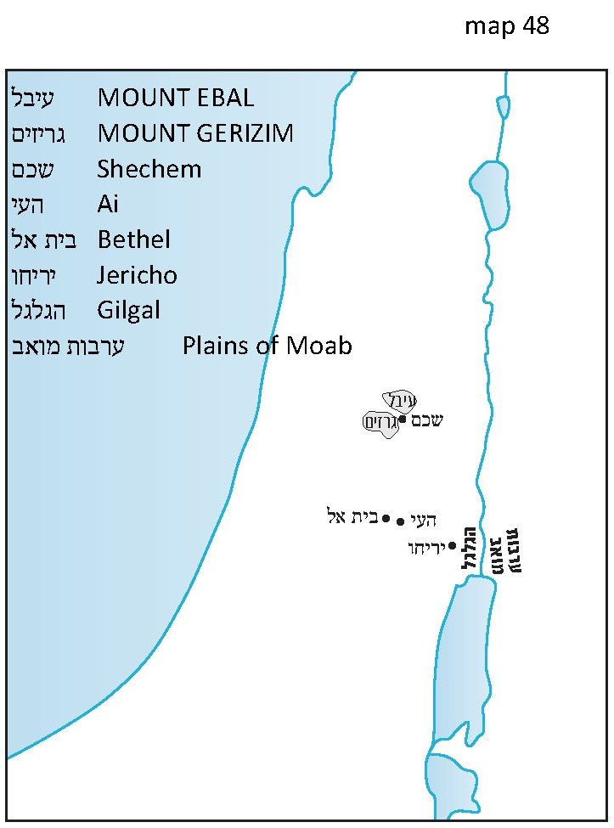

The Place

The place where the event took place is exceedingly important to the Torah, and as such the Torah describes it in detail: “Both are on the other side of the Jordan, beyond the west road that is in the land of the Canaanites who dwell in the Arabah – near Gilgal, by Elonei Moreh” (Deuteronomy 11:30). This is a highly detailed description, but at the same time it is quite enigmatic as well. It is worth considering the fact that while the Torah goes on at length in describing this location, it refrains from mentioning the place that we would certainly have expected to see in this geographical context: Shechem! In the remainder of our discussion, we will attempt to suggest an explanation for this exclusion. Most of the components in this geographic description cannot be deciphered easily, but the parts that can be understood present a kind of internal contradiction. “The Canaanites who dwell in the Arabah” and “Gilgal” seem to direct us to the Jordan Rift Valley, but “by Elonei Moreh” clearly leads us to Shechem (see Genesis 12:6: “Abram passed through the land as far as the site of Shechem, at Elonei Moreh.”)

The Time

A similar contradiction exists with respect to the time at which the event was set to take place. On the one hand, the Torah states that the matter of Mount Gerizim and Mount Ebal must be done “as soon as you have crossed the Jordan” (Deuteronomy 27:2), “after you have crossed the Jordan” (27:12), meaning that it must happen immediately after entering the land. On the other hand, the Torah also states that the ritual must take place specifically on Mount Gerizim and on Mount Ebal, which, as far as we know, are located in the heart of the land, near Shechem – or as Chazal put it, sixty mil from the Jordan. Thus, the ritual could not possibly take place immediately upon entering the land. This contradiction requires one either to assume that a miracle took place that was not mentioned in the verses – that the people were able to travel a distance of 120 mil in one day (as the baraita in Sota suggests) – or to follow Rabbi Elazar’s suggestion that Mount Gerizim and Mount Ebal were actually located near the Jordan: “They put up two mounds and called one Gerizim and one Ebal” (Yerushalmi Sota 21c). But the simple geographical fact is that Mount Gerizim and Mount Ebal are located in Samaria, near Shechem. This is written explicitly in Judges 9:7: “When Jotham was informed , he went and stood on top of Mount Gerizim and called out to them in a loud voice. ‘Citizens of Shechem!’ he cried, ‘listen to me, that God may listen to you.’” In other words, Mount Gerizim is within earshot of Shechem. It seems that the Torah is expressing that, on the one hand, this is a mitzva that applies immediately once the people of Israel enter the land, but on the other hand it is a mitzva that is intimately linked to Shechem and its environs in the epicenter of the land. As in other similar examples, the Torah is not a book of halakhic guidelines in the vein of the Shulchan Arukh. Rather, it presents both possible directions and then places the responsibility to find the proper solution on the nation of Israel – in this case, on Joshua and his generation. One who reads the book of Joshua on a simple level will find that Joshua indeed found a practical solution to the Gerizim-Ebal contradiction that did not match any of those proposed by Chazal. This solution took into consideration the two principles stated in the Torah and weighed them against the reality of Joshua’s own practical considerations. Joshua believed that once the nation of Israel enters the land, it was their responsibility to put in the utmost effort to conduct the ritual as soon as possible. The moment that Jericho and Ai were in his hands, Joshua could have relied on the paucity of Canaanite settlement in the Mount Ephraim area and taken the whole nation of Israel to Mount Ebal to forge the covenant of the blessing and the curse.

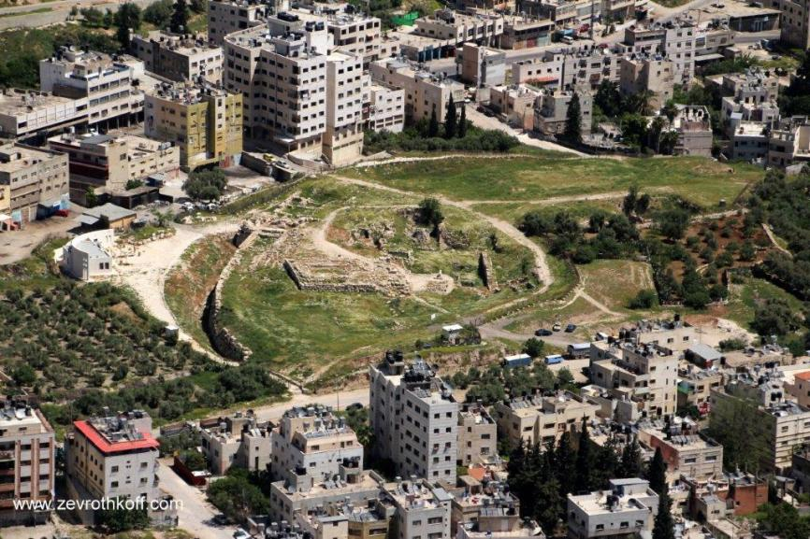
“[Jotham] went and stood on top of Mount Gerizim… ‘Citizens of Shechem, listen to me!’” A view of ancient Shechem from the top of Mount Gerizim. Note the city wall and the temple with the large stone to its right. (Courtesy of Dr. Zev Rothkoff)

The Details

What happened at Mount Gerizim and Mount Ebal? Once again, the limited scope of this discussion forces us to skip over many long and rich disputes on this question. We will suffice in saying, in brief, that the nation apparently stood between Mount Gerizim and Mount Ebal in the valley where the modern-day city of Shechem can be found today. Joshua 8:33 states: “All Israel – stranger and citizen alike – with their elders, officials and magistrates, stood on either side of the Ark… half of them el mul Mount Gerizim and half of them el mul Mount Ebal.” Based on what we explained in our discussion on Parashat Tzav, this means that six tribes stood at the foot of Mount Gerizim or on its slopes and six tribes stood at the foot of Mount Ebal. The area between the two mountains is enclosed, the Ark is situated in the middle, the priests and Levites surround the Ark and all of Israel stands on either side. The explanation for the division of the tribes into two groups that are not familiar from other contexts – Simeon, Levi, Judah, Issachar, Joseph and Benjamin opposing Reuben, Gad, Asher, Zebulun, Dan and Naphtali – was discovered by Rabbi Dr. Michael Broyde. It turns out that from a mathematical perspective, this was the division that would split the nation most effectively (based on the census of Parashat Pinchas) into two equal halves.

What is the nature of the “large stones” regarding which we were commanded to “coat them with plaster and inscribe upon them all the words of this Torah”? First of all, according to the simple reading of the verse, there is no connection between these stones and the altar stones, nor between these stones and the stones that were taken from the Jordan and set up at Gilgal. My father, z”l, taught me to follow Rabbi Saadia Gaon’s interpretation on this matter, cited in Ibn Ezra’s commentary here, that these stones served as posters or placards, such as those used today at important ceremonies. In other words, the stones were coated with plaster in order to emphasize the text that was written upon them, in this case, select verses from the Torah that would have the capacity to inspire the hearts of the event’s participants and draw their attention to the magnitude of the event and the significance of the covenant. These included verses such as “Hear, O Israel! The Lord is our God, the Lord alone” (Deuteronomy 6:4); “Today you have become the people of the Lord your God” (27:9); “You have affirmed this day that the Lord is your God… and the Lord has affirmed this day that you are His treasured people” (26:17-18); “There is none beside Him” (4:35); and “For thereby you shall have life and shall long endure upon the soil that the Lord swore to your ancestors, Abraham, Isaac and Jacob, to give to them” (30:20).

What Did the Levites Proclaim?

Again, there is a contradiction between the peshat and the midrashic tradition. According to the Mishna, the twelve “Cursed be” verses in the passage were also accompanied by twelve parallel blessings:

They turned their faces toward Mount Gerizim and opened with the blessing: Blessed be anyone who does not make a sculptured or molten image, abhorred by the Lord, a craftsman’s handiwork, and does not set it up in secret. And both parties respond, Amen. They then turned their faces toward Mount Ebal and opened with the curse: Cursed be anyone who makes a sculptured or molten image, abhorred by the Lord, etc. And both parties respond, Amen. (Sota 32a)

This interpretation is difficult to accept: If the Torah decided to present an abridged version of the Levites’ proclamation, why would it choose to present only the curses? Would it not make more sense to present the blessings and allow the reader to “fill in” the implied curses? Another difficulty was raised by one of my students after we studied this passage together. She asked: I can understand why a person who does not make idols or who “upholds the terms of this Torah and observes them” deserves to be blessed. But can it truly be that thousands of Levites were instructed to stand up and proclaim out loud, for the whole nation of Israel to hear: “Blessed be anyone who does not lie with his father’s wife” or “Blessed be he who does not lie with any beast”? People who engage in these depravities are certainly worthy of being cursed, but that does not mean that anyone who does not do so automatically earns a blessing or a yasher ko’ach!

Rabbi David Zvi Hoffman found that the blessing/curse passage following the twelve “Cursed be” verses contains six short “Blessed be” clauses followed by six parallel “Cursed be” clauses. These six blessing/curse pairs form a kind of basic skeleton for the blessings and the curses in general:

Blessed/Cursed shall you be in the city;

Blessed/Cursed shall you be in the country;

Blessed/Cursed shall be the issue of your womb, the produce of your soil, and the offspring of your cattle, the calving of your herd and the lambing of your flock;

Blessed/Cursed shall be your basket and your kneading bowl;

Blessed/Cursed shall you be in your comings;

Blessed/Cursed shall you be in your goings.

According to Rabbi Hoffman, these twelve blessings and curses were directed at the twelve tribes, six “Blessed be” clauses for Mount Gerizim and six “Cursed be” clauses for Mount Ebal.

It seems that a preferable position is that of Ibn Ezra, who explains that the twelve unpaired “Cursed be” verses are merely an introduction. The actual blessings and curses are “Now, if you obey… all these blessings shall come upon you and take effect… But if you do not obey… all these curses shall come upon you and take effect…” These passages detail at length the blessings that will come upon the people if they faithfully observe God’s commandments, and at much greater length the curses, the exiles and the torments that will befall the people if they betray their God. Admittedly, there is seemingly still one difficulty with this interpretation, namely, the final verse: “These are the terms of the covenant which the Lord commanded Moses to conclude with the Israelites in the land of Moab” (28:69). This means that the lengthy blessing and curse sections were meant to be read in the plains of Moab and not at Mount Ebal. Ibn Ezra resolves this difficulty by proposing an original syntactical understanding. He explains, in brief, that “the land of Moab” is an adverbial adjunct of the phrase “which the Lord commanded” and not of “to conclude.” Thus, it is as if the Torah is saying, “These are the terms of the covenant which the Lord commanded Moses in the land of Moab to conclude with the Israelites.”

In the end, the very fact that Moses, on the eve of his departure, stood up and transmitted the entire lengthy blessing and curse before the nation of Israel created a “covenant at the plains of Moab” here. Moses himself preceded the commandment regarding the blessing and curse of Gerizim and Ebal with the festive words: “The Lord your God commands you this day to observe… You have affirmed this day that the Lord is your God… And the Lord has affirmed this day that you are His treasured people.” Later, he concluded the section saying, “I make this covenant, with its sanctions, not with you alone, but both with those who are standing here with us… and with those who are not with us here this day.” But by definition, this covenant was a preparation for the great covenant forged between Gerizim and Ebal, and the ambiguous language of the verse, “These are the terms of the covenant…” gives a measure of power to the covenant at the plains of Moab as well. Ibn Ezra’s approach also fits the verse in Joshua 8:34: “After that, he read all the words of the Torah, the blessing and the curse, just as is written in the Book of the Torah.” The opening of the impressive ceremony was punctuated by the initial proclamation of the twelve “Cursed be” verses, through which each Israelite swore to adhere to commandments that are germane to the private realm – and thus practically unenforceable at the hands of the community. These curses were presented to the nation of Israel as a warning and an oath for each of its members, and the entire nation – all twelve tribes – answered with a great, resounding “Amen.”

Why Specifically on Mount Gerizim and Mount Ebal?

Now let us dedicate a few words to the question of why Mount Gerizim and Mount Ebal specifically were chosen as the venue for this event. What is the unique significance of this place? And why was the city of Shechem not mentioned explicitly in the Torah’s description of the location? I will present three ideas here that are not mutually exclusive; rather, they complete one another.

The first idea was proposed by Henry Baker Tristram, a Christian scholar who possessed great love and knowledge of the Tanakh. Tristram toured the land and studied its sites, focusing specifically on their flora and fauna, about 150 years ago. He scaled Mount Gerizim, reaching its peak on December 21, 1863. According to Tristram, Mount Gerizim was chosen for the blessing and curse ceremony, and later as the site where Jotham delivered his parable, because of the unique acoustic effect created by the two tall mountains that enclose the Shechem valley. Tristram writes:

A single voice might be heard by many thousands, shut in and conveyed up and down by the enclosing hills. In the early morning we could not only see from Gerizim a man driving his ass down a path on Mount Ebal, but could hear every word he uttered as he urged it on; and in order to test the matter more certainly, on a subsequent occasion two of our party stationed themselves on opposite sides of the valley, and with perfect ease recited the commandments antiphonally.

I do not know what inspired Tristram’s companions to recite the Ten Commandments specifically for this test, but the key point here is the technical appropriateness of the location for its purpose, as Tristram states: “It is impossible to conceive a spot more admirably adapted for the purpose than this one.” It is interesting to note that Eusebius, the Greek bishop of Caesarea around 320 CE, believed that Mount Gerizim and Mount Ebal near Shechem are not the actual mountains in question, since “they are not able to hear one another when calling out from one” (Onomasticon 64:13-15). Tristram’s “test” and my own personal experience (as well as that of many others) seem to belie this statement.

While Tristram’s account is as charming as it is true, it is somewhat difficult to suffice with such a technical explanation for such a portentous choice. I will present here two additional avenues of thought that relate to the connection between the two mountains and the essence of the covenant.

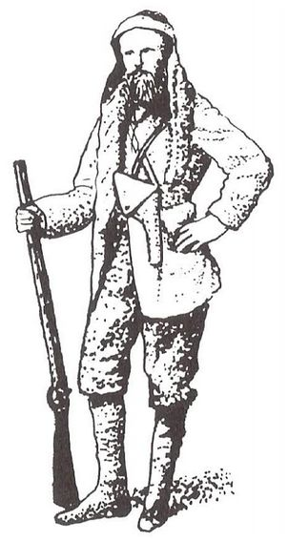
Henry Baker Tristram (1822-1906)

The second idea is my own. Let us recall once again what we already noted above: that the Torah stresses that the blessing and curse ceremony must take place between the two mountains, Gerizim and Ebal; and that the Torah intentionally refrains from mentioning Shechem by name, seemingly in order to distance the covenant from any connection to the city. While Shechem certainly has its own virtues, the covenant of the blessing and the curse is not connected to those virtues but to those of the two mountains. Nonetheless, Shechem can provide us with a frame of reference for the division of the land into regions. A map of the cities of refuge in the land of Israel demonstrates that Shechem is located in the central region of the land. The northern city of refuge is Kedesh in Naphtali, the middle city is Shechem and the southern city is Hebron, and the Torah states, “You shall divide into three parts the territory of the country” (Deuteronomy 19:3). This teaches us that Shechem, located between Mount Gerizim and Mount Ebal, is considered the midpoint of the land of Israel. From the perspective of road travel as well, one of the branches of the ancient international road bisected the land of Israel at the valley conveniently located between Mount Gerizim and Mount Ebal. From here, this branch splits off into the national road from Shechem, passing through Shiloh, Bethel, Jerusalem, Bethlehem, Hebron and Beersheba. Jacob, and apparently Abraham before him, arrived in the land of Canaan via this road. Mount Gerizim and Mount Ebal are very tall mountains; Mount Ebal is 3084 feet above sea level, while Mount Gerizim is 2890 feet above sea level. A steep slope from each mountain leads to the valley between the two, about 1640 feet above sea level.

The Hebrew verb for forging a covenant is kerita (literally, cutting off) and similar verbs serve the same purpose in other languages as well. In two places in the Tanakh, we indeed find that the parties involved in a covenant would cut up the body of a live animal and pass through the pieces. Thus we read regarding the Covenant of the Pieces:

Bring Me a three-year-old heifer, a three-year-old she-goat, a three-year-old ram, a turtledove and a young bird… He cut them in two, placing each half opposite the other… There appeared a smoking oven and a flaming torch (Rashi: the proxy of the Shekhina, which is fire) which passed between those pieces. (Genesis 15:9-17)

Likewise, in Jeremiah 34:18: “The calf which they cut in two so as to pass between the halves.” The meaning of this practice in the context of forging a covenant is perhaps the following statement: We are both symbolically connected to each other as one live body. If we violate the terms of the covenant, may the two of us be like these two carcasses. In light of this, it seems to me that Mount Gerizim and Mount Ebal were chosen because this was the place where it was as if God cut the land of Israel in two. Between the pieces, the Ark – representing the Shekhina – stood along with the people of Israel and together forged a covenant. The covenant between God and the people of Israel had already been forged at Sinai, but that was merely a theoretical covenant, established in the wilderness, over a Torah that was neither connected to the land of Israel nor grounded in reality. In the land of Canaan, the Torah assumed its true form, as it was given “for you to observe in the land that you are about to cross into and occupy” (Deuteronomy 4:14). The land of Israel is a living body, a land that bestows its bounty upon its faithful children (“The land shall yield its fruit” [Leviticus 25:19]), listens closely to the word of God (“Let the earth hear the words I utter!” [Deuteronomy 32:1]), acts as a witness (“I call heaven and earth to witness against you this day [30:19]) and spews out those that defile it (“Let not the land spew you out for defiling it” [Leviticus 18:28]). Now, the covenant is renewed together with the land itself, between the pieces of the “living body” of the land of Israel.

The third idea was conceived by Rabbi Uri Sherki of Jerusalem. I heard this idea from Rabbi Yisrael Ariel, a teacher at Yeshivat Od Yosef Chai in Yitzhar. The yeshiva was situated in the very plot of land purchased by Jacob (Genesis 33:19) in which Joseph’s Tomb was later situated (Joshua 24:32) near the mound of ancient Shechem until the riots of September-October 2000. It can be said that the Biblical virtue of this site and its vicinity was a central theme in the yeshiva’s world view. The following is the idea, in brief.

Rabbi Uri Sherki of Jerusalem

The area between Gerizim and Ebal has a distinctive landscape, one that resembles an overturned mountain. The ceremony at Mount Gerizim and Mount Ebal can be seen as a kind of negative image of the revelation at Sinai. At Mount Sinai, the people of Israel stood at the foot of the mountain. The mountain itself was enveloped in thick cloud, smoke and fire, and God’s voice emanated from within the fire, addressing the nation. At this heady juncture, what does the nation do? All the people need to do is listen. This task is perfectly suited for the people who had only recently left Egypt, who now subsist on manna in the wilderness; all that is asked of them is to listen to the voice of God. Upon entering the land, however, their hierarchy of values is turned on its head. In the land of Israel, nature takes the place of miracles; “You shall gather in your new grain and wine and oil” (Deuteronomy 11:14). God’s voice does not emanate from within the fire; rather we must broadcast God’s voice on our own. In the land of Israel, the divine word does not come from some mountain that towers above us; quite the opposite, God’s voice stems from within the holy ground itself. The Ark stands in the middle, surrounded by the Levites, in lieu of God’s actual voice, the Levites transmit God’s message from within the land and the nation of Israel stands on the slopes of Mount Gerizim and Mount Ebal on both sides of the valley. Instead of clouds and smoke, there are stones painted by the Israelites themselves with white plaster. The whole ceremony acts as a metaphor for divine worship in the land of Israel, a worship that is firmly rooted in the land’s holy soil. Even the very voice of God does not ring out on its own; we must listen for it and broadcast it on our own.

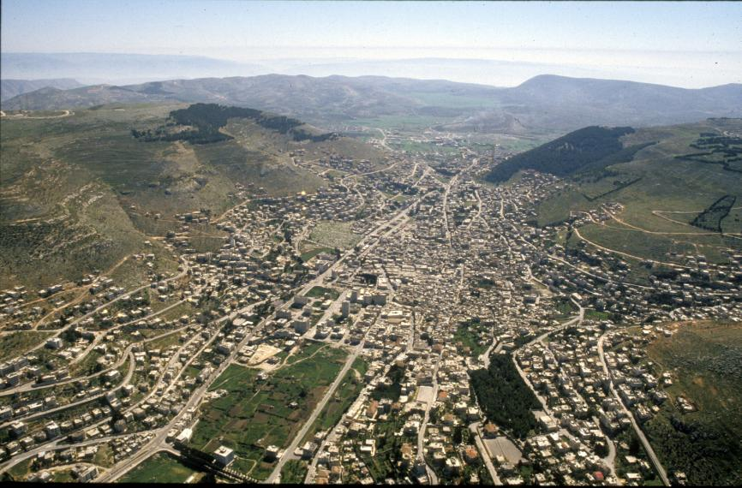
Aerial photograph from the west of Mount Gerizim (right), Mount Ebal (left) and the valley in which the covenant was forged. (Z. Radovan)

I will close by adding another wrinkle to this idea that I came to understand through an emotional encounter. In the year 2007, I spent the Shabbat of Parashat Lekh Lekha in Elon Moreh – a settlement overlooking ancient Shechem from the east, and whose name is featured in that parasha – along with many other like-minded Jewish visitors. In the afternoon, after viewing Mount Gerizim and Mount Ebal from a lookout point and speaking about their importance, I was approached by Yael Lieberman, the widow of Rabbi Hillel Lieberman, who was murdered on his way to Joseph’s Tomb during the Arab riots of September 2000. Yael showed me a piece of gold jewelry made of two triangles that she received as a gift from her husband. Hillel had explained to his wife (based on the teachings of Rabbi Sherki as well, as he later communicated to me) that the two triangles – one pointing up and the other pointing down – represent Mount Sinai and the valley between Mount Gerizim and Mount Ebal, respectively. When combined, the two triangles form the basis for the essence of the covenant between the nation of Israel and God. It is no coincidence that this combination of the upright triangle and the inverted triangle was chosen as the symbol of the nation of Israel: the Star of David.

Rabbi Hillel Lieberman Hy”d (1964-2000)

For further study:

Y. Ariel, Tabur Ha-aretz: Li-shevachah shel Ir Ha-berit, Jerusalem 1990, 18 [Hebrew].

E. S. Artom, “Berit,” Encyclopaedia Biblica 2, col. 347-351 [Hebrew].

M. J. Broyde, “A Mathematical Analysis of the Division of the Tribes and the Role of the Levites on Grizim and Aval in Deuteronomy 27,” Tradition 27 (1992), 48-57.

G. S. P. Freeman-Grenville, R. L. Chapman and J. Tailor, The Onomasticon by Eusebius of Caesarea, Jerusalem 2003, 40-41.

H. B. Tristram, The Land of Israel, a Journal of Travels with Reference to its Physical History, London 1865, 149-150.

Translated by Daniel Landman

See Map 48
The Samaritans solved this problem in a characteristic manner: In their version of the Torah, they add the phrase “near Shechem.” Chazal were familiar with this version, as we read in Sota 33b and parallels: “You have falsified your Torah but you gained nothing thereby.”
Compare to “Canaanites dwell by the Sea and along the Jordan” (Numbers 13:29) and “They encamped at Gilgal on the eastern border of Jericho” (Joshua 4:19).
For verses with a similar structure, compare to Deuteronomy 12:2 (and Rashi’s commentary) and Amos 9:12 (and Radak’s commentary).
For the authenticity of this site and its role in the public discourse in contemporary Israel, see our discussion on Parashat Vayishlach.

