YESHIVAT HAR ETZION
ISRAEL KOSCHITZKY VIRTUAL BEIT MIDRASH (VBM)
*********************************************************

GEOGRAPHY IN THE PARASHA

PARASHAT TZAV

Mul
By Prof. Yoel Elitzur

El Mul Panav

“And he set the headdress on his head; and on the headdress, el mul panav, he put the gold frontlet, the holy diadem – as the Lord had commanded Moses” (Leviticus 8:9).

The word mul is a very common preposition in modern, spoken Hebrew. It means “opposite” – on the opposite side. If, for example, a Hebrew speaker tells you that the Cohen family lives “mi-muli,” he is saying that he lives on one side of the street and the Cohens live on the other side.

If we only consider this contemporary usage, the above verse makes little sense. The headdress is, of course, placed on the head of the High Priest, and we read in Exodus that the frontlet is placed beneath it – “on Aaron’s forehead” (28:38). How can Aaron’s forehead possibly be considered the “opposite” side of Aaron’s face?

Slaughtering the Bird Offering

A similar usage of mul is found in the Torah’s instructions for slaughtering a bird as a sin offering: “He shall pinch its head mi-mul the nape without severing it” (Leviticus 5:8) – a process known as melika. What is the meaning of mi-mul here? Once again, if we interpret mul the way that it is used in modern Hebrew, we would have to conclude that melika is performed by pinching the bird’s head on the side opposite its nape, namely, on its neck. But if that were true, then why would the Torah mention this explicitly? Animal offerings are unquestionably slaughtered at the neck, so a statement indicating that birds are slaughtered at the neck as well would be superfluous. Moreover, why would the Torah use such a circumlocutory phrase as “opposite the nape” instead of saying, simply, “at the neck”?

Therefore, it is clear that melika is not performed at the neck but at the nape, as Chazal state:

If one cut at the nape, the slaughtering is invalid; if one pinched off [the head] from the nape, the melika is valid. If one cut at the neck, the slaughtering is valid; if one pinched off [the head] from the neck, the melika is invalid. For the whole of the nape is the appropriate place for melika, and the whole of the neck is the appropriate place for slaughtering. It follows, therefore, that the place which is appropriate for slaughtering is inappropriate for melika, and the place which is appropriate for melika is inappropriate for slaughtering. (Mishna Chullin 1:4)

Thus, it is well documented that a bird offering is slaughtered at the nape. However, our linguistic question remains unsolved: Why did the Torah use the word mi-mul when describing the appropriate place for melika, instead of simply saying “He shall pinch its head at the nape”?

Origin of Mul and its Appearances in Tanakh

The key to solving this problem is a close examination of the word mul. The results of this examination will likely have a significant impact on several areas of Tanakh, and on Biblical geography in particular.

First, we learn that the preposition mul has no equivalent in any Semitic language besides Hebrew. Even in Hebrew, mul is not used in the language of Chazal, and even in Tanakh it appears only in the prose sections; it is absent from the poetry sections of Tanakh. In the prose sections of Tanakh, however, mul does appear relatively frequently – over thirty times. In addition, we find instances of mul throughout the Biblical period, from Exodus to Nehemiah and Chronicles. The word is usually vowelized with a shuruk (מוּל – mul), but it is vowelized in one instance with a cholam (מוֹל – mol) and once with a cholam and an additional alef (מוֹאל – mol). The etymological background of the word is unknown, and it is difficult to find another word or root that might be connected to it. In the scholarly literature, I found ten different suggestions attempting to explain the linguistic background of the word mul, none of which is convincing.

I would like to propose an additional, albeit speculative, suggestion. Perhaps we might view the word mul as a kind of expansion of the prepositional prefix le-. The letter mem is commonly added to the ends of common or proper nouns in Semitic languages. In Biblical poetry, the word fragment mo is often appended to the prepositional prefixes le-, be- and ke-, creating the words lemo, bemo and kemo. It may be that in our case, mo was added to the beginning of the preposition instead of to the end of it. Regardless, this entire discussion is marginal. At the end of the day, understanding the etymology of mul will not truly help us, and, as usual, we are better off trying to understand the word through the various contexts in which it appears.

Mul in Unambiguous Contexts

In many of the dozens of times that the word mul appears in Tanakh, the context is unclear. Let us attempt to isolate the instances where the context is clear and unambiguous, and use these examples to arrive at an accurate understanding of the word.

One example can be seen in the story of Balaam, when the messengers of Balak inform Balaam: “There is a people that came out of Egypt; it hides the earth from view, and it is settled mi-muli” (Numbers 22:5). Where were the people of Israel settled at the time? The answer is provided a few verses earlier, in the final verse of Parashat Chukat: “The Israelites then marched on and encamped in the steppes of Moab, across the Jordan from Jericho” (22:1). Balak and his dignitaries resided in the hills of Moab, and wandered with Balaam through the hills overlooking the Israelite encampment. In other words, mi-muli means “at my feet” in this context. If Balak were speaking in modern Hebrew, he would only have been able to say “and it is settled mi-muli” – meaning, “opposite me” – in earnest once Joshua conquered the part of the land of Israel west of the Jordan and apportioned it to the twelve tribes!

Another example can be found in the book of Joshua: “All Israel, with their elders, officials and magistrates, stood on either side of the Ark… half of them el mul Mount Gerizim and half of them el mul Mount Ebal” (8:33). In modern Hebrew, “el mul Mount Gerizim” means “on Mount Ebal” and “el mul Mount Ebal” means “on Mount Gerizim” – as the two mountains stood opposite each other. It is almost nonsensical to imagine that the verse would use such a backward phrase to describe the place where the nation stood. Rather, the solution follows the description found in the Mishna:

And the priests and Levites with the Ark were stationed below in the center, the priests surrounding the Ark, the Levites [surrounding] the priests, and all Israel on this side and that side, as it is said: “All Israel, with their elders, officials and magistrates, stood on either side of the Ark.” (Sota 7:3)

In other words, half the nation stood at the foot of Mount Gerizim or on its slopes, and the other half stood at the foot of Mount Ebal or on its slopes.

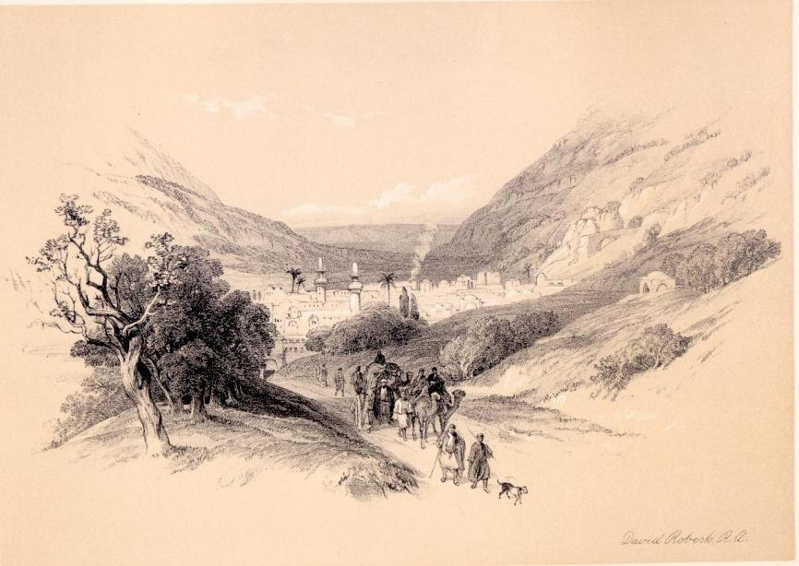
Nineteenth-century Nablus (David Roberts 1849), where the tribes of Israel stood “half of them el mul Mount Gerizim and half of them el mul Mount Ebal”

Perhaps the most prominent example can be found in the story of the battle at Michmas in I Samuel 13-14. In describing the place where Jonathan and his attendant surprised the Philistines, the verses go into great detail regarding the scenery:

At the crossing by which Jonathan sought to reach the Philistine garrison, there was a rocky crag on one side, and another rocky crag on the other, the one called Bozez and the other Seneh. One crag was located on the north, mul Michmas, and the other on the south, mul Geba. (14:4-5)

Geba and Michmas are well-known locations, both of whose names were preserved until the modern era. They are situated on either side of Nahal Michmas (Wadi Suweinit in Arabic), a deep and rocky wadi. The modern Arab village of Mikhmas is located north of the wadi and the village of Jaba’ is located south of the wadi. Years ago, when I was wandering around this region, I was happy to run into a group from the Society for the Protection of Nature in Israel. The members of the group were carrying Tanakhim and following the trail of the dramatic Biblical story of Michmas in the very places where the events unfolded. The tour guide graced the members of his group with an original explanation of the names of the two villages on either side of the wadi, relating that this was a prime example of the phenomenon of “name wandering.” Place names in the land of Israel, said the tour guide, frequently shift to a different location up to a few kilometers away. But this place is unique, he claimed, in that the names of these two spots not only moved, but actually switched places! As we see in the Tanakh, the northern crag was mul – opposite – Michmas, and the southern crag was mul – opposite – Geba; today, however, the town of Mikhmas is in the north and Geba is in the south.

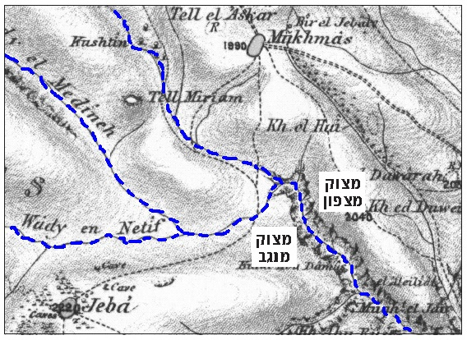
The 1880 map of the Palestine Exploration Fund

With all due respect to this tour guide’s originality, the simple explanation is that “mul Michmas” does not mean “opposite Michmas” but “on the same side as Michmas” or “at the foot of Michmas” – and the same is true for “mul Geba” as well.

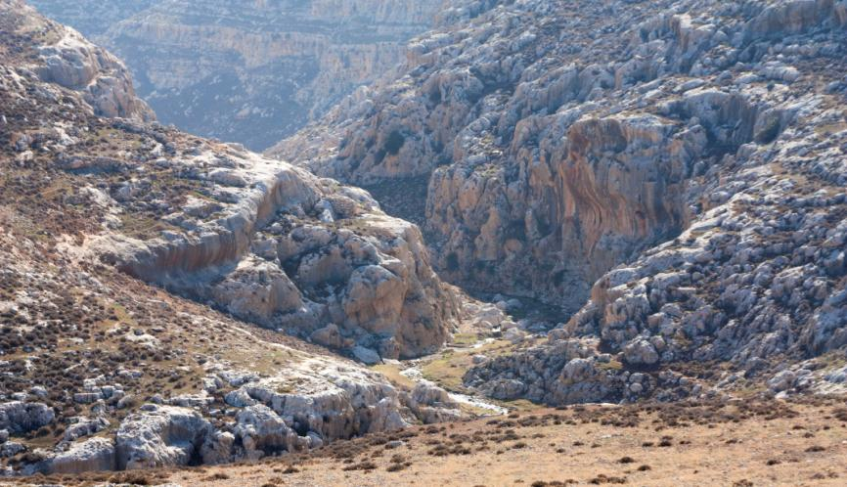
Bozez and Seneh (courtesy of Alexander Lysyi), “one crag… on the north, mul Michmas, and the other on the south, mul Geba”

Mul in Other Contexts

Apparently, then, the word mul took on a new meaning in modern Hebrew that runs counter to its original meaning. In the Biblical period, mul meant “on the same side as” or “at the foot of,” the exact opposite of the meaning of mul today. If a modern Hebrew speaker were to meet Joshua, King David, Isaiah or Ezra and tell them that the Cohen family lives mul his own house, they would undoubtedly conclude that the Cohen family lives adjacent to him – either next door or directly below him.

Returning now to Leviticus, it is clear that melika is performed on the same side as the bird’s nape. The verse seemingly uses mul here to indicate that there is no need to insist on pinching any specific point on the bird’s nape; rather, it is as the mishna cited above states: “For the whole of the nape is the appropriate place for melika.” The same principle applies to the golden frontlet as well: It is placed adjacent to the headdress on the same side as the priest’s face.

Understanding the meaning of mul has implications for several issues in Tanakh. For instance, when Jethro says to Moses, “You represent the people mul God” (Exodus 18:19), we now understand this to mean that Moses will be on the same side as God. Moses will be God’s representative to the nation rather than the nation’s representative to God. In another example, the command, “Let the seven lamps give light el mul the front of the Menorah (penei ha-menora)” (Numbers 8:2), is not easy to understand; the early Sages disputed its precise meaning. We will suffice in noting that the basic intent of the statement is to bring the seven lamps closer to “the front of the Menorah,” not to distance them from the Menorah or to situate them opposite it. Compare to the parallel verse: “The lamps shall be lighted as to give the light on its front side (al ever paneha)” (Exodus 25:37).

The Altar of the Gadites and the Reubenites

The most interesting case in which we can arrive at a novel explanation thanks to our new understanding of the word mul is the episode involving the altar of the Gadites and the Reubenites in Joshua 22. The Reubenites, the Gadites and the half-tribe of Manasseh built an altar in the steppes of the Jordan, “el mul the land of Canaan” (22:11). Most commentators, especially the modern ones, maintained – in an explanation that may seem justified from a logical perspective as well – that the tribes of the Transjordan built an altar in their own territory, on the side of the Jordan opposite the land of Canaan. However, according to our analysis, it seems that they actually built the altar on the same side as the land of Canaan, in the Cisjordan – outside of their own territory. A more thorough review of this episode is beyond the scope of our discussion. In brief, however, this chapter hints at a kind of contradiction between the intense anger directed at the Gadites and the Reubenites and the severity of their actual transgression. The atmosphere in the chapter is extremely tense. The actions of the Gadites and the Reubenites constitute a rebellion and a betrayal of God, akin to the heresy of Peor. In response, the rest of the tribes amassed their troops and prepared to go to war against the two and a half rebellious tribes. On the other hand, the only “crime” that they were charged with was building a bama – an altar dedicated to God, considered illicit only in that it was constructed outside the Mishkan. Throughout Tanakh, such a transgression is generally considered a relatively light offense. Even the most righteous kings of Israel, who always strove to do what was pleasing in the eyes of God, were unable to eradicate this phenomenon; most did not even attempt to do so.

The solution, it seems, is that it was precisely the act of building an altar west of the Jordan, outside of their territory, that caused the tense conflict. If the Gadites and the Reubenites had built the altar within their own territory, perhaps the nation’s leaders would have sufficed in sending two or three elders to explain to them that from the moment the Mishkan in Shiloh was built, it was no longer appropriate to worship God anywhere else. The conflict would have been completely resolved then and there. Instead, the Gadites and the Reubenites built the altar in the steppes of the Jordan, adjacent to their territory but pointedly outside its borders – in the western part of the land of Israel. This was an extremely problematic gesture; it indicated that the Gadites and the Reubenites believed that only the Cisjordan constituted the Holy Land, whereas they regarded their own home in the Transjordan as “unclean” (Joshua 22:19). They saw themselves not as true members of the people of Israel, but as tribes that simply accompanied that nation into their land, allies of Israel who recognized the God of Israel and occasionally chose to participate in His worship, similar, for example, to the Kenites. In other words, they completely misunderstood the nature of the agreement that they had arranged with Moses, and as a result they had essentially become mere desert nomads with no connection to the nation of Israel and its territory. The creation of such a deep schism constituted an unforgivable act of rebellion and betrayal.

For further study:

E. Ben Yehuda, A Complete Dictionary of Ancient and Modern Hebrew, Jerusalem 1908-1959, 2843-2844 [Hebrew].

Yoel Elitzur, “מול: ‘Near, Below, On the Same Side As,’” Lĕšonénu 67 (2005), 7-20 [Hebrew].

J. Reider, “The Etymology of Hebrew MŪL or MŌL,” HUCA 12-13 (1937-1938), 89-96.

Translated by Daniel Landman

In Tanakh, compare to Laish (Judges 18) – Leshem (Joshua 19:47).
See the map below, taken from the 1880 map of the Palestine Exploration Fund.
This interpretation follows Ibn Ezra’s approach and goes against that of Ramban.

