YESHIVAT HAR ETZION
ISRAEL KOSCHITZKY VIRTUAL BEIT MIDRASH (VBM)
*********************************************************

Prophets vs. Empires: A Survey of Nevi’im Acharonim
Rav Yoel Bin-Nun

Shiur #29: The Reign of Yoshiyahu (1a)

There are three characteristics that are common to Menashe, king of Yehuda, and Yoshiyahu, his grandson:

- Both ascended the throne as children
- Each of them led a political, religious, and cultural revolution in relation to their predecessors
- Each enforced his revolution with determination, using force against opponents within the kingdom.

In other aspects, Menashe and Yoshiyahu were complete opposites: while Menashe’s reign was characterized by assimilation into the pagan environment, Yoshiyahu led a fervent return to Torah.

As discussed previously in this series, Menashe became king after Chizkiyahu, his father, when he was just twelve years old:

Menashe was twelve years old when he began to reign, and he reigned fifty-five years in Jerusalem…
And he built again the high places which Chizkiyahu, his father, had destroyed, and he put up altars for Ba’al, and made an Ashera, as did Achav, king of Israel [earlier, in Shomron] and worshipped all the host of heaven, and served them…
And Menashe shed innocent blood, very much, until he had filled Jerusalem from one end to another... (Melakhim II 21: 1-3, 16)

It seems therefore that we must attribute at least the beginning of the great revolution in the days of Menashe to the ministers and advisors who surrounded him – those who believed that Chizkiyahu’s policies and actions had led to Sancheriv’s campaign and its disastrous consequences for Israel.

Menashe may have freed himself of the cabal of advisors when he was suspected by the administration of the Assyrian Empire of disloyalty (for reasons that are not clear), and led as a captive to Babylonia:

And the Lord spoke to Menashe and to his people, but they gave no heed. So the Lord brought upon them the captains of the host of the king of Assyria, who took Menashe with hooks, and bound him with fetters, and carried him to Babylon.
And when he was in distress, he besought the Lord his God, and humbled himself greatly before the God of his fathers.
And he prayed to Him, and He acceded to him, and heard his supplication, and brought him back to Jerusalem into his kingdom. Then Menashe knew that the Lord is God…. (Divrei Ha-yamim II 33:10-13)

We then learn (vv. 15-16) that Menashe removed “the figurine (semel – referring to the Assyrian idol) from the house of the Lord, and all the altars that he had built in the mountain of the house of the Lord, and in Jerusalem, and cast them out of the city… and commanded Yehuda to serve the Lord God of Israel” – but this description is rather surprising: Why is no mention made of this complete turnaround in Sefer Melakhim, nor in Yirmiyahu (15:4 – where the decree of destruction for Jerusalem is explained explicitly as being “because of Menashe, son of Chizkiyahu, king of Yehuda, for that which he did in Jerusalem”)?

Furthermore, we must ask why the description in Sefer Melakhim attributes the great purification of Yehuda, Jerusalem, and the house of God to Yoshiyahu alone, with no mention of Menashe?

Apparently, Menashe’s personal revolution came too late and could not influence Amon, his son, who seems to have succeeded him during his lifetime (from the moment that Menashe was led into captivity). It likewise had no effect on the circles of ministers and advisors.

And Amon sacrificed to all the grave images which Menashe, his father, had made, and served them.
And he did not humble himself before the Lord, as Menashe, his father, had humbled himself; rather, this same Amon became guilty more and more. (Divrei Ha-yamim II 33:22-23)

This seems the most likely explanation for why Menashe's profound teshuva is mentioned nowhere in Sefer Melakhim, nor in Yirmiyahu. Those around him did not accede to his teshuva; they continued the abominations of the younger Menashe, which had shaped the politics and culture of the generation.

Yoshiyahu ascended the throne at the age of eight, and the circle of ministers and advisors that had surrounded Menashe and Amon continued their path for a further twelve years:

Yoshiyahu was eight years old when he began to reign, and he reigned thirty-one years in Jerusalem. And he did that which was right in the eyes of the Lord, and walked in the ways of David, his father, and did not turn aside to the right or to the left…
And in the eighth year of his reign, while he was still young, he began to seek after the God of David his father, and in the twelfth year he began to purge Yehuda and Jerusalem from the high places and the Asherim and the graven images and the molten images. (Melakhim II 22:1-2 + Divrei Ha-yamim II 34:1-3)

Here we must stop and ask: after almost seventy years (55 + 2 + 12) of Menashe's policies, which were strictly enforced, how did young Yoshiyahu (aged somewhere between 16 and 20) manage to extricate himself from the ring of powerful policy-setters and revert to the outlook and aims of Chizkiyahu, his great-grandfather, all on his own?

Prophecies of Tzefanya and Yoshiyahu, four generations back

The word of the Lord which came to Tzefanya, son of Kushi, son of Gedalia, son of Amaria, son of Chizkiyahu, in the days of Yoshiyahu, son of Amon [son of Menashe, son of Chizkiyahu], king of Yehuda… (Tzefanya 1:1)

Tracing Tzefanya's genealogy four generations back expresses the prophet’s connection to the generation of Yeshayahu and Chizkiyahu – despite the terrible rupture created by the reigns of Menashe and Amon. This connection is seen in the significant parallels between Tzefanya and Yeshayahu, as for example in the prophecy of "the great day of the Lord… a day of darkness and gloominess… a day of the horn and alarm…" (Tzefanya 1:7-16).

Identifying this connection between the prophets sheds light on the great mystery of how the young Yoshiyahu was motivated to seek God when the house of David, and Jerusalem, had been disconnected from His word for nearly seventy years.

As noted, Yoshiyahu reigned as a child, and eight years later, at the age of 16, he began to "seek the God of David, his father" and to explore his path; "and in the twelfth year [i.e., at the age of 20] he began to purge Yehuda and Jerusalem" from the various types of idolatry (Divrei Ha-yamim II 34:3).

Tzefanya's prophecy (Chapter 1) describes a comprehensive purging of Jerusalem and the royal house of pagan worship. Admittedly, the prophet's description seems to imply that an outside enemy will effect this purification, but Yoshiyahu's campaign of purging is so similar to Tzefanya's prophecy that it is clear who guided him in his search for God and for the path of David:

And I will stretch out My hand upon Yehuda, and upon all the inhabitants of Jerusalem,
And I will cut off the remnant of Ba'al from this place, and the name of the idolatrous priests with the priests,
And those that worship the host of heaven upon the housetops, and those that worship, that swear to the Lord and swear by Malkam (=Milkom=Molekh);
Also those who have turned back from following the Lord, and those that have not sought the Lord, nor inquired after Him…
And it shall be, on the day of the Lord's sacrifice, that I will punish the princes, and the king's sons, and all such as are clothed with foreign apparel. (Tzefanya 1:4-8)

Yoshiyahu's revolution

Yoshiyahu took to heart Tzefanya's call to seek God before it was too late:

Before the decree is born…before the day of the Lord's anger comes upon you,
Seek the Lord… seek humility; perhaps you may be hidden on the day of the Lord's anger. (Tzefanya 2:2-3)

Yoshiyahu wasted no time. The abominations of paganism that Tzefanya described were uprooted and burned over six years (628-622 B.C.E.) of purification of Yehuda and Jerusalem and the northern regions, culminating in the celebration of Pesach and the renewal of the covenant of the Torah.

Tzefanya continues with another surprising element of Yoshiyahu's plans: an audacious renewed push into Philistia. When Chizkiyahu acted against Ekron, his actions invited Sancheriv's campaign, leading to the destruction of the cities of the lowlands. Now, Yoshiyahu returned to Philistia and advanced all the way to the coast – once again, inspired by Tzefanya (although here again, Tzefanya does not specify who will undertake the move):

For Gaza shall be forsaken, and Ashkelon a desolation; they shall drive out Ashdod at noon, and Ekron shall be uprooted…
And the [sea coast] portion shall be for the remnant of the house of Yehuda, whereupon they shall feed their flocks… (2:4-7)

Within a short period – twelve wondrous years (622-610 B.C.E.) – of accelerated growth and development in Yehuda, the rehabilitation of the fortified cities of the lowlands, which had been destroyed during Sancheriv's campaign, was complete. Yehuda was once again deeply lodged within Philistine territory, and for the first time there were Jewish fortifications, too – on the coast (in the area of today's Yavneh-Yam/Palmachim and also between Jaffa and the Yarkon estuary), seemingly aimed at halting the Egyptian army. New settlements were established in all these areas, as well as in the Judean desert.

Yoshiyahu also undertook a great socio-moral initiative, in accordance with the covenant of the "book of the Torah.” Surprising evidence of this campaign was found in the archaeological excavations at Metzad Hashavyahu, near the coast, revealing both the might of Yehuda during the time of Yoshiyahu and the confidence with which a regular laborer could submit a complaint against his supervisor for unjust treatment.

The Yavneh-Yam Ostracon – a laborer’s appeal for justice

The inscription on the shard is an appeal by a simple laborer, a reaper at Chatzar Asam, who had finished reaping “before Shabbat” when the overseer – Hoshayahu ben Sabay – came by “and took your servant's garment… he took the garment of your servant” (apparently a cloak or other over-garment which the reaper had set aside during his work). The garment would seem to have been confiscated because the overseer found the reaper at rest, but the reaper claims in his letter that he had completed his fixed quota of reaping and storing “as [required] all the days.”

The letter is addressed to “my lord, the governor” and concludes with an appeal for compassion and a return of the garment that was confiscated unjustly, since the reaper has faithful witnesses as to his innocence – "My companions… the reapers with me in the heat of the harvest; yes, my companions can answer for me. Amen! I am innocent of guilt."

"Answer for me" means to "bear witness on my behalf", as in, "You shall not bear false witness against your neighbor [literally, 'answer for your neighbor as a false witness']" (Shemot 20:12). "Amen" is the affirmation of an oath as to the truth of one's testimony, as at the forging of the covenant in Sefer Devarim (27:15-26).

The letter is extraordinary in many respects:

- The coherent if unprofessional Hebrew writing of a simple reaper, located at a fortress of Yehuda at the end of the period of the monarchy, far from Jerusalem.
- The intensity of the pain and shock at the injustice of confiscating the garment. The taking of the garment is mentioned twice, and the request for mercy to return the garment appears three times. This serves to highlight the emphasis in the Torah – both in Parashat Mishpatim and in Sefer Devarim – on the obligation to return a garment taken as a pledge “by the setting of the sun,” since the poor man has nothing else – “In what shall he sleep?”
- The absolute confidence of the reaper that he can complain about the overseer to the governor, knowing that there is hope for a just and merciful judgment and the return of the garment, tells us that in the time of Yoshiyahu, king of Yehuda, there was a powerful system of law that extended to the furthest reaches of the kingdom.
- In Yirmiyahu’s prophecy about “the house of the king of Yehuda,” he describes the great hope awakened by the period of Yoshiyahu: “Execute justice in the morning, and deliver the spoil out of the hand of the oppressor, lest My fury go forth like fire…” (Yirmiyahu 21:12 – 22:5). Yoshiyahu indeed stood up to the test, as we later learn (22:15-16 – in complete contrast to Yehoyakim, his son): “Did your father [Yoshiyahu] not eat and drink [in moderation], and do justice and righteousness – and it was well with him. He judged the cause of the poor and needy; then it was well. Is not this to know Me? Says the Lord.”

The silent testimony of the Yavneh-Yam ostracon is echoed precisely in the words of Yirmiyahu the prophet.

Translated by Kaeren Fish

Appendix: Shard of the laborer
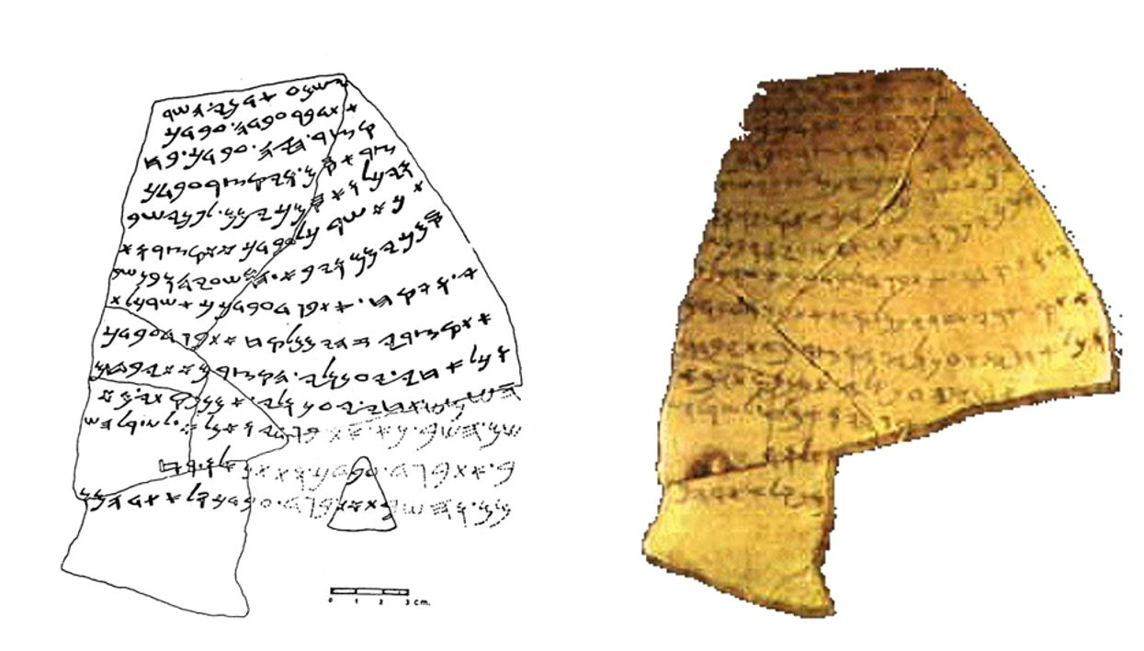

This demand to seek "humility" is unique to Tzefanya; perhaps it contains a hint to Yoshiyahu to take care and be humble, not just to undertake a campaign of purification.
See illustration in the appendix to this shiur.
Shemot 22:25-26.

