YESHIVAT HAR ETZION
ISRAEL KOSCHITZKY VIRTUAL BEIT MIDRASH (VBM)
*********************************************************

GEOGRAPHY IN THE PARASHA

This shiur is available in the archives at:
http://vbm-torah.org/archive/geography/11vayigash.htm

PARASHAT VAYIGASH

Beersheba
By Prof. Yoel Elitzur

City of the Patriarchs

We turn now to Beersheba, the City of the Patriarchs. We first encounter Beersheba in Parashat Vayera and then in Parashat Toldot, where we learn of its role in the lives of Abraham and Isaac. Following Parashat Vayigash, Beersheba takes an extended hiatus from the Biblical narrative, disappearing from view for the remainder of the Chumash. We finally return to the city in the book of Joshua, in the description of the portions of land allotted to the tribes of Israel. Our separation from Beersheba in Parashat Vayigash is perhaps a reflection of Jacob and his sons’ parallel separation from Beersheba and indeed from the whole country. Jacob descends to Egypt, leaving behind the land of Israel, where he will not return in his lifetime. To be sure, Jacob’s descendants will eventually return – as conquerors and settlers in the land – but only after the fulfillment of the fateful prophecy: “They shall be enslaved and oppressed” (Genesis 15:13). It seems almost fitting that the point of departure from the land of Israel is Beersheba:

So Israel set out with all that was his, and he came to Beersheba, where he offered sacrifices to the God of his father Isaac. God called to Israel in a vision by night: “Jacob! Jacob!” He answered, “Here.” And He said, “I am the God, the God of your father. Fear not to go down to Egypt, for I will make you there into a great nation. (Genesis 46:1-3)

God’s revelation to Jacob in Beersheba was the third stage of the ongoing interaction between the Patriarchs and this place, beginning with Abraham – “Abraham planted a tamarisk at Beersheba, and invoked there the name of the Lord, the Everlasting God” (Genesis 21:33) – and followed by Isaac:

From there he went up to Beersheba. That night the Lord appeared to him… and I will bless you and increase your offspring for the sake of My servant Abraham. So he built an altar there and invoked the Lord by name. (26:23-25)

Now God reveals Himself to Jacob in Beersheba as well – three Patriarchs, three visits to Beersheba, and three divine revelations. It is no coincidence that Jacob’s departure from the land of Canaan, along with the promise of “I Myself will also bring you back” (46:4), takes place in Beersheba. This was the place that his father and grandfather both invoked God’s name and merited divine revelation, not to mention lived their lives and dug their wells.

Following Joshua’s conquest of the land, Beersheba reprises its role as a central location in the national narrative of the people of Israel. From this point forward, Beersheba is depicted in Tanakh as the primary city of the Negeb, and it is consistently used to denote the southern extreme of the inhabited part of the land of Israel. The phrase, “from Dan to Beersheba,” is repeated in Tanakh seven times, and the phrase “from Beersheba to Dan” appears twice, both times in Chronicles. While the various historical upheavals that befell the Land and its people over the years rendered this usage irrelevant, this did not detract from Beersheba’s importance as a city. Following the split between the kingdoms of Judah and Israel, we find the borders of the kingdom of Judah described as “from Beersheba to the hill country of Ephraim” (I Chronicles 19:4). Additionally, the borders of Josiah’s kingdom toward the end of the First Temple period, following the exile of the ten tribes, are listed as “from Geba to Beersheba” (II Kings 23:8). Further still, following the return to Zion, the Judean people lived “from Beersheba to the Valley of Hinnom” (Nehemiah 11:30). Beersheba, a place so intrinsically connected to the Patriarchs, had become the perennial capital of the South for their descendants.
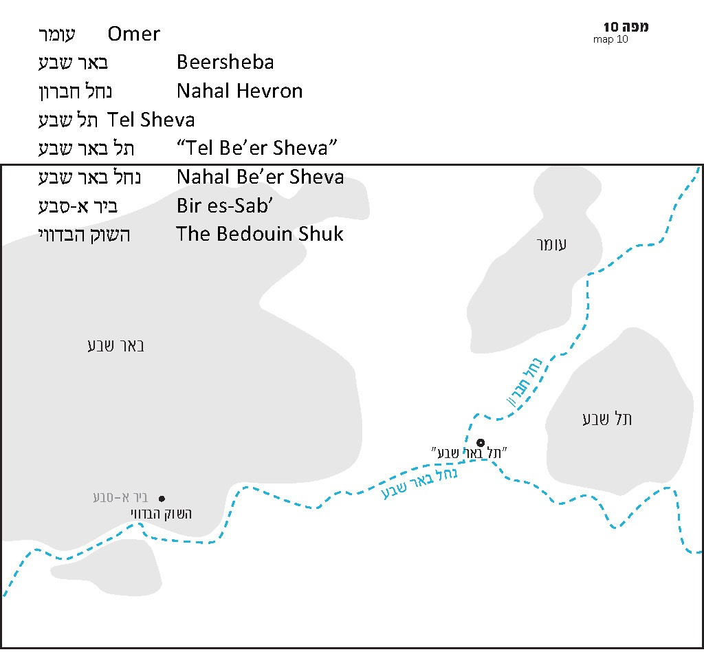

City of the Children

Today, Beersheba is a thriving Jewish city that ranks among the largest in Israel. It is the only city in Israel where one can find streets named for each one of the Patriarchs. Before the War of Independence, there was only a small Arab city known as Bir es-Sab’, built in the late nineteenth century by the Ottomans atop a ruin that bore that name. By 1944, the city had a population of 3,700, and this number rose to about 6,500 by the start of the War of Independence. The city was conquered on October 21, 1948, its Arab residents fled, and Beersheba was once more a city belonging to the descendants of Abraham, Isaac and Jacob. By early 1950, the Jewish population of Beersheba was 1,167, and by mid-2011 it was 205,588 (according to Israel’s Central Bureau of Statistics). Today Beersheba is home to schools and yeshivas, one of Israel’s major universities, several colleges, a prominent hospital, a rabbinical court and a regional court, industrial areas, a Bedouin market and modern malls, hotels, a high-tech complex, a large prison, community centers, a sinfonietta that plays for a 712-seat hall and Glidat Be’er Sheva, an ice cream factory that is almost as old as the state itself.

Bīr es-Sab’ (Tristram 1865)

Biblical Beersheba – on Road Signs and in Scholarly Literature

Where is Biblical Beersheba located? Generally, Biblical Beersheba is identified with Tel Be’er Sheva, about three miles east of the Old City of modern Beersheba, where the wadis Nahal Hevron and Nahal Beersheba meet. All the road signs refer to the site as Tel Be’er Sheva, as do most common encyclopedias, works of archaeological literature and modern Biblical commentaries – not to mention websites. The tell was excavated during the 1970s by Yohanan Aharoni, and, following his death in 1976, Ze’ev Herzog continued his work. Aharoni pronounced that Tel Be’er Sheva is “a location whose identification is not in doubt.” An impressive array of finds was unearthed at the tell, primarily from the Israelite period, including strong fortifications, an elaborate water system, well-dressed stone blocks from a large horned altar and the deepest cistern in the Negev (226 ft.).

Tel Be’er Sheva is now a National Park, as well as a UNESCO World Heritage Site. It is an extremely well-maintained site, with paths that are replete with clearly labeled signs explaining the archaeological finds. Partially preserved walls have been restored to their full original height, with precise indications distinguishing between what was found at the site and the restored sections. Visitors can view the deep cistern, as well as indentations from the rope that was used to draw water from the cistern in ancient times. Groups of children and teens often participate in hands-on activities, like pita baking in a traditional oven and making mudbricks using authentic materials.

“Tel Be’er Sheva” and “Tel Sheva”

A particularly perceptive driver on his way to this site might notice that alongside the brown “historical site” road sign that reads “Tel Be’er Sheva,” there is another road sign that directs motorists to a Bedouin town called Tel Sheva. This town was established by Israel in 1968, was made a local council in 1984 and today has a population about 16,500. But why is this Bedouin town called “Tel Sheva,” while the ancient tell in close proximity to it is called “Tel Be’er Sheva”? The answer is that “Tel Sheva” is the Hebrew version of the Arabic name “Tall es-Sab’,” the Bedouins’ name for the tell and its surroundings, which today include the modern Bedouin town itself.

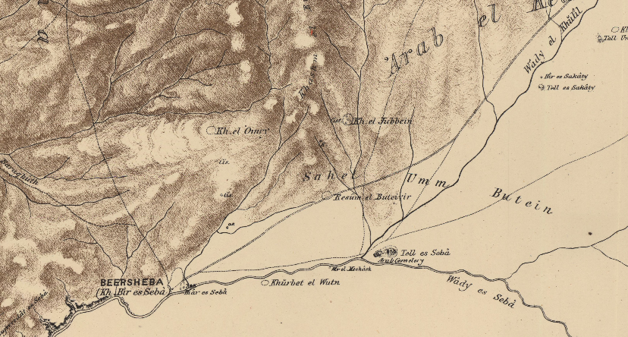
PEF map (1880): Tell es Seb, where Wâdy el Khŭlîl and Wâdy es Seb meet, east of Kh. Bîr es Seb

Let us summarize what we know about the various names for these two locations. There are the Hebrew names: the city of Beersheba and the historical site Tel Be’er Sheva three miles east of the city. And there are the Arabic names: the city of Bir es-Sab’ and the tell (and town) of Tall es-Sab’ three miles east of that city.

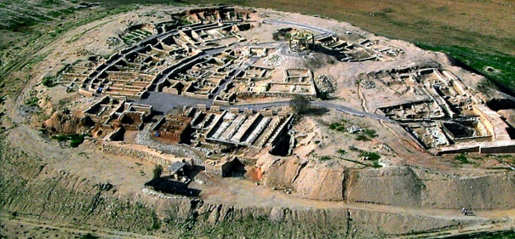
Tel Sheva (“Tel Be’er Sheva”) (Z. Radovan)

Turning now to Joshua 19, we encounter a surprising revelation. The first section of the chapter delineates the borders of the portion of land assigned to the Simeonites, in the Judean Negev (“The portion of the Simeonites was part of the territory of the Judites” [19:9]). The list of the Simeonite cities begins: “The second lot fell to Simeon… Their portion comprised: Beersheba and Sheba and Moladah” (19:1-2). We see that the verse lists two distinct locations in close proximity to each other – Beersheba and Sheba. In light of the well-known fact that Arabs tend to preserve the original ancient names of many of the places in which they live, and in light of the existence of the Arabic pair Bir es-Sab’ and (Tall) es-Sab’ and the Biblical pair Beersheba and Sheba, it seems logical to assume that Bir es-Sab’ is Beersheba and (Tall) es-Sab’ is Sheba. Sheba can also be found elsewhere in Joshua, in the list of cities in the Judean Negev (parallel, in part, to the list of Simeonite cities). There, it appears as “Shema”: “Amam, Shema, Moladah” (15:26).

Some commentators and scholars have posited that the phrase “Beersheba and Sheba” that appears in Joshua is actually referring to one location, and “Sheba” is either an alternate name for Beersheba or simply an unnecessary repetition of part of the name “Beersheba.” This position helps provide a solution for a numerical problem in the text. At the end of the list of the first group of Simeonite cities, the verse states that there were “thirteen cities, with their villages” (19:6), but a quick count yields fourteen cities. If “Sheba” is not counted as a distinct city, this would bring the total down to thirteen, thus resolving the contradiction. In my opinion, however, nothing is gained by twisting the meaning of one verse in order to make sense of another. The simple meaning of the text is that Beersheba and Sheba are two different locations, a reading that is corroborated by both the parallel list in chapter 15 and the apparent preservation of the name as “es-Sab’.”

The problem of the verse’s reference to thirteen cities is beyond the scope of this discussion. Suffice it to say, though, that a more problematic contradiction of this type exists regarding the list of cities in the Judean Negev. The solution seems to be that in desert and semi-desert regions, certain unwalled cities were mentioned in the list but not included in the final count, in which only walled cities were included.

The Archaeological View

According to archaeologists, Tel Sheva – the site that appears on Israeli road signs and maps as “Tel Be’er Sheva” – does not fit its depiction in Tanakh as one of the central cities in the land of Israel. Its physical area is about 2.7 acres, which is quite small, especially in comparison to cities like Lachish, whose area is over 30 acres. In addition, Tel Sheva is not actually a tell in the traditional sense. In archaeology, a tell is generally a fortification from the middle Bronze (Canaanite) period, in which earth is piled up around a city, forming a trapezoidal shape. These tells preceded Joshua’s conquest of the land. In contrast, Tel Sheva dates from the Iron (Israelite) period, and more closely resembles an Israelite fortress than a tell, from a strictly archaeological perspective. While this Israelite fortress is certainly a thing of beauty, as well as the source of many fascinating finds, it is not Beersheba – it is Sheba.

This rejection of Tel Sheva as the identification for Biblical Beersheba was proposed years ago by Prof. Nadav Na’aman, a scholar with whose views I frequently disagree. This time, however, I believe that Na’aman is right. Some scholars did adopt Na’aman’s position, but the predominant view among scholars – and with them, grant organizations, educational institutions, the Government Appellation Committee, the Nature and Parks Authority and mapmakers – was that Tel Sheva is indeed what remains of ancient Beersheba. Whether this was a result of Yohanan Aharoni’s outstanding influence and authority as one of the leading speakers in the field, or because of the need to pinpoint a precise location in identifying the City of the Patriarchs, this became the accepted view.

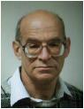
Prof. Nadav Na’aman, Tel Aviv University

In Beersheba, in the Bedouin shuk within the city proper, remnants of settlement from the Israelite period were found. Remnants from a walled city have not yet been found. There is no need to search for remnants from the Patriarchal age, as the Torah implies that the Patriarchs lived not in the city itself but in tents near a well. Later in history, there was apparently a walled city here, and perhaps someday this will be found as well.

To summarize, I am certain that those who maintain that ancient Beersheba was located within the borders of modern-day Beersheba are correct. Conversely, the tell that road signs, maps and the majority of the scholarly literature confidently label “Tel Be’er Sheva” is actually Tel Sheva, an Israelite fortress from the First Temple period.

In all likelihood, our Patriarchs – Abraham, Isaac and Jacob – and their descendants from the time of Joshua until the Second Temple period lived in the vicinity of the modern city of Beersheba. This region was home to a fortified city during the Israelite period (that has yet to be found), and it was also home to Abraham’s well and his tamarisk, and the altars built by Isaac and Jacob. The promise of “I will bless you and increase your offspring” (Genesis 26:24) that was made in Beersheba has come to fruition in our generation, in the tens of thousands of Jewish people living today in Beersheba and all throughout the land of Israel.

For further study:

Y. Aharoni, “Excavations at Tel Beer-Sheba,” Biblical Archaeologist 35 (1972), 111-127.

Y. Aharoni, “Excavations at Tel Beer-Sheba,” Tel Aviv 1 (1974), 34-42.

Z. Herzog, “Tel Beersheba,” The New Encyclopedia of Archaeological Excavations in the Holy Land, 1, 167-173.

N. Na’aman, “The Inheritance of the Sons of Simeon,” ZDPV 96 (1980), 149-151.

I. Press, “Beersheba I,” Encyclopedia of Palestine, I, 61-62 [Hebrew].

Translated by Daniel Landman

See map below.
Other examples where the letters beit and mem are interchangeable include Dibon-Dimon and Abanah-Amanah.
See Joshua 11:13: “However, all those towns that are still standing on their mounds were not burned down by Israel.”

