YESHIVAT HAR ETZION
ISRAEL KOSCHITZKY VIRTUAL BEIT MIDRASH (VBM)
*********************************************************

The Path of the Piaseczner Rebbe
By Dr. Ron Wacks

Shiur #08: R. Kalonymus’s Works (Part IV)

How to Learn from Books

Committing teachings of and about chassidut in books is not enough. Guidance is needed as to how to extract the proper benefit from them; as R. Kalonymus notes, even if a person reads many Chassidic works, they may nevertheless remain “lying there within him like books in a crate.”

In a teaching on Parashat Tzav written in the year 1938 (5698), he discusses the importance of internalizing Chassidic teachings and forging an inner connection with them. The main goal is that they should influence the person and advance his Divine service. Every individual can find books that influence him. He must turn these into his “Torah”:

Not all books act on every person directly, but every person has some book among the holy works that when he reads it for a prolonged time, at times that are suited to him, then when he ceases looking at the book, he feels that it has affected him; his thoughts are activated and his will is aroused in a different way… He feels a drive to do and exert himself more in Torah and Divine service; his is no longer satisfied with his present situation. Sometimes it seems to him that his eyes have been opened; he looks differently at the entire world and sees in the Torah that which he had not seen previously.

And this is something that he learns by himself, and it is more difficult than learning that he hears from his teacher. For when he hears his teacher, he is hearing only his teacher’s Torah, but when he learns for himself, he must now make Torah of his own…

The responsibility lies with the student. He must internalize the content of the teachings and “make Torah of his own.”

R. Kalonymus goes on to say that this should not be regarded as a simple task. He points out that there are many people who have studied and learned, but there is a separation between the knowledge they have acquired and themselves: “They and the Torah are two separate things.”

R. Kalonymus’s Sources and His Connection to Polish Chassidut

R. Kalonymus was proficient in the entire treasury of Torah wisdom, and he quotes from throughout the Talmudic and midrashic literature. His knowledge of Kabbala is apparent in all his writings; he cites extensively from the Zohar, the writings of the Ari and R. Moshe Cordovero, the Or Ha-Chama written by the Chida, Kanfei Yona by R. Menachem Azaria da Fano, Sha’arei Kedusha by R. Chaim Vital, the Maharal, Shefa Tal (R. Shabtai Sheftel Horowitz of Prague), and more. His non-kabbalistic sources are rooted mainly in the tradition of Polish chassidut, but he also draws from the Chassidic traditions of Galicia, Karlin, and Chabad. The works and authors that he cites include the Ba’al Shem Tov; R. Yaakov Yosef of Polnoe and his Toldot Yaakov Yosef; the Maggid of Mezeritch and the book that cites his teachings – Likkutim Yekarim; R. Barukh of Mezhibozh; R. Elimelekh of Lizhensk and his No’am Elimelekh; R. Yisrael of Kozhnitz and his Avodat Yisrael; R. Kalonymus’s own grandfather – R. Kalonymus Kalman, author of Maor Va-Shemesh; R. Shneur Zalman of Liadi and his Likkutei Amarim Tania, Likkutei Torah, and Boneh Yerushalayim; R. Yisrael of Ruzhin; R. Asher of Stolin; Sefer Benei Yissakhar by R. Tzvi Elimelekh Shapiro of Dinov; Sur Me-Ra’ Ve-Aseh Tov by R. Tzvi Hirsch of Ziditshov; Beit Aharon by R. Aharon of Karlin; and R. Kalonymus’s father, R. Elimelekh of Grodzisk and his works Imrei Elimelekh and Divrei Elimelekh. His works are also influenced by R. Nachman of Breslov, although R. Kalonymus does not note this explicitly.

One of the central questions that we must ask ourselves with regard to R. Kalonymus’s teachings concerns the influence of Polish chassidut, which was greater in scope than the Chassidic movements in other countries and comprised a great many courts.

From the works listed above, it is easy to see that R. Kalonymus viewed himself as an heir to Polish chassidut prior to the “revolution” and that he focused mainly on figures connected to his biological and Chassidic lineage. We will expand briefly upon this point.
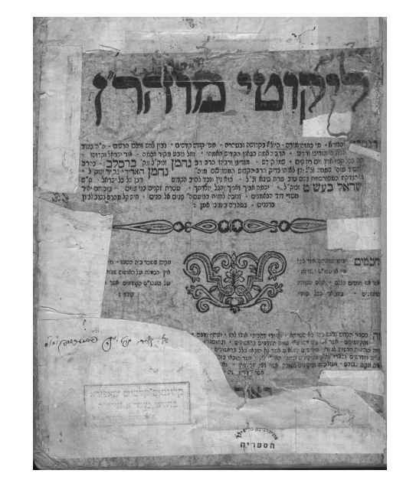
A copy of Likkutei Moharan with R. Kalonymus’s stamp (bottom left)

During the period of R. Yaakov Yitzchak, the Seer of Lublin, the Chassidic court of Przysucha came into existence under the leadership of the “Holy Jew,” who “rebelled” against the path of the Seer of Lublin and his disciples and aimed to recreate chassidut as it had been in its early generations. Przysucha detested the populism that had come to characterize chassidut, the preoccupation with miracles performed by the tzaddik, and the lack of any demands on the chassidim that they themselves engage in intensive spiritual work. The “Holy Jew” attracted a group of exceptional disciples who were committed to rejuvenating the original spirit of Chassidic Divine service. They studied in depth and emphasized work on personal character, extreme humility, and an absolute quest for truth.

Przysucha had a major influence on Polish Jewry and produced many great Chassidic leaders, including R. Simcha Bunim of Przysucha; the Rebbe of Gur and the entire glorious Gur dynasty; R. Menchem Mendel of Kotzk, son-in-law of R. Avraham Bornstein of Sokhatshov; R. Mordechai Yosef Leiner of Izbica; R. Tzadok Ha-Kohen of Lublin; R. Yisrael Yitzchak of Warka; R. Yechiel of Alexander and his dynasty (among the largest of the Polish Chassidic courts prior to the Holocaust); R. Yaakov David of Amshinov; and many others that split from these and developed into independent courts.

It must be emphasized that one cannot generalize and view all these courts as totality committed to a single spiritual position. Each of these leaders was unique and forged his own special path. Nevertheless, the influence of Przysucha was manifest in most of them.

While Przycucha made a lasting impression on many Polish Chassidic courts, there were others that disagreed with the Przycucha approach and viewed themselves as continuing the tradition of the great Polish Chassidic leaders going back to the glorious period of R. Elimelekh of Lizhensk. Among these were Kozhnitz, Lublin, and Ziditshov (Galicia). R. Kalonymus’s family was descended from this dynasty, as described in the previous chapter. Thus, it comes as no surprise – nor is it mere coincidence – that R. Kalonymus’s works make no mention of the Chassidic leaders of Przshucha or their disciples.

This might lead us to propose simply that R. Kalonymus grew up and was educated in the non-Przysucha tradition and viewed himself as an heir to the Lublin-Kozhnitz dynasty. However, such a hypothesis is unsatisfactory, since he does quote other Chassidic sources that are not naturally part of his Chassidic heritage – such as, for instance, Breslov. Also, R. Kalonymus frequently cites the Admor Ha-Zaken of Chabad (a Chassidic court that developed in Russia). He clearly had a broad knowledge and was unquestionably familiar with the Przysucha literature.

His books make no direct and explicit reference to Przysucha or its offshoots, such that we cannot ascertain his position with any degree of certainty. A comprehensive comparison between Piaseczno and Przysucha would require detailed and extensive study, exceeding the scope of the present work. I will therefore suffice with the following brief comment.

It seems to me that R. Kalonymus’s choice to focus on Chassidic leaders and works belonging to his own biological and Chassidic lineage reflects his perception of the issues at the heart of his teachings, including enthusiasm, serving God with simplicity, spiritual work through imagination, the importance of perfecting one’s character, the emphasis on service of the heart and the emotions, etc. These he imbibed from the sources enumerated above, elaborating and developing them. In contrast, we do not find in his works any extensive attention to issues that occupied the Przysucha school, such as the extreme quest for truth, balancing on the boundaries, emphasis on scholarship (as opposed to study); and in-depth occupation with Medieval Jewish scientific works and their priority over the study of Kabbala.

Translated by Kaeren Fish

Derekh Ha-Melekh, p. 139.
Ibid., pp. 139-140.
Ibid.
At a later point, we will offer some examples of teachings of R. Nachman of Breslov that parallel teachings of R. Kalonymus, although no explicit mention is made of Breslov chassidut. Mendel Piekarz is apparently correct in asserting that R. Kalonymus was familiar with R. Nachman’s works (M. Piekarz, Chassidut Polin, p. 400). His hypothesis is supported by the fact that Dr. Tzvi Leshem, with the help of Prof. Tzvi Mark, found a copy of Likkutei Moharan bearing R. Kalonymus’s stamp in the section for rare works at Bar Ilan University (Leshem, p. 46).
For more on the revolution in Polish chassidut and the splitting of the courts, see A.Z. Eshkoli, Ha-Chasidut Be-Polin (Jerusalem, 5760), pp. 53-72; Z.M. Rabinowitz, Bein Przysucha Le-Lublin: Ishim Ve-Shitot Be-Chasidut Polin (Jerusalem, 5757), pp. 257-369.
We will discuss this at a later juncture.
Z.M. Rabinowitz, pp. 327-330. For more on the opposition to the path of Przysucha, see ibid., pp. 312-315.

