YESHIVAT HAR ETZION
ISRAEL KOSCHITZKY VIRTUAL BEIT MIDRASH (VBM)
*********************************************************

GEOGRAPHY IN THE PARASHA

For easy printing, see
http://vbm-torah.org/archive/geography/06toldot.htm

PARASHAT TOLDOT

Gerar

By Prof. Yoel Elitzur

Gerar and the wadi of Gerar are the central locations of Isaac’s narrative, where he consistently reinforces his connection to the Promised Land. It was there that he dug his wells, there where he returned to re-dig his father’s wells, which the Philistines had stopped up, and there that he “sowed in that land and reaped a hundredfold” (Genesis 26:12). One of the two times Isaac experienced divine revelation was while he resided in Gerar. What is more, that revelation itself concerned Gerar:

Stay in the land which I point out to you. Reside in this land, and I will be with you and bless you; I will assign all these lands to you and to your heirs, fulfilling the oath that I swore to your father Abraham. (26:2-3)

The phrase, “all these lands,” hints at the land of Gerar and the area surrounding it.

This is not the first time we learn of Gerar’s significance in Genesis. It is mentioned in the Torah’s description of the “Canaanite territory” in chapter 10 and it is noted as the seat of the king of the Philistines during the time of Abraham and Isaac. During Joshua’s conquest and apportionment of the land, Gerar does not appear, nor can the name be found in any other place in Tanakh, aside from one appearance in II Chronicles. Gerar is absent from extra-biblical sources of the biblical period as well (suggestions connecting Gerar with a location found in Egyptian sources are unconvincing). It is only during the Talmudic era that Gerar returns to prominence, appearing in both Jewish and non-Jewish sources.

Where was Gerar?

Before we proceed, we must clarify that the “land of the Philistines” that appears in Genesis bears no geographical connection to the “land of the Philistines” that appears in Judges and Samuel. Joshua Meir Grintz, and subsequently his mentor Umberto Cassuto as well, demonstrated convincingly that the Philistines of the Torah are a completely different people from the Philistines of the Early Prophets. The Philistines who serve as frequent antagonists in Judges and Samuel were a cruel, warlike nation that continuously terrorized the neighboring Israelites. They lived all along the Mediterranean coast in a pentapolis of five city-states: Gaza, Ashkelon, Ashdod, Ekron and Gath. Each city-state was governed by its own lord, known as a “seren,” a word whose Greek parallel reflects the foreign elements that influenced Philistine language and culture.

In contrast, the Philistines of Genesis were much less aggressive people, shepherds and farmers whose lifestyle resembled that of Abraham and Isaac. These Philistines had one city – Gerar – and wells along the wadi of Gerar; the conflict between them and our Patriarchs over these disputed wells ended peaceably, with a pact signed between the two parties. Their ruler was called a melekh (king), and he bore a distinctly Semitic name: Abimelech. Genesis makes no mention at all of a connection to the Mediterranean coast. In Genesis, the Philistines have Hamitic-Egyptian ancestry (10:14), whereas the rest of Tanakh speaks of Caphtor, where the Cherethites resided (modern-day Crete), as the ancestral home of the Philistines.

In light of this, it seems unlikely that Gerar was located in the coastal region, and certainly not in the vicinity of Ashdod or Ashkelon. If so, what information can we find in Tanakh to help us identify the location of Gerar?

Let us begin in Genesis. According to chapter 10, Gerar was apparently not far from Gaza: “The Canaanite territory extended from Sidon as far as Gerar, near Gaza” (10:19). On the other hand, we read later: “Abraham journeyed from there to the region of the Negeb and settled between Kadesh and Shur. He sojourned in Gerar” (20:1). This verse seems to point to a location much farther to the south: Kadesh is identified as northwest of Makhtesh Ramon in the Negeb and Shur is what we know today as the northern Sinai Peninsula. This southern location fits well with the identification of biblical Rehoboth with the ruin at Ruheibeh (known in Israel today as Rehovot Ba-Negev), about twenty miles southwest of Beersheba. It also fits in light of the verse describing Asa’s war with the Cushites: “All the cities in the vicinity of Gerar were defeated… All the cities were plundered… They also ravaged the encampment of herdsmen, capturing much sheep and camels” (II Chronicles 14:13-14).

The two major Christian sources from the Byzantine period on the historical geography of the land of Israel – Eusebius’s Onomasticon and the Madaba Map – contain important information for our discussion. The Onomasticon (early fourth century CE) states that the entire region surrounding Gerar was known as “Geraritike,” and is located 25 Roman miles (23 miles) south of Eleutheropolis (Beit Guvrin). The Madaba Map (sixth century CE) notes the town of Gerara between Beersheba and Gaza and labels the area surrounding it “Geraritikon Salton.”

R. Saadia Gaon, in his Arabic translation of the Torah, renders Gerar as “al-Khalūṣ,” modern-day Haluza – some fifteen miles southwest of Beersheba and about thirty miles southeast of Gaza!

The scholarly literature has yielded a variety of opinions on the matter of Gerar’s location. Grintz argued forcefully for a southern location based on the information outlined above, rendering the phrase “bo'akha Gerara ad Azza” not “as far as Gerar, near Gaza,” but “near Gaza, on the route that eventually leads to Gerar.” According to Grintz, the only reason that Gerar is mentioned in this context is that it features prominently in the later stories of the Patriarchs. In contrast to Grintz, most scholars maintain that Gerar is a general term for the western Negeb region, between Beersheba and Gaza. The information provided by both Eusebius and the Madaba Map spell out this interpretation almost explicitly.

Proponents of this approach must then explain the above verse, “[Abraham] settled between Kadesh and Shur. He sojourned in Gerar” (20:1), in a new light. They note the use of two distinct verbs: va-yeshev (he settled) and va-yagor (he sojourned). In contrast to modern Hebrew, the word lagur in its various forms always refers to a temporary dwelling, while lashevet always refers to a permanent dwelling. With this in mind, it seems what the Torah is conveying is that Abraham settled down for several years in the southern region between Kadesh and Shur (home to Beer-lahai-roi, where Isaac resided and Sarah’s tent stood), and for a separate, shorter period he sojourned in Gerar – a completely different location.

This region between Beersheba and the Gaza Strip contains four large archaeological tells: Tell esh-Sharia (Tell Shera on Hebrew maps), Tell Abu Hureyra (Tell Haror), Tell el-Farah (Tell Sharuhen, based on Albright’s identification) and Tell Jemmeh (Tell Gama or Tell Re’im). The last tell in this list may be familiar to some from the period before the disengagement from Gush Katif, as it is situated just before the Kissufim crossing. Each one of these archaeological sites has been suggested by scholars as a candidate for the identification of Gerar.

The identification with Tell el-Farah, suggested by several early scholars, was rejected after the academic world became convinced of its identification with the ancient town of Sharuhen. Many scholars do still support the identification of Gerar with Tell esh-Sharia or with Tell Abu Hureyra on the banks of Wadi esh-Sharia, as it fits well with the distance measurements found in the Onomasticon. Based on these identifications, Israel’s naming department called Wadi esh-Sharia “Nachal Gerar.”

From an archaeological standpoint, Tell Haror (suggested by Yohanan Aharoni) seems like the most likely candidate of the four. It is a large tell, most of whose settlement activity occurred during the Middle Bronze Age, which corresponds to the Patriarchal age. Few remains of settlement have been found from the late Canaanite period and the first Israelite period, but significant remains were found from the latter half of the Israelite period, which may be reflected in Gerar’s appearance in Chronicles.

Despite this, my late father, Prof. Yehuda Elitzur, concurred with the assessment of W. J. Phythian-Adams and Sir Flinders Petrie, who identified Gerar with Tell Gama on the southern bank of Nachal Ha-Besor (Wadi Gaza), about ten miles west of Tell Haror and about three miles east of Kissufim. This identification is supported by the persistence of the name Gerar throughout history: A large Byzantine-era ruin called Khirbet Umm-Jarrar (Chorvat Gerarit in Hebrew) is located two miles north of the tell. Its distance from Beit Guvrin is greater than the 25 Roman miles described in the Onomasticon, but it may be that Eusebius was referring to the region he called Geraritike and not to one precise location.

In my father’s opinion, eastern and southern identifications of Gerar do not fit the Torah’s formulations well enough to pass muster. For example, Parashat Toldot relates that when famine struck the land of Canaan, Gerar – with its many wells – was flourishing agriculturally. In light of this, Gerar must have been closer to the coast, not in the central Negeb, and certainly not in areas further to the south. The phrase, “as far as Gerar, near Gaza,” indicates that Gerar must have been located somewhere in the western Negeb and not in its central region. According to this identification, “the wadi of Gerar” mentioned in our parasha is not Wadi esh-Sharia – Nachal Gerar on Israeli maps – but the wadi we know today as Nachal Ha-Besor.

“A bad climate” and the holiness of the Land

Chazal’s description of Gerar, found in the Yerushalmi (Shevi’it 6a) and in Bereishit Rabba (52, 64), is of utmost importance for our analysis here. The Midrash provides an explicit identification for Gerar: “‘He sojourned in Gerar’ – in Gerarike”; “‘And Isaac went to Abimelech, the king of the Philistines, in Gerar’ (26:1) – to Gerarike.” The Midrash then goes on to discuss Gerarike:

Why did they obligate (gazeru) the region of Gerarike [in commandments that only apply in the land of Israel]? Because it has a bad climate. And until where did they obligate them? Rabbi Chanin said in the name of Rabbi Shemuel bar Rav Yitzchak: Until the wadi of Egypt.

The Yerushalmi has a slightly different text:

Why didn’t they obligate (lo gazeru) the region of [Gerarike]? Rabbi Simon said in the name of Rabbi Yehoshua ben Levi: Because its climate is bad. Until where? Rabbi Chanin said in the name of Rabbi Shemuel bar Yitzchak: Until the wadi of Egypt.

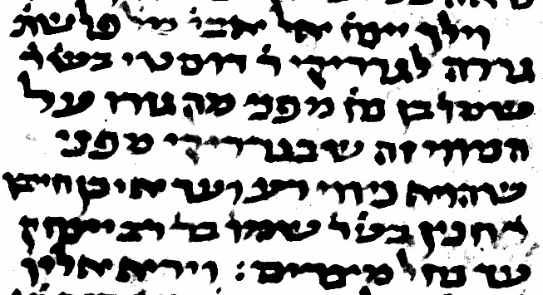
Bereishit Rabba 64, as it appears in MS Vatican 60: “to Gerarike”; “and until where did they obligate them” (Image courtesy of the Vatican Library)

My father z”l, Prof. Yehuda Elitzur, explained the seemingly contradictory passages as follows: Despite the fact that Gerarike lay well to the south of Ashkelon, which is generally considered the southern border of the territory of the “returnees from the Babylonian exile,” it was nevertheless considered part of the land of Israel. This includes its obligation (“gazeru”) in terumot, tithes and shemita, and, on the other hand, the fact that the region was not considered “impure” (“lo gazeru”) like most areas outside of the land of Israel. Even though more non-Jews lived then in that location than Jews (similar to Beit She’an and Ashkelon), and this factor was generally enough to exclude even a place within the borders of the Land from land-based commandments and holiness, Gerar was still considered part of the Land for those purposes.

The reason for Gerar’s anomalous inclusion, according to the Midrash and the Yerushalmi, is that its region has “a bad climate” – it is unsuitable for farming due to its relative aridity and abundance of sand dunes. These conditions made it very difficult for the region’s residents to make a living, so it was only sparsely settled, with no large population of non-Jews to preclude the presence of the holiness of the Land. In contrast, concludes the Yerushalmi, Gaza itself possesses “a good climate,” and thus it is exempt from tithes and shemita.

In conclusion, even if we cannot be absolutely certain of the precise identification of Gerar, we can still be fairly sure of its general whereabouts. The relatively arid swaths of land in the western Negeb, the region that contains the tributaries of Nachal Ha-Besor, including Gush Katif and the Yamit region, as far as Wadi el-Arish – this is what God was referring to when he promised “all these lands” to Isaac in our parasha. These lands are the “Gerarike” of the Midrash and the Yerushalmi and these lands are “Geraritike” of the Onomasticon.

Gush Katif and Yamit were located in a sandy, arid region, which, until Jewish settlements started to crop up there, was almost completely desolate. It seems that our sages had precisely this desolation in mind when they considered the region surrounding Gerar “a bad climate” – and, as a result, obligated its residents in land-based commandments. The fact that we, the children of Abraham, Isaac and Jacob, were able to transform this same Gerar into a thriving paradise is a testament to the ever-present hand of God guiding our undertakings, fulfilling the promise made to Isaac himself – the man of the field – in this very location.

The crime of the destruction of Gush Katif and the expulsion of its inhabitants, like the wells of Abraham that were stopped up by the Philistines and filled with earth, can only be atoned for when the children of Isaac can once again return to their rightful place. Then can we merit the blessing of our Patriarchs: “The Lord has granted us ample space to increase in the land” (26:22).

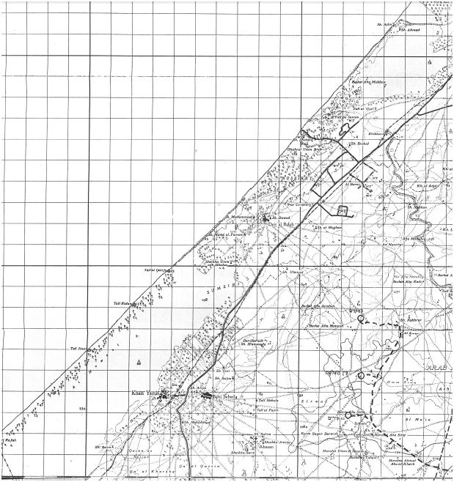
British map of the Gaza Strip with Israeli emendations (1955). Note the sandy empty space in the southwest: “a bad climate.” (Image courtesy of the Survey of Israel)

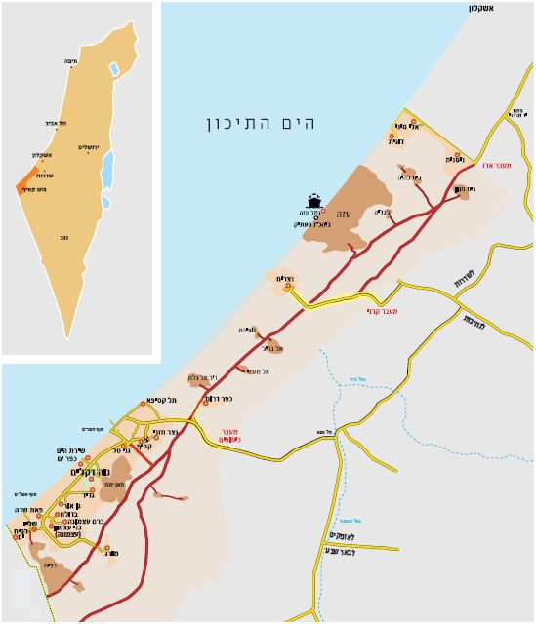
Map of Gush Katif. The Jewish settlements in the Gush fill the desolate sandy area of the British map above. (Image courtesy of the Gush Katif and Northern Samaria Commemoration Center)

For further study:

U. Cassuto, A Commentary on the Book of Genesis (trans. I. Abrahams), 2, Jerusalem 1964, 206-208.

Y. Elitzur, “Eretz Gerar,” Israel and the Bible, Ramat-Gan 2000, 352-356 [Hebrew].

J. M. Grintz, “Ha-Pelishtim Ha-rishonim,” Studies in Early Biblical Ethnology and History, Tel-Aviv 1969, 99-129 [Hebrew].

E. D. Oren, “Gerar,” Anchor Bible Dictionary, 2, 989-990.

E. D. Oren, “Haror, Tel,” The New Encyclopedia of Archaeological Excavations in the Holy Land, 580-584.

G. W. van Beek, “Jemmeh, Tell,” The New Encyclopedia of Archaeological Excavations in the Holy Land, 667-674.

Translated by Daniel Landman

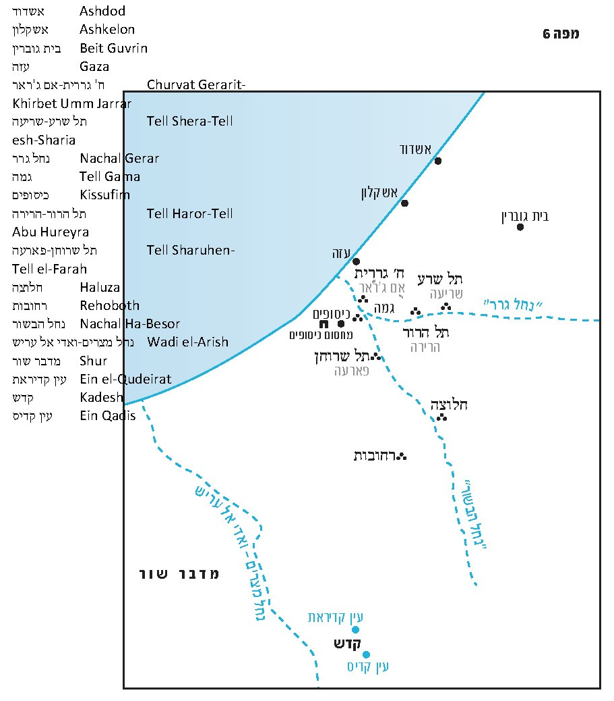

In the account of King Asa’s defeat of Zerah the Cushite in II Chronicles 14:12. The name Gerar also appears in the Septuagint’s translation of the description of the Simeonites’ expansion in the time of Hezekiah (in contrast to the Masoretic text, which reads “Gedor” (I Chronicles 4:39).
It is noteworthy that the Septuagint distinguishes between two types of Philistines. In the Torah they are called Phylistiim, while in the Prophets they are called allophyloi, or “strangers.”
Tyrannos, meaning “tyrant.” Other examples of foreign words adopted by the Philistines are argaz and the name Akhish.
See map at end of this shiur.
In this context, the verse refers presumably to the land of Gerar and the city of Gaza.
See the discussion in Parashat Beha’alotekha.
“Salton” here indicates that the region is Caesarean territory.
The phrase, “Va-yagor bi-Gerar,” is also a play on the similarity of the two words, but this does not take away from the normal linguistic meaning of the word.
This is according to the text found in MS Vatican 60, p. 283. Other versions read “Gerdike.”
Chazal considered the semi-desert of Geraritike similar to the Mediterranean Sea, in that the consideration of population is irrelevant and therefore it did not interfere with the original borders of the Torah. According to Gittin 8a and Yerushalmi Shevi’it 6:1, the inland border of the land of Israel ends in the north at Acre or Achzib, while the seaward border stretches from the Nur Mountains in modern-day Turkey (which Chazal identify with the northern Hor Ha-har of Numbers 34:7-8) to “the wadi of Egypt” (34:5) – Wadi el-Arish.

