YESHIVAT HAR ETZION
ISRAEL KOSCHITZKY VIRTUAL BEIT MIDRASH (VBM)
*********************************************************

GEOGRAPHY IN THE PARASHA

For easy printing, see
http://vbm-torah.org/archive/geography/02noach.htm

PARASHAT NOACH

The Borders of Canaan

By Prof. Yoel Elitzur

Parashat Noach – An International Story

When reading Parashat Noach, the Jewish reader might feel some confusion and strangeness, as if suddenly he has been thrust into an alien environment, like a visitor in a foreign country with no familiar face in sight. Parashat Noach describes a world without the Jewish people. We begin with the Flood – pairs of animals enter the ark and exit once the flood has abated – continue with the story of Noah getting drunk, enduring humiliation and cursing his grandson, and then we become lost in a tangle of Pathrusim and Casluhim, the great warrior Nimrod and a tower “with its top in the sky.” Only at the end of the parasha do we return to the comfort of the known, when we meet an old friend: “When Terah had lived seventy years, he begot Abram, Nahor and Haran… Abram and Nahor took to themselves wives, the name of Abram’s wife being Sarai… Terah took his son Abram, his grandson Lot the son of Haran… and they set out together from Ur of the Chaldeans for the land of Canaan” (11:26-31). We encounter Canaan and Abraham and begin to feel more at home.

From a geographic perspective as well, the parasha makes it clear that our characters inhabit a vast world, home to seventy nations with strange, exotic names like Ashkenaz, Riphath, Togarmah, Elishah, Tarshish, Kittim and Dodanim. Only at the very end, when rest of the ancient world has seemingly been mapped out completely, do we arrive at the land of Canaan.

The Canaanite Nations and Their Land

There are two groups of people listed in Parashat Noach, the borders of whose respective geographical regions are described. The first is the children of Joktan: “Their settlements extended from Mesha as far as Sephar, the hill country to the east” (10:30). More interesting to us is the second group – the Canaanites. It is noteworthy that the list of Canaanite families described here is markedly different from the “seven Canaanite nations” that we find later in Tanakh. In fact, this is an earlier list, one that places greater emphasis on the northern Canaanite nations. Alongside the Jebusites, Amorites and Girgashites, we find a host of “northern” names: Hivites, Arkites, Sinites, Arvadites, Zemarites and Hamathites.

The Torah proceeds with the borders of the land of Canaan: “The Canaanite territory extended from Sidon as far as Gerar, towards Gaza, and as far as Sodom, Gomorrah, Admah and Zeboiim, towards Lasha” (10:19). The inclusion of these geographic details is no coincidence. It clearly serves to prepare the reader for what is eventually in store: the entry of Abram, and eventually the nation of Israel, into the land of Canaan. However, it must be noted that the land of Canaan described here is not identical to the land of Canaan described later in the Torah. Interestingly, the Samaritans, who have a tendency to emend Biblical verses creatively in order to avoid internal contradictions, suggest a textual change here. In the Samaritan version of the Torah, the verse reads: “The Canaanite territory extended from the river of Egypt to the great river, the Euphrates River, to the Western Sea.” This substituted text is borrowed from God’s promise to Abraham in Genesis 15, as well as a parallel promise in Deuteronomy 11. In any case, the Masoretic text and all the other versions of this verse are unlike any other description of the borders of the land of Canaan mentioned in the Bible. Instead, we are confronted with several place names that we do not generally think of as borders of the Holy Land. These locations delineate the pre-Abrahamic borders of the land of Canaan.

Where is “Lasha” and What is the Geographical Logic Behind the “Canaanite Territory”?

The first thing we need to do in order to make some sense of these borders is to identify each one geographically. We already know the locations of Sidon and Gaza; conveniently, these ancient sites roughly correspond to their modern-day equivalents. The location of Gerar is disputed, but it is unquestionably in the vicinity of Gaza. Sodom, Gomorrah, Admah and Zeboiim are generally assumed to be located in the southern Dead Sea region, but the location of Lasha is problematic. The name cannot be found in any other source outside of Genesis 10:19.

Some have suggested that Lasha might be connected to Leshem (Joshua 19:47), an alternate name for Dan, a northern city near the headwaters of the Jordan. If this theory were true, a symmetrical picture would have emerged from the list of borders: Sidon in the northwest; Gaza and Gerar in the southwest; Sodom, Gomorrah, Admah and Zeboiim in the southeast; and Lasha/Leshem in the northeast. There is only one problem: “Lasha” is not “Leshem,” and the two cannot be equated simply because they share two of three letters.

Others attempted to link Lasha with La’ash, a city near the ancient Aramean capital of Hamath, in modern-day Syria, mentioned in an early Aramaic inscription found between Hamath and Aleppo. However, this identification is equally problematic: While letter transmutations do occur in Biblical Hebrew – prominent examples include kesev / keves, salma / simla and the place name Timnath Serah / Timnath Heres – they are rare. More importantly, the Lasha-La’ash connection is geographically problematic as well: La’ash should be situated at a line of latitude approximately 100 miles north of that of Sidon, creating an asymmetrical – and thus unlikely – border scheme.

Various imaginative (and improbable) textual emendations have also been suggested: “Lasha” becomes “Bela,” or even “Lashon.” Interestingly, Targum Yerushalmi (MS Neofiti) and Targum Pseudo-Jonathan translate “Lasha” as “Kalrahi,” referring to Kalliroē, the Greek name for a group of hot springs in the northeast Dead Sea region. This translation is based not on an interpretation of the words of the verse, but rather on a traditional identification presumably known among the inhabitants of the region. Seemingly, this identification of Lasha is difficult to accept as well, as it excludes the entire northeast corner of the land of Canaan.

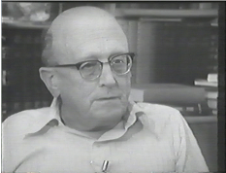
Yehoshua Meir Grintz

One particularly illuminating explanation for our verse was suggested by Yehoshua Meir Grintz in his article “Eretz Ha-ye’ud.” Grintz emphasizes, first and foremost, that the verse speaks of “the Canaanite (Ha-Kena’ani) territory” rather than “the land of Canaan (Kena’an).” In other words, the locations listed in the verse are not the borders of Canaan as we know it, but those of the land inhabited by the Canaanite nation, the most eminent nation among the various peoples of Canaan. With regard to the identity of Lasha, Grintz accepts the local tradition reflected in the Targum Yerushalmi and the Midrash – “Kalrahi” – and explains that the “Sidon” listed here is actually a general territorial term for the entire region of what is now southern Lebanon.

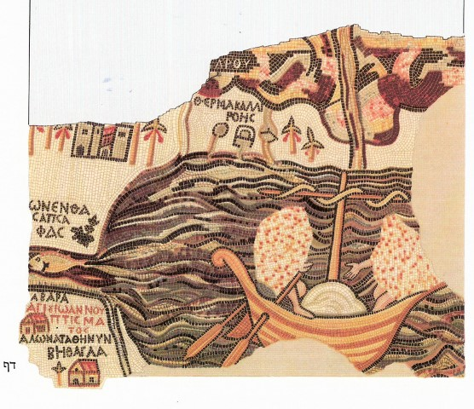
Καλλιρ(ρ)όη, meaning “beautiful flow

Grintz marshals several Biblical sources that support this usage of “Sidon.” First, the people of Laish, a city by the headwaters of the Jordan River, are described as “dwelling carefree, after the manner of the Sidonians” (Judges 18:7). On the other hand, the city itself is “distant from Sidon” (18:28), seemingly implying that Laish and the other cities of that region were governed from afar by Sidon. Another example is the description of Mount Hermon found in Deuteronomy: “Sidonians called Hermon Sirion, and the Amorites call it Senir” (3:9). How a person would refer to Mount Hermon depended on geography; those to the west of the mountain would call it Sirion, while those to the south would call it Senir. Once again, we see that “Sidon” is used in the territorial sense – it is the region that abuts upon Mount Hermon.

Now that we understand “the Canaanite territory” in its more limited meaning, we can begin to make sense of the borders. The northern border is the territory of Sidon, or southern Lebanon. From there, the western borderline is drawn southward along the coastal plain, “as far as Gerar, near Gaza,” and the eastern borderline stretches across the Jordan Rift Valley, “as far as Sodom, Gomorrah, Admah and Zeboiim, near Lasha.” This understanding seems to jibe nicely with the two places in Tanakh where the geographic divisions of the land of Canaan between the Canaanite nations are described. The first instance can be found in the report of the Twelve Spies on the land: “Amalekites dwell in the Negeb region; Hittites, Jebusites and Amorites inhabit the hill country; and Canaanites dwell by the Sea and along the Jordan” (Numbers 13:29). The second instance can be found in Joshua; it is a description of the northern Canaanite nations that joined forces to battle the people of Israel: “To the Canaanites in the east and in the west; to the Amorites, Hittites, Perizzites and Jebusites in the hill country…” (11:3).

In conclusion, it is clear that the description of the borders of “the Canaanite territory” found in our parasha served to prepare the reader for the encounter with the land of Canaan, which would later be promised to the Patriarchs and then given to their descendants. However, it is important to note the delicate terminology used in the verse, seemingly written with a careful eye to the geographic realities of that period. Indeed, at the time there was no land of Canaan as we know it from later Biblical narratives. Accordingly, it is not described in Parashat Noach as one unified bloc of land, but rather as a sprawl of individual territories, in which the northern Canaanite tribes asserted their dominance over the region. Despite this sensitivity to relating an accurate account of history, there is still an underlying tone of purpose and preparation for the next series of narratives – the story of Abraham and the Israelite inheritance of the land of Canaan.

Translated by Daniel Landman

For further study:

H. L. Ginsberg, “Lasha,” Encyclopaedia Biblica 4, 532 (Hebrew).
Y. M. Grintz, Motza’ei Dorot, Tel-Aviv 1969, 141-142 (Hebrew).

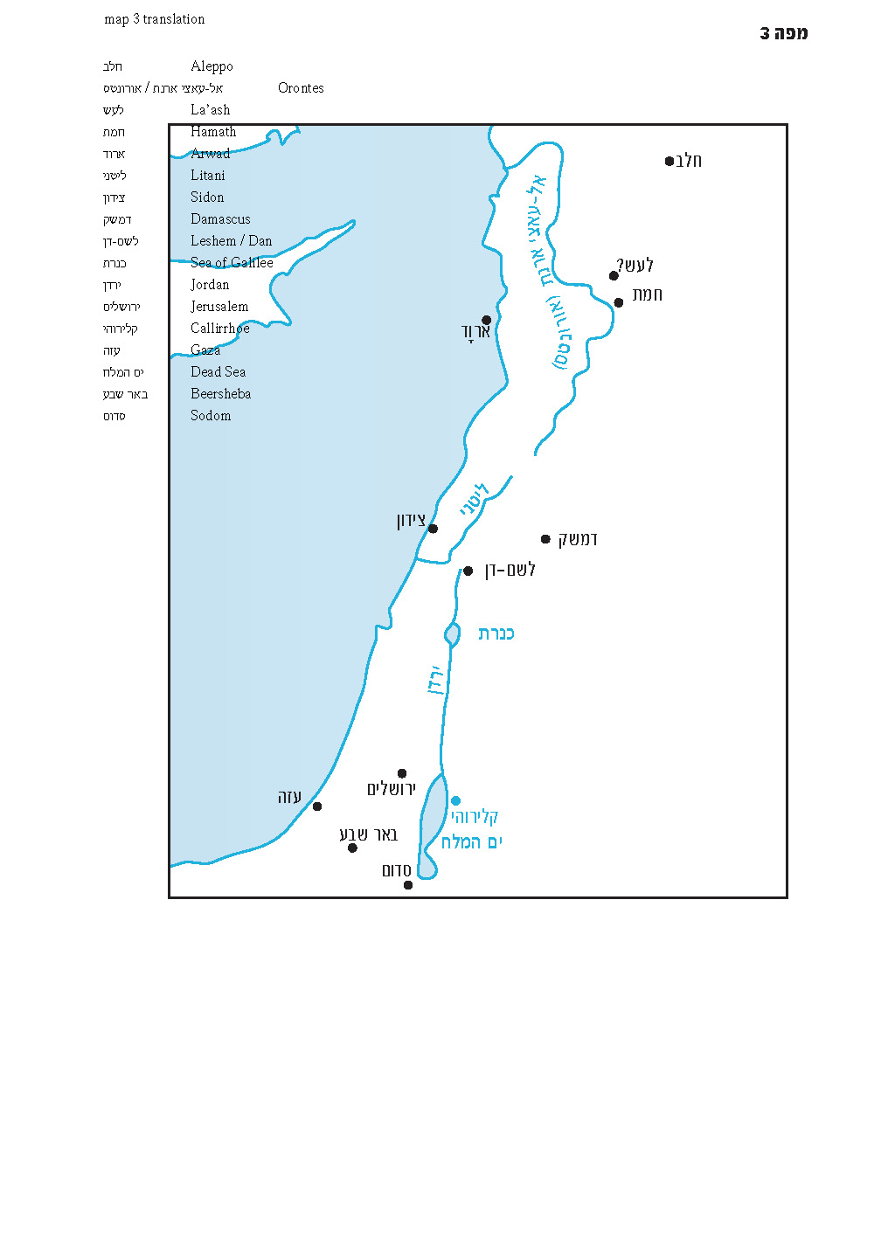

See map3.
See Joshua 11:3: “And to the Hivites at the foot of Hermon, in the land of Mizpah.”
A similar emendation can be found in the Samaritan Bible in Moses’s surveillance of the Promised Land from Mount Nebo, supplanting our text in Deuteronomy 34:1-3.
We will discuss this question in depth later, in Parashat Toledot.
See the discussion in Parashat Vayera.
See Bereishit Rabba 37:6, where the same term can be found.
Καλλιρ(ρ)όη, meaning “beautiful flow,” is also the name of a spring located near Athens, as well as several figures in Greek mythology. See also http://vbm-torah.org/archive/geography/02noach-Kalliroe.pdf
According to Grintz, the word “bo’akha” (“as far as”) signifies a distant point that the borderline seems to lead to but does not actually reach. Thus, the city of Gerar must be located somewhere in the western Negev, south of Gaza.

