YESHIVAT HAR ETZION
ISRAEL KOSCHITZKY VIRTUAL BEIT MIDRASH (VBM)
*********************************************************

GEOGRAPHY IN THE PARASHA

For easy printing, see
http://vbm-torah.org/archive/geography/01bereishit.htm

PARASHAT BEREISHIT

The Garden of Eden and the Euphrates River

By Prof. Yoel Elitzur
Translated by Daniel Landman

Where is the Garden of Eden?

As we begin the yearlong cycle of Torah reading with Parashat Bereishit, it is striking that most of the action in the parasha centers around a unique setting: the Garden of Eden. Where is this mysterious place? Is it some supernatural realm that does not truly exist in the world as we know it, or can we actually pinpoint its location on a map, given enough information?

The Torah describes the Garden of Eden using concrete geographical terminology:

A river issues from Eden to water the garden, and it then divides and becomes four branches. The name of the first is Pishon, the one that winds through the whole land of Havilah, where the gold is… bdellium is there, and lapis lazuli. The name of the second river is Gihon, the one that winds through the whole land of Cush. The name of the third river is Tigris, the one that flows east of Asshur. And the fourth river is the Euphrates. (10-14)

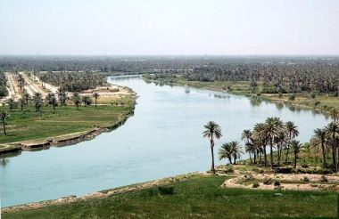
Two of these four rivers are well known to us: the Tigris and the Euphrates. In contrast, we are unfamiliar with the identities of the first two rivers listed here, and what is more, they are not mentioned thereafter in all of Tanakh. The verses provide us with hints as to their locations, but these serve only to confuse us further: Pishon surrounds the land of Havilah, while Gihon surrounds the land of Cush. Cush can ostensibly be found somewhere in Africa. The land of Havilah, “where the gold is,” is most likely connected to the “Havilah” listed as one of the sons of Joktan (a descendant of Noah). Joktan’s sons and their descendants were tribal people who settled in the southern end of the Arabian Peninsula. The problem is that there are no significant rivers in South Arabia, and all attempts to link Pishon to one of the torrents of that region have been unconvincing. In light of this, perhaps we must conclude that the information presented to us in these verses does not actually reflect real-world geography. On the other hand, the Tigris and the Euphrates are quite real, and furthermore, the descriptions of Pishon and Gihon are written in a realistic, geographic style, not in the abstract terminology that characterizes descriptions of otherworldly locations and entities.

What are the major rivers of the Eastern Mediterranean, the home of our forefathers? Undoubtedly these are the Tigris and the Euphrates in the north and the Nile in the southwest. Since the tributaries of the Nile originate in "the land of Cush," which is in central Africa, there may actually be some justification in identifying them as Pishon and Gihon, and their meandering course might fit the phrase, “the one that winds through.” Indeed, following the lead of William F. Albright, many believe that Pishon and Gihon are what we refer to today as the Blue Nile and the White Nile, the two major tributaries of the Nile River.

But this theory creates a new, fundamental problem: The Blue Nile and the White Nile are located far to the south of the so-called Fertile Crescent, while the Tigris and the Euphrates are located far to the north. Because of this difficulty, there is a wide range of other opinions on the identity of Pishon and Gihon. According to an ancient Jewish interpretation, Pishon is the Ganges and the land of Havilah is India. Still others maintain that Pishon and Gihon are located in Asia Minor, and other opinions abound. In order to square these interpretations with the Biblical text, some invoke a possible alternative location for the land of Cush: what we know today as the mountainous Hindu Kush region in Afghanistan and northern Pakistan. This discrepancy is reflected in the Talmud Bavli, Megilla 11a: “One said that Hoddu [India] is at one end of the world and Cush is at the other, and the other said that Hoddu and Cush adjoin one another.”

Dov Ashbel placed the Garden of Eden in the vicinity of Mount Ararat in Eastern Anatolia, the region in which both the Tigris and the Euphrates originate. Ashbel maintained that Pishon and Gihon are additional rivers local to that region that drain into the Caspian Sea and the Black Sea, forcing him into some creative interpretations of “the land of Havilah” and “the land of Cush.”

German scholar Friedrich Delitzsch, who dedicated an entire book to the question of the Garden of Eden’s location, maintained that the Biblical Garden of Eden was in Babylonia, specifically its fertile southern region adjacent to the Persian coast. Delitzsch identified Pishon and Gihon as canals running from the Euphrates (which originally may have been natural streams) and Cush as the land known as kašši, or northern Babylonia. Others placed the Garden of Eden in modern-day southern Iraq and identified Pishon and Gihon as the Karun and Karkheh Rivers, which originate in the mountains of Iran (the Karkheh flows through the ruins of ancient Shushan).

Hermann Gunkel took his analysis of this question to an entirely different dimension – quite literally to outer space. The river that “issues from Eden,” according to Gunkel, refers to the Milky Way and its four spiral “arms” that are visible to the naked eye. The names that the Torah gives to these arms are borrowed from the names of four famous rivers throughout the world.

At the end of the day, it seems unlikely that we will be able to pinpoint the precise location of the Garden of Eden. All we know is where we are today – exiled from its borders, with the “fiery ever-turning sword” barring us from entering again.

The Euphrates River

The Euphrates is the fourth river listed in the geographical description of the Garden of Eden, and we would be remiss if we did not discuss its great importance in the region. The Torah often refers to the Euphrates as “The Great River.” It is longer than the Tigris, and unlike the Tigris, all of its water originates in the northern mountains and no tributaries augment its flow in its course through Iraq, the more significant section of its overall course. As a result, the flow of the Euphrates in its southern part is generally serene, and the water level decreases only gradually. The area of the Tigris-Euphrates river system is known as Mesopotamia, Greek for “between the rivers,” and is often termed “the cradle of civilization.” The land between the Euphrates and the Tigris was home to Assyria in the northeast, Mari and Aram in the northwest and Sumer, Babylonia and Akkadia in the south.

Chazal interpreted “The Great River” as a reference to its role as the border of the land of Israel. However, it is worth noting that throughout Tanakh, the term “The River” is a reference to the Euphrates as well. In his farewell speech to the nation, Joshua reminds the people of Israel of their roots: “In olden times, your forefathers lived beyond The River” (Joshua 24:2). Ahijah the Shilonite later warns the people of the exile that will drive the nation back to that region: “And [He] will scatter them beyond The River” (I Kings 14:15). In addition to the mention of the Euphrates’s role as a border in God’s promise to Abraham – “from the river of Egypt to The Great River, the Euphrates River” (Genesis 15:18) – we find another mention in God’s promise to his descendants at Sinai: “I will set your borders from the Sea of Reeds to the Sea of Philistia, and from the wilderness to The River” (Exodus 23:31).

A well-known characteristic of Biblical poetry is the lack of the definite article. Because of this, in the poetic portions of Tanakh, the Euphrates is often referred to simply as “River,” and not “The River.” For example, Jeremiah laments: “What, then, is the good of your going to Egypt to drink the waters of the Nile? And what is the good of your going to Assyria to drink the waters of River?” (Jeremiah 2:18). Similarly, we find in Psalms: “Let him rule from sea to sea, and from River to the ends of the earth” (72:8), an abbreviated version of the promised borders we read of in Exodus 23.

Ever Ha-nahar – Beyond the Euphrates

At a certain point during the Biblical Period, the meaning of the expression “beyond the Euphrates” seems to have changed. We already noted the usage of the phrase in both Joshua’s farewell address and in Ahijah’s ominous prophecy, where they mean “beyond” quite literally: Joshua is speaking about our forefathers who lived on the “other side” of the Euphrates, with respect to the land of Israel – meaning beyond its eastern banks – and Ahijah is threatening that the people of Israel would later be exiled to that same far-flung region. The same usage can be found in the description of David’s wars: “Hadadezer sent for and brought out the Arameans from across the Euphrates” (II Samuel 10:16).

However, in the beginning of I Kings we read that Solomon “controlled the whole region beyond the Euphrates – all the kings beyond the Euphrates, from Tiphsah to Gaza” (5:4). In this verse, it seems clear that “beyond the Euphrates” refers not to the eastern side of the river, but to its western side, where the people of Israel actually lived. If so, why is this region called “beyond the Euphrates”?

The answer to this question can be found by examining the book of Ezra-Nehemiah. The expression “ever ha-nahar” or variations of the phrase appear 13 times throughout the book, each time referring to the area within the boundaries of the greater land of Israel – from the Euphrates to the Egyptian border. This usage can be traced back to the time of Sargon II, king of the Assyrian Empire, when it was written in Assyrian texts as eber nāri. In the Esarhaddon inscriptions, this place is linked with the word ḫatti, the Akkadian name for Syria. From here the usage passed to the Babylonians and the Persians, who minted coins bearing the Aramaic version of the name: “avar nahara.” The same phrase was also found in a Greek inscription, written as “peran Euphratou” – literally “beyond the Euphrates.”

The fundamental question here is where the true geographical center of gravity lies. The earliest interpretations of the expression “beyond the Euphrates” adopted the perspective of the land of Israel: We are “here” and they – Assyria, Babylonia and Harran – are “beyond the Euphrates.” Only much later do we find sources that unintentionally take the opposite approach, identifying ourselves as the “other”: Assyria, Babylonia and Susa represent the epicenter of the world, while we in the land of Israel are resigned to the region “beyond the Euphrates.”

We can draw an analogy here to the modern usage of the expression “Middle East” (synonymous with “Near East”), a term used even by those who live in the region, despite its Eurocentric implications. From the perspective of the Europeans who coined the phrase, Israel and its neighbors lie, literally, to the near east, while China and Japan comprise the Far East based on similar logic.

The watershed moment at which “beyond the Euphrates” reversed its meaning was, in all likelihood, the rise of the Assyrian Empire. The only difficulty with this explanation is the verse in I Kings describing Solomon, who predated the rise of the Assyrians by many years. The answer, quite simply, is that the verse – “For he controlled the whole region beyond the Euphrates – all the kings beyond the Euphrates” – is a reflection on the mindset of the author of the book of Kings and not on that of Solomon or the people of his time.

Appearances in the Targumim

It is worth noting that Onkelos and Jonathan, in their respective Aramaic translations of the Torah and the Prophets, render the Hebrew word nahar as perat (Euphrates) even when the term is plainly used in the general sense. Balaam’s laudatory description of the people of Israel upon seeing their encampment – “Like palm-groves that stretch out, like gardens beside a river” (Numbers 24:6) – was translated by Onkelos as “Like palm-groves that flow onward, like the watered garden by the Euphrates.” The same phenomenon can be seen in the final chapter of Isaiah: “I will extend to her prosperity like a river” (66:12), translated by Jonathan as “I will bring to her prosperity like the floods of the Euphrates River.” The first example may, to some extent, reflect the speaker’s background. After all, Balaam lived in the vicinity of the Euphrates, and it stands to reason that river imagery, whether consciously or subconsciously, would enter into his poetic lexicon.

Kerei and ketiv

One interesting example of the interplay between “The River” and “The Euphrates River” in Tanakh can be found in II Samuel’s description of David’s battle with Hadadezer: “David defeated Hadadezer son of Rehob, king of Zobah, who was then on his way to restore his monument at the Euphrates River” (8:3). The commentators dispute exactly what series of events led to David’s victory: Did David ambush Hadadezer while the king of Zobah was en route to the Euphrates? Or was it David himself who was traveling to the river to restore his own monument, stopping along the way to defeat Hadadezer? The answer to this question does not interest us here; instead we will focus on a quirk in the wording of the verse. According to Masoretic tradition, the word “Euphrates” is an example of kerei ve-lo ketiv, a word that is read along with the rest of the verse but not actually written in the traditional text. Thus, the “ketiv” of the verse reads, simply, “to restore his monument at the River.” Which version we accept – the ketiv or the kerei – is irrelevant; the two traditions are equivalent in meaning. Whether we read “the River” or “the Euphrates River,” the identity of the river here is never in question.

The Euphrates as a Border of the Land of Israel

Before we conclude, it is critical that we emphasize that the most important function of the Euphrates River is its role as one of the borders of the greater land of Israel. The Euphrates plays a part in each of the Torah’s repetitions of the borders of the land of Israel in its broad, promised form. The river is mentioned as a border in God’s original promise to Abraham at the Covenant of the Pieces: “To your offspring I assign this land, from the river of Egypt to the great river, the river Euphrates” (Genesis 15:18). This pledge is repeated at the covenant at Sinai (Exodus 23:31) and three times in the plains of Moab (Deuteronomy 1:7; 11:24; Joshua 1:3).

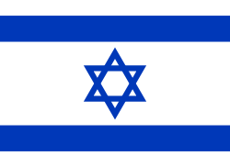
We will close with a remarkable commentary from an unlikely source. In several interviews, Yasser Arafat made a startling claim regarding the modern Israeli flag: The two broad blue stripes represent the Nile and the Euphrates Rivers, and the Star of David between the stripes represents the Jewish people. Thus, argued Arafat, the flag symbolizes Israel’s intent to expand its territory to the entire area between the two major rivers. Arafat’s theory angered many Israelis at the time, but the truth is that his take on the flag was merely a visual representation of what can be found explicitly in the words of the Torah. Instead of reacting to Arafat’s commentary as if it were a kind of blood libel, we should instead see it as a message of well-wishing for the realization of our national destiny.

For further study:
W. F. Albright, “The Location of the Garden of Eden,” AJSL 39 (1922), 15-31.
D. Ashbel, “Arba’a Neharot Ha-yotze’im Me-Eden,” Beit Mikra 40 (1970), 100-104.
A. M. Bagg, Die Orts und Gewässernamen der neuassyrischen Zeit, Teil 1: Die Levante (RGTC 7/1), Wiesbaden 2007, 64.
U. Cassuto, A Commentary on the Book of Genesis, Illinois 2005, 114-121.
F. Delitzsch, Wo lag das Paradies, Leipzig 1881.
Y. Elitzur and Y. Kil, Atlas Da’at Mikra, Jerusalem 1993, 20-21.
J. J. Finkelstein, “Mesopotamia,” JNES 21 (1962), 73-92.
Y. M. Grintz, Studies in Early Biblical Ethnology and History, Jerusalem 1969, 35-50 (Hebrew).
W. W. Müller, “Pishon,” Anchor Bible Dictionary, 5, 282.
Y. T. Radai, “Arba’a Neharot,” in Y. T. Radai et al. (eds.), La-ateret Tzevi: A Token of Friendship in Honor of Rabbi Professor Zvi A. Kurzweil, Haifa 1980, 25-30 (Hebrew).
A. F. Rainey, “Ever Ha-nahar, Ever Nahara, Avar Nahara,” Encyclopaedia Biblica 6, 43-48 (Hebrew).

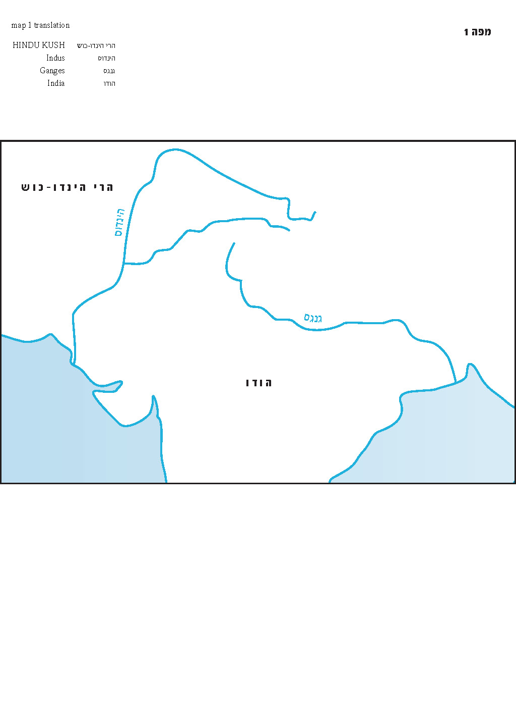
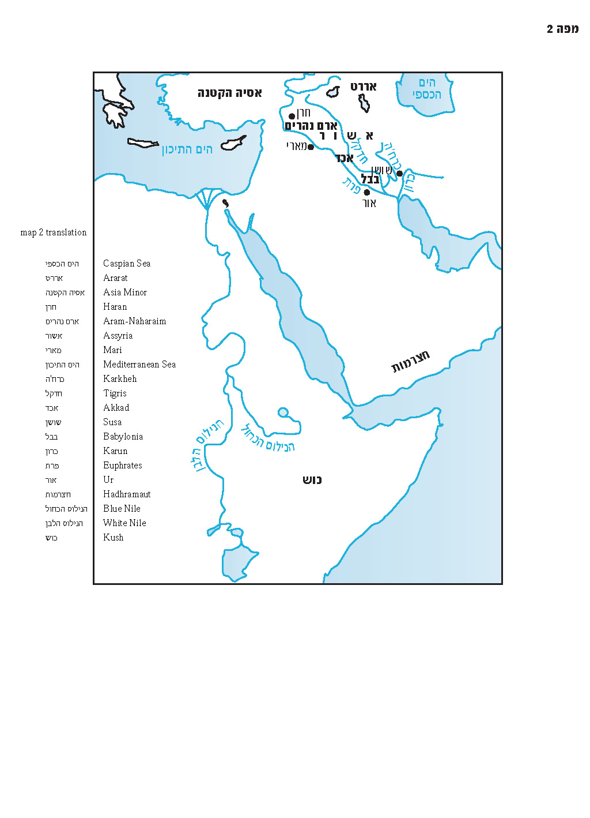

See http://vbm-torah.org/archive/geography/01bereishit-maps1-2-eng.pdf We thank Yediot Books and Waldman Studio for allowing us to reprint maps for this series; the maps appeared originally in Prof. Elitzur’s book, Places in the Parashah, 2013. See also
See http://commons.wikimedia.org/wiki/File:Murchison_Falls_-_by_Boschlech.jpg
Arabs trace the lineage of these southern tribes to an ancient forefather named Qaḥṭān, apparently equivalent to the Biblical Joktan.
See Josephus, Antiquities 38a, Targum Neofiti, Targum Pseudo-Jonathan and even Jerome, the Church Father, apparently following his Jewish teachers, in his book Hebraicae Quaestiones in Libro Geneseos.
See Sifrei Devarim 7 and Bereishit Rabba 16:3, pp. 145-146.
There is some debate over whether this was the meaning of “Mesopotamia” in the original Greek. Jacob J. Finkelstein argued that the word, along with the Hebrew name “Aram Naharayim” that preceded the Greek, actually referred solely to the Euphrates.
See also Zechariah 9:10.
See Numbers 22:5, 23:5 and 23:7.
See the parallel verse in I Chronicles 18:3, where the verse reads “to set up his monument.”
See http://vbm-torah.org/archive/geography/01bereishit - Israeli flag.png

